<http://www.wakegov.com/elections/data/Pages/data.aspx>

Download Wake County Voter Data

Bring locally

Unzip

Open in Excel and save as .csv

studio.azureml.net

New -> Dataset -> From Local File

New ->Experiment -> Blank Experiment

SavedDatasets -> My Datasets -> vrdb

Data Transformation -> Manipulation -> Project Columns

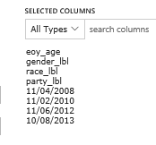

Data Transformation -> Manipulation -> Metadata Editor

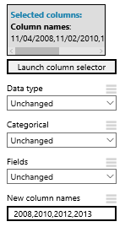

R Language Modules -> Execute R Script

data.set <- maml.mapInputPort(1) # class: data.frame

data.set[,5:8] <- !is.na(data.set[,5:8])

maml.mapOutputPort("data.set");

Data Transformation -> Manipulation -> Metadata Editor

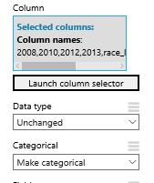

Data Transformation -> Sample and Split -> Split Data

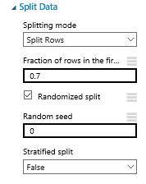

Machine Learning -> Initialize Model -> Classification -> Two-Class Logistic Regression

Machine Learning -> Train -> Train Model

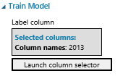

Machine Learning -> Score -> Score Model

Machine Learning -> Evaluate -> Evaluate Model

Machine Learning -> Initialize Model -> Classification -> Two-Class Boosted Decision Tree

