**RDBMS Relationship & Description**

1. **List Table**

| Table Name | Description | Type |
| --- | --- | --- |
| auth_assignment | table to identify the user based on the authentication item name | Assign |
| auth_item | Auth Item table as Master for initiating authentication items with role access. | Master |
| auth_item_child | Child item table from authentication item master | Assign |
| auth_rule | Rules authentication and authorize | Assign |
| employee | Employee table as master for employee data as well as initiation for users and okr ownership. | Master |
| position | Position table as an employee position is master used to view the position of the user's level and organization. | Master |
| t_approval_okr | The approval table as an OKR approval list that will hold approved or rejected status. | Assign |
| t_category | Table for storing a list of category names for okr progress | Master |
| t_dependency | List detail dependency of okr | Assign |
| t_key_result_okr | Detail key result of OKR | Master |
| t_log | Table for storing activity logs on OKR. | Logs |
| t_menu_management | OKR Management Menu Table to set access to the selected role. | Master |
| t_objective_okr | Table to store the details of the objective data OKR | Master |
| t_okr | Table stores the main data of the OKR created | Main |
| t_period | Table saves the date and time histories the development and monitoring of OKR | Master |
| t_si | The table stores all history and "Strategic Initiative" data that are active at a certain period by year | Master |
| t_so | The table stores all history and "Strategic Objective" data that are active at a certain period by year | Master |
| t_unit_code | Storing all unit code positions of company employees | Master |
| temp_dependency | Storing temporary depency list created by a user | Temp |
| user | Save all user Data for the identifier for the Oktari access | Main |

1. **Relationship**

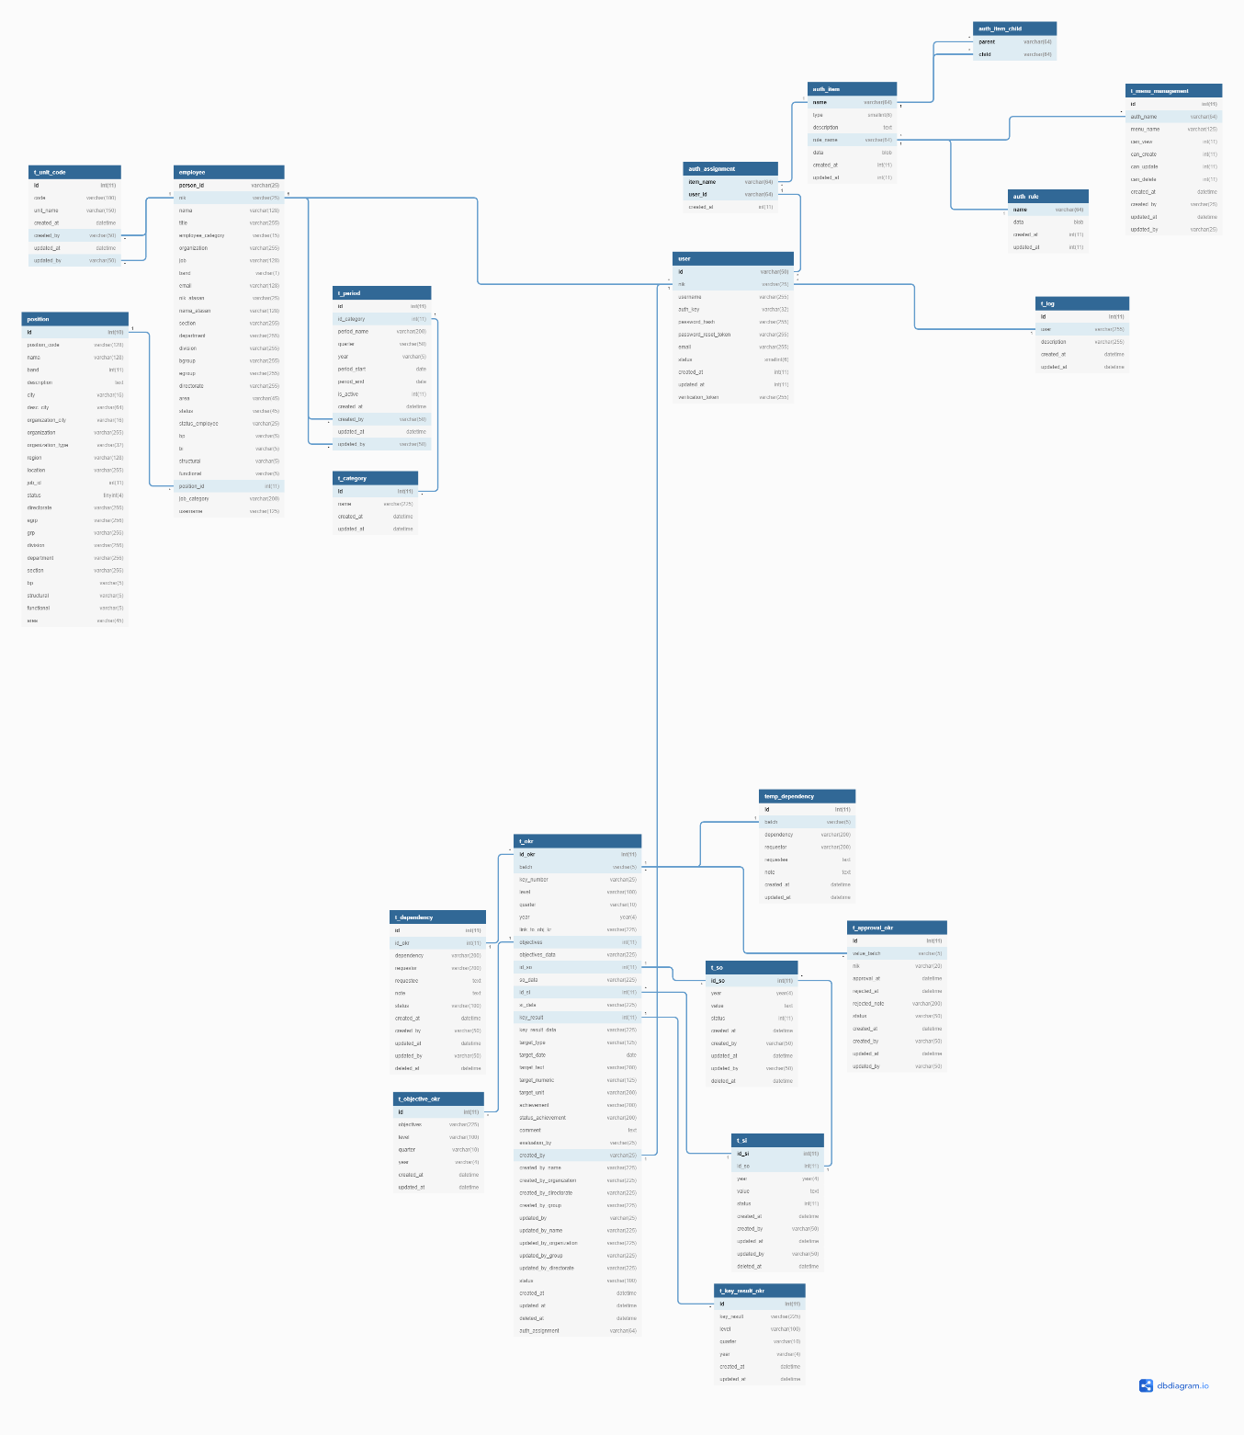

**Employee Section**

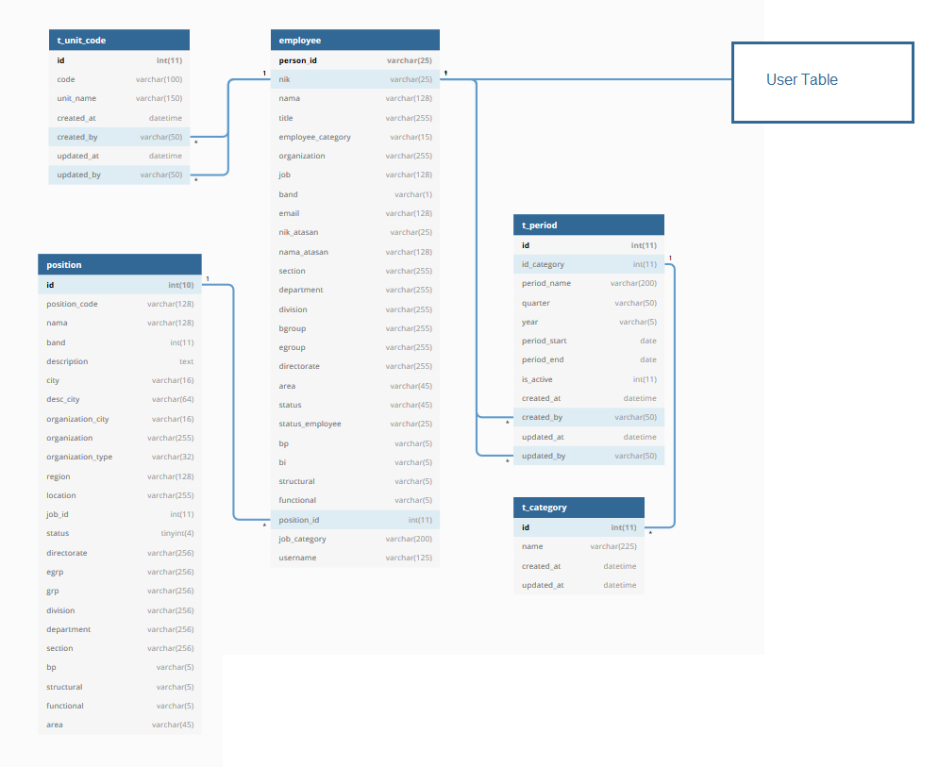

**Roles Section**

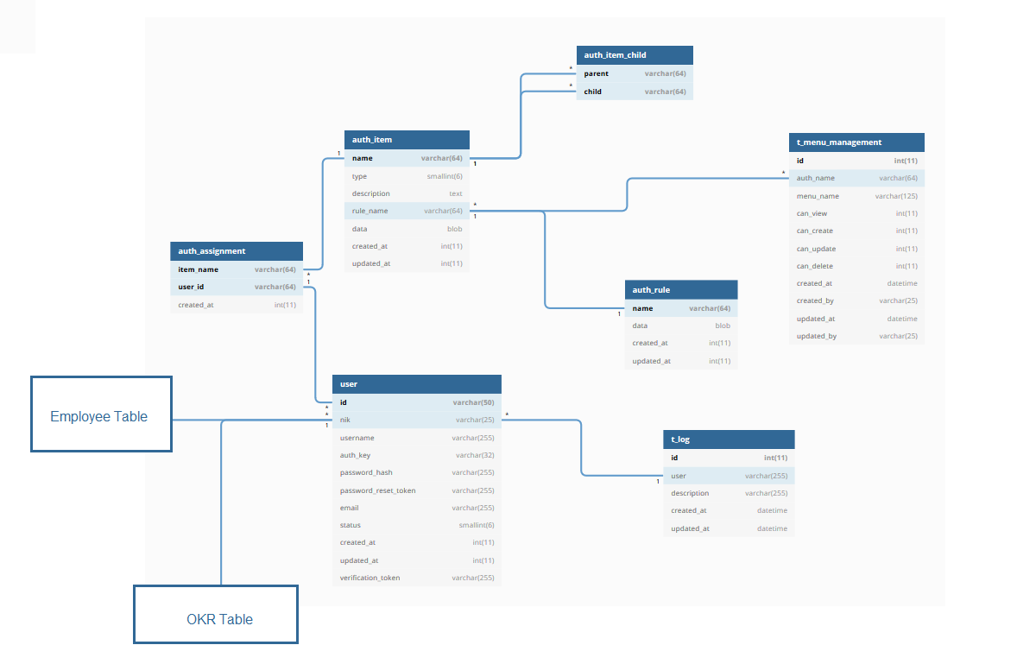

**OKR Section**

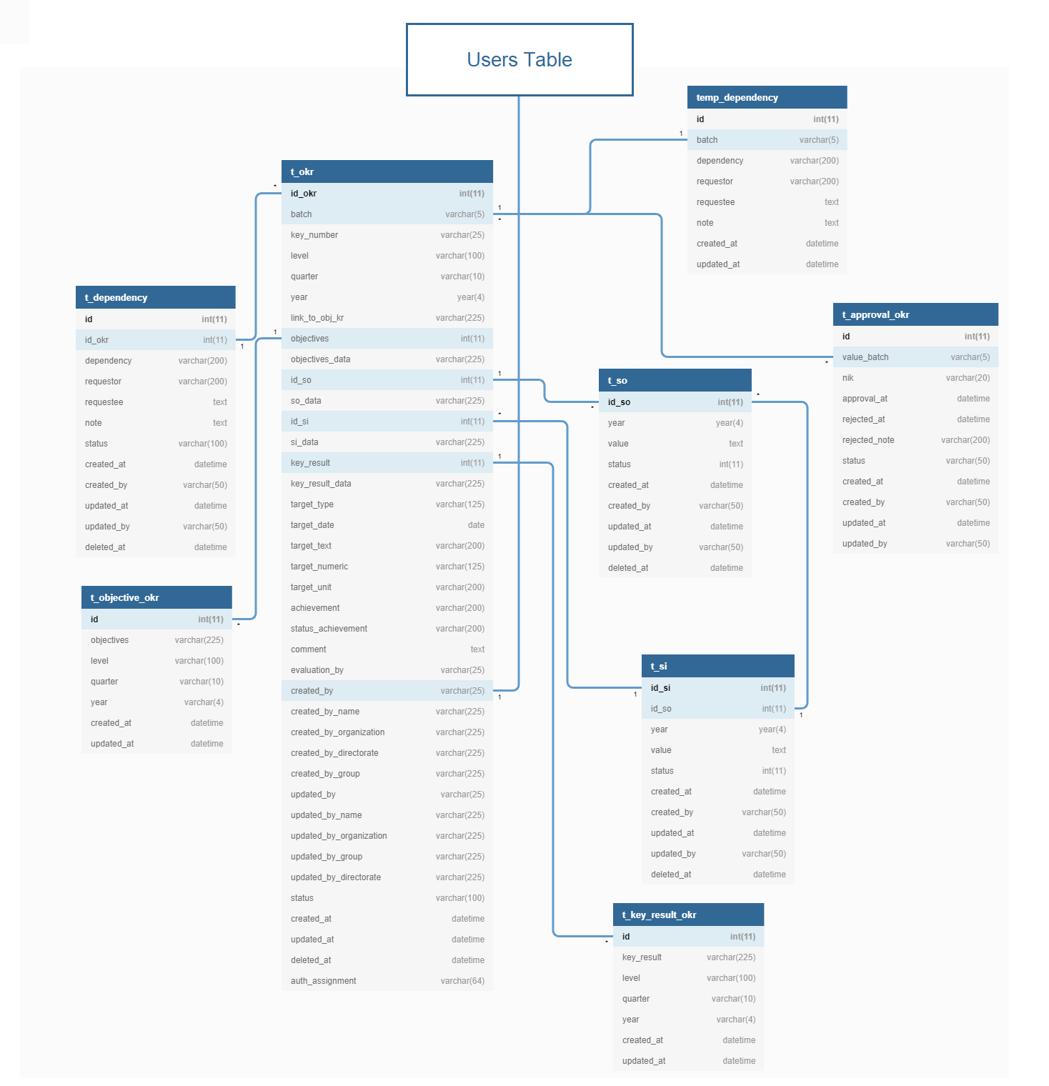

1. **Table Detail Description**
2. Auth assignment (auth_assignment)

The Auth Assigment table as a table to identify the user based on the authentication item name

| Field Name | Type | Description | **Key** |
| --- | --- | --- | --- |
| item_name | varchar(64) |  | PRI |
| user_id | varchar(64) |  | PRI |
| created_at | int(11) |  |  |

1. Auth Item (auth_item)

Auth Item table as Master for initiating authentication items with role access.

| Field Name | Type | Description | **Key** |
| --- | --- | --- | --- |
| name | varchar(64) |  | PRI |
| type | smallint(6) |  | MUL |
| description | text |  |  |
| rule_name | varchar(64) |  | MUL |
| data | blob |  |  |
| created_at | int(11) |  |  |
| updated_at | int(11) |  |  |

1. Auth Item Child (auth_item_child)

Child item table from authentication item master

| Field Name | Type | Description | **Key** |
| --- | --- | --- | --- |
| parent | varchar(64) |  | PRI |
| child | varchar(64) |  | PRI |

1. Auth rule(auth_rule)

Rules authentication and authorize

| Field Name | Type | Description | **Key** |
| --- | --- | --- | --- |
| name | varchar(64) |  | PRI |
| data | blob |  |  |
| created_at | int(11) |  |  |
| updated_at | int(11) |  |  |

1. Employee (employee)

Employee table as master for employee data as well as initiation for **users** and **okr** ownership.

| Field Name | Type | Description | **Key** |
| --- | --- | --- | --- |
| person_id | varchar(25) | ID Person | PRI |
| nik | varchar(25) | Unique code Employee | UNI |
| nama | varchar(128) | Employee name |  |
| title | varchar(255) | Employee tittle |  |
| employee_category | varchar(15) |  | MUL |
| organization | varchar(255) | Employee organization name |  |
| job | varchar(128) | Employee job |  |
| band | varchar(1) |  |  |
| email | varchar(128) |  |  |
| nik_atasan | varchar(25) | Unique code employer |  |
| nama_atasan | varchar(128) | Employer name |  |
| section | varchar(255) | Employee section |  |
| department | varchar(255) | Employee department name |  |
| division | varchar(255) | Employee division name |  |
| bgroup | varchar(255) |  |  |
| egroup | varchar(255) |  |  |
| directorate | varchar(255) | Employee directorate name |  |
| area | varchar(45) |  |  |
| status | varchar(45) | Employee Status |  |
| status_employee | varchar(25) |  |  |
| bp | varchar(5) |  |  |
| bi | varchar(5) |  |  |
| structural | varchar(5) |  |  |
| functional | varchar(5) |  |  |
| position_id | int(11) | ID Position Relationship to Position Table |  |
| job_category | varchar(200) | Employee job category |  |
| username | varchar(125) |  |  |

1. Position (position)

Position table as an employee position is master used to view the position of the user's level and organization.

| Field Name | Type | Description | **Key** |
| --- | --- | --- | --- |
| id | int(10) unsigned | ID Position | PRI |
| position_code | varchar(128) | Code position |  |
| nama | varchar(128) | Position name |  |
| band | int(11) |  |  |
| description | text | Position organization |  |
| city | varchar(16) | Address office position |  |
| desc_city | varchar(64) | City description |  |
| organization_city | varchar(16) | Organization place |  |
| organization | varchar(255) | Organization name |  |
| organization_type | varchar(32) | Organization type |  |
| region | varchar(128) | Region |  |
| location | varchar(255) | Location Position office |  |
| job_id | int(11) | Id Job |  |
| status | tinyint(4) | Position status |  |
| directorate | varchar(256) | Directorate of position |  |
| egrp | varchar(256) |  |  |
| grp | varchar(256) | Group of position |  |
| division | varchar(256) | Division of position |  |
| department | varchar(256) | Department of position |  |
| section | varchar(256) | Position Section |  |
| bp | varchar(5) |  |  |
| structural | varchar(5) |  |  |
| functional | varchar(5) |  |  |
| area | varchar(45) | Position Office Area |  |

1. Approval OKR(t_approval_okr)

The approval table as an OKR approval list that will hold approved or rejected status.

| Field Name | Type | Description | **Key** |
| --- | --- | --- | --- |
| id | int(11) | ID | PRI |
| value_batch | varchar(5) | Batch Identifier Number |  |
| nik | varchar(20) | Unique Code Employe |  |
| approval_at | datetime | Confirmation time approval |  |
| rejected_at | datetime | Confirmation time rejected |  |
| rejected_note | varchar(200) | Notes of Rejection |  |
| status | varchar(50) | Status Approval |  |
| created_at | datetime | Time Created |  |
| created_by | varchar(50) | Created by (Employee Code) |  |
| updated_at | datetime | Time Updated |  |
| updated_by | varchar(50) | Update by (Employee Code) |  |

1. Category (t_category)

Table for storing a list of category names for okr progress

| Field Name | Type | Description | **Key** |
| --- | --- | --- | --- |
| id | int(11) | ID Category | PRI |
| name | varchar(225) | Category Name |  |
| created_at | datetime | Time Created |  |
| updated_at | datetime | Time Updated |  |

1. Dependency(t_dependency)

List detail dependency of okr

| Field Name | Type | Description | **Key** |
| --- | --- | --- | --- |
| id | int(11) | ID Dependency | PRI |
| id_okr | int(11) | ID OKR |  |
| dependency | varchar(200) | Dependency Text |  |
| requestor | varchar(200) | Requestor of dependecy |  |
| requestee | text | Requestee of dependency |  |
| note | text | Dependency notes |  |
| status | varchar(100) | Dependency Status |  |
| created_at | datetime | Time Created |  |
| created_by | varchar(50) | Created By (Employee code) |  |
| updated_at | datetime | Time Updated |  |
| updated_by | varchar(50) | Updated By (Employee code) |  |
| deleted_at | datetime | Time Delete |  |

1. Key Result OKR(t_key_result_okr)

Detail key result of OKR

| Field Name | Type | Description | **Key** |
| --- | --- | --- | --- |
| id | int(11) | ID Key Result | PRI |
| key_result | varchar(225) | Value Key Result |  |
| level | varchar(100) | Level Key Result |  |
| quarter | varchar(10) | Quarter of key result |  |
| year | varchar(4) | Year of key result |  |
| created_at | datetime | Time created |  |
| updated_at | datetime | Tiime updated |  |

1. Log (t_log)

Table for storing activity logs on OKR.

| Field Name | Type | Description | **Key** |
| --- | --- | --- | --- |
| id | int(11) | ID Log | PRI |
| user | varchar(255) | User Id | MUL |
| description | varchar(255) | Log Description |  |
| created_at | datetime | Time created |  |
| updated_at | datetime | Time updated |  |

1. Management Menu (t_menu_management)

OKR Management Menu Table to set access to the selected role.

| Field Name | Type | Description | **Key** |
| --- | --- | --- | --- |
| id | int(11) | ID Menu | PRI |
| auth_name | varchar(64) | Auth item set |  |
| menu_name | varchar(125) | Menu name |  |
| can_view | int(11) | Status Can View |  |
| can_create | int(11) | Status can created |  |
| can_update | int(11) | Status can update |  |
| can_delete | int(11) | Status can delete |  |
| created_at | datetime |  |  |
| created_by | varchar(25) |  |  |
| updated_at | datetime |  |  |
| updated_by | varchar(25) |  |  |

1. Objective OKR (t_objective_okr)

Table to store the details of the objective data OKR

| Field Name | Type | Description | **Key** |
| --- | --- | --- | --- |
| id | int(11) | ID Objective | PRI |
| objectives | varchar(225) | Objective data value |  |
| level | varchar(100) | Level objective created |  |
| quarter | varchar(10) | Quarter of objective |  |
| year | varchar(4) | Year of objective |  |
| created_at | datetime | Time created |  |
| updated_at | datetime | Time updated |  |

1. OKR (t_okr)

Table stores the main data of the OKR created

| Field Name | Type | Description | **Key** |
| --- | --- | --- | --- |
| id_okr | int(11) | ID OKR | PRI |
| batch | varchar(5) | Batch code of OKR |  |
| key_number | varchar(25) | Key Number OKR |  |
| level | varchar(100) | Level OKR Created |  |
| quarter | varchar(10) | Quarter of OKR |  |
| year | year(4) | Year of OKR |  |
| link_to_obj_kr | varchar(225) | Link To Objective OKR |  |
| objectives | int(11) | Objective ID |  |
| objectives_data | varchar(225) | Objective Data Value |  |
| id_so | int(11) | SO ID |  |
| so_data | varchar(225) | SO Value |  |
| id_si | int(11) | SI ID |  |
| si_data | varchar(225) | SI Value |  |
| key_result | int(11) | Key Result ID |  |
| key_result_data | varchar(225) | Key Result Value |  |
| target_type | varchar(125) | Type of target |  |
| target_date | date |  |  |
| target_text | varchar(200) |  |  |
| target_numeric | varchar(125) |  |  |
| target_unit | varchar(200) |  |  |
| achievement | varchar(200) | Achievement on target |  |
| status_achievement | varchar(200) | Status Achievement |  |
| comment | text | Commentary |  |
| evaluation_by | varchar(25) | Evaluation by (Code Employee) |  |
| created_by | varchar(25) | Created By (Code Emplotee) |  |
| created_by_name | varchar(225) | Name Created |  |
| created_by_organization | varchar(225) | Organization created |  |
| created_by_directorate | varchar(225) | Directorate Created |  |
| created_by_group | varchar(225) | Group Created |  |
| updated_by | varchar(25) | Updated By (Code Employee) |  |
| updated_by_name | varchar(225) | Name Updated |  |
| updated_by_organization | varchar(225) | Organization Updated |  |
| updated_by_group | varchar(225) | Directorate Updated |  |
| updated_by_directorate | varchar(225) | Name Updated |  |
| status | varchar(100) | Status OKR |  |
| created_at | datetime | Time Created |  |
| updated_at | datetime | Time Updated |  |
| deleted_at | datetime | Time Deleted |  |
| auth_assignment | varchar(64) | Auth Assignmnt |  |

1. Period (t_period)

Table saves the date and time histories the development and monitoring of OKR

| Field Name | Type | Description | **Key** |
| --- | --- | --- | --- |
| id | int(11) | ID Period | PRI |
| id_category | int(11) | ID Category of period |  |
| period_name | varchar(200) | Name of period |  |
| quarter | varchar(50) | Quarter of period |  |
| year | varchar(5) | Year of period |  |
| period_start | date | Date Start of period |  |
| period_end | date | Date End of period |  |
| is_active | int(11) | Status of period |  |
| created_at | datetime | Time Created |  |
| created_by | varchar(50) | Created by (Code Employee) |  |
| updated_at | datetime | Time Updated |  |
| updated_by | varchar(50) | Updated by (Code Employee) |  |

1. Strategic Initiative (t_si)

The table stores all history and "Strategic Initiative" data that are active at a certain period by year

| Field Name | Type | Description | **Key** |
| --- | --- | --- | --- |
| id_si | int(11) | ID Strategic Initiative | PRI |
| id_so | int(11) | Strategic Objective ID |  |
| year | year(4) | Year of Strategic Initiative |  |
| value | text | Value of Strategic Initiative |  |
| status | int(11) | Status SI |  |
| created_at | datetime | Time Created |  |
| created_by | varchar(50) | Created by (Code Employee) |  |
| updated_at | datetime | Time Updated |  |
| updated_by | varchar(50) | Updated by (Code Employee) |  |
| deleted_at | datetime | Time Deleted |  |

1. Strategic Objective (t_so)

The table stores all history and "Strategic Objective" data that are active at a certain period by year

| Field Name | Type | Description | **Key** |
| --- | --- | --- | --- |
| id_so | int(11) | ID Strategic Objective | PRI |
| year | year(4) | Year of SO |  |
| value | text | Value of SO |  |
| status | int(11) | Status of SO |  |
| created_at | datetime | Time Created |  |
| created_by | varchar(50) | Created by (Code employee) |  |
| updated_at | datetime | Time Updated |  |
| updated_by | varchar(50) | Updated by (Code Employee) |  |
| deleted_at | datetime | Time deleted |  |

1. UNIT CODE (t_unit_code)

Storing all unit code positions of company employees

| Field Name | Type | Description | **Key** |
| --- | --- | --- | --- |
| id | int(11) | ID UNIT CODE | PRI |
| code | varchar(100) | Code of unit |  |
| unit_name | varchar(150) | Unit name value |  |
| created_at | datetime | Time created |  |
| created_by | varchar(50) | Created by (Code Employee) |  |
| updated_at | datetime | Time Updated |  |
| updated_by | varchar(50) | Updated by (Code Employee) |  |

1. Temp Dependency (temp_dependency)

Storing temporary depency list created by a user

| Field Name | Type | Description | **Key** |
| --- | --- | --- | --- |
| id | int(11) | ID TEMP | PRI |
| batch | varchar(5) | Value Batch Code |  |
| dependency | varchar(200) | Dependency name |  |
| requestor | varchar(200) | Requestor of Dependency |  |
| requestee | text | Requestee of Dependency |  |
| note | text | Notes of Dependency |  |
| created_at | datetime | Time Created |  |
| updated_at | datetime | Time Updated |  |

1. User (user)

Save all user Data for the identifier for the Oktari access

| Field Name | Type | Description | **Key** |
| --- | --- | --- | --- |
| id | varchar(50) | ID User | PRI |
| nik | varchar(25) | Code Employee User |  |
| username | varchar(255) | Username | UNI |
| auth_key | varchar(32) | Auth Key |  |
| password_hash | varchar(255) | Password Hash Key |  |
| password_reset_token | varchar(255) | Reset Token Key | UNI |
| email | varchar(255) | User Email | UNI |
| status | smallint(6) | User Staus |  |
| created_at | int(11) | Time Created |  |
| updated_at | int(11) | Time Updated |  |
| verification_token | varchar(255) | Verification token |  |