DRC EText Library Web Application Functional Specification

The DRC-EText web application provides an alternative media library of class materials for disabled students. The application does not provide a comprehensive library, rather materials are uploaded and made available for the students to download only when they are needed and requested. This application will provide an interface that instructors can upload their course syllabus, an interface that students can use to download their alternative media files, and an interface for staff to manage student’s requests for service and media and to upload needed files.

Functional owner and Key stakeholder is Isabel Dees of DRC Staff. Data manger is Penny Davis of the registrar’s office.

Objectives

The objectives of this project include the following:

- Provide an improved interface that better matches the needs and processes of the DRC staff and students.
- Provide a cleaner and more maintainable code base by migrating to a PHP framework.
- Reduce manual data entry by obtaining data feeds from the DRC data in the AIS database.
- Provide an interface, which meets student’s accessibility needs.
- Standardize user logon and authentication using UCSC Shibboleth servers.

Requirements

Business Processes and Use Cases:

The normal workflow process for a student receiving alternative media is as follows:
- Student contacts DRC and makes initial request for services.
- DRC staff creates records for student in AIS database and approves student for services.
- Student meets with DRC staff and identifies specific media and media type needed.
- Student or Professor provides syllabus-identifying media needed for class.
- DRC Staff creates one or more media requests for student and class (currently spreadsheet).
- DRC Staff upload media to library and update media request status (currently spreadsheet).
- Student accesses library. Media for that student with a complete status can be downloaded.
- Staff can view or download reports to aid in managing current requests and files.

Business objects:

Existing business processes use the following objects or data items:

- Approved Students: Prior to using the DRC-EText library a student applies and is approved for DRC services. A record is created in the AIS database for each approved student with information about the student, the services they need and how long they are approved for the services.
- Service requests: Once a DRC approved student enrolls in a course he selects services for that class and records are is created in the AIS database identifying the student, the course and the request(s).
- Course Data: Data is available in the AIS database for each course and section that students are enrolled in.
- Course Materials (Books): Using a syllabus provided by the student, instructor and/or information from the bookstore; a list of the materials required for a class can be created.
- Alt Media Requests (Assignments): The student meets with the DRC Staff and identifies which course materials they will need in alternate format and what that alternate format will be for the term. The student also shows proof of purchase for each requested material. Currently each of these alt media requests is tracked in a spreadsheet. The status of each request is updated as the alternative files are found or produced, uploaded and made available to the student.
- Files: For each media request (assignment) one or more files are available to the students who are enrolled in that class and approved for that type of media. To do this each file is either burned to cd, or uploaded to a local or externally hosted online library.
- Users: The system maintains accounts for users who are allowed to use the system. Each user has a role: student, instructor, staff or admin. Different roles have access to different features of the system

Key Functions:

- Student, instructor, and staff interfaces are required.
- Course, Student and Accommodation (Service Request) data will be imported from AIS.
- Media files are identified and uploaded for each class and student when needed.
- Students can only access their approved media. The student will need to show proof of purchase to a DRC staff member.
- Students can filter their assignments (media requests) by term and subject.
- The system can track multiple media requests for each student and class.
- Staff and admin can filter or sort service requests and media requests (assignments) by student, subject, term and due date.
- Send automatic emails to notify instructors of requests and notify staff and students of status changes.

Functional Overview

Functional Parts:

- Logon
  - Integrates to Shibboleth server and login page. If user is already authenticated in Shibboleth then login page is skipped.

- Role Based Access (student, staff, admin, instructor)
  - Student can view media requests and download media.
  - Instructors can upload course syllabus and media files.
  - Staff can do the above and update media requests and upload media.
  - Admin can do all of the above and also create media requests and users and assign users roles.

- Manage Service Requests (staff, admin)
  - Staff can request or schedule import of Service Request data from AIS.
  - Service requests identifies student by emplid, and identifies course.
  - Sort and filter requests by term, user, course or subject.
  - Data will include student emplid, course subject, and course number.
  - Automatic e-mail will notify instructor of new service request and ask them to provide syllabus or materials list. Staff can choose to send an additional series of automated emails to the instructor when needed. Email wording will be in templates editable by staff.

- Manage Course Information (staff, admin, instructors) (optional)
  - Course data will be imported from AIS.
  - Data will include course name, number, section, description, department, and material list.
  - Instructors can upload course syllabus and media files. Media files uploaded by instructor can later be assigned to an assignment by staff.

- Manage Assignments (staff, admin)
  - Enter or update data for assignments.
  - Each assignment is associated with a Service Request.
  - Upload and download media files associated with assignment.
  - Sort and filter assignments by term, user, course or subject.
  - Data will include media (file) type, due date and filenames.
  - Required assignments for a course will be identified from the syllabus.
  - Material list will identify name, author, and ISBN.

- Manage Books (staff, admin)
  - Enter or update data for books.
  - Each book is associated with one or more assignments.
  - Upload and download Book files associated with book.
  - Data will include name, author, and ISBN.
  - Data will be provided by the student, the book store or hunted down by staff.

- Manage Users (admin)
  - Create or update data for Users.
  - Assign users a role: student, instructor, staff or admin.
  - Data will include emplid and Cruzid so data from AIS can be associated with user for Shibboleth login.
  - Data will also include first and last name and phone numbers.

- View Assignment and Download Media (students)
  - View assignments and status for the logged on user.
  - Select assignments by term, course and student.
  - Download media files associated with complete requests.

- Navigation:
  - Course pages, will have a link to instructor’s directory page.
  - Student pages will link to course pages, for that student.
  - Course pages will link to assignment list pages, for that course.
  - Course lists will provide links to pages for individual courses.

See proposed interface below for more navigation details.

Proposed Interface

This section shows the proposed page views for the user interface. Separate sections show the pages seen by students, instructors, staff and administrators.

User logon is through the Shibboleth authentication system. The DRC-EText app does not need to provide it’s own logon page. Each user type will be taken to the first page in each section below once they are authenticated by Shibboleth.

Please note that the following screen shots are wire frame representations of the proposed EText application interface. Actual implementation may differ from that illustrated but functionality should be the same.

Accessibility:
This application will be developed to meet the UCSC standards for application accessibility. For screen readers the order of the page should flow in the following order: Top Navigation → Section Title → Section Navigation → Section Content.

The DRC strives for integration of universal design principals in all of its applications which include equal usability (ease of use) not just required accessibility standards whenever possible.
Student Interface: Home page, Course Listing

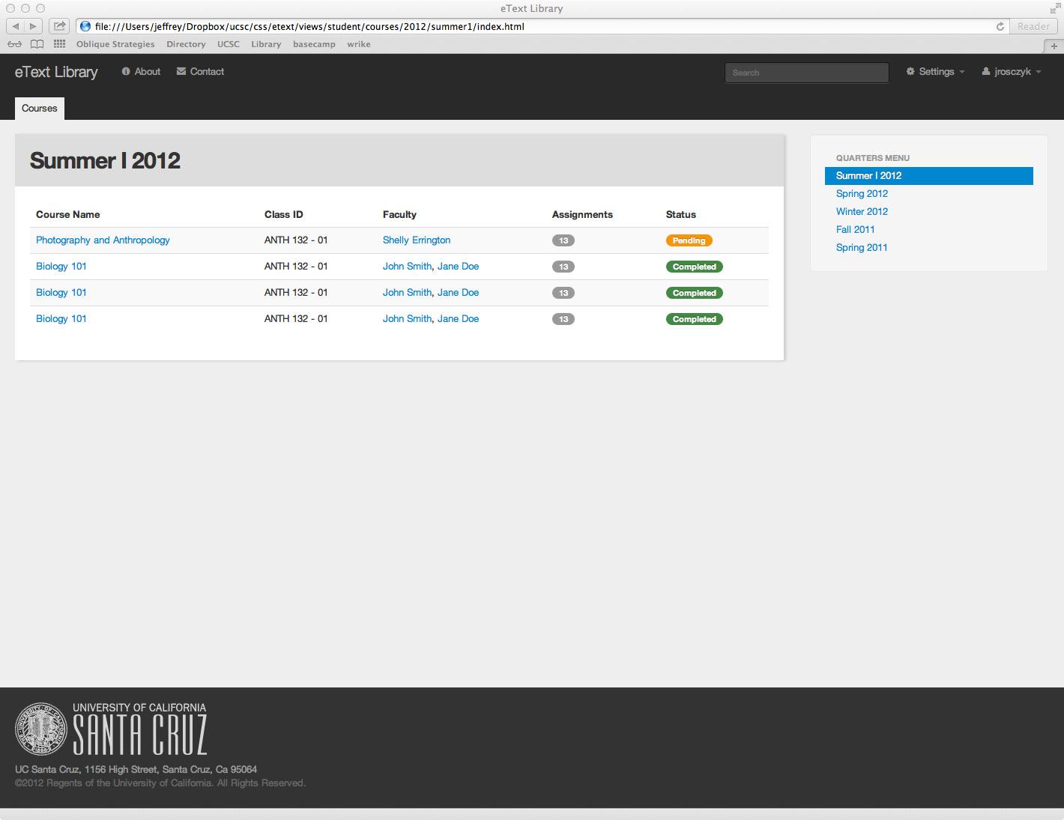

This page is displayed after student logs in through Shibboleth. It displays all courses for the quarter selected, that the student is enrolled in, and has requested alternate format text services in the DRC Request Service page in AIS. The page default is for the most recent quarter. The Status column shows the collective status of all assignments for that course. If the materials for all assignments for the course have been uploaded it shows a completed status, and pending if they have not. The Class ID will be created by combining ‘subject catalog# - section#’.

Navigation:
When the Course Name is clicked, it loads the Assignments page for that course. When the Faculty link is clicked, it loads that faculty member page in the Campus Directory. The Quarter Menu allows the student to choose the quarter they want to view.

Student Interface: Course Assignments page

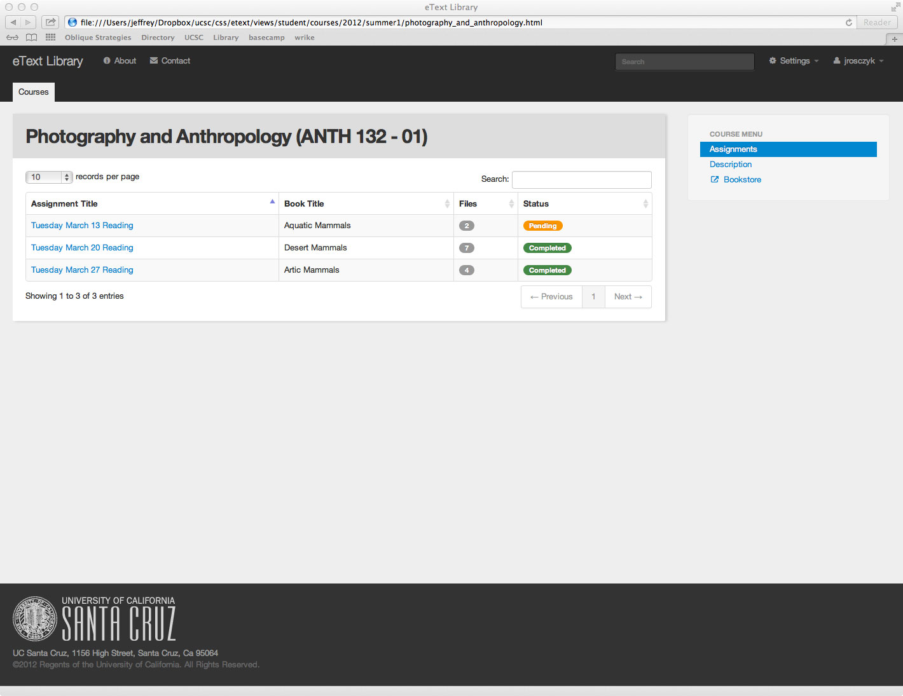

This page displays all assignment requests associated with the selected course and the currently logged on student (by their accommodation file type.) The status field indicates if the material for that assignment has been uploaded by DRC staff and is ready for the student to download. It will have three states: Pending, Completed, and Proof of Purchase Needed.

Navigation:
This page is reached when the student clicks the course name link on the courses page. When the Assignment Title is clicked, it loads the Assignments Files page for that assignment. In the side menu the Assignments link is highlighted indicating the current page is the assignments page for the selected course. The Description link provides a link to course information. The Bookstore link connects the user to the bookstore page for this course. Clicking on a column heading will sort the table by that column.
Student Interface: Assignment Files page

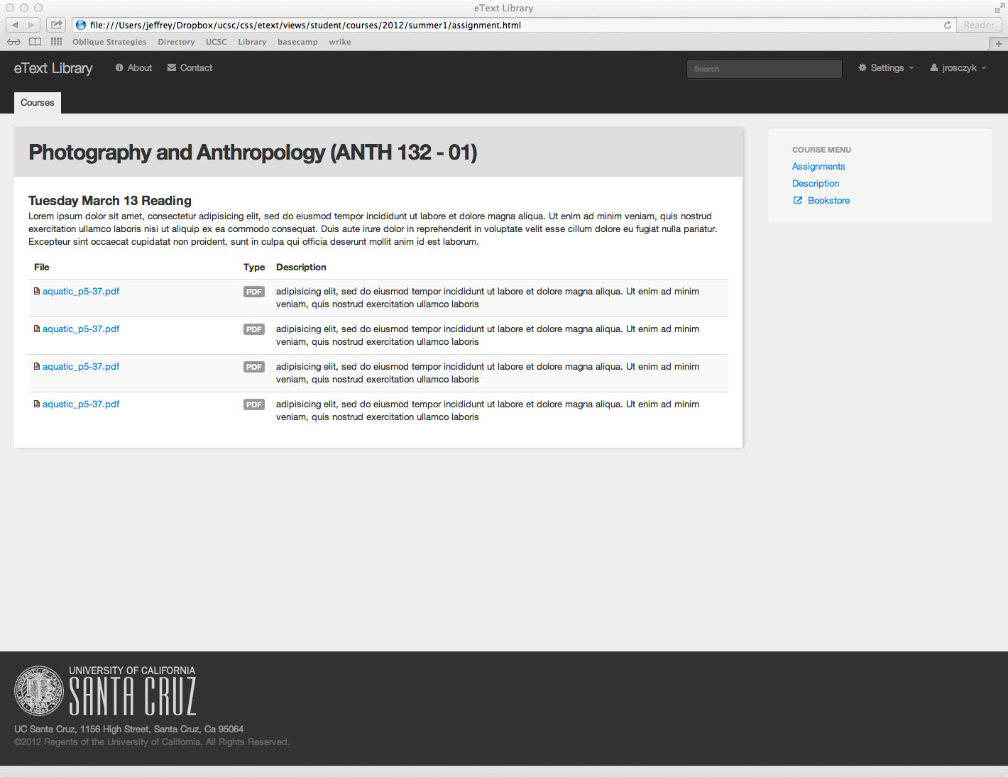

This page lists a description of the assignment the files that the student can download for that assignment based on their disability type and whether they bought the book. File size will also be included in this display. When a student clicks on the file name to download a file a pop up will provide a legal statement regarding copyright infringement. The student will need to acknowledge the message by clicking “ok” before the download will begin.

Navigation:
This page is reached when the student clicks the assignment title link on the assignments page for a course. Clicking on a file name will begin the download of that file.

Student Interface: Course Description page

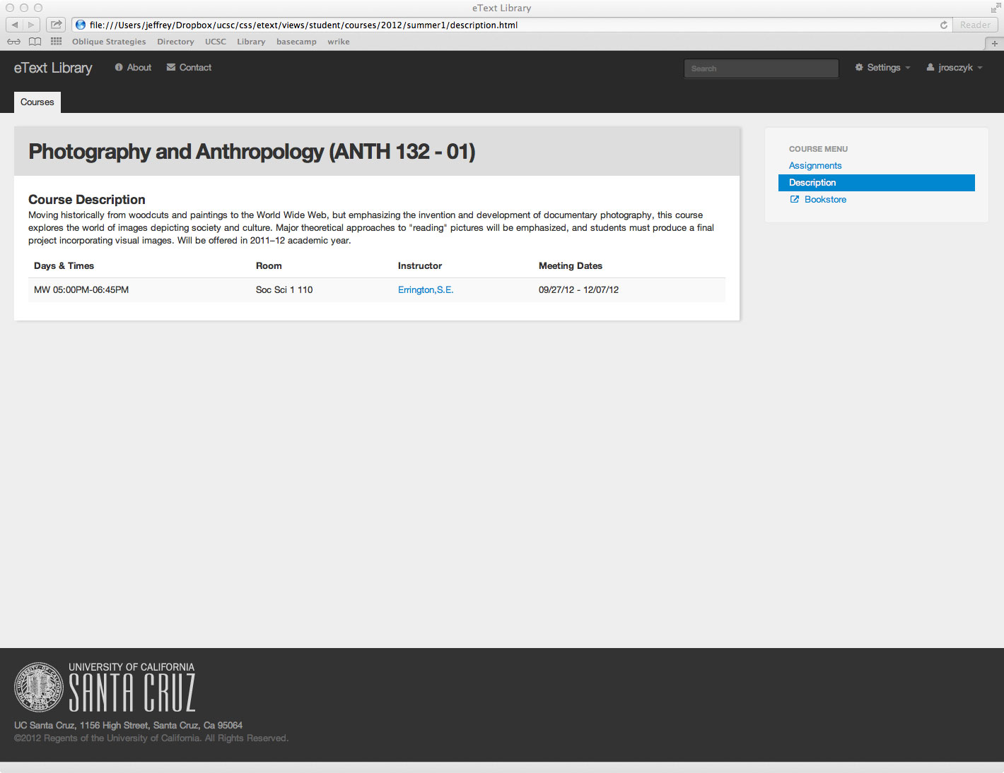

This page displays the course description and other information related to the course (such as the unique course id and instructors).

Navigation:
This page is reached when the student clicks the description button on the assignments page for a course. When the instructor name is clicked, it loads the instructor’s page from the UCSC directory. In the side menu the Assignments button returns the student to the assignments page for the selected course. The Description button is highlighted to indicate the current page. The Bookstore link connects the user to the bookstore page for this course.

Instructor Interface: Home page, Course List page

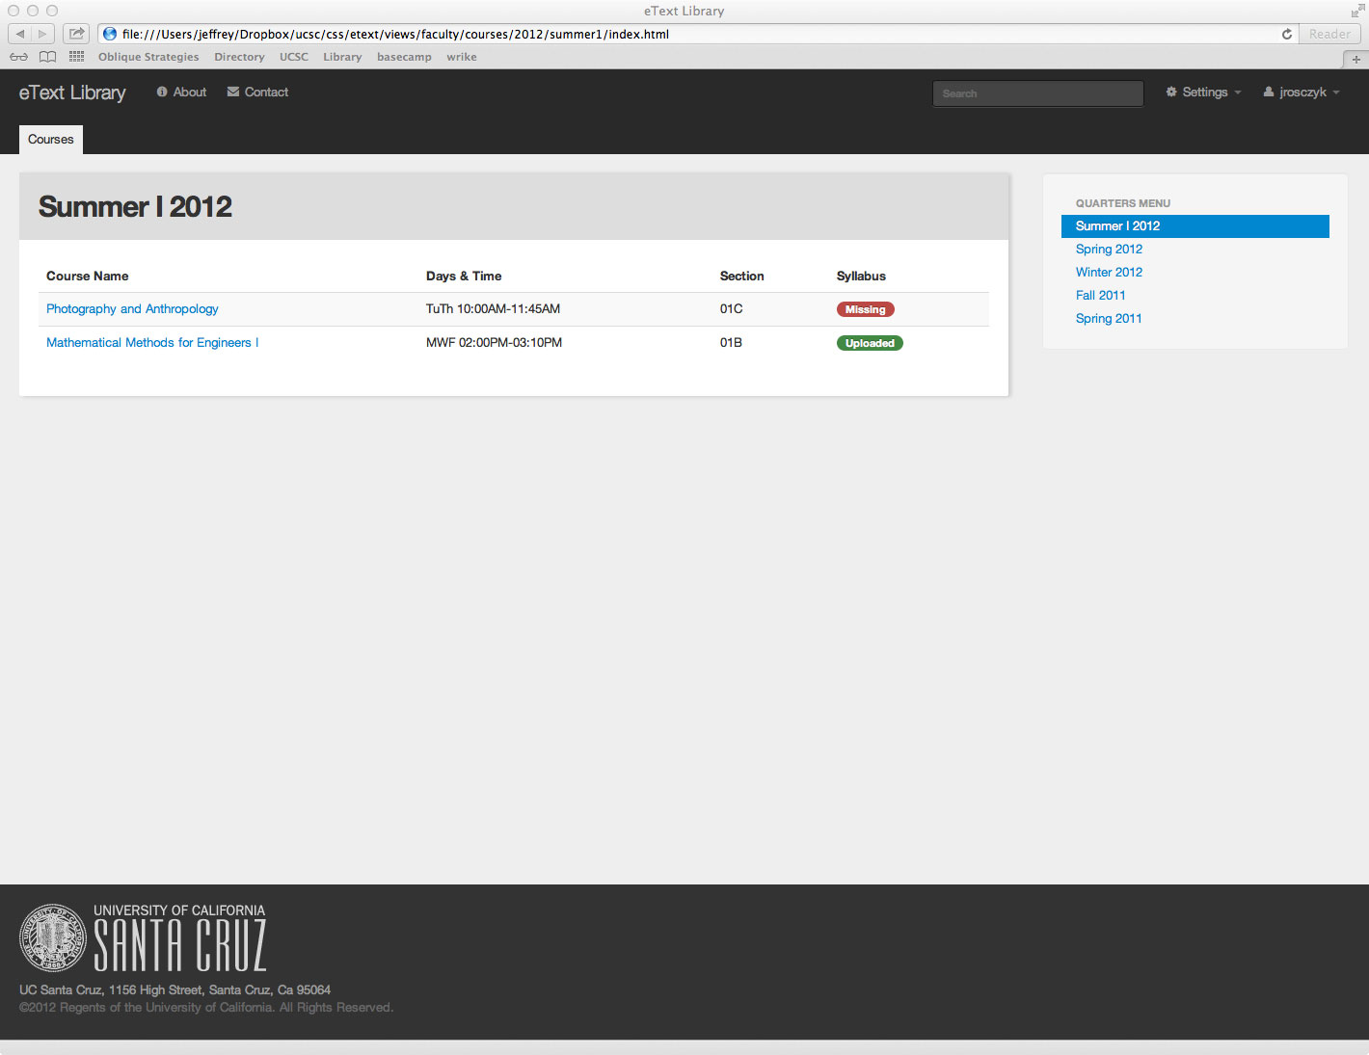

This page is displayed after course instructor logs in through Shibboleth. It displays all courses for the quarter selected that the instructor has students who have made a request for alternative format text services in the class. The page default is for the most recent quarter. The Syllabus indicates if the instructor has uploaded the course syllabus to DRC for the listed course.

Navigation:
When the Course Name is clicked, it loads the course upload page for that course. The Quarter Menu allows the instructor to choose the quarter they want to view. Clicking on a column heading will sort the table by that column.

Instructor Interface: Course Upload Page

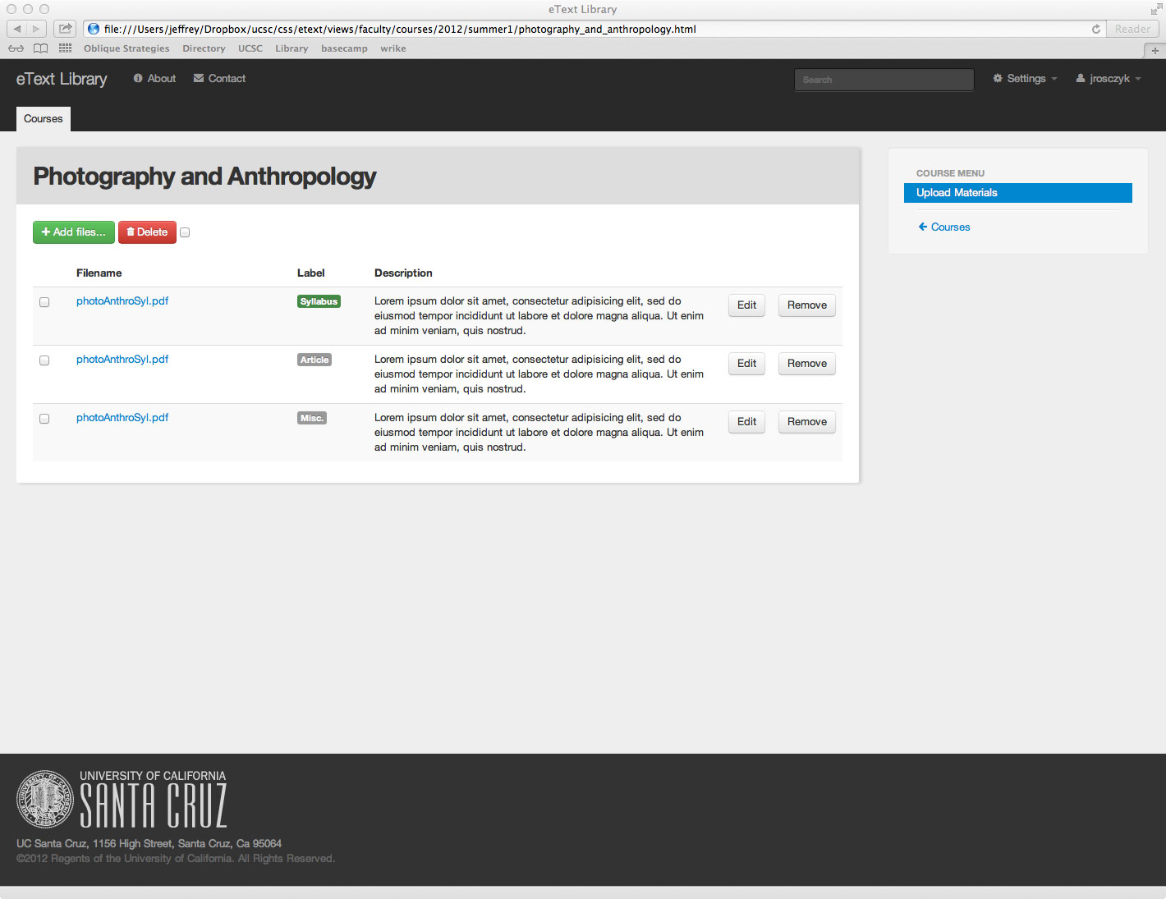

This page allows the instructor to upload their syllabus and other files for the course selected on the previous page. The illustration is not an exact representation however it illustrates proposed functionality. The page will include an Add File button that will open a plugin that will allow the instructor select and upload a file from their computer and to enter label and description data for that file. The page will also include a list of all files that the instructor has uploaded for the selected course.

Navigation:
This page is reached when the instructor clicks the course name link on their course list. The Student List Link takes the instructor to their student list page for the currently selected course. The Edit buttons link to the edit file data page for each file.

Instructor Interface: Edit File data page

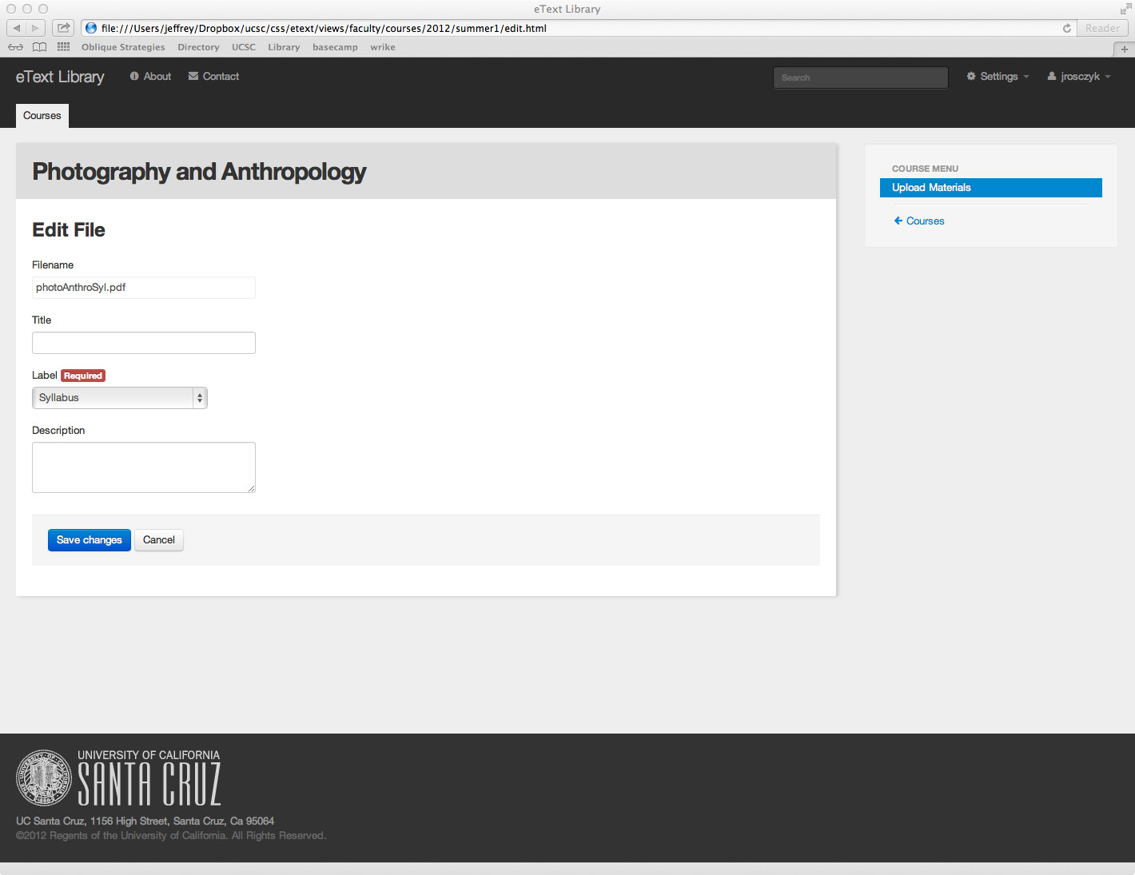

This page allows the instructor to add a label and description to the file they have uploaded. Label will have three options: Syllabus, Article, and Other.

Navigation:
This page is reached when the instructor clicks an Edit button on the course upload page. The Upload Materials Link takes the instructor back to on the course upload page for the currently selected course. The Student List Link takes the instructor to their student list page for the currently selected course.

DRC Staff Interface: Home page, Student List page

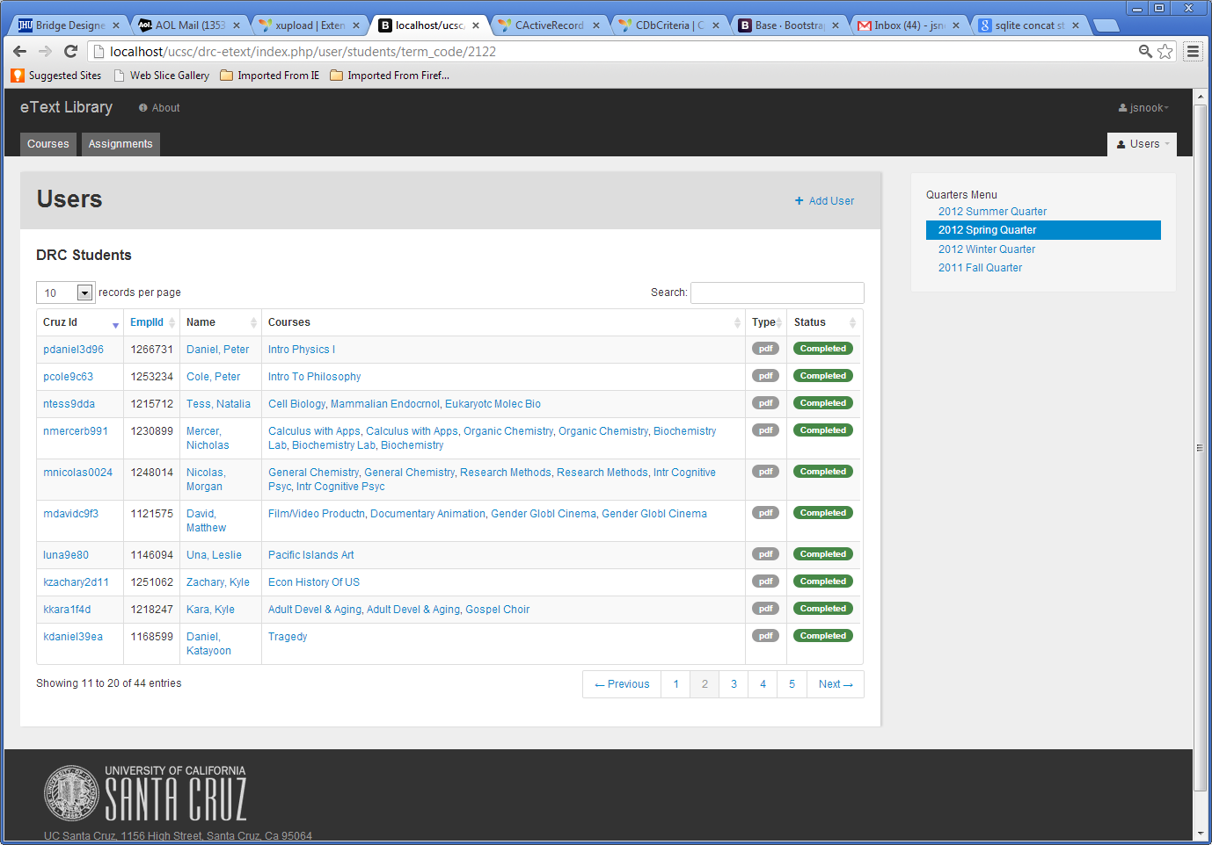

This page is displayed after DRC staff log in through Shibboleth. It displays a list of all students and each course that services are approved for during the quarter selected. The page default is for the most recent quarter which has any DRC service requests. The Type column shows the file types requested by that student. The Status column shows the combined status of all assignments for that student and course. If the materials have all been uploaded it shows a completed status, and pending if it has not. The Users tab will provide a drop down menu to also select pages for viewing and managing data for staff and faculty.

Navigation:
When the username (CruzID) is clicked, it loads the user profile page for that student. When the Name is clicked, it loads the user courses page for that student. When the Course name is clicked, it loads the course assignments page for that course. When the status is clicked, it loads an assignments page for that course and student. The Quarter Menu allows staff to choose the quarter to view students and courses for. Clicking on a column head will sort the table by that column. The Courses Tab Links to the Course page. The Assignment Tab links to the All Assignments page
Future Options (not Shown here and not planned in version 1):
- The Dashboard Tab.
- The Reports tab will link to a Reports page.
- The Roles Tab will provide fine grained administration of user roles.
DRC Staff Interface: Faculty List page

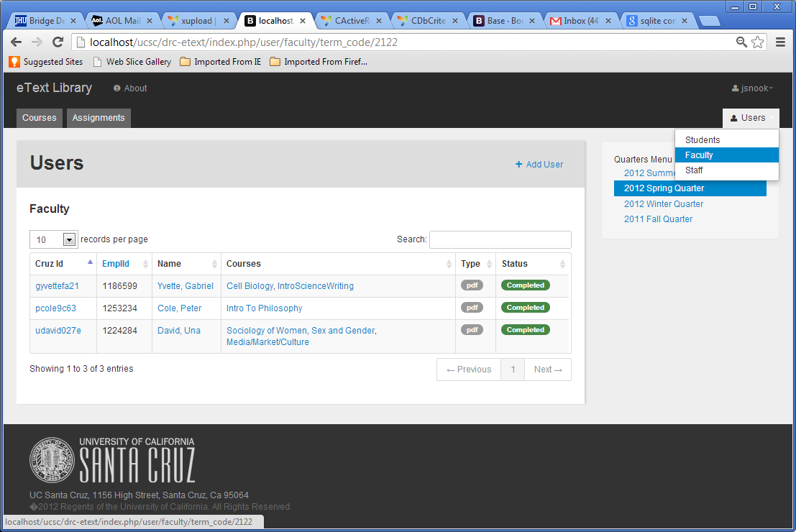

This page is displayed when the user selects ‘Faculty’ from the User drop down menu. It displays a list of all faculty who have courses that services are approved for during the quarter selected. The page default is for the most recent quarter which has any DRC service requests. The Type column shows the file types requested for that faculty. The Status column shows the cumulative status of assignments for that faculty member. If all materials for that faculty for the selected term have been uploaded it shows a completed status, and pending if it has not. The Users tab will provide a drop down menu to also select pages for viewing and managing data for staff and students.

Navigation:
When the username (CruzID) is clicked, it loads the user profile page for that faculty. When the Name is clicked, it loads the user courses page for that faculty. When the Course name is clicked, it loads the course assignments page for that course. When the status is clicked, it loads an assignments page for that course. The Quarter Menu allows staff to choose the quarter to view faculty and courses for. Clicking on a column head will sort the table by that column. The Courses Tab Links to the Course page. The Assignment Tab links to the All Assignments page

DRC Staff Interface: Staff List page

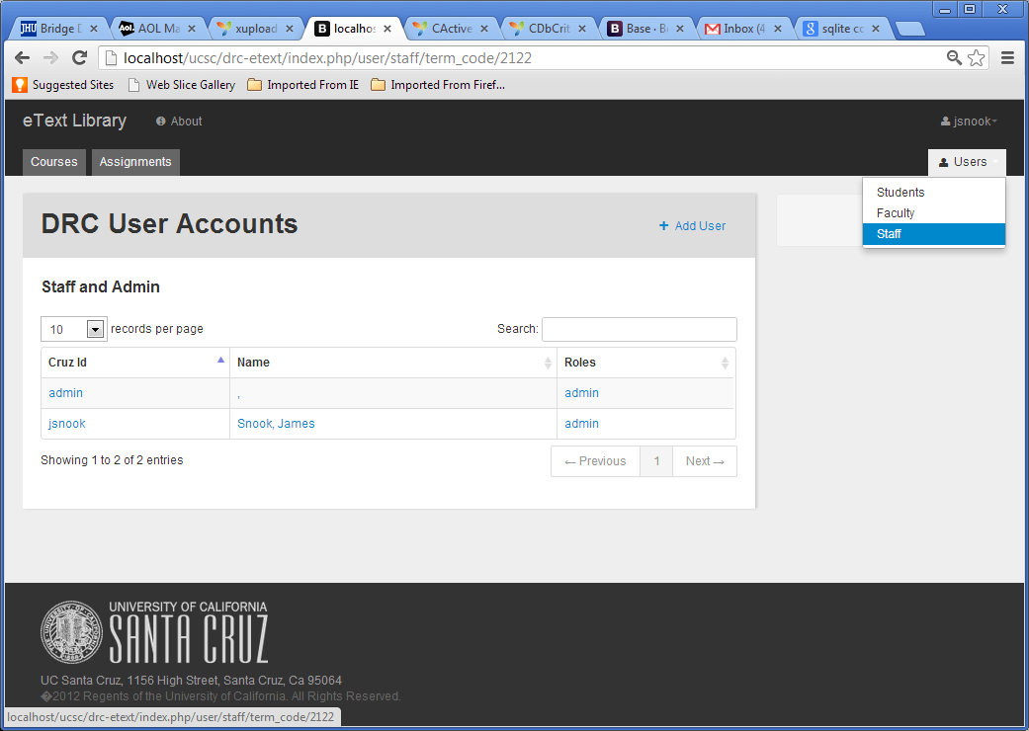

This page is displayed when the user selects ‘Staff’ from the User drop down menu. It displays a list of all staff who have admin or staff accounts. No term menu is provided as all staff will be shown. The Users tab will provide a drop down menu to also select pages for viewing and managing data for faculty and students.

Navigation:
When the username (CruzID) or Name is clicked, it loads the user profile page for that staff. Clicking on a column head will sort the table by that column. The Courses Tab Links to the Course page. The Assignment Tab links to the All Assignments page
DRC Staff Interface: User Courses page

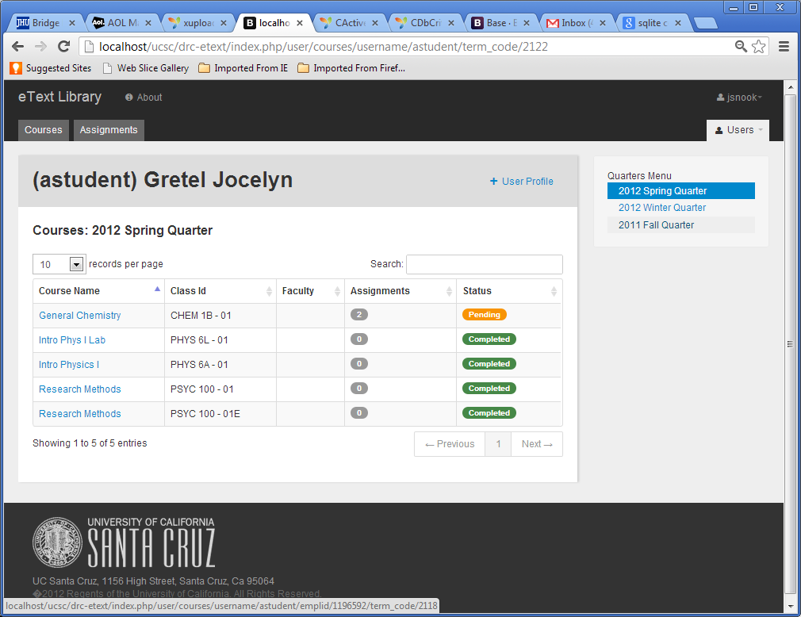

This page displays all courses associated with the selected student or staff that have alt-media requests for that class. The status field indicates if all materials for that course have been uploaded by DRC staff and are ready for the student to download. (For students it will reflect status for only the media type they have requested. For faculty it will be a combined status for all media types required for that class.) The Status column will have three states: Pending, Completed, and Proof of Purchase Needed.

Navigation:
This page is reached when staff clicks the name link on the student or faculty list pages. When the Course name is clicked, it loads the course assignments page for that course. When the status is clicked, it loads an assignments page for that course and user. A term menu at the right will allow selection of which quarter to display classes for.
DRC Staff Interface: User Profile Edit Page

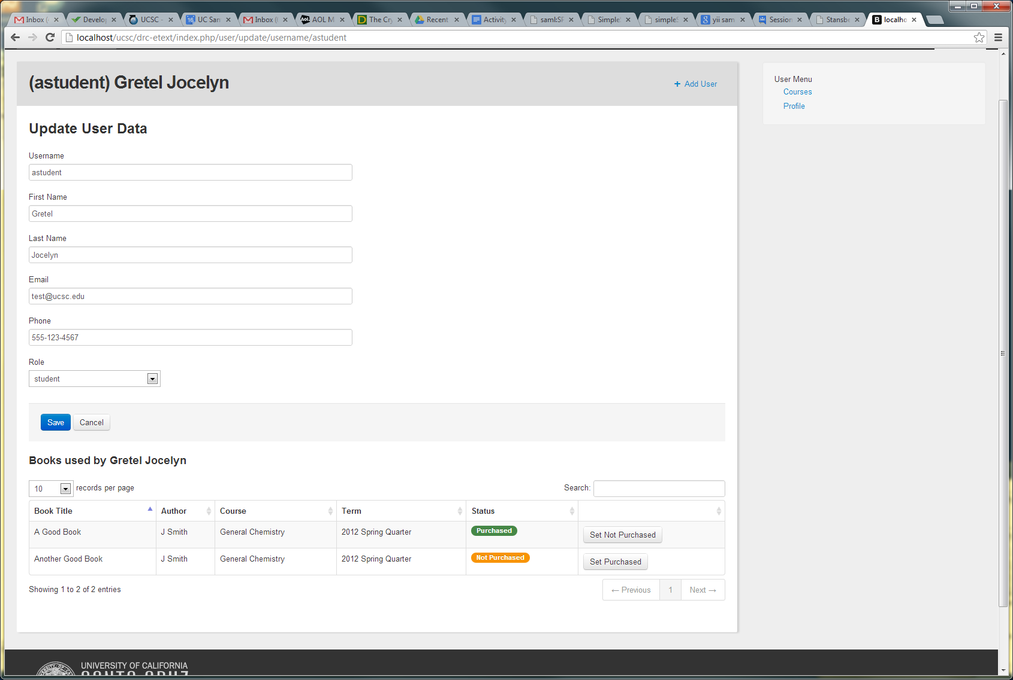

This page displays personal data for an individual user as needed by DRC Staff. This page will allow staff and admin users to update user data as needed. Data fields will include First name, Last Name, user role and email and phone contact information for the user. This page also allows management to view and update Book purchase information for the courses that student is or has received DRC services for in the currently selected term.

Navigation:
This page is reached when staff clicks the student username (CruzID) on the user courses page. The Course link provides a link to the user courses page.

DRC Staff Interface: New User Page

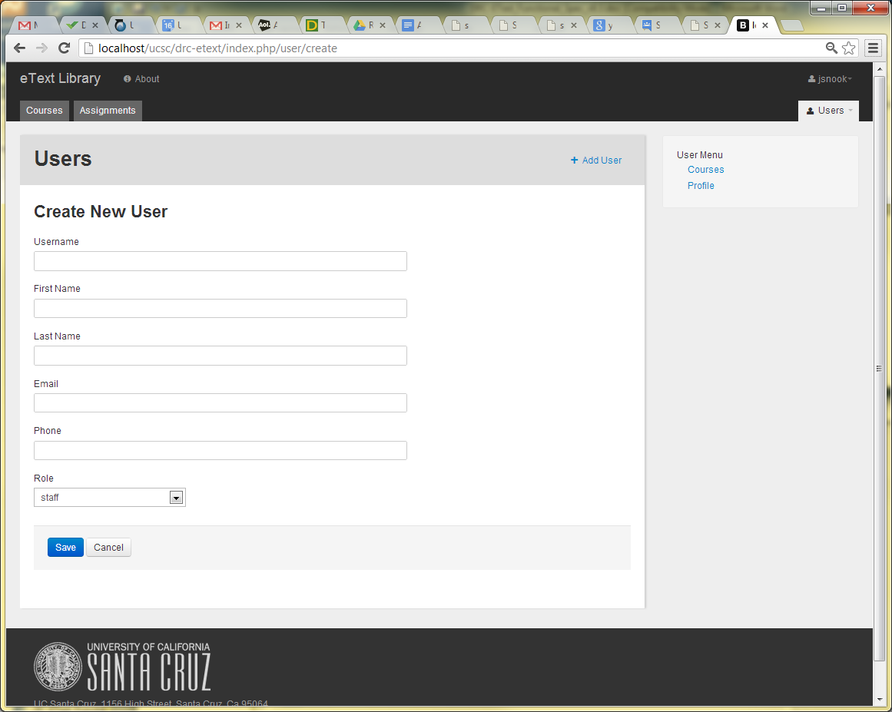

This page allows creation of a user account and input of personal data for an individual user as needed by DRC Staff. Data fields will include First name, Last Name, user role and email and phone contact information for the user.

Navigation:
This page is reached when staff clicks the ‘+ Add User’ link at the top of any of the user list pages.

DRC Staff Interface: Course Assignment List page

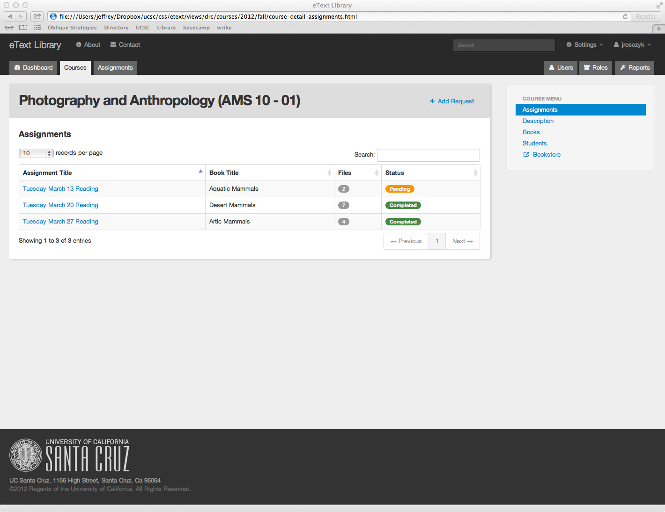

This page displays all assignment requests associated with the selected course. The status field indicates if all materials for that assignment have been uploaded by DRC staff and are ready for the students to download.

Navigation:
This page is reached when staff clicks the course name link on the user course list page. When the Assignment title is clicked, it loads the course assignment edit page for that assignment. In the side menu the Assignments link is highlighted indicating the current page is the assignments page. The Description link provides a link to course information. The Books link loads a book list for this course and allows creation and uploading of new books. The Student link loads a student list for this course. The Email link (not shown) loads a list of emails previously sent and available to send to instructors for the course. The Bookstore link connects the user to the bookstore page for this course. Clicking on a column heading will sort the table by that column. The add Assignment link (shown as ‘Add Request’) is used to create a new assignment request for that course.
DRC Staff Interface: Course Assignment Edit page

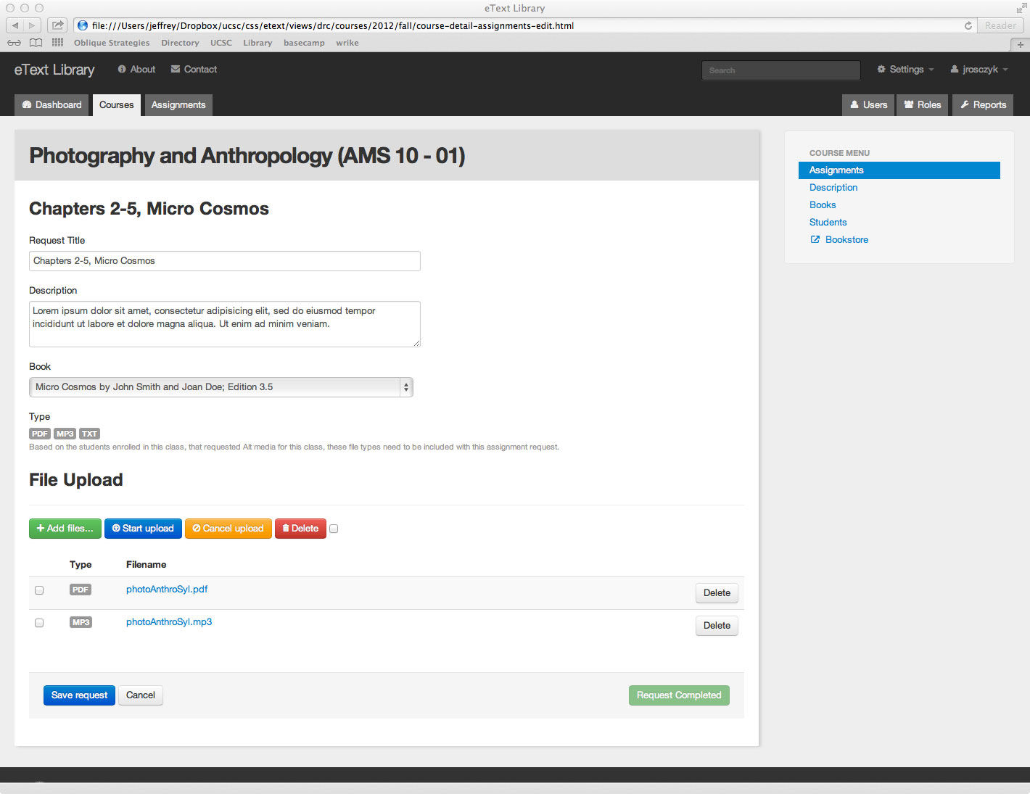

This page displays data for a single assignment in a specific course, but possibly for multiple students. This page allows the DRC staff to edit the assignment request fields and also upload files to attach them to the request. Since an assignment can have different file types for different students this page informs the DRC staff what file types need to be uploaded. This is determined from AIS data and shown by the Type indicators. If some students do not need certain assignments then DRC staff can choose not to upload the files for that student. If there is only one assignment and it is deleted, then the status returns to pending on the Course Assignment List page.

Navigation:
This page is reached when staff clicks the assignment name link on the course assignment list page. The Book dropdown allows staff to select an existing book (or other media) from the DRC database or create a new book to associate with the assignment. File upload is handled by an established plugin to be documented elsewhere. In the side menu the Assignments link is highlighted but clicking this will take the user back to the course assignments list page. Other side bar items are described on the previous page

DRC Staff Interface: Course Create Assignment page

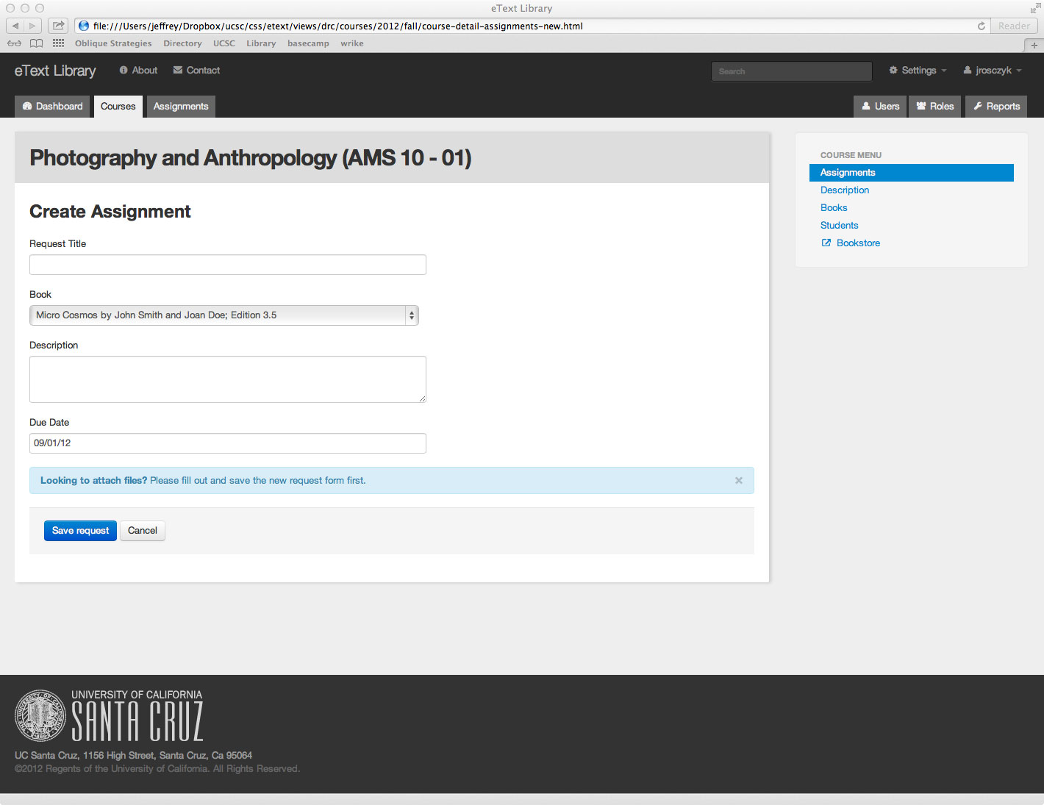

This page is where the DRC will enter data for all the instructor's assignments that need to be processed, and saved into the system. Once the save button is selected, the page will redirect to the view/edit request page where the DRC can upload files and attach them to the assignment request. This page includes data for a single assignment in a specific course, but possibly for multiple students.

Navigation:
This page is reached when staff clicks the ‘Add Assignment’ link on the course assignment list page. The Save Request button will redirect the user to the course assignment edit page where staff can upload files and attach them to the assignment request. The left side bar menu has been described previously.
DRC Staff Interface: Course Description page

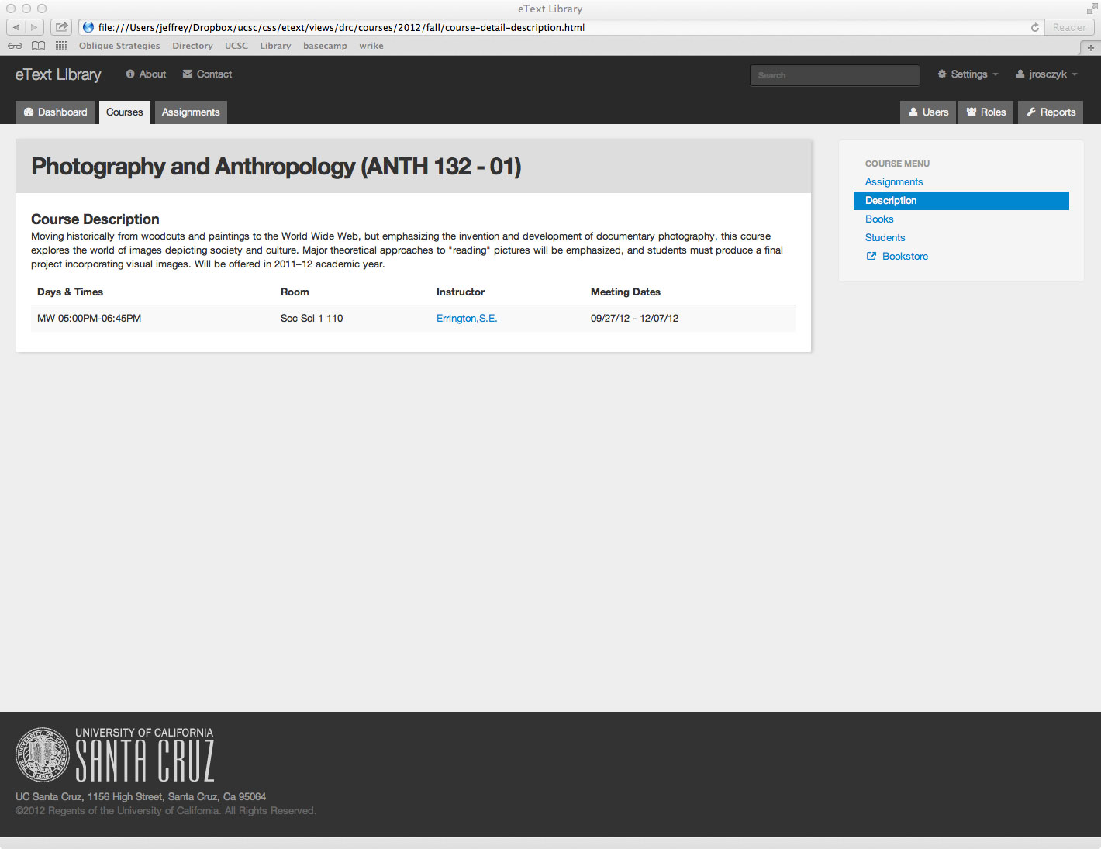

This page displays information about a course. This information is obtained from the AIS database. The course description will be a ‘class level’ description and not a ‘course level’ description.

Navigation:
This page is reached when staff clicks the Description link in the side menu. Clicking on the instructor name will take the user to the instructor’s page in the campus directory. The side menu items have been described previously.

DRC Staff Interface: Course Books page

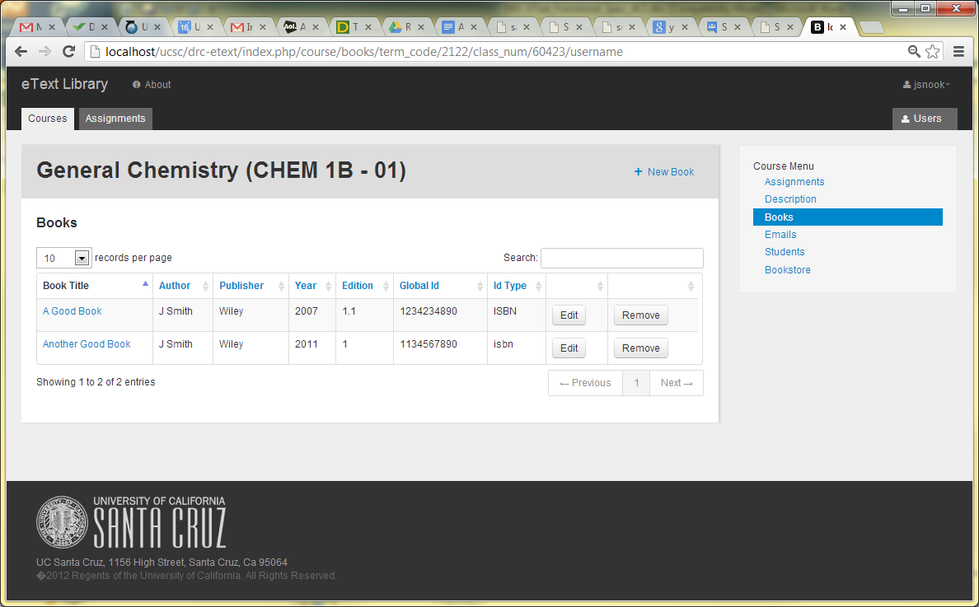

This page displays a list of books or other media items assigned to a course. This information is obtained from course syllabus or the books store database. The DRC staff, using the book edit page, creates each item and enters the data displayed here.

Navigation:
This page is reached when staff clicks the Books link in the side menu. Clicking on the Add Book link will take the user to the book edit page to input data for a new book. Clicking on the edit button will take the user to the book edit page to modify data for the book, upload files for the book and to indicate which students have purchased the book. Clicking on the remove button will remove the book from association with the selected course but will not remove the book from the database or other courses. The side bar menu has been previously described.
DRC Staff Interface: Course Books Edit page

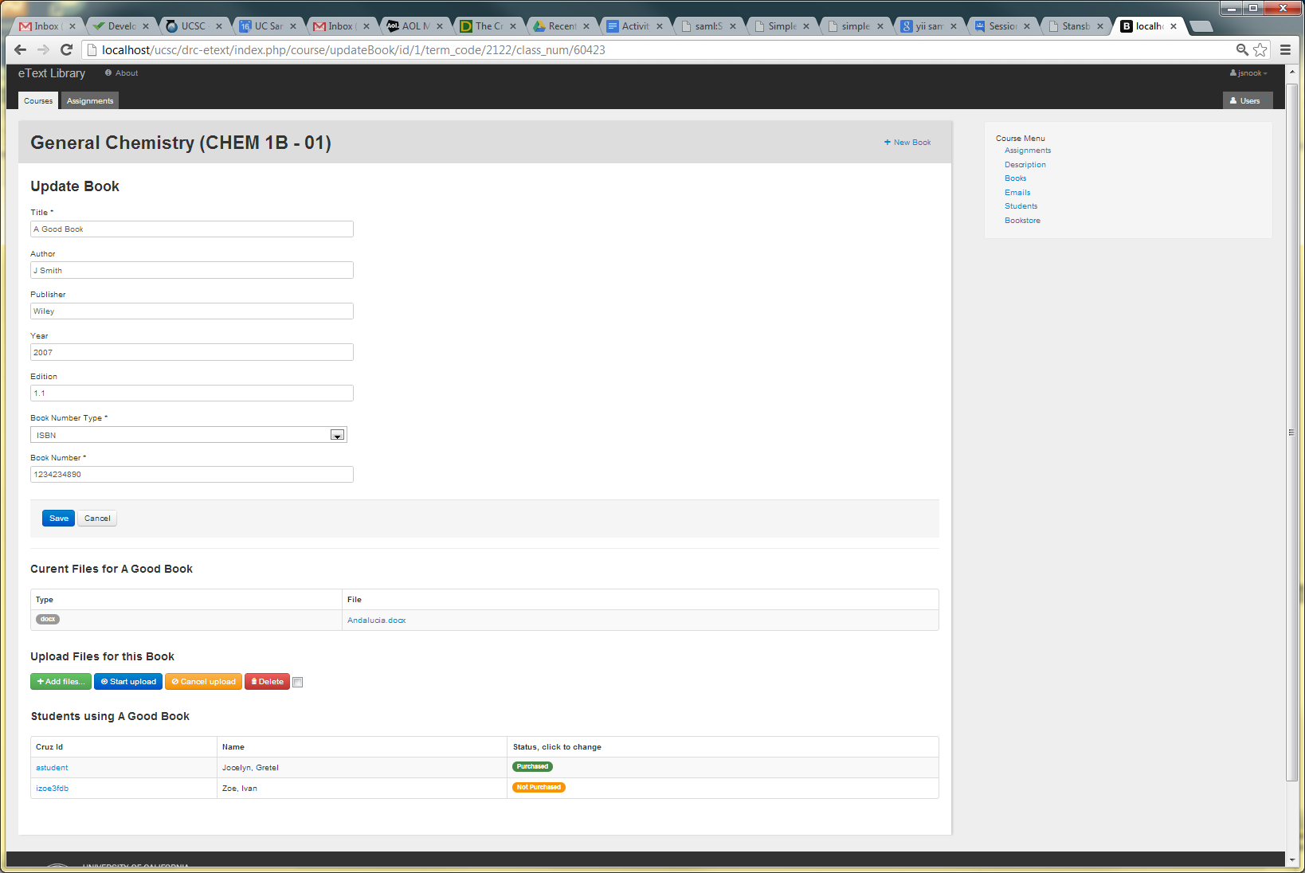

This page displays a book’s information that is available to be edited. This information is obtained from course syllabus or the books store database. The DRC staff, using the book edit page, edits each item. The data displayed will include ISBN material types: SBN (9 digits), ISBN (10 digits before '07, 13 digits currently), pISSN, and e-ISSN (8 digits) which is an eight digit number divided by a hyphen into two four-digit numbers.

This page also allows management of files and proof of purchase for a book and course.

A file upload widget can be used to upload files and associate them with the book. Though this file is uploaded in the context of a particular course it will be accessible for any course with assignments using the book.

DRC students in the course will be listed with a label indicating if they have provided proof of purchase for this book. Clicking the label will toggle this, allowing staff to enter or remove proof of purchase status for each student.

Navigation:
This page is reached when staff clicks the edit button for a book on the Books page. The user can edit and update a book’s information. The side bar menu has been previously described.
DRC Staff Interface: Course Books New page

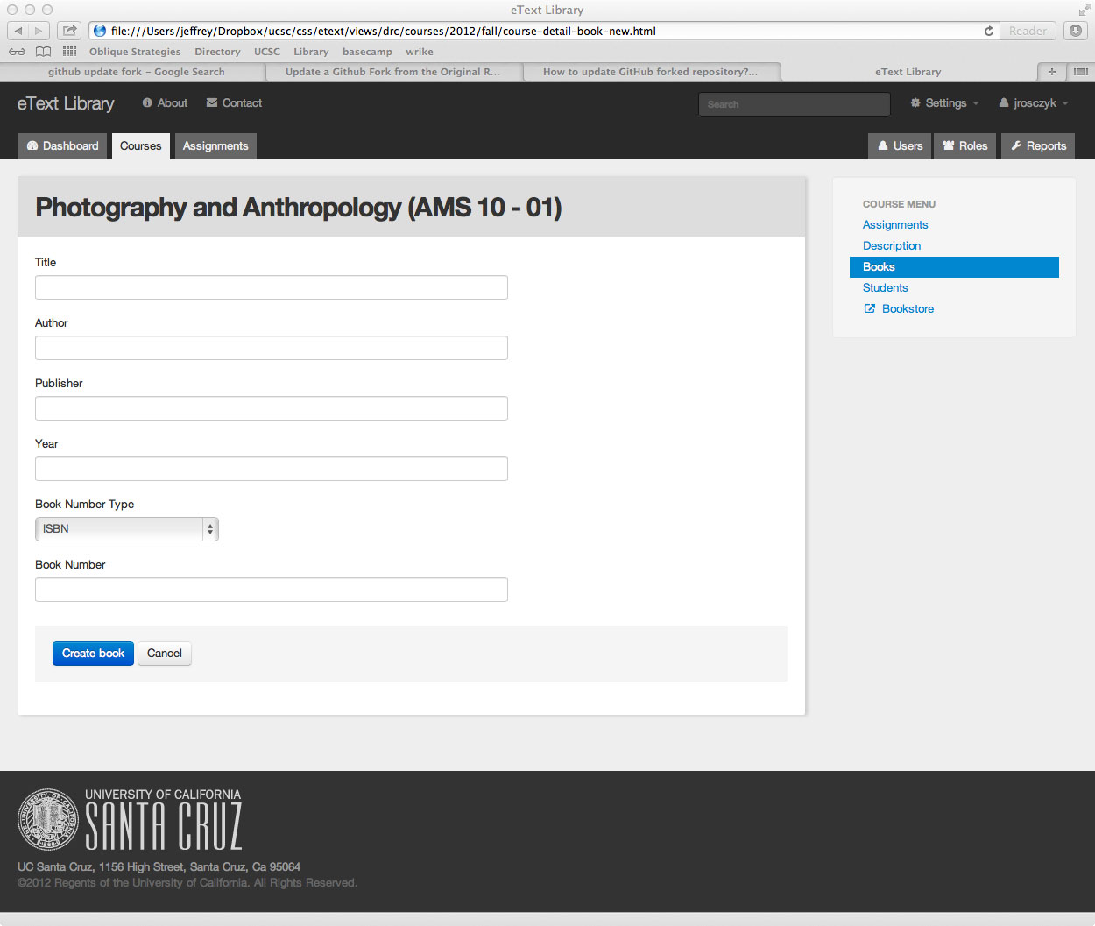

This page displays a form to input a book’s information. This information is obtained from course syllabus or the books store database. The DRC staff, using the book new page, creates each item. The data displayed will also include ISBN material types: SBN (9 digits), ISBN (10 digits before '07, 13 digits currently), pISSN, and e-ISSN (8 digits) which is an eight digit number divided by a hyphen into two four-digit numbers. The Book Number field will validate that the number matches the appropriate ISBN material type.

Though this data is entered in the context of a particular course this books can later be associated with assignments for any course.

Navigation:
This page is reached when staff clicks the Books link in the side menu and then clicks on the Add Book button. The side bar menu has been previously described.

DRC Staff Interface: Course Students page

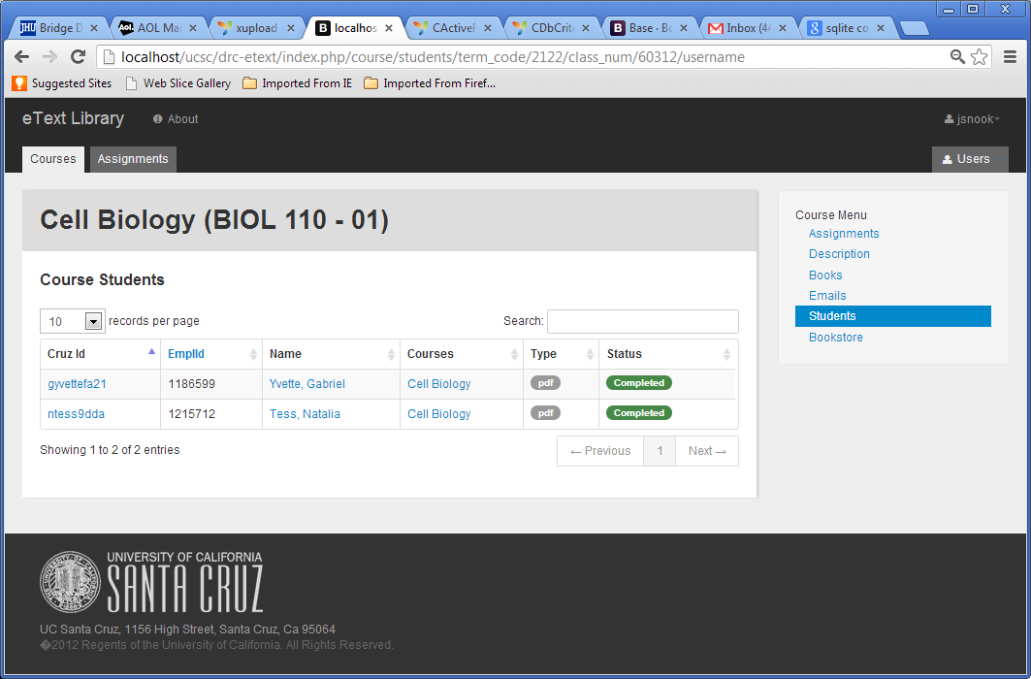

This page displays a list of students who have requested alternate format text services for the selected course. This information is obtained from AIS. A remove button will appear if the student was added manually. Only the Admin users will have the ability to add and Remove students and other users.

Navigation:
This page is reached when staff clicks the Students link in the side menu. Clicking on student’s name will take the user to the user edit profile page to modify data for the student. Clicking on the remove button will remove the student from association with the selected course but will not remove the student from the database or other courses. If we assume AIS data is good this will not be allowed. The side bar menu has been previously described.

DRC Staff Interface: All Requests page

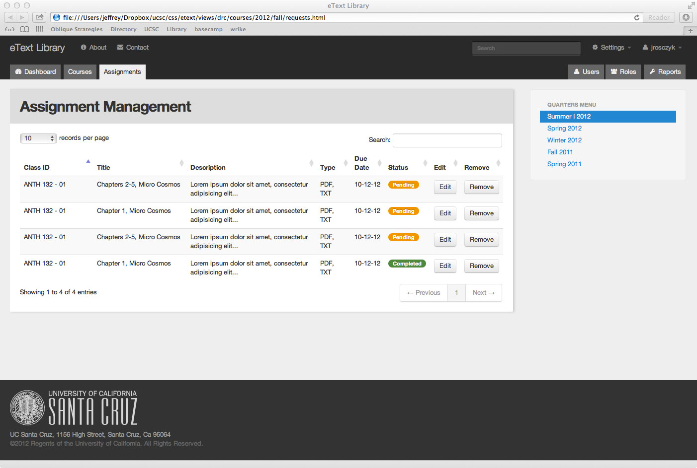

This page displays all unique media requests (individual book or media upload requests, not service requests) within the selected quarter. There are multiple entries for each assignment with more than one file type needed for that assignment. These will be displayed with the pending first and the completed last. There are no duplicate requests for multiple students needing the same files. These requests are based on the instructor's syllabus. There will be identification on what type of file and instructions within the request view page. The staff can manage the files that are needed to upload can use this page.

Navigation:
This page is reached when staff clicks the Requests Tab. Clicking on an Edit button will take the user to the course assignment edit page for the assignment associated with this request. The Quarter Menu allows staff to choose the quarter to view assignments (requests) for. Clicking on a column head will sort the table by that column.

DRC Staff Interface: Course Emails page

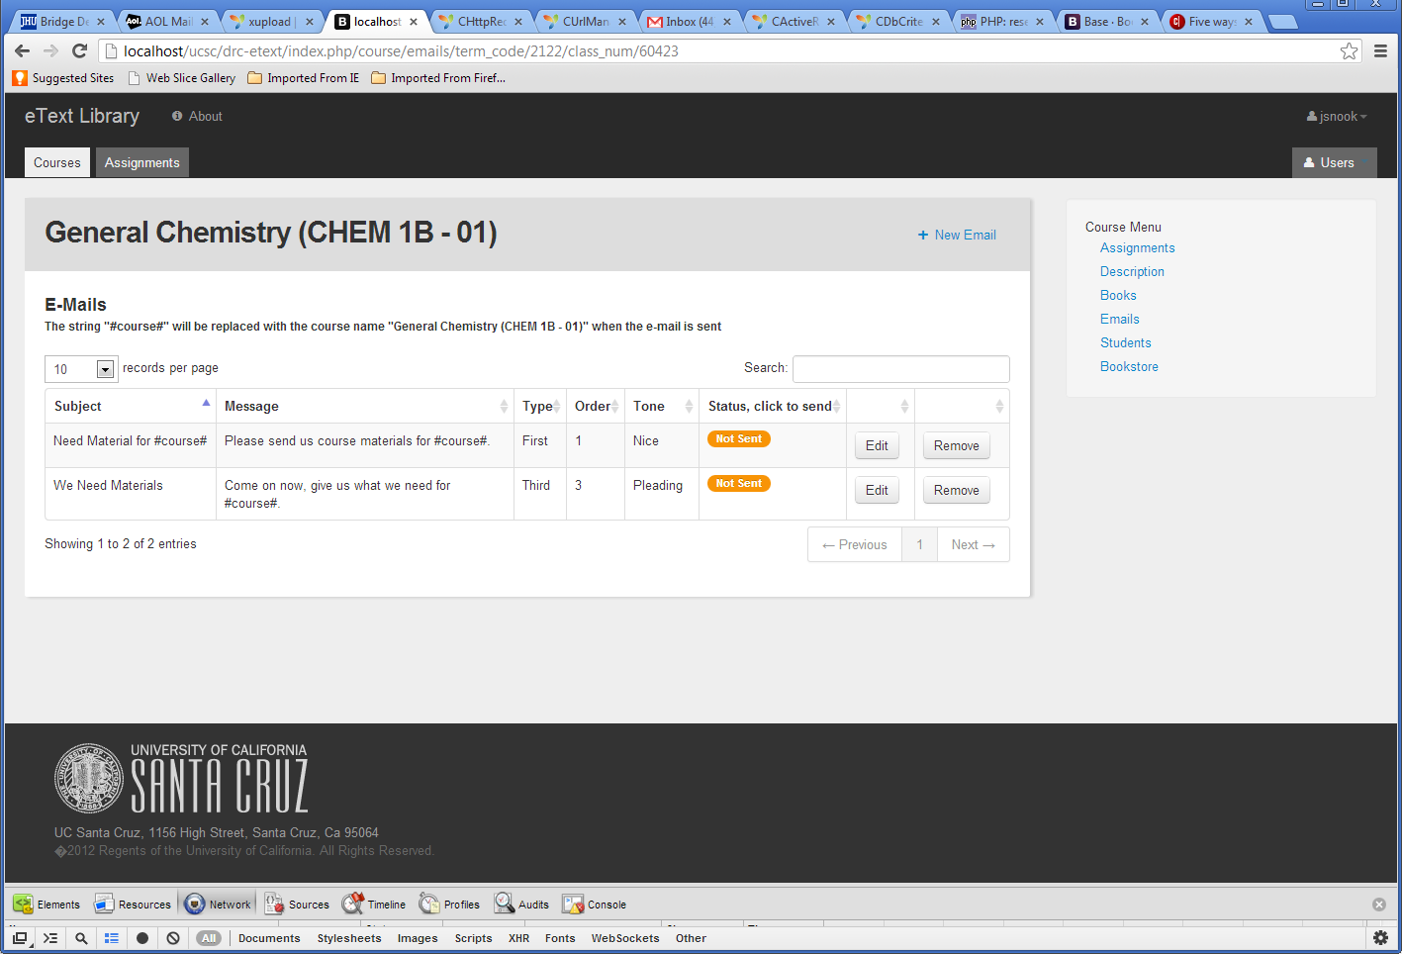

This page displays a list of email messages sent or available to send to instructors for a course. Subject heading, Message body and message type and tone are displayed. Where the string #course# appears in the subject or message the actual course name will be substituted when the message is sent. (This is because these are general e-mails available to be sent for all courses.) Clicking on the ‘Not Sent’ status will send the email to the instructors for the course and change the status to ‘Sent.’ Emails are not automatically sent. Staff must visit this page and take action to send emails to instructors.
Navigation:
This page is reached when staff clicks the Emails link in the side menu. Clicking on the New Email link will take the user to the Email edit page to input data for a new email. Clicking on the edit button will take the user to the Email edit page to modify data for the email. (Modified e-mails are saved as a new email so that the old version can be recovered if needed.) Clicking on the remove button will remove the email from availability to be sent but will not remove the email from the database or the list in cases where it has already been sent. The side bar menu has been previously described.
DRC Staff Interface: Course Emails Edit page

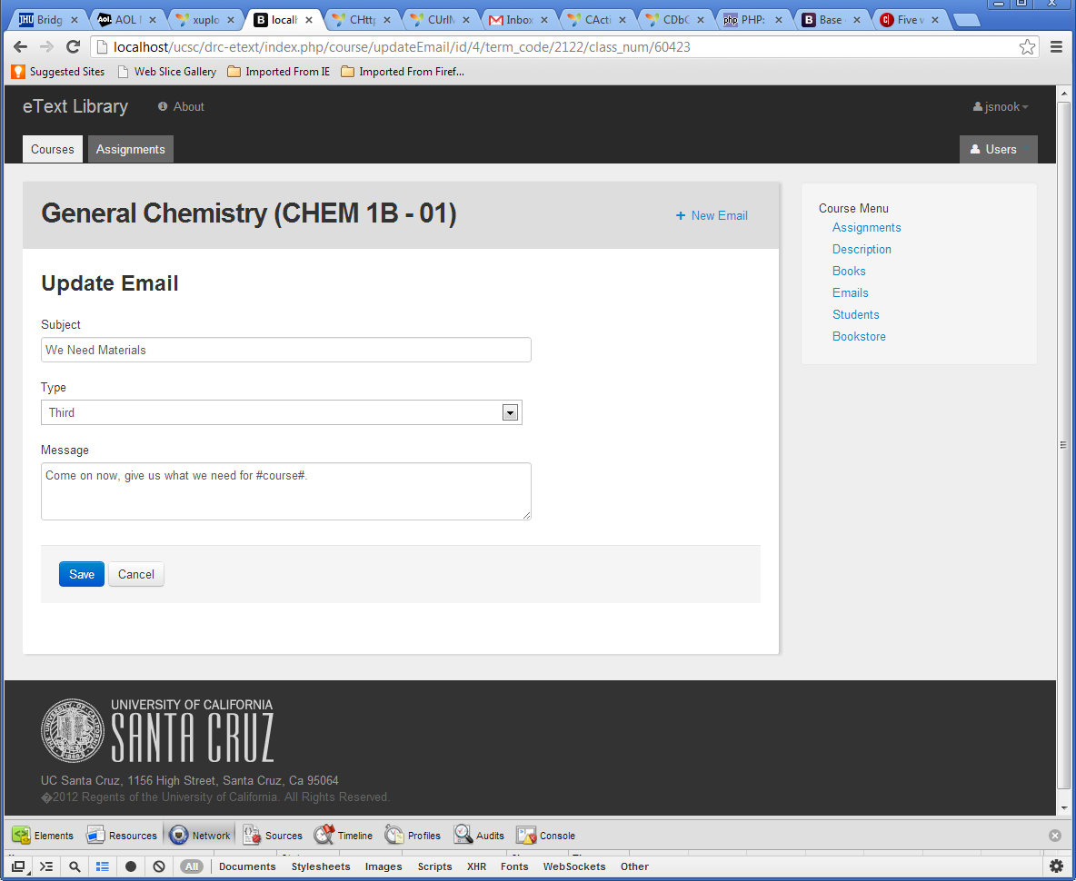

This page displays an email’s information that is available to be edited. Though created and edited in a course context the message will be available for all courses. To maintain this flexibility the string #course# should be used where ever the course name needs to appear. (It will be placed in the message as it appears at the top of the page.)

Navigation:
This page is reached when staff clicks the edit button in the Email menu. The user can edit and update an email’s content. The side bar menu has been previously described.
DRC Staff Interface: Course Email New page

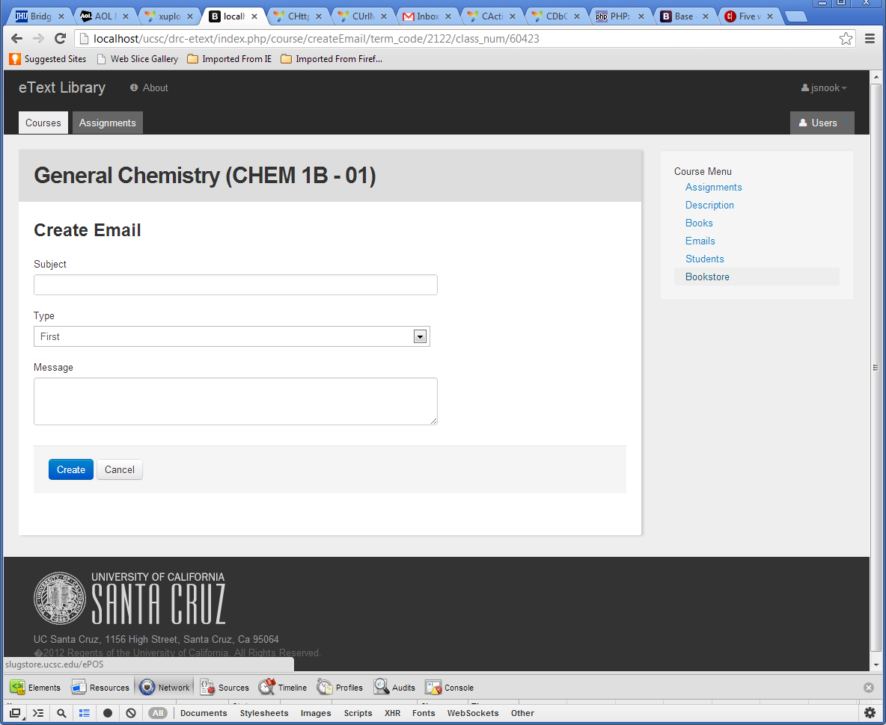

This page is used to create new e-mails. It displays an email’s information that is available to be edited. Though created and edited in a course context the message will be available for all courses. To maintain this flexibility the string #course# should be used where ever the course name needs to appear. (It will be placed in the message as it appears at the top of the page.)

Navigation:
This page is reached when staff clicks the ‘New Email’ link on the emails or email update pages. The user can edit and update an email’s content. The side bar menu has been previously described.

Appendices and Additional Details

Application Security
Role based security as described above will be used to limit users to the parts of the system they are authorized to use.

Data Security

Functionality entails access to confidential data. Students should only be able to view texts for the classes they are enrolled in, where they have provided proof of purchase for the text and where they have acknowledged they will not share texts with others.

Accessibility
The Application must have an interface that is useable by the disabled students who use it. It must work well with screen readers. This application will be developed to meet the UCSC standards for application accessibility. For screen readers the read order of the page should flow in the following order: Top Navigation → Section Title → Section Navigation → Section Content.

External Dependencies
The system is dependent on a web service providing data feeds from the AIS database. It optionally could use data obtained from the Baytree Bookstore Web pages. It is also dependent on the university Shibboleth authentication servers.

Risk and Benefit

Risks:

If the EText Library is not functioning it could preset a legal issue. Students who currently have access to the EText Library have access to books on the EText Library that they did not purchase and this definitely presents a legal risk to the university because it is a violation of copyright law.

Benefits:
Students will find their course materials more easily. This application will provide DRC a paper free way to track workflow, production and delivery of text in an alternate format that is more efficient and accurate, as well as provide data on use of delivered text by students requesting this accommodation.

Availability and Production Support

Student users need access 24/7 during Fall, Winter, Spring Quarters and Summer Sessions I & II. Offline and/or unavailable times are limited to Winter Quarter break only. High access times for scanners and admin are the first 4 weeks of the quarter. Access is still important, but not as critical as user access.

Automated scheduled jobs will populate student and course data from AIS.

Attachments

Attachments: None

Written By: Ken Schumann, Jeff Rosczyk, and Jim Snook | Date: 9/28/2012
Approved By: | Date
Title

Change Log

Modification Change Log
Requested Target Date | Change Date | Changed By | Approve Date | Approved by | Status | Description

