FIAP – MBA Engenharia de Dados
Solution Sprint 1
Grupo L

Consultas SQL
As queria abaixo foram executadas através do Hue para consultar as tabelas criadas no Hive.

- Segmentar clientes por geolocalização

  - Segmentando por estado

select customer_state, count(*) as quantidade
from olist.olist_customers
group by customer_state
order by quantidade desc

Retorno:

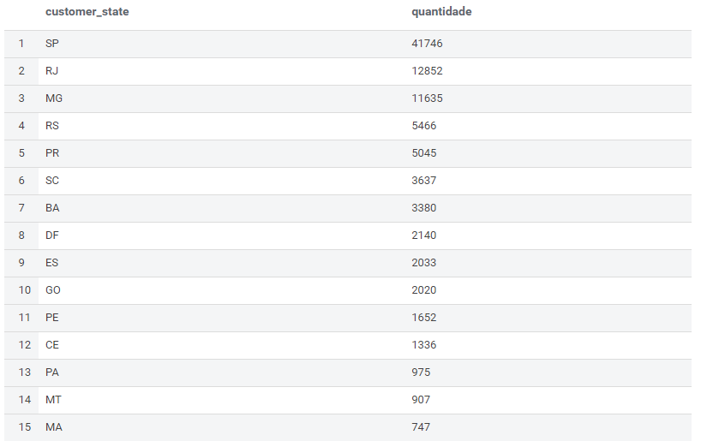
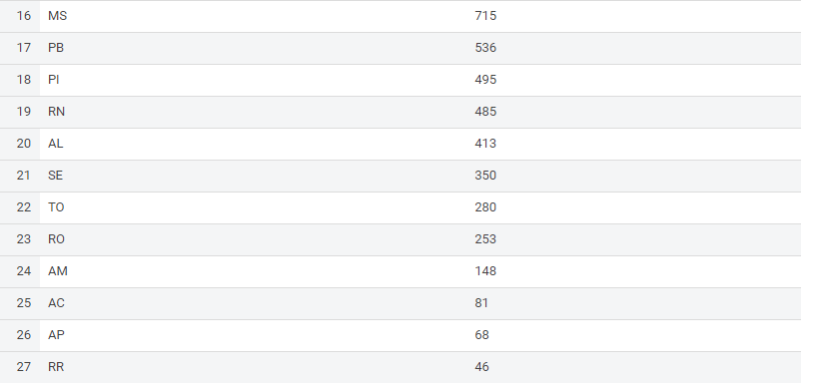

  - Segmentando por cidade
select customer_city, count(*) as quantidade
from olist.olist_customers
group by customer_city
order by quantidade desc

Retorno:

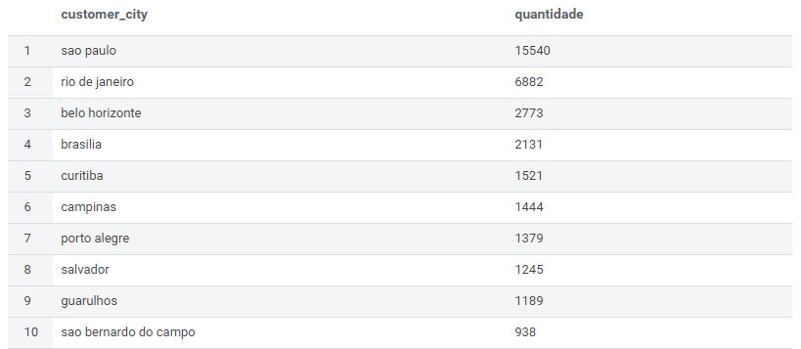

- Total de pedidos por período e categorias
SELECT year(orders.order_purchase_timestamp) || '-' || LPAD(month(orders.order_purchase_timestamp), 2, '00') as order_purchase_year_month,
products.product_category_name, count(*) as quantidade
FROM olist_orders orders
INNER JOIN olist_order_items order_items
ON orders.order_id = order_items.order_id
INNER JOIN olist_products products
ON products.product_id = order_items.product_id
group by year(orders.order_purchase_timestamp) || '-' || LPAD(month(orders.order_purchase_timestamp), 2, '00'), product_category_name
ORDER BY order_purchase_year_month

Retorno:

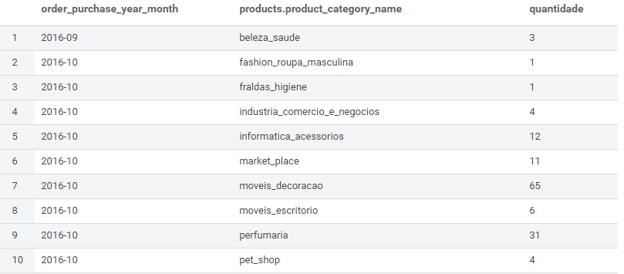

- Total de pagamentos por método de pagamento
SELECT payment_type, count(*) as quantidade
FROM olist.olist_order_payments
group by payment_type
order by quantidade desc

Retorno:

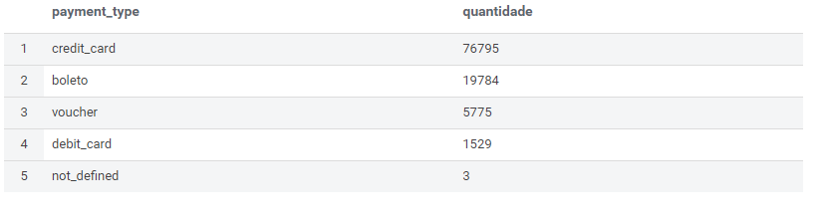

- Notas das avaliações
select review_score, count(*) as quantidade
from olist_order_reviews
group by review_score
order by quantidade desc

Retorno:

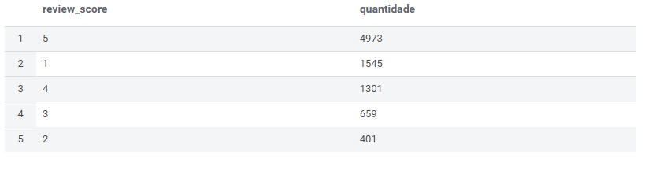
- Vendedores x vendas

  - Por período
SELECT year(orders.order_purchase_timestamp) || '-' || LPAD(month(orders.order_purchase_timestamp), 2, '00') as order_purchase_year_month,
sellers.seller_id, count(*) as quantidade
FROM olist_orders orders
INNER JOIN olist_order_items order_items
ON orders.order_id = order_items.order_id
INNER JOIN olist_sellers sellers
ON sellers.seller_id = order_items.seller_id
group by sellers.seller_id, year(orders.order_purchase_timestamp) || '-' || LPAD(month(orders.order_purchase_timestamp), 2, '00')
ORDER BY order_purchase_year_month

Retorno:

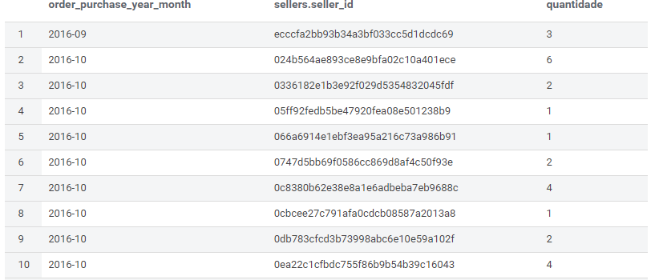

  - Por vendedor
SELECT sellers.seller_id, count(*) as quantidade
FROM olist_orders orders
INNER JOIN olist_order_items order_items
ON orders.order_id = order_items.order_id
INNER JOIN olist_sellers sellers
ON sellers.seller_id = order_items.seller_id
group by sellers.seller_id
ORDER BY quantidade desc

Retorno:
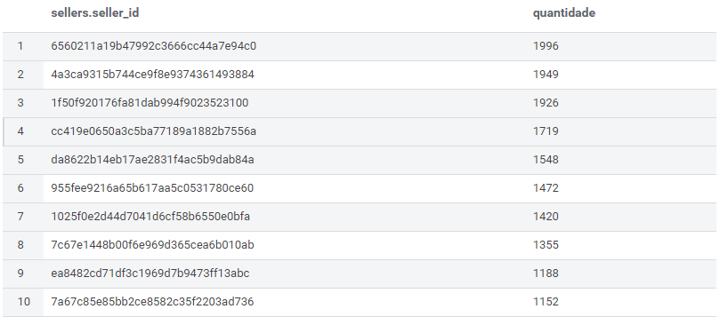

- Categoria de Produtos mais vendidos
SELECT products.product_category_name, count(*) as quantidade
FROM olist_orders orders
INNER JOIN olist_order_items order_items
ON orders.order_id = order_items.order_id
INNER JOIN olist_products products
ON products.product_id = order_items.product_id
group by product_category_name
ORDER BY quantidade desc

Retorno:

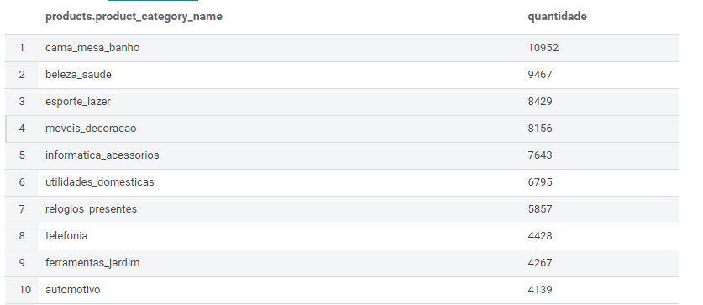

- Outras consultas

  - Média de notas por categorias de produtos
select products.product_category_name, round(avg(reviews.review_score), 2) as media_notas
from olist_order_reviews reviews
inner join olist_orders orders
on orders.order_id = reviews.order_id
inner join olist_order_items order_items
on order_items.order_id = orders.order_id
inner join olist_products products
on products.product_id = order_items.product_id
group by products.product_category_name
order by media_notas desc

Retorno:

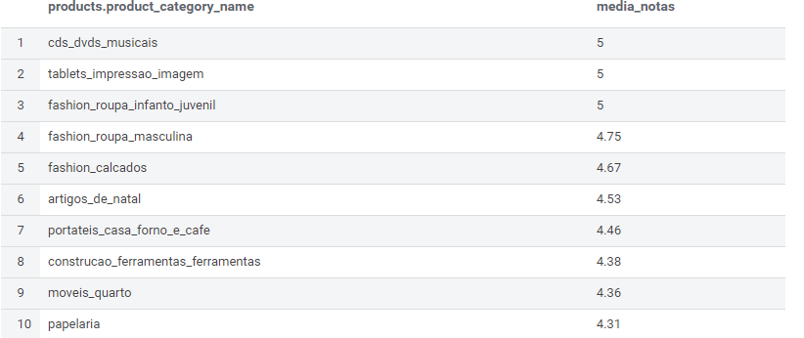

  - Média do frete por estado
select customers.customer_state, 'R$ ' || round(avg(order_items.freight_value), 2) as media_frete
from olist_customers customers
inner join olist_orders orders
on orders.customer_id = customers.customer_id
inner join olist_order_items order_items
on order_items.order_id = orders.order_id
group by customers.customer_state
order by media_frete

Retorno:

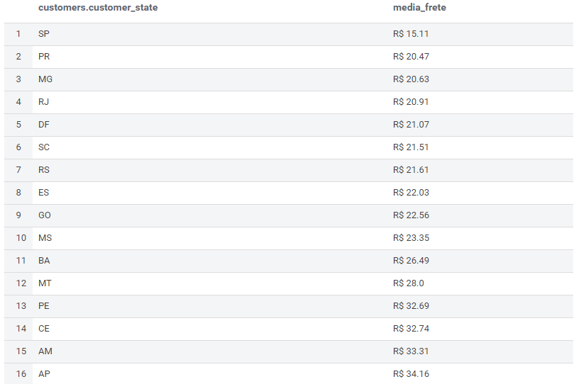
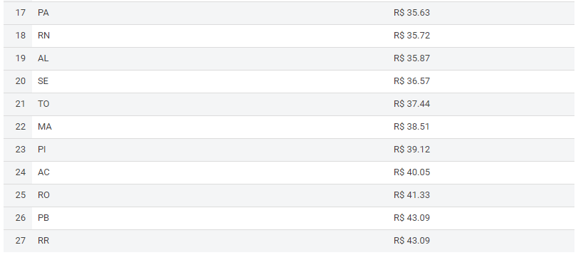

  - Média de tempo de entrega em dias por Estado
select geolocation.geolocation_state, round(avg(datediff(date(order_delivered_customer_date),date(order_estimated_delivery_date))),2) as media_entrega
from olist_orders orders
inner join olist_customers customers
on customers.customer_id = orders.customer_id
inner join olist_geolocation geolocation
on geolocation.geolocation_zip_code_prefix = customers.customer_zip_code_prefix
group by geolocation.geolocation_state
order by media_entrega desc

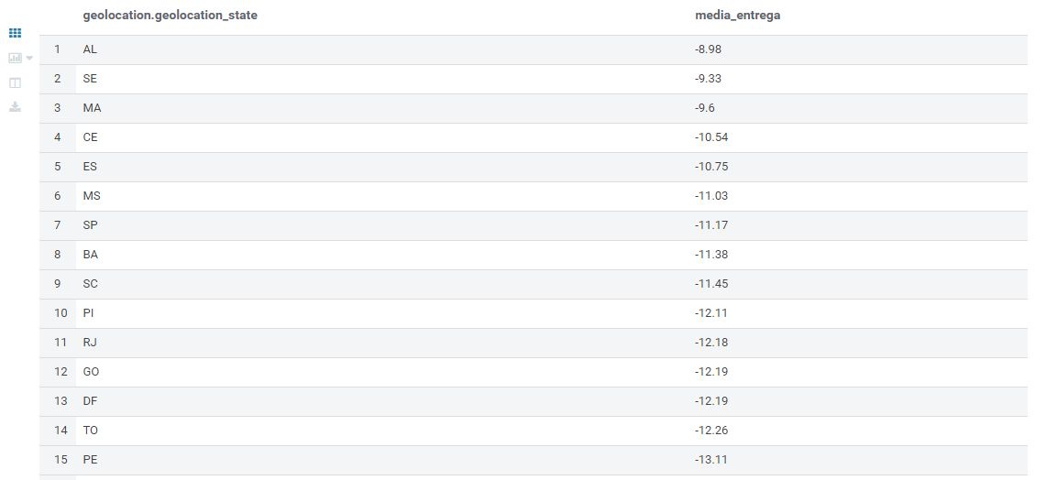
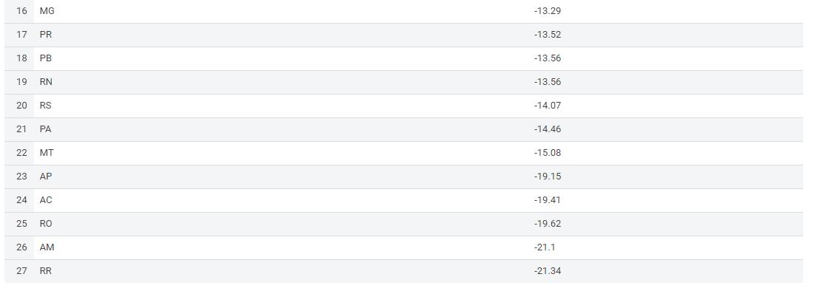

  - Mediana de tempo de entrega em dias por Estado
select geolocation.geolocation_state, round(percentile(datediff(date(order_delivered_customer_date),date(order_estimated_delivery_date)), 0.5),2) as mediana_entrega
from olist_orders orders
inner join olist_customers customers
on customers.customer_id = orders.customer_id
inner join olist_geolocation geolocation
on geolocation.geolocation_zip_code_prefix = customers.customer_zip_code_prefix
group by geolocation.geolocation_state
order by mediana_entrega desc

Retorno:

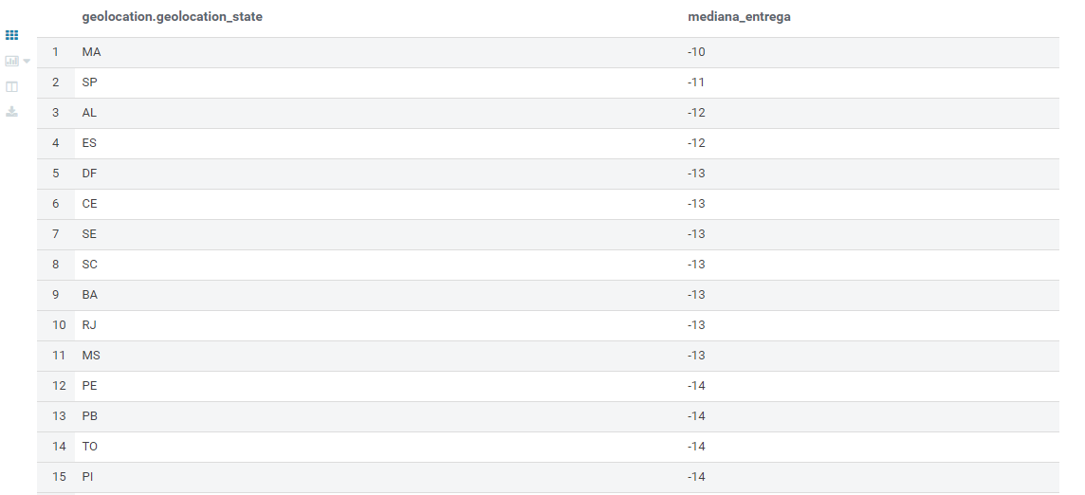
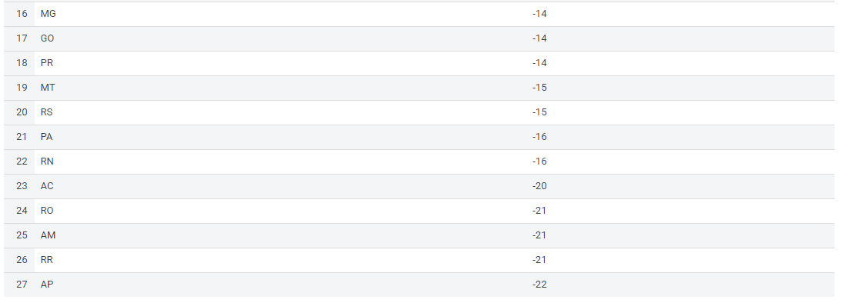

  - Itens por Vendedor
SELECT sellers.seller_id, count(*) as quantidade
FROM olist_sellers sellers
INNER JOIN olist_order_items order_items
ON sellers.seller_id = order_items.seller_id
group by sellers.seller_id
ORDER BY quantidade desc

Retorno:
