**Consultas SQL**

1. **Segmentar clientes por geolocalização** 
   1. **Segmentando por estado**

select customer_state, count(*) as quantidade

from olist.olist_customers

group by customer_state

order by quantidade desc

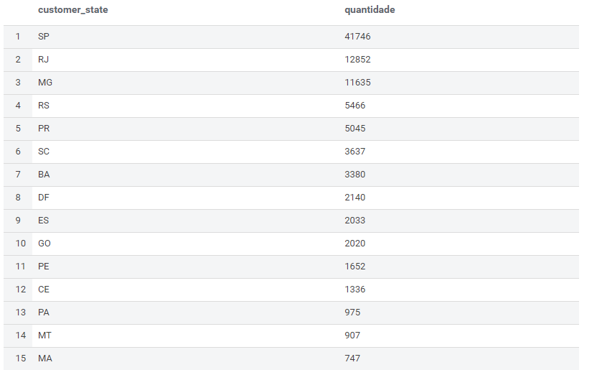

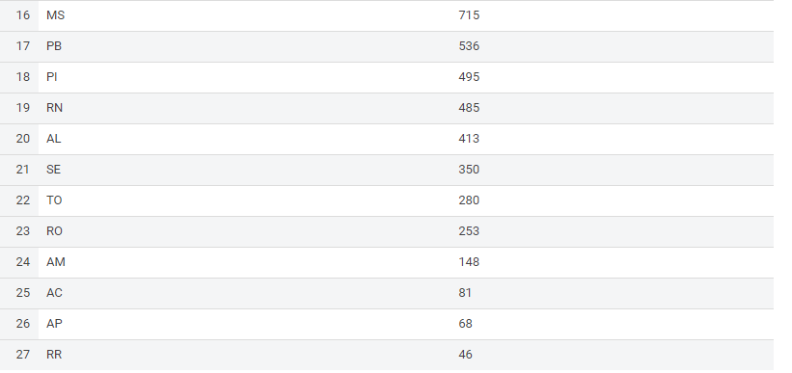

* 1. **Segmentando por cidade**

select customer_city, count(*) as quantidade

from olist.olist_customers

group by customer_city

order by quantidade desc

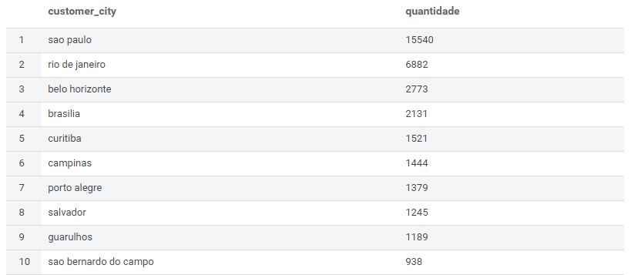

1. **Total de pedidos por período e categorias**

SELECT year(orders.order_purchase_timestamp) || '-' || LPAD(month(orders.order_purchase_timestamp), 2, '00') as order_purchase_year_month,

products.product_category_name, count(*) as quantidade

FROM olist_orders orders

INNER JOIN olist_order_items order_items

ON orders.order_id = order_items.order_id

INNER JOIN olist_products products

ON products.product_id = order_items.product_id

group by year(orders.order_purchase_timestamp) || '-' || LPAD(month(orders.order_purchase_timestamp), 2, '00'), product_category_name

ORDER BY order_purchase_year_month

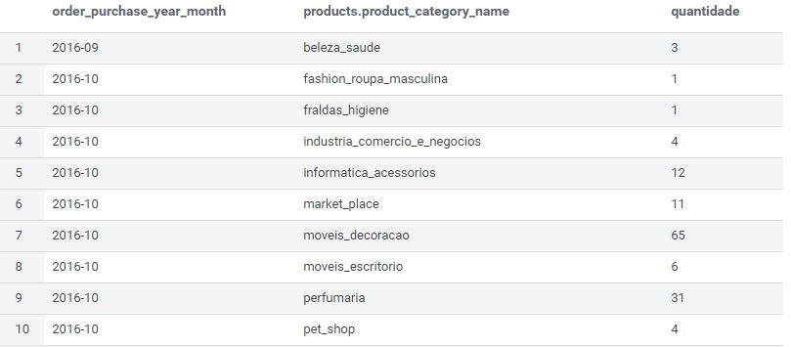

1. **Total de pagamentos por método de pagamento**

SELECT payment_type, count(*) as quantidade

FROM olist.olist_order_payments

group by payment_type

order by quantidade desc

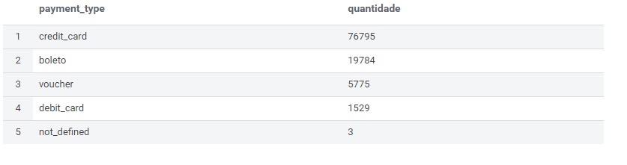

1. **Notas das avaliações**

select review_score, count(*) as quantidade

from olist_order_reviews

group by review_score

order by quantidade desc

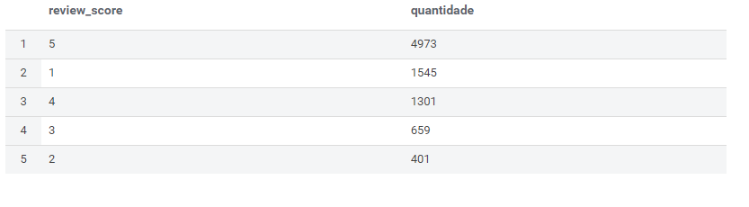

1. **Vendedores x vendas**
   1. **Por período**

SELECT year(orders.order_purchase_timestamp) || '-' || LPAD(month(orders.order_purchase_timestamp), 2, '00') as order_purchase_year_month,

sellers.seller_id, count(*) as quantidade

FROM olist_orders orders

INNER JOIN olist_order_items order_items

ON orders.order_id = order_items.order_id

INNER JOIN olist_sellers sellers

ON sellers.seller_id = order_items.seller_id

group by sellers.seller_id, year(orders.order_purchase_timestamp) || '-' || LPAD(month(orders.order_purchase_timestamp), 2, '00')

ORDER BY order_purchase_year_month

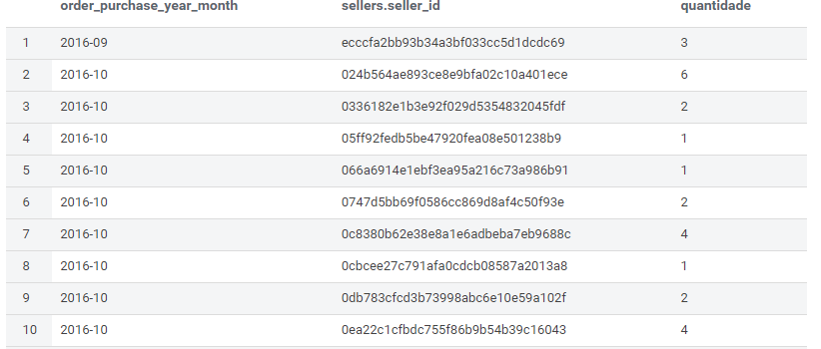

* 1. **Por vendedor**

SELECT sellers.seller_id, count(*) as quantidade

FROM olist_orders orders

INNER JOIN olist_order_items order_items

ON orders.order_id = order_items.order_id

INNER JOIN olist_sellers sellers

ON sellers.seller_id = order_items.seller_id

group by sellers.seller_id

ORDER BY quantidade desc

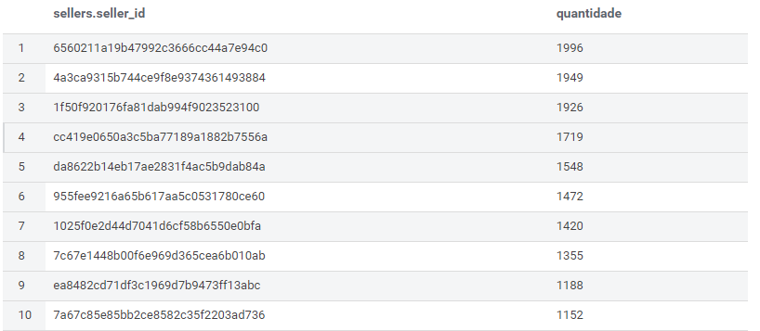

1. **Categoria de Produtos mais vendidos**

SELECT products.product_category_name, count(*) as quantidade

FROM olist_orders orders

INNER JOIN olist_order_items order_items

ON orders.order_id = order_items.order_id

INNER JOIN olist_products products

ON products.product_id = order_items.product_id

group by product_category_name

ORDER BY quantidade desc

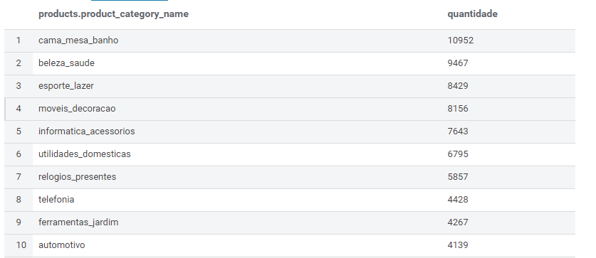

1. **Outras consultas**
   1. **Média de notas por categorias de produtos**

select products.product_category_name, round(avg(reviews.review_score), 2) as media_notas

from olist_order_reviews reviews

inner join olist_orders orders

on orders.order_id = reviews.order_id

inner join olist_order_items order_items

on order_items.order_id = orders.order_id

inner join olist_products products

on products.product_id = order_items.product_id

group by products.product_category_name

order by media_notas desc

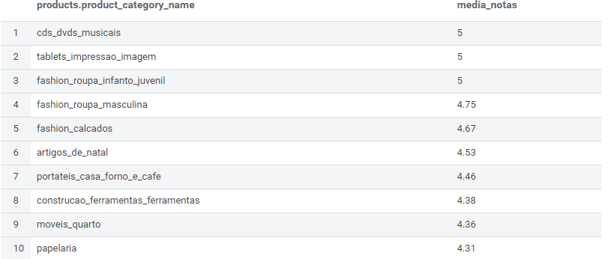

* 1. **Média do frete por estado**

select customers.customer_state, 'R$ ' || round(avg(order_items.freight_value), 2) as media_frete

from olist_customers customers

inner join olist_orders orders

on orders.customer_id = customers.customer_id

inner join olist_order_items order_items

on order_items.order_id = orders.order_id

group by customers.customer_state

order by media_frete

