

Solar system simulation
[Document subtitle]

Table of Contents
Analysis 1
Description of program 1
Description of the Problem 1
Description of Research Methods 1
Summary of Research Findings 1
Description of the End User 1
Background Identification of the Problem 1
Specific Project Objectives 1
Data Modelling (which could include) 1
Data Flow Diagram 1
Data Flow Diagram 1
Entity Relationship Diagrams 1
State Diagrams 1
Scientific/Mathematical Models or Formulae 1
Graphs & Charts 1
Graphs & Trees 1
Design 1
A Structure/Hierarchy Chart 1
Systems Flowcharts 1
Data Flow Diagrams 1
Object Diagrams (UML) / Class Diagrams 1
Non-Standards Diagrams 1
Sample of Planned Algorithms 1
Planned Data Structures 2
File Structure and Organisation 2
Database Design 2
Sample of Planned SQL Queries 2
Human Computer Interaction (HCI) 2
Hardware Selection and Design 2
Technical Solution 2
Completeness of Solution - reference your code in an appendix 2
Programming Techniques Used - reference your code in an appendix 2
Testing 2
Description of Testing Methods 2
Testing Plan/Testing Table 2
Evidence of Testing 2
Evidence of Remedial Actions 2
Evaluation 2
Review of Objectives against the Final System 2
Description of Evaluation Methods 2
Analysis of Third Party Feedback 2
Discussion of How the Solution Could Be Improved 2
Bibliography 2
Harvard Referencing of all Sources Used 2
Appendices 2
Evidence of Primary Research (questionnaires, surveys, meeting notes, transcripts of interviews etc.). 2
Evidence of Secondary Research (screenshots of websites, scans/photocopies of articles used). 3
Program Code 3
Evidence of Feedback Questionnaires 3

Analysis

Description of program
I a going to be creating an solar system simulation for educational use that can be used within schools.

Simulations are used in schools to help students visualise hard concepts. There are a few solar system simulations out there but none of which are directed at education within high schools. These simulations would be used by teachers to show concepts that they are teaching to help the students learn. Many of the solar system simulations out there are mainly used for entertainment purposes not mainly for educational use.

Solar system scope is a good example of a program that is based around online entertainment and less about the education side of things. Even though there are parts of the program where you can learn about he planets are the rest of the solar system there is no place to show that the student has consolidated that information but having quizzes.

Description of Research Methods
Primary research which includes questionnaires, these will allow for people to answer the necessary questions. From the questionnaire where necessary there has been a scale of 1 to 10 of attributes that my program could have and from that data if the answers are majority 10’s then them attributes will be placed in the program but if the answers to the questions are near the lower end of the scale it shows that people may not think that it is a good idea to have the section in the program.

Summary of Research Findings
•Screen shots of programs that I have researched:
Solar system scope.
“Solar System Scope is a model of Solar System, Night sky and Outer Space in real time, with accurate positions of objects and lots of interesting facts.”
Solar System Scope. (2018). Solar System Scope. [online] Available at: http://www.solarsystemscope.com/ [Accessed 31 Aug. 2018].
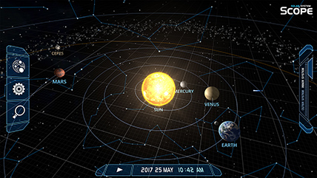
Space engine.
“SpaceEngine is a realistic virtual Universe you can explore on your computer. You can travel from star to star, from galaxy to galaxy, landing on any planet, moon, or asteroid with the ability to explore its alien landscape. You can alter the speed of time and observe any celestial phenomena you please. All transitions are completely seamless, and this virtual universe has a size of billions of light-years across and contains trillions upon trillions of planetary systems. The procedural generation is based on real scientific knowledge, so SpaceEngine depicts the universe the way it is thought to be by modern science. Real celestial objects are also present if you want to visit them, including the planets and moons of our Solar system, thousands of nearby stars with newly discovered exoplanets, and thousands of galaxies that are currently known.”
Spaceengine.org. (2018). Space Engine – the universe simulator. [online] Available at: http://spaceengine.org/ [Accessed 31 Aug. 2018

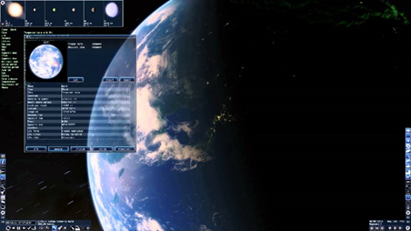

Universe sandbox.
“Universe Sandbox ² is a physics-based space simulator.
It merges gravity, climate, collision, and material interactions to reveal the beauty of our universe and the fragility of our planet
Create, destroy, and interact on a scale you've never before imagined.”
Universesandbox.com. (2018). Universe Sandbox. [online] Available at: http://universesandbox.com/ [Accessed 2 Sep. 2018].
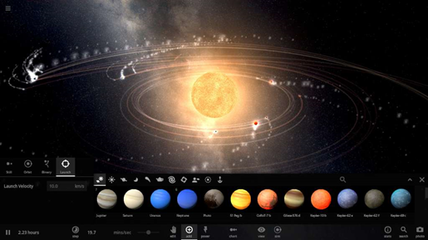
These 3 different programs all have aspects to them that I want with in my program but yet they are more like games then actual educational programs. If they were to have tests of what you were too learn with in the program then it would be more suited to my end user, but in the case of these 3 programs they are not.

From the other systems that I have looked at, I can say that they are very good in the way of presenting the planets an making them look good, but they don’t focus on the educational side of things and really showing how current breaking edge physics can be simplified down to make students understand it. and that’s what I am to make, a program that implies current physics in a simple way.

Description of the End User
The target audience of my end user is students in high school and college. From research I have found that a very little percentage of students are interested in physics and astronomy. As the program is based around those two things, I believe having the program available in schools it will allow all students the opportunity to learn about the solar system. As most schools have computers it will be very widely accessible for all students. Every student will have their own login that they can make for the program this is so when they make changes to the solar system within the program, they will be able have that saved and come back to it. This would mean every student could have their own solar system and test scores from the test that are within the program.

Background Identification of the Problem
I am going to create a solar system simulation with educational uses in schools, to make sure that it address the errors that the other programs didn’t address.

The software will rely heabely on an SQL database that will be used to store lot of the data from the data that the users inputs when making there own solar system to the questions that they have answered in the quizzes. For all the the users to be able to use the simulatipon it will have to be easy to use so that there learning expernce is the best, helping them focus on what is important.

Each of the student will have there own account that they can log into so that they can load up there own solar system simulation. Hence the start of the program being a login screen. My login screen will consist of the title of the program along with two entry boxes that the user can input there username and passwork into. These will be checked against the SQL database by sql quires. If the user doesn’t have there details in the database they wont be allowed into the program the user can make a account by clicking the make user button that will lead to another tkinter page by rasiing a frame above the login frame. This will constis of two entry boxes that the new user can enter there details into. Onces that have clicked make account button there details will then be added to the database, which means that they can then login to there own account. Every account will have the sae level of access as there is no need for an admististater account as it it purposely for testing the students.

Onces the student has loged in it will then lead to the main page ill will constist of the majority of the wigets for the rest of the program.

The Top Row:

In the top layer of the main page it will have the title to keep the name of the program contistent, as well as allowing teacher to able to easily identify what there students are using. There will also be a user details label wich will show the user id to see what account that they are login with, this helps the student identify easily what account they are in incase they get confused to why they can find there solar system simulation. Finally on the top row there will be a logout button so tat they can logout if they find them selfs finished in the account that they are login as. The fuction of this button will call the login screen program wich will then load up and then can be used again.

Second Row

This is where the main buttons of the premade finction will load, like the inner and outer solar system simulation and the information button. The Inner solar sysrem button will be user to load up the simulation that show the inner palents, this will use constants set within the code, the same goes for the outer solar system button but has the difference of the planets and there orbits. The reason that they will feature in different screens will be that having all the planets on one screen will mean that the first four planets will be harly visible due to the propotions, this will not work as the aim of the program is to help with the visualisation of the planets. The buttons both load up a pygame window that displays the simulation using the newton law of grationation mathematical methord. The information button will load up a tkinter page that will have all the planets in a button formation that when clicked on will load up the information about that planet or star. This information will taken from the SQL database and then be displaied on the screen. All these buttons will be big and easy to use.

The Third Layer

In the third layer there will be all the otion for what planets that you want to be visible in the simulation that will be loaded when you lcick the buttons above them. The check boxes will be beside the name of the planet that you want to show and once the check box has been clicked it will become TRUE as it is a Boolean value and that will indicate wither when the button is pressed if thr planets will be displayied in the simulation.

Forth layer

This is where the stident will be able to click on the buttons to make there own solar system simulation from what they have learned from the inner and outer simulation and the information page. This layer will have the create solar system and load solar system btton aswell as the quiz button that will bring up a set of quizzes that the user can select to take a test on everyoing that they have learned.

The problem that I aim to solve is the lack of knowledge in students on the universe. I believe that the solar system is such a huge part of our lives as its where we live. Most people don’t understand what is really happening up in space. Know about the solar system is not just interesting but it helps students with skills needed in there working lives by being able to understand maths and improves their problem-solving skills.

The other systems out there are all good in their own ways but noon of them focus directly on students and my program means to do that. I aim to make my system understandable for high school students and easily accessible with in their schools. Which would mean not having a price for it like many of the other similar systems do. Both front and back end of my program aim to well executed and easy to run. The back end of my program will have to be constantly processing data that the various math mathematical equations as the simulation runs, and as the user enters different variables. The front end will need to be easy to use and able to be understand by everyone in the target audience range.

Login screen:
SQL Database:
All the data of the users will be stored in the data base, this will include the users, name and password as well as when they login to there account the file that they made with there own personalised solar system and test scores will be open when the login, this will mean they will be able to keep track of what they have been learning in the program about space.
Layout
The lay out of the login page will be made in tkinter with a simplistic design but interesting design. He layout will be as follows:
Starting from the top of the window there will be a title displaying “Solar system simulation” this will be the most prominent feature of the window.
Below the title will be the heading “Username”
Below this will be an input box where the user will in put there username.
Below this will be the second heading of “Password”
Bellow this will be another entry box for the user to entre there password into, the difference with this box is that when they entre there password the letters will before dots just like with most password entry boxes so that when they are type in it in the password is not displayed on the screen.
After this is the login button which will be pressed this will then run the back end program and link to the SQL data base to see if the information entre matches to the information the database, if this is true then the main page will be loaded up with that specifics users saved files.
At the very bottom of the page will be a button with the text “Create an account” on it. When this button is pressed the user will be taken to a new screen which will have all the inputs to make a new user.
The layout will be as follows:

The use of it
Solar System Simulation Graphics:
What the main screen will look like
Once you have loged in to the simulation the main page will load up and will be the visual simulation of the solar system this will not be the edited one, the personal system will be able to be located by opening up the file by clicking the button on the left hand side of the screen this will load up all the saves of the system and let the user pick from the one that they want , this feature will allow for students to have more than one personal system.
The main screen will be in motion and will be interactive, the user will be able to click on the planets on the main screen such as Earth and Jupiter, when clicking on these planets then a dismissible window will pop up this will contain the name and some little information followed by a button allowing the user to open up a sub window. Other interactive aspects of the main screen will be able to zoom in and out of the solar system as well as being able to increase and decrease the speed at which time passes.
Buttons on the screen
The main screen will not be full of buttons so that it is ascetically well presented because by having loads of buttons will make it look cluttered. There will be a total of 3 buttons which will be the load personal system button, exit button and interactive time button.
Information on the screen
The initial information on the screen before clicking on a one of the interactive planets will be quite little so that it doesn’t look cluttered, but the information will come on the screen from clicking on the planets and the stars this is where the chuck of all the information will be for the main page will be when the users clicks on the planets. The information will be on a dismissible window which will have basic information about the object that has been clicked on.
How you interactive with it.
The graphics of the solar system will be able to move around the page so that the whole of the solar system will be able to seen from different angles, as well as being zoomed in on.
Getting from the screen to other parts of the program.
On the dismissible windows there will be a button that will allow for the user to click on to another window that comes up will all the information about the object that was clicked on, with the topic tests. All the buttons on the main screen will bring the users to a new screen.
Graphs of the solar system:
Different types of graphs.
The different types of graphs will be there to show the user how different aspects of the planets will change if different variables are changed. The main two of graphs will be velocity-time graphs and displacement-time graphs, these will be able to show both how the velocity of an object changes and the distances it moves relative the its orbit.
Where they appear.
The different graphs will be show in sperate windows to the main program as it allows for the user to see both the simulation and the graphs being made at the same time.
How to access them.
There will be a button on the side of the screen that allows the user to open the window that controls the graphs and which is processing the data within the program. This button will run a function within the program that gathers the live data of the simulation and transmit it into a graph format, allowing the user to see it on screen.
Educational information screen:
How to get to this screen.
All the education information’s such as the stats and the test of individual planets starts etc, will be access on the main screen through clicking of the objects that the user will want to look at. All the information will pop up onto the currant open window. To exit this screen the user will be able to press the back button present on this frame, this will then raise the frame of the simulation.
The information.
All the information and data within the program will be taken from trusted websites such as NASA. The non-wordy information such as the mass of a planet or the velocity at which it travels will all be read in from an excel document, this will allow for the program to read in addition external information.
The layout.
There will be a page of all the different stats of a specific object and then there will a page on the history of that object, the final page of each object will consist of a little test about that object where the user can answer and get a result all with in that one page by ticking boxs and the questions will be multiple choice. At the end of the test there will be a check your answers button with will compare all the users answers with the answers in the data base and will work out a percentage of what the user got write and will then tell the user what ones that they got wrong and where about they can find that information with in the program.
Tests at the end of topics.

Specific Project Objectives
- Log in page: I want to get this done first so that I can make sure that when the rest of the program get completed it can all be accessed individually from different account. This will mean having to make a SQL data base for the logins and making sure that usernames and passwords are saved in the data base.
- The solar system sandbox: once the login page is working I can start working on the largest chunk of the course work which will be the graphical interface which is the solar system. This will take the most time as there will be a lot of maths involved in back ground calculations of how the planets orbit round their star. The first step will be working out what equations will be needed to make sure that all the planets orbit accurately.
- Graphs: The graphs will be showing visually the calculations of the orbits and will allow the students to under stand how data from graphs in collected.
- Information and tests: The final step if the program will be the information that will be displayed when clicking on a planet. This will be the part where the students will learn the most about the solar system. For every section of information wither that be about a planet or the stars, orbits and asteroid belt there will be a multiple-choice test. The tests score will then be stored in the data base along with that username so that when that same user logs in they will have the same results, this makes sure that other users don’t all get the same results as each other but have their own individual score.

Data Modelling (which could include)

Data Flow Diagram

Data Flow Diagram
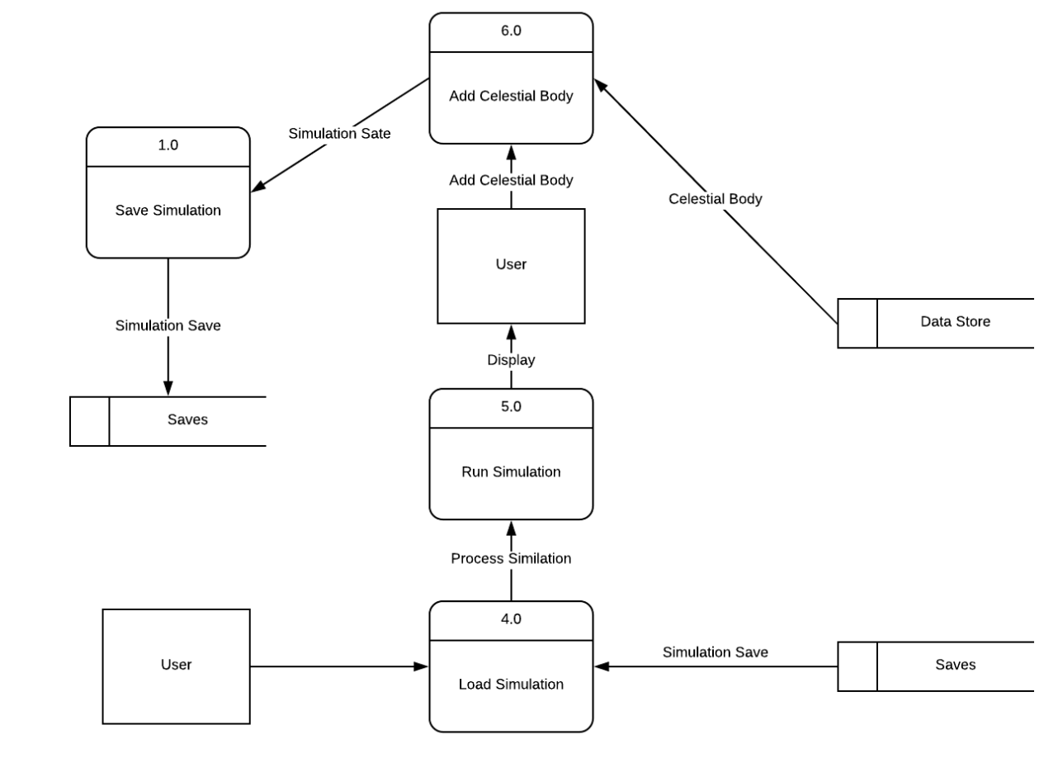

Entity Relationship Diagrams

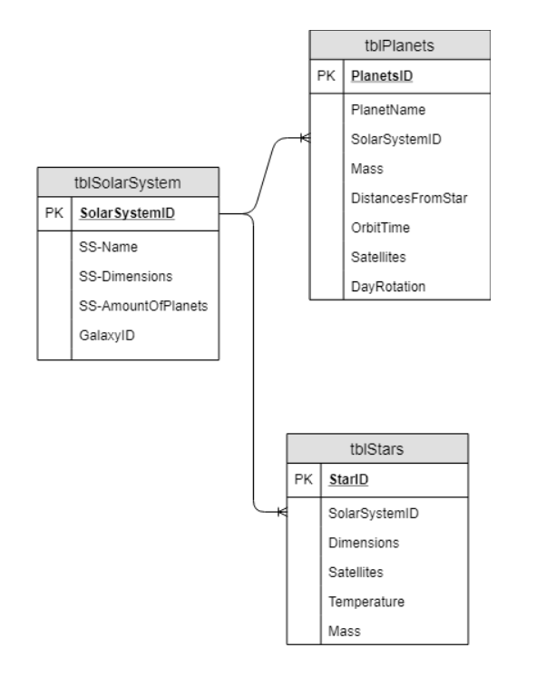

State Diagrams

Scientific/Mathematical Models or Formulae

Graphs & Charts

Graphs & Trees

Design

A Structure/Hierarchy Chart

Systems Flowcharts

Data Flow Diagrams

Object Diagrams (UML) / Class Diagrams

Non-Standards Diagrams

Sample of Planned Algorithms

Planned Data Structures

File Structure and Organisation
SQL Database
Username | Password | Solar System ID
Username | User Password | User System

The User System ID connects the user login to there own personalised solar system.

Planet Velocity (x) | Planet Velocity (y) | Planet Name | Planet Mass | Planet Size | Planet Position (x) | Planet Position (y) | Planet Path Length | Planet Colour
(x) Float Value | (y) Float Value | String Value | Float Value | Integer Value | (x) Float Value | (y) Float Value | Integer Value | Hex Value

Star Name | Star Mass | Star Size | Star Position (x) | Star Position (y) | Star Colour
String Value | Float Value | Integer Value | (x) Float Value | (y) Float Value | Hex Value

Text Files

For the information section of the program where the user can learn about individual planets there will be .txt files being imported to so the mass of the written information.

Image Files

Database Design

Sample of Planned SQL Queries

Human Computer Interaction (HCI)

Hardware Selection and Design
The minimum system requirements to run python and my program are
Processors: Intel Atom® processor or Intel® Core™ i3 processor
Disk space: 1 GB
Operating systems: Windows* 7 or later, macOS, and Linux
Python* versions: 2.7.X, 3.6.X
Included development tools: conda*, conda-env, Jupyter Notebook* (IPython)
Intel® Threading Building Blocks, pyDAAL, Jupyter, mpi4py, PIP*, and others.
While this minimum is recommended just as intel have that you use an Intel® Core™ i5 processor 4300M at 2.60 GHz or 2.59 GHz (1 socket, 2 cores, 2 threads per core), 8 GB of DRAM

Minimums:
Monitor Screen: 14”
Anything smaller would be hared to see the simulation as well as the text on the screen on well, any size bigger is recommended as the program will adjust to the size of the monitor.
Keyboard: Standard Qwerty Keyboard
Mouse: USB Mouse

Technical Solution

Completeness of Solution - reference your code in an appendix

Programming Techniques Used - reference your code in an appendix

Testing

Description of Testing Methods

Testing Plan/Testing Table

Evidence of Testing

Evidence of Remedial Actions

Evaluation

Review of Objectives against the Final System

Description of Evaluation Methods

Analysis of Third Party Feedback

Discussion of How the Solution Could Be Improved

Bibliography

Harvard Referencing of all Sources Used

Appendices

Evidence of Primary Research (questionnaires, surveys, meeting notes, transcripts of interviews etc.).

Evidence of Secondary Research (screenshots of websites, scans/photocopies of articles used).

Program Code

Evidence of Feedback Questionnaires

