**P3 – Imaginary Numbers**

Prep

2.1 Complex Number Operations

Some of the standard operations you can do with complex numbers is addition, subtraction, multiplication and division.

2.2 Complex Number Class

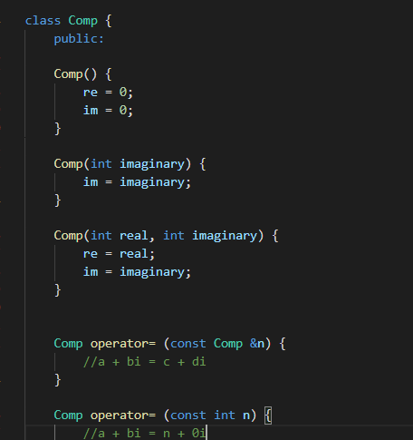

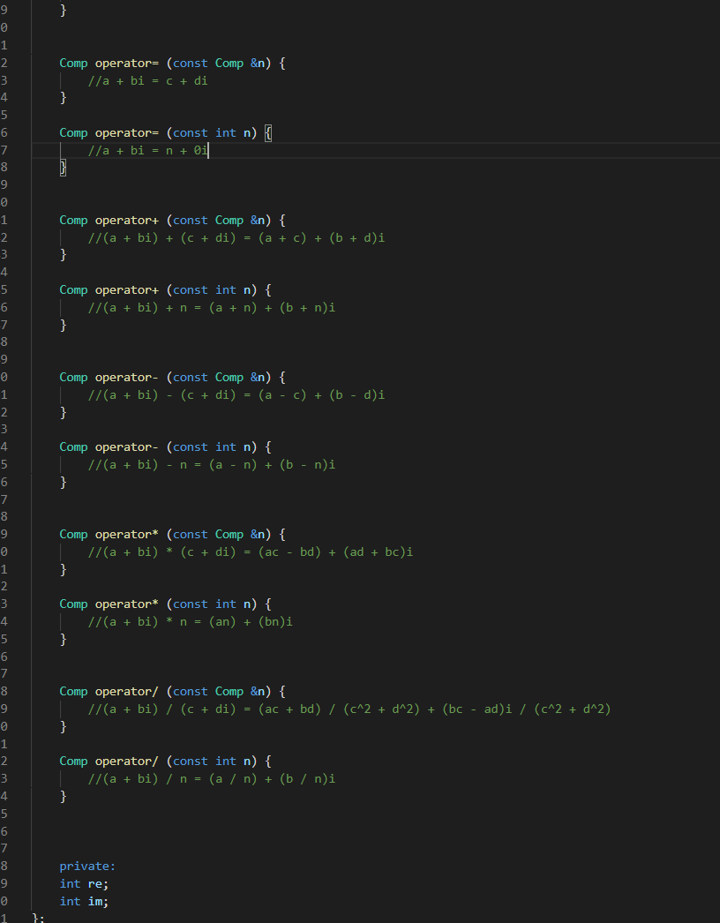

2.3 Impedance of Circuits

1. The real part of a series RLC circuit is the resistor.
2. The reactive part is the XL – XC. Where XL is ωL and XC is 1/ωC.
3. 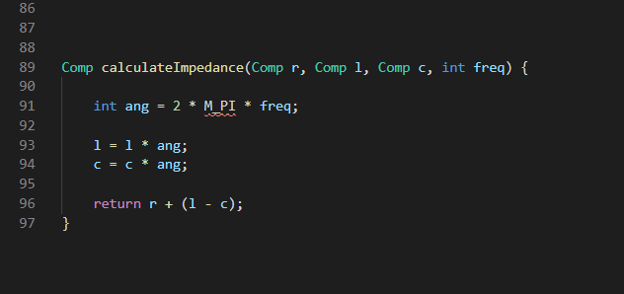
4. Impedance is the amount of opposition to the charge flow in a circuit, it is what mathematically links voltage and current.