**P6 – Sudoku GUI 1**

2.1 Prepare SD Card

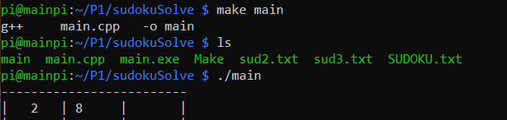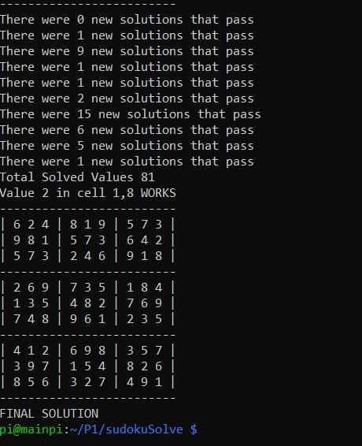

2.2 GUI Programming

* Model View Controller – This is a control loop which is the basis behind most GUIs, the screen displays a View, the user changes something in the Controller, and then the Model changes the View according to what the user has changed. This loop repeats indefinitely.
* For the case of a Sudoku GUI, the View would be the display boxes, the Controller would react to the user’s mouse clicks and the Model would either display the number changed by the user or solve the sudoku itself.
* The inputs can be made using spin boxes which allow the user to increment or decrement the number in the box or allows them to change the number using their keyboard. QT will handle all the information needed to decide whether the mouse has clicked on that specific box or button.
* Range checking will have to be done on all the data inputted by the user so that only the numbers between 1 and 9 can be inputted.