**P7 – Sudoku GUI 2**

3.1 Create the GUI

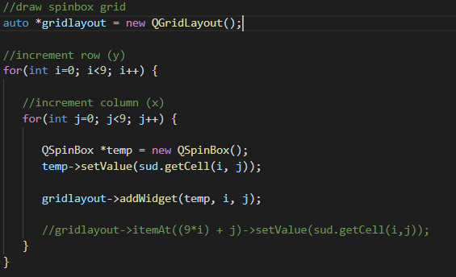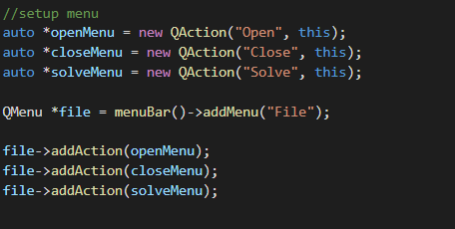

3.2 Initialize the GUI

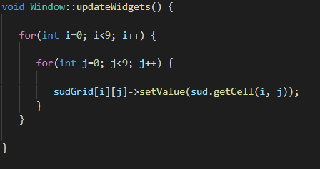

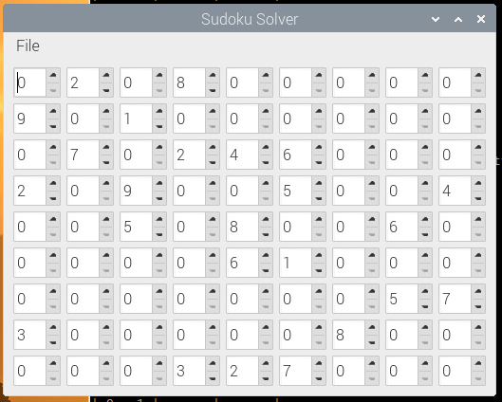

3.3 Implement Signals and Slots

To accommodate signals and slots I had to store the widgets more permanently. To do this I just created a simple 2D array to store the SpinBox widgets so that their values can be changed later.

