**C10 – Interrupts**

Preparation

1. Firstly all the pins on the Il Matto can be used as interrupts. Also there are various other sources to cause interrupts for example various timers, SPI and UART inputs and Watchdog Timers.
2. The volatile keyword is used for variables which you want to be used by both interrupt routines and the main program function.
3. The sei() function is used to enable interrupts and the cli() is used to disable interrupts.
4. 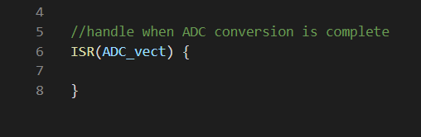
5. The use of an interrupt can be used for an ultrasonic distance sensor. This sends out a pulse and an interrupt can be used to detect when the receive pin goes high which means the computer can do other things in the mean time.