**C4 – Pointers, Files and Strings**

2. Preparation

1. “&” is to get the address of a variable, “*” is to get the value of a pointer.
2. To pass in an integer array you pass in the starting address (as a pointer) and the length of the array (to know where the end is).
3. “FILE” is the variable type for a file. “fopen” will open a file and return a FILE variable. “fclose” will cclose a file when you pass in a FILE variable. “fget” gets a single character in the file and will return “EOF” if it is at the end of the file.
4. 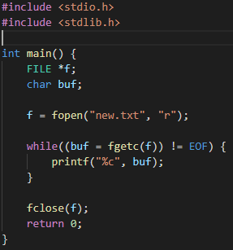
5. The “string.h” header file.
6. The ascii value of “A” is 65.
7. A Caesar Cipher is when the letters of the alphabet are shifted by an amount and the message is encrypted and decrypted using this conversion (source: Wikipedia.org).
8. The percent sign (%) is used to implement a modulo.