**C5 – Data Structures and Dynamic Memory Allocation**

Preparation

1. A struct is a data structure which defines a new data type which can have more than one variable type, an enum is a datatype which defines a list of constants.
2. 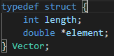
3. 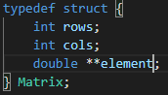
4. Malloc reserves an amount of space in memory (an amount that you define) and Calloc reserves the amount of space for a number of items, each of a size you define.
5. To free up memory which has been reserved you use the function free and cast in the specific pointer.
6. To compile multiple source files you just keep listing the programs after the main program when compiling with gcc.
7. Arguments can be passed into the program using argc and argv, argc is the number of arguments and argv is an array of each of these arguments.