**C6 – Digital Input and Output**

Preparation

1. The header file required to interface to the digital pins is the avr/io.h file. To set a port as an output DDRx = 0xFF; where x is the port letter.
2. Vs = 3.3V, Vled = 2v, therefore Vr = 3.3 – 2 = 1.3, I = 0.01A, R = 1.3/0.01 = 130Ω.
3. This cant be replaced with a single resistor since if multiple segments are lit then more current is going through the resistor and therefore there is a bigger voltage drop across it and the two segments are more dim than if a single one was lit.
4. The standard power delivery for USB 2.0 is 5V at 500mA which is plenty bigger than 8x10mA.
5. 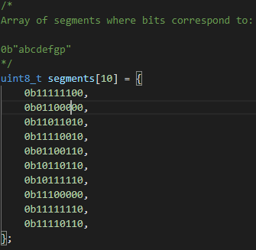
6. To configure a port as input you use the command DDRx = 0x00; where x is the port letter.
7. It is a good ideas to have a pullup resister enabled since it doesn’t leave the pin floating, this often adds a resistor between 20 and 50kR. To enable this feature use the command PORTx = 0xFF; where x is the port letter.
8. To read a logical high the voltage must be above 2.53v, to read a logical low it must be bellow 0.66v.
9. Switch bounce is when the switch is moved from one voltage level to another but keeps flicking back and forth quickly and then settles. This is as the contacts meet.
10. One simple hardware fix for this is to add a small capacitance to the pin (e.g. 100nF) which will help dampen the logic level as the button is pressed. A simple software solution is to add a small delay. The software solution will add unwanted use of processor time but is free to implement compared to the hardware solution.
11. With the rotary encoder there are two switches A and B. If switch A is switched first then the rotary encoder is rotating in one direction, if switch B is switched first then it is rotating in the opposite direction.
12. The speaker takes 30mA of current whereas the microcontroller can drive 40mA.