**C7 – Serial Communication**

3.1 UART Debugging

|  |  |
| --- | --- |
|  |  |
|  |  |

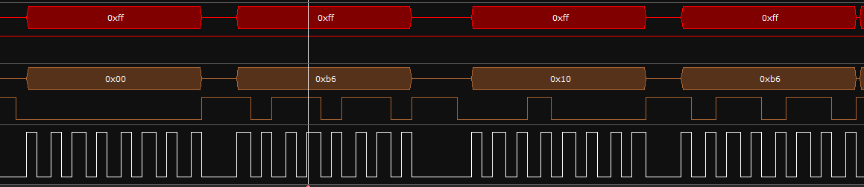3.2 SPI Digital Potentiometer

CLK

MOSI

MISO

|  |  |
| --- | --- |
|  |  |

The first byte selects pot 0 to write, the next byte writes the value 0xb6 to pot 0, the next byte selects pot 1 to write, then the last byte writes the value 0xb6 to pot 1.