**C8 – Timers/Counters and Pulse-Width Modulation**

Preparation

2.1.1.Tone Oscillator

1. Timer 1 is a good choice since it is a 16 bit timer compared to the others which are 8 bit timers. This is better since it allows us to set a greater range of frequencies as there are 16 bits of resolution, the same range of frequency could be done with an 8 bit timer you just have to change the clock divide.
2. By setting the COM1A0 bit, this sets the mode to toggle on compare. Then setting the WGM10 bit this well set the PWM mode to Phase and Frequency correct. This can be done in avr C with the bitwise or and the _BV function.
3. The prescaler should be 8.
4. 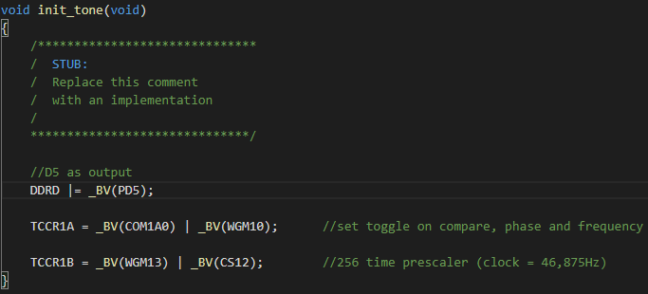
5. 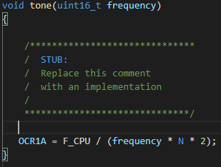

2.1.2 PWM Oscillator and Amplitude Control

1. I chose Timer 2 since one of the outputs of Timer 0 is shared with the SPI which is used to program the board, so using Timer 2 avoids possible future programming problems.
2. F = 12,000,000 / (2 * 1 * 2^8) = 23,437.5Hz
3. The Timer 2 should be put into Phase Correct mode by setting the WGM20 and WGM22 bits. Then we set it to toggle mode using bit COM2A0 and set no clock prescale using bit CS20.

2.2 Pin Assignment

|  |  |
| --- | --- |
| Pin Name | Description |
| PD5 | Oscillator / Timer 1 |
| PD6 / PD7 | Modulation / Timer 2 |
| PD4 | Trigger |