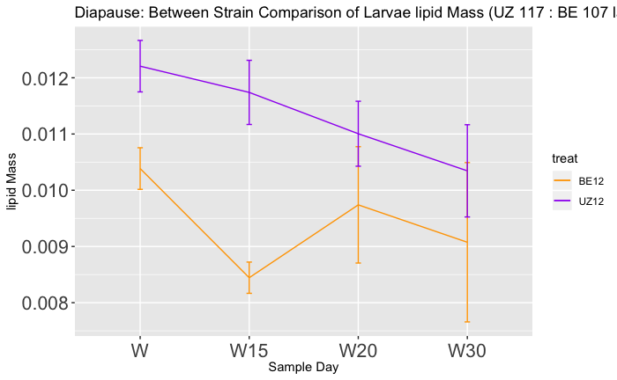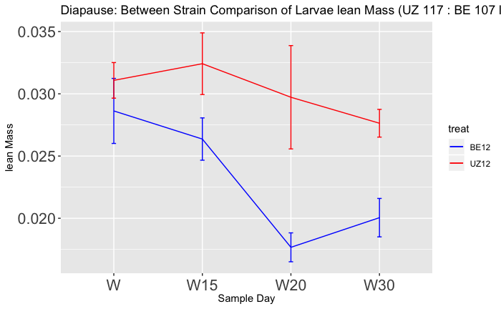

Diapause Day 15

Diapause Day 20

Diapause Day 30

**B**

**A**

Time (days)

Wandering Day

Lipid Mass (g)

Time (days)

Diapause Day 30

Diapause Day 20

Wandering Day

Diapause Day 15

Lean Mass (g)

Short-Diapause

Long-Diapause

Short-Diapause

Long-Diapause