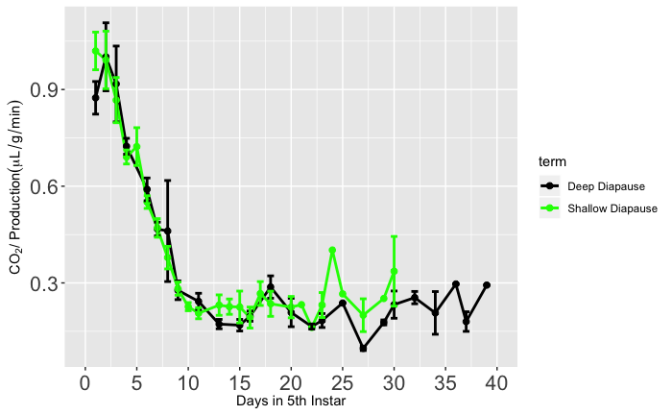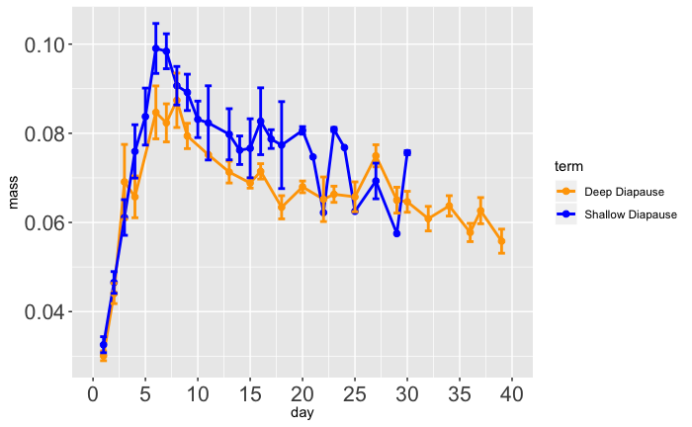

0.9

0.6

0.3

0.10

0.08

0.06

0.04

0 5 10 15 20 25 30 35 40

Time (days)

0 5 10 15 20 25 30 35 40

Time (days)

CO2 Production (µ/g/min)

(Short-Diapause Genotype)

Wet Mass (g)’

(Short-Diapause Genotype)

B

Deep Diapause

Shallow Diapause

A

Deep Diapause

Shallow Diapause