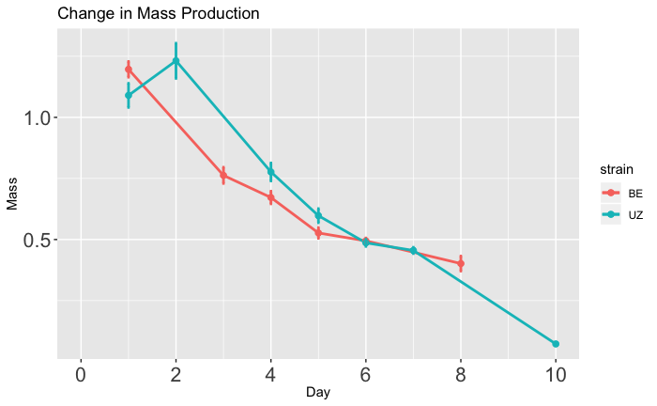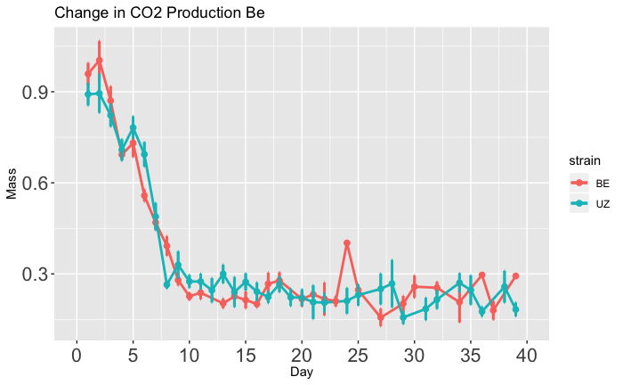

CO2  Production (µ/g/min)

**\***

**\***

**A**

**B**

CO2  Production (µ/g/min)

Time (days)

**Long-Diapause**

**Short-Diapause**

Time (days)

**Long-Diapause**

**Short-Diapause**