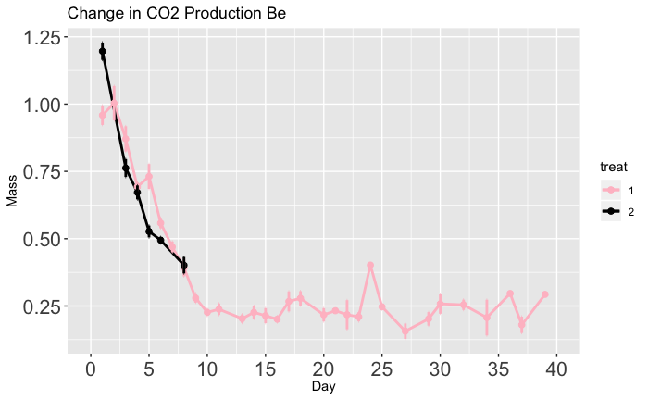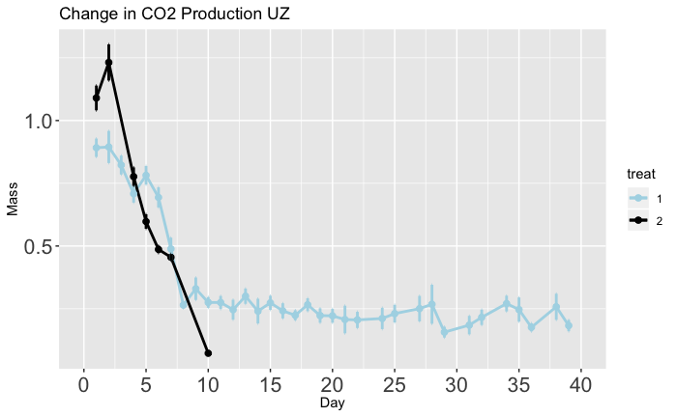

**\***

**\***

**B**

Time (days)

CO2  Production (µ/g/min)

Time (days)

CO2  Production (µ/g/min)

**A**

**Diapause Programming**

**Non Diapause**

**Diapause Programming**

**Non Diapause**