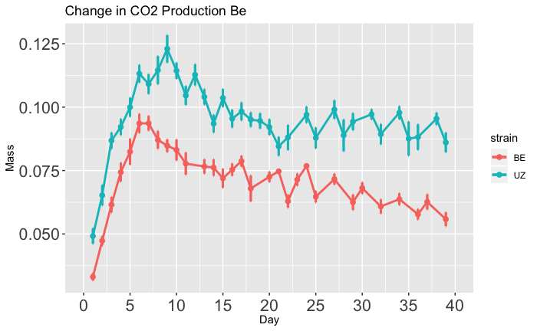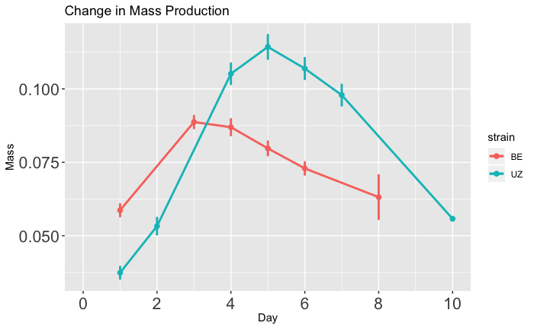

Wet Mass (g)

(Non-diapause)

Wet Mass (g)

(Diapause)

**B**

Time (days)

**Long-Diapause**

**Short-Diapause**

Time (days)

**Long-Diapause**

**Short-Diapause**

**A**