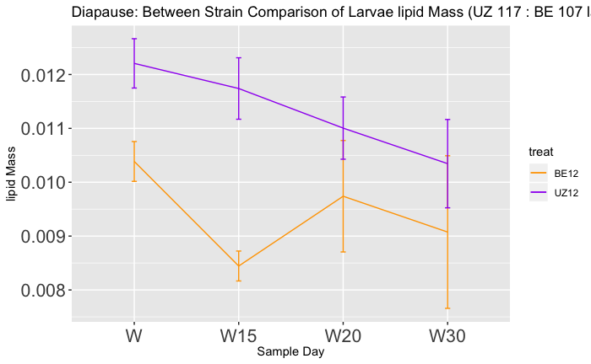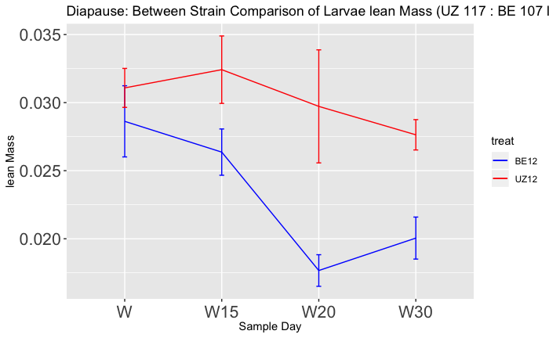

0.012

0.011

0.010

0.009

0.008

0.035

0.030

0.025

0.020

Lean Mass (g)

Diapause Day 15

Diapause Day 20

Diapause Day 30

B

A

Time (days)

Wandering Day

Lipid Mass (g)

Time (days)

Diapause Day 30

Diapause Day 20

Wandering Day

Diapause Day 15

Short-Diapause

Long-Diapause

Short-Diapause

Long-Diapause