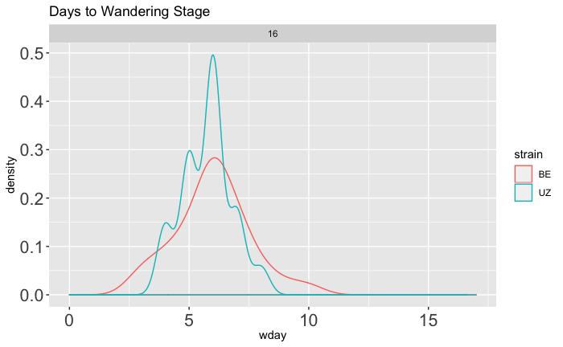

Non Diapause Programming

**A**

Time (days)

Short-Diapause

Long-Diapause

Wandering Density Plot

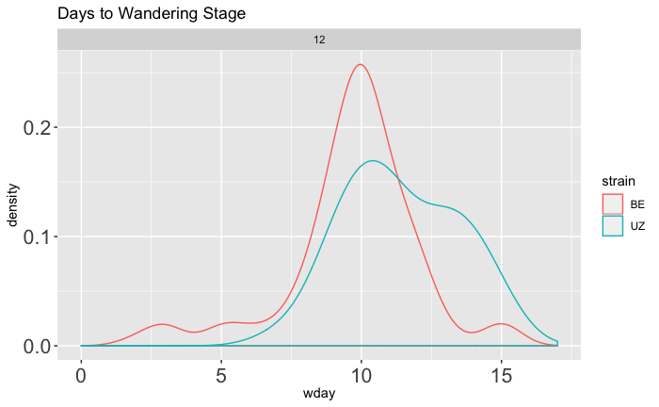

Diapause Programming

Short-Diapause

Long-Diapause

Time (days)

**B**

Wandering Density Plot