ENEL-UC Berkeley Short-Term Experiment Scope

**Methodology**

Analyzers:

1. Optasense ODH-3 Distributed Acoustic Sensor interrogator (Φ-OTDR)
2. Luna Innovations ODiSI6000 Commercial system (OFDR)
3. Alicia (BOTDR)

The tower is instrumented with NanZee Sensing NZS-DSS-C02 single mode, tightly buffered fiber optic cables.

**Scope**

The scope of the short-term experiment is to systematically test the ability of the distributed fiber optic sensing technologies that are currently installed on site. The utility of the research is to be able to detect the amount of bolt loosening for each bolt along the tower flanges. This would allow for a better understanding of the real-time conditions of the bolts, as well as making the maintenance procedures related to the bolt torquing.

**Monitoring Plan**

The short-term testing program will consist of hammer, braking, and normal operation tests under different bolt configurations (loosening up to 10% torque or 60 degrees loosening, without having to replace the bolts). **Note: The cost of the short-term experiment is dependent on if we can loosen bolts without having to replace the bolts. We also need to know how long can we have the bolts loose if we fully loosen bolts.**

Loosen Bolt

Cables

Figure 1: Left image: Full flange, with 120 bolts. Right image: Cartoon of bolts and which to loosen.

Hammer Here

Loosen Bolt

Hammer Here

Loosen Bolt

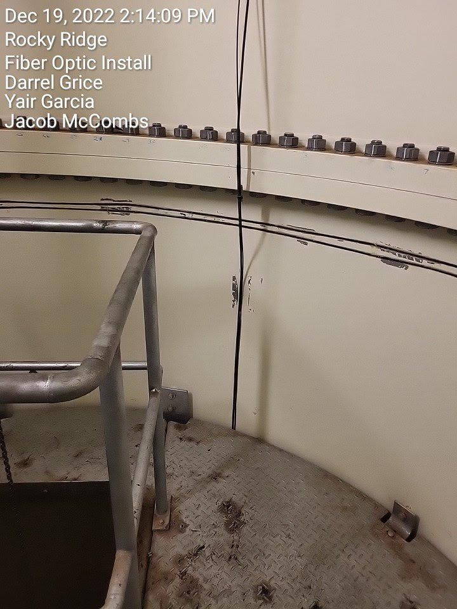

Figure 2: Example of where to hammer.

Detailed Testing Plan

5 Bolt configurations

1. Bolts as is
2. One Loose bolt (60 degrees loosening), directly under one of the longitudinal cable
3. One Loose bolt (60 degrees loosening), 15 degrees from longitudinal cable (or 5 bolts away)
4. One Loose bolt (60 degrees loosening), 30 degrees from longitudinal cable (or 10 bolts away)
5. One Loose bolt (60 degrees loosening), 45 degrees from longitudinal cable (or 15 bolts away)

For each bolt configuration:

1. Turbine turned off for static strain to determine the temperature along the fiber optic cables (Alicia)
2. Hammer Test (ODH3 and Luna)
   1. One at the first flange (Just above the flange)
      1. Right above one of the channels
      2. In between two of the channels
3. Braking test (ODH3 and Luna)
   1. Brake the turbine from normal operation, so that the tower can sway back and forth
4. Nearby Vibration Generation (ODH3 and Luna)
   1. Driving away from the tower, down the road and back
   2. Drive around the turbine
5. Normal operation (Attempt to record at the same time as other tests). Do this twice, at different times of the day.
   1. Measure temperature along the fiber optic cables (~11 am and ~2 pm) (Alicia)
   2. Record for 20 minutes (~11 am and ~2 pm) (ODH3 and Luna)
6. If applicable, retighten bolts and measure temperature (Alicia)

Notes:

* Make sure that signal loss isn’t severe in any load scenario.
* Record a log of testing times so that we can request the corresponding SCADA data after.
* For the dynamic measurements, wait for the transient response to die out ~5 minutes (at least).
* Try to record data at roughly the same time of each day (For temperature considerations).
* Try to be consistent in driving (We can use our own car, or a pickup truck that Enel has).
* The times 11 am and 2 pm don’t have to be precise, only roughly due to unpredictable wind conditions.
* Be aware of the turbine yawing during normal operation. This causes a different form of vibration.
* Try to have consistent wind conditions (Choose a week during the windy season, where the wind is more consistent?).