ENEL-UC Berkeley Monitoring Plan

**Background**

This project uses several different technologies to capture strain due to the backscattering of light. This includes Optical Frequency Domain Reflectometry (OFDR) and Phase-based Time Domain Reflectometry (Φ-OTDR) which is commonly used in Distributed Acoustic Sensing (DAS). Both of these technologies use Rayleigh scattered light, caused by local refractive index fluctuations along the glass core. This information can then be converted into dynamic strain measurements. The two technologies have different capabilities, such as maximum sampling rate and spatial resolution. In particular, a sampling rate of 2.5 Hz and a spatial resolution of 2.6 mm for the OFDR system were used. A sampling rate of 4 kHz and a spatial resolution of 2-7 meters for the Φ-OTDR were used. It is important to note that the OFDR technology is limited to 100 meters of sensing, while the Φ-OTDR technology has the capability to measure up to 10 km. This spatial resolution and sensing distance-sampling rate tradeoff suggests that there are tradeoffs when selecting a technology to determine the dynamic strain. This study examines the efficacy of the two technologies for detecting relevant strain phenomena that are indicative of connection degradation.

**Instrumentation**

Analyzers:

1. Optasense ODH-3 Distributed Acoustic Sensor interrogator (Φ-OTDR)
2. Luna Innovations ODiSI6000 Commercial system (OFDR)
3. Alicia (BOTDR) (Currently being repaired)

The tower was instrumented with NanZee Sensing NZS-DSS-C02 single mode, tightly buffered fiber optic cables.

Due to the Luna system’s limited sensing length of 100 meters, the system can only be effectively used to measure the local strain at the two flanges. The ODH-3 system was used to measure both the longitudinal and circumferential strain. To capture both global and local strain phenomena, cables were adhered to the wind turbine in both longitudinal (up the height of the turbine tower), and circumferentially (adjacent to the flanges of the tower), as shown in Figure 2.

Shed Location

Figure : Site Overview of Turbine B6 and Shed Location.

The initial installation was conducted from 10/17/22 – 10/21/22, and the final installation was completed from 12/19/22 – 12/23/22. One turbine (B6 shown in Figure 1) in the Rocky Ridge wind farm was instrumented with fiber optic cables. A ropes team aided in installing and epoxying the cable by rappelling down from the respective platforms for the longitudinal cables, as shown in Figure 3.

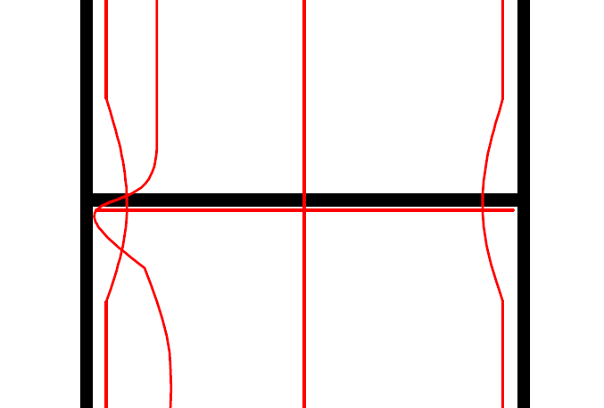

Figure : Cables attached to turbine, with close up of the circumferential cable at the flange

**Monitoring Plan**

Short Term Plan

The short-term testing program will consist of hammer tests under different bolt configurations (loosening up to 10% torque) NEEDS TO BE CONFIRMED.

Short Term Plan

Loosen Bolts?

1. Bolts as is
   1. Hammer Test (WHAT ARE THE BEST LOCATIONS?)
   2. Nearby Vibration Generation
      1. Driving down the road (Drive around the wind turbine)
      2. Walking up the stairs?
   3. Monitoring data for 10 minutes during normal operation? (LONGER PERIOD?)
2. One Loose bolt, under one of the longitudinal cables
   1. Hammer Test
   2. Nearby Vibration Generation
      1. Driving down the road
      2. Walking up the stairs?
   3. Monitoring data for 10 minutes during normal operation?
3. One Loose bolt, between two longitudinal cables
   1. Hammer Test
   2. Nearby Vibration Generation
      1. Driving down the road
      2. Walking up the stairs?
   3. Monitoring data for 10 minutes during normal operation?

Make sure that signal loss isn’t severe in any of the load scenarios.

Questions: Is ALICIA even useful in this case? Doubtful that we’ll see anything useful, but if we stated that we are going to use 3 types of analyzers, we can still bring it. James Wang said it should be fixed by sometime next week.

Confirming with Ray for best datatype for DAS… Strange setting that they suggested. Need to confirm with them.

Date conflicts with Gilroy and Eureka tests, will have to be either week of June 5th or June 12th. Up to Eureka test date to determine which one is best.

Luna laptop is having issues, Linqing said he had issues with it before. Currently looking for a replacement, something to bring with us to Oklahoma. Analyzer itself is working fine.