Analysis

Introduction

Problem Identification

Stakeholders of the Project

Research

*“3.1.3 Research the problem*

*(a) Research the problem and solutions to similar problems to identify and justify suitable approaches to a solution.”*

My project is not the first of its nature and as such many systems that provide similar experiences are available. Many music streaming services make use of algorithms to help listeners broaden their listening tastes. By analysing the ways that different programs present their data and how they reach their recommendations I will be able to make the best of previous designs and make a very accessible and flexible program.

1 – Spotify:

One of the major programs that makes use of music recommendation algorithms. As a very popular music streaming platform it attempts to broaden user’s music listening activity. One of their features is an automatic playlist generation that will match the user’s genre tastes, the “Daily Mix” playlists are auto generated and such are powered by a powerful algorithm that can find songs that may not be related by artist but have a similar sound. They also provide a “Discover Weekly” playlist which as the name suggests is generated weekly. These suggest songs by artists that the user hasn’t listened to before, based on artists that they do listen to regularly.

Platform:

Spotify has been developed for a large range of different platforms due to its large user base. It has applications on the Google Play Store, Apple App Store and Microsoft Windows Store, on top of this it has a web player and applications for Windows, Mac OS, Linux and Chromebooks.

Price and Versions:

All of these applications are free to download and use, but Spotify offer a Premium subscription based service as well which costs £9.99/month. On top of the basic streaming functionality Premium allows users to listen un-interrupted by advertisements and skip an unlimited number of songs. The basic version of Spotify allows users to stream their music at 96kbps on mobile devices and 160kbps on desktop programs, this is upgraded by the premium version allowing users to stream at 320kbps.

These versions do not impact the recommendations the user gets, both versions have access to the personalised playlists.

Spotify have a very advanced method of recommendation that takes into account multiple different ways of matching songs and then converge these into a verdict on whether or not the user will like them.

Sources:

<https://medium.com/s/story/spotifys-discover-weekly-how-machine-learning-finds-your-new-music-19a41ab76efe>

<https://support.spotify.com/is/using_spotify/the_basics/what-is-spotify/>

2 – Gnoosic:

Gnoosic is web-based algorithm that takes in 3 artists from the user and recommends a different artist which the user can either select 'like', 'dislike' or 'Don't know'.

In comparison to Spotify it does not have as many features due to it being a simple recommendation site and not having the streaming functionality.

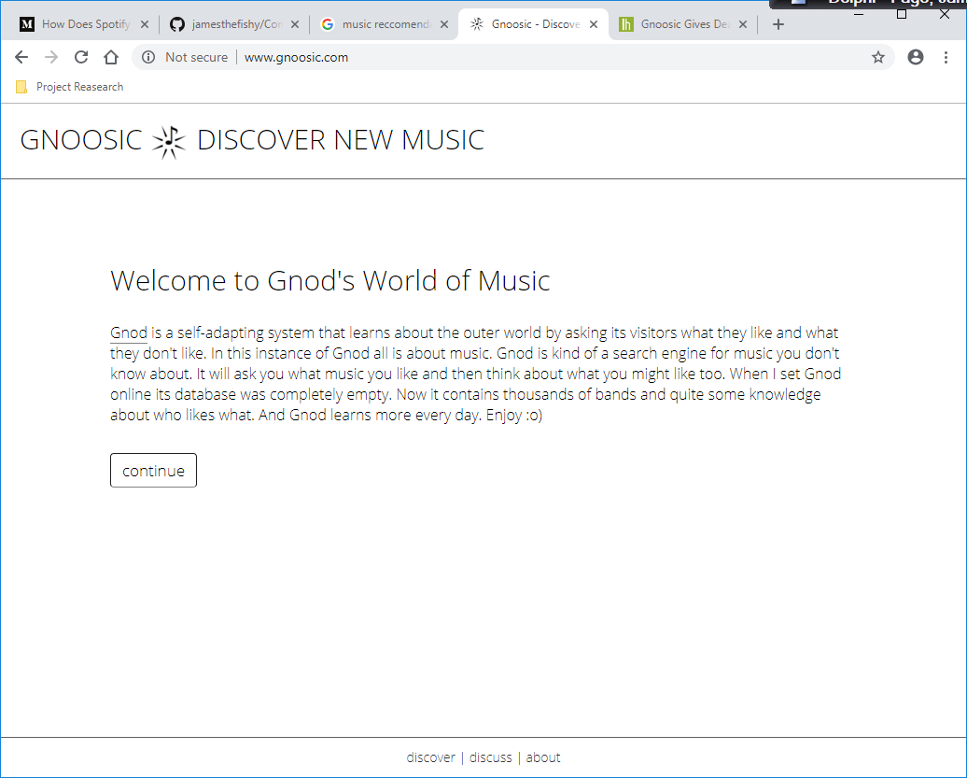

Platform:

Gnoosic is part of a collection of recommendation algorithms called The Global Network of Discovery, all of these services are web-based so available on all web connected devices.

Price and Versions:

As it’s a web-based program, and anyone can access it online, it is completely free for anyone to use.

It only has one version but as part of the Gnod group of programs there is a connected website called music-map which shows how the recommendations are linked.

User interface:

Gnoosic uses a simple white form user interface that allows the user to enter 3 artist choices and then shows you the name of a different artist that is linked to a the 3 entered by the user.

Sources: <http://www.gnoosic.com/about>

*https://www.music-map.com*

3 – TasteDive:

Proposed Solution