

Practices for Secure Software Report

Table of Contents
Document Revision History 3
Client 3
Instructions 3
Developer 4
1. Algorithm Cipher 4
2. Certificate Generation 4
3. Deploy Cipher 4
4. Secure Communications 4
5. Secondary Testing 4
6. Functional Testing 4
7. Summary 4
8. Industry Standard Best Practices 4

Document Revision History

Version | Date | Author | Comments
1.0 | April 26, 2026 | James Page

Client



Instructions

Submit this completed practices for secure software report. Replace the bracketed text with the relevant information. You must document your process for writing secure communications and refactoring code that complies with software security testing protocols.

- Respond to the steps outlined below and include your findings.
- Respond using your own words. You may also choose to include images or supporting materials. If you include them, make certain to insert them in all the relevant locations in the document.
- Refer to the Project Two Guidelines and Rubric for more detailed instructions about each section of the template.

Developer
James Page

Algorithm Cipher

For this project, the selected cryptographic method is SHA-256, which belongs to the SHA-2 family standardized by the National Institute of Standards and Technology (NIST). SHA-256 is a hashing algorithm that transforms input data of any size into a fixed 256-bit output. This makes it ideal for verifying data integrity rather than encrypting data.
The algorithm is considered secure because of its resistance to collisions and preimage attacks. With an output space of 2²⁵⁶ possible values, it is computationally impractical to reverse a hash or generate two different inputs that produce the same output. SHA-256 processes data in 512-bit blocks and applies multiple rounds of bitwise operations, including shifts and logical functions.
Unlike encryption algorithms, SHA-256 does not use keys and is deterministic, meaning the same input always produces the same output. In contrast, secure communication within this application is handled using asymmetric cryptography. Specifically, an RSA 2048-bit key pair is used as part of TLS encryption. The private key is stored securely in a keystore, while the public key is shared through a certificate.
Although newer algorithms such as SHA-3 exist, SHA-256 continues to be widely used due to its efficiency, hardware support, and compatibility with modern systems. It remains recommended by NIST and is commonly required for regulatory compliance.

Certificate Generation
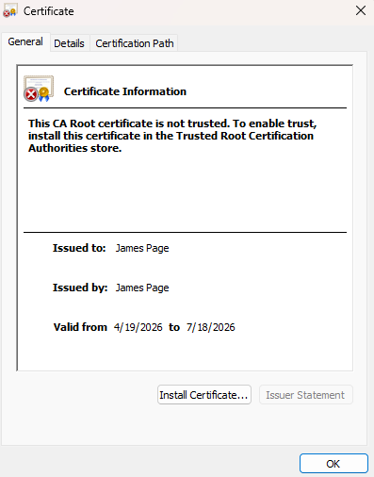
Insert a screenshot below of the CER file.

Deploy Cipher
Insert a screenshot below of the checksum verification.

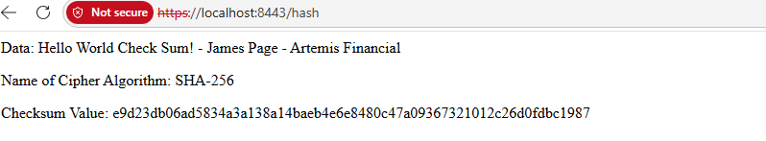

Secure Communications
Insert a screenshot below of the web browser that shows a secure webpage.



Secondary Testing
Insert screenshots below of the refactored code executed without errors and the dependency-check report.

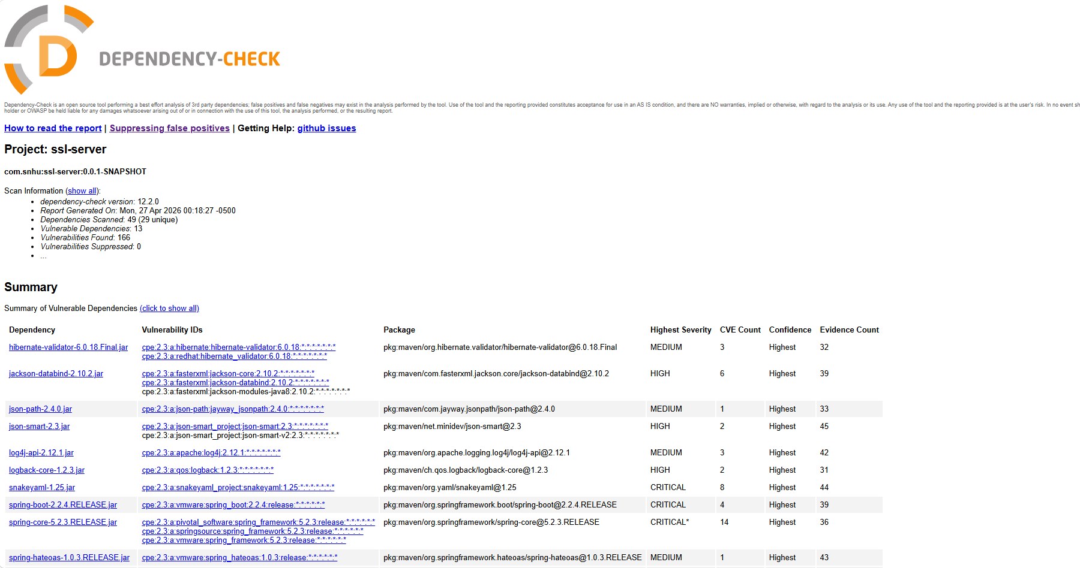

Functional Testing
Insert a screenshot below of the refactored code executed without errors.
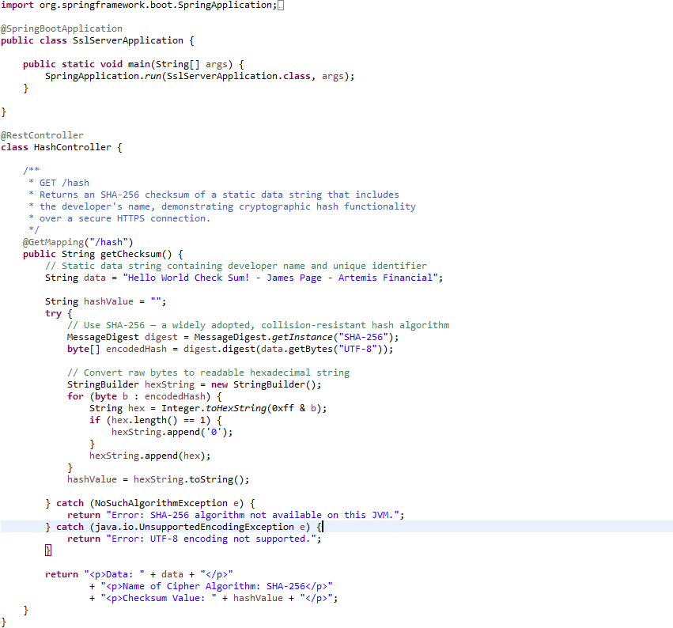

Summary

The updates made to the Artemis Financial application significantly improved its overall security. One of the key enhancements was the implementation of SHA-256 hashing, which ensures data integrity by generating a unique fingerprint for transmitted data. Any modification to the data would result in a different hash value, making tampering easy to detect.
Another important improvement was the transition from HTTP to HTTPS. By enabling TLS with an RSA 2048-bit key pair, all communication between the client and server is encrypted. This protects sensitive data from interception and unauthorized access.
The refactored code also follows secure development practices. Exceptions are handled properly, sensitive data exposure is minimized, and responsibilities are separated into appropriate classes. These improvements reduce the likelihood of vulnerabilities and improve maintainability.
Additionally, running a dependency-check scan ensured that no new security risks were introduced. Limiting the use of external libraries also helps reduce the overall attack surface of the application.

Industry Standard Best Practices

The changes made to the application align with recognized industry standards for secure software development. The approach focused on adding only necessary security features while preserving existing functionality. This reflects guidance from organizations such as OWASP, which emphasize minimizing attack surface and avoiding unnecessary complexity.
Implementing HTTPS ensures confidentiality and authentication, while SHA-256 provides data integrity. Together, these measures protect sensitive financial information and reduce the risk of attacks such as man-in-the-middle interception.
From a business standpoint, these practices support compliance with regulations such as PCI-DSS and the Gramm-Leach-Bliley Act, both of which require protection of financial data. Additionally, visible indicators like HTTPS increase user trust and confidence in the system.
Using well-established cryptographic standards ensures long-term reliability and reduces the need for future redesigns due to outdated security methods.

References

National Institute of Standards and Technology. (2015). Secure Hash Standard (FIPS PUB 180-4). https://nvlpubs.nist.gov/nistpubs/FIPS/NIST.FIPS.180-4.pdf
National Institute of Standards and Technology. (2013). Digital Signature Standard (FIPS 186-4).
OWASP Foundation. (n.d.). Secure Coding Practices Quick Reference Guide. https://owasp.org/www-project-secure-coding-practices-quick-reference-guide/
OWASP Foundation. (n.d.). Transport Layer Protection Cheat Sheet. https://cheatsheetseries.owasp.org/
PCI Security Standards Council. (n.d.). PCI DSS Quick Guide.
Rescorla, E. (2018). The Transport Layer Security (TLS) Protocol Version 1.3 (RFC 8446).

