Background
This document contains the assignments to be completed as part of the hands on for the subject CSS (Cascading Style Sheet). These tutorials assume a working knowledge of HTML.

Assignments for CSS
All the assignments in this section must be completed.

Assignment 1: Understanding CSS

Objective: To understand the usage of CSS and provide cascading style for your HTML documents.

Background: You have learned how to create HTML documents. Style Sheets is a breakthrough in Web design because it allows developers to control the style and layout of multiple Web pages all at once.

Note: CSS1 Accepted by the W3C Consortium in 1996
In 1998, CSS2 was introduced to add more power to CSS.
However, no browsers support all of the CSS2 features; although, many support parts of it. Internet Explorer 6, Netscape 6, and Opera 6 have almost full support of CSS2.

Step 1: Type the following code and save it as css1.html.
<html>
<body>
<!-- Comment: Using Inline Style -->
<h2 style=”color:red”> This is my first HTML page with CSS</h2>
</body>
</html>

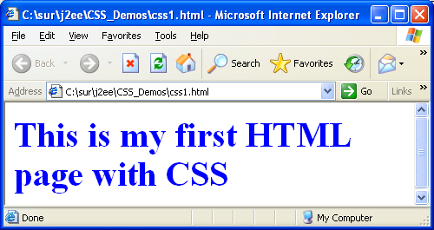
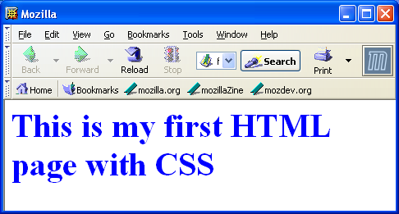

Step 2: In the above example replace the <h2> tag with the following code and save the file as css2.html

<h2 style="color:blue; font-size:10pt;"> This is my first HTML page with CSS</h2>

Step 3: Save the file as css3.html and change the color of the font to green and size of the font to 50 pt;

Step 4: Using style Tag, save the file as css4.html

<html><head>
<!-- Comment: <style> tag is used to define styles -->
<style>
h2{
color:red;
font-size:30pt;
}
</style><head>
<body>
<h2> This is my first HTML page with CSS</h2>
</body>
</html>

Summary of this exercise:
You have just learnt
- Using inline style sheet.

Deliverables of the exercise:

1) css1.html
2) css2.html
3) css3.html
4) css4.html

Assignment 2: CSS syntax

Objective: To understand the CSS syntax and different kind of selectors.

Note: CSS syntax has two components, the selector and the style declaration. The selector specifies what the style rule is acting upon. A selector can be one of two things. It can be an HTML element name or it can be an attribute reference.

Step 1: Type the following code and save it as “csselement.html”.

<html><head>
<style>
h1{
color: red;
font-size:30pt;
}
</style><head>
<body>
<h1> First H1 Tag</h1>
<h1> Second H1 Tag</h1>
</body>
</html>

Step 2: In the above code add <h2> tag and <h3> tag. Provide necessary style using element selector.

Note: HTML has an attribute called the class attribute. It is specifically for use with style sheets. Classes allow you to assign style rules only to selected elements that have the correct class attribute value in their tag.

Step 3: Type the following code and save the file as “class1.html”

<html><head>
<style>
h1{
color:red;
font-size:30pt;
}
h1.c
{
color:blue;
}
</style><head>
<body>
<h1> First H1 Tag</h1>
<h1 class="c"> Second H1 Tag</h1>
</body></html>

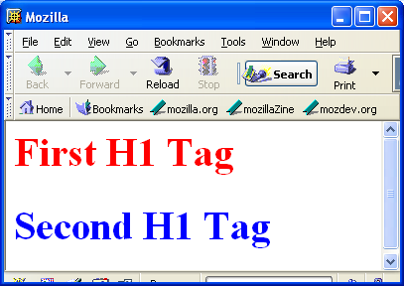

Step 4: In the above example add the following line and save it as “class2.html”. Check the output.
<h2 class="c"> new h2 Tag with class</h2>

Note: The regular classes takes the form of elementName.classValue { ... }.
Generic classes work on any tag that has that class applied to it and takes the form
.className { ... }

Step 6: Type the following code and save the file as “class3.html”.

<html><head>
<style>
h1{
color:red;
font-size:30pt;
}
.c
{
color:blue;
}
</style><head>
<body>
<h1> First H1 Tag</h1>
<h1 class="c"> Second H1 Tag</h1>
<h2 class="c"> Second H1 Tag</h2>
</body>
</html>

Note: You can also use ID's as classes. Since an ID must be unique to a document, this means that the corresponding style rules can only apply to a single instance of a single element within a document. The id selector normally use with DHTML to dynamically change styling within a document.

Step 7: Type the following code and save it as “cssid.html”.
<html>
<head>
<style>
font{
color:blue;
font-size:20pt;
}
#f {
color:red;
}
</style>
<head>
<body>
<font> first font tag</font><br>
<font id="f"> second font tag with ID selector</font>
</body>
</html>

Summary of this exercise:
You have just learnt
CSS syntax.
Element selectors.
Class selectors
ID selectors.

Deliverables of the excercise:
- csselement.html
- class1.html
- class2.html
- class3.html
- cssid.html

Assignment 3: Some more selectors.

Objective: To understand different kind of selectors like Inheritance, Contextual Selectors,
Grouping and pseudo selectors.

Note: Style properties are inherited from the parent element to the child element.

Step 1: Type the following code and save it as “cssinher.html”.

<html><head>
<style>
body{
color: red;
}
h1
{
font-size:10pt;
}
</style><head>
<body>
<h1> Heading</h1>
Some text
</body>
</html>

Step 2: Type the following code and save the file as “csscon.html”

<html><head>
<style>
p font{
color:red;
}
</style><head>
<body>
<p> Para <font> Inside font</font></p>
<font>Outside Para</font>
</body>
</html>

Note: The above style rule enforce that the text inside the <font> tag which is inside <p> tag will display in red color.

Step 3: Type the following code and save the file as “cssgroup.html”.

<html><head>
<style>
p,font,h1{
color:red;
}
h1
{
font-size: 10pt;
}
</style><head>
<body>
<h1> Hello H1</h1>
<font> Hello Font</font>
<p> Hello P</p>
</body>
</html>
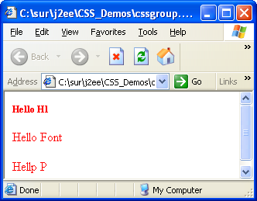

Note: The above style rule enforce that all the group element would display in same style.

Step 4: modify the above program and use class selectors instead of group selector and save as “cssclassnew.html”.

Note: Pseudo-classes are special "classes" that are automatically recognized by CSS-supporting browsers. Pseudo-classes can be assigned to the A element to display links, visited links and active links differently. The pseudo classes are
A:link -- link
A:active -- active link
A:visited -- visited link
A:hover -- Mouse Over

Step 5: Type the following code and save it as “csspsedo.html”.

<html>
<head>
<style>
a:link
{
color:blue;
}
a:visited
{
color:red;
}
</style>
<head>
<body>
<h2> Go to sparsh <h2><a href="http://sparsh">Sparsh</a>
</body>
</html>

Step 6: In the above program include the following code inside the <style> tag.

a:hover
{
color:green;
}

Step 7: Open the page in browser and move mouse over the link and verify the output.

Step 8: In “psedo.html” add style for a:active pseudo class.

Summary of this exercise:
You have just learnt
Inheritance selector.
Contextual selector.
pseudo selector.
Group selector.

Deliverables of the excercise:
- cssinher.html
- csscon.html
- cssgroup.html
- csspsedo.html

Assignment 4: External Style sheet, <DIV> and <SPAN>

Objective: To understand the advantage of External style sheet and usage of <DIV> and <SPAN> tag.

Note: An external style sheet is ideal when the style is applied to many pages. The external style sheet file extension should be “.css”.

Step 1: Type the following code and save it as “ext.css”.

/* Comments: do not use <style> tag here */
h1
{
color:red;
}
h2
{
color:blue;
}

Step 2: Type the following code and save is as “extcss.html”. ( css file and html files should be inside the same folder).

<html><head>
<link rel="stylesheet" type="text/css" href="ext.css">
<head>
<body>
<h1> style from external css</h1>
<h2> style from external css</h2>
</body>
</html>

Note: The <link> element provides a way to define the relationship between linked objects. The <link> element allows a style sheet for a document to be referenced from a separate file.

Note: DIV was introduce as a generic block level element who's original purpose was to serve as a container(block) for the logical 'parts' or divisions of a document. The Span tag is a generic inline container element. If you want to group text without using a block element, use the <span> element.

Step 3: Type the following code and save it as “cssdiv.html”.

<html>
<head>
<style>
div{
color:blue;
}
</style>
<head>
<body>
<div>
<h1>Division heading </h1>
<p>many paragraphs and block elements</p>
<p>Notice that color is blue</p>

<div>
</body>
</html>

Step 3: Modify the above program, include a <font> tag with some text inside the <div> tag. Save the file as “cssdiv1.html”.

Step 4: Type the following code and save the file as “cssspan.html”.

<html>
<head>
<style>
span.imp
{
color:blue;
}
</style>
<head>
<body>
<p> In this sentence <span class="imp">Some of the text is important</span></p>
</body>
</html>

Summary of this exercise:
You have just learnt
External style sheet.
Usage of <div>
Usage of <span>
Deliverables of the excercise:
- ext.css
- extcss.html
- cssdiv.html
- csspspan.html

Assignment 5: Using text, font, box and position properties

Objective: To understand the usage of defining font in text and appearance of the text. Defining box properties and

Step 1: Type the following code and save it as “cssfont1.html”.

<html>
<head>
<style>
h2
{
font-style:italic;
font-size:28pt;
color:cyan;

}
</style>
<head>
<body>
<h2> Using Font Style</h2>
</body>
</html>

Step 2: Modify the above code and provide the font family as “Courier New”.
Hint: use font-family property.

Step 3: Type the following code and save it as “csstext.html”.

<html>
<head>
<style>
h2
{
letter-spacing:4pt;
font-size:40pt;
color:blue;
text-align:center;
}
</style>
<head>
<body>
<h2>Wipro Technologies<sup>&reg;</sup> Bangalore</h2>
</body>
</html>

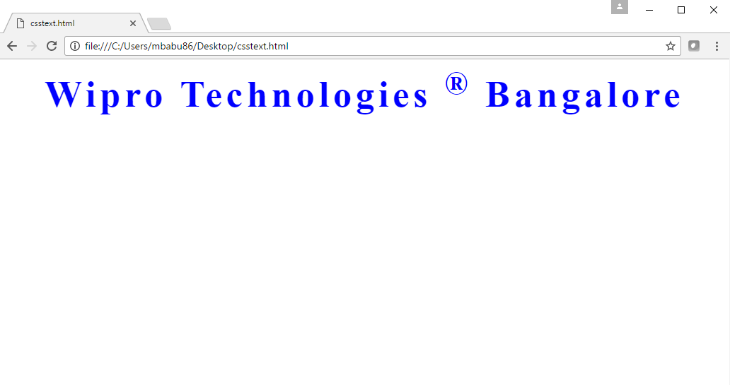

Step 4: Modify the above program and display the text with underline.
Hint: Use text-decoration property.

Step 5: Type the following code and save it as “cssborder.html”.

<html>
<head>
<style>
h2
{

text-align:center;
color:blue;
border-width:thick;
border-color:green;
Border-style:solid;
}
</style>
<head>
<body>
<h2>Wipro<sup>&reg;</sup> Mysore</h2>
</body>
</html>

Note: The border property is shorthand for setting the border-width, border-style, and border-color of an element's border.

Step 5: Modify the above program with the following code and save it as “cssborder1.html”.
<style>
h2
{
text-align : center;
color : blue;
border : thick dotted red;
}
</style>

Step 6: Type the following code and save the file as “csspos.html”.

<html>
<head>
<style>
h2
{
letter-spacing:4pt;
font-size:40pt;
color:blue;
text-align:center;
position: absolute;
top:0px;
}
h3
{
letter-spacing:4pt;
font-size:40pt;
color:blue;
text-align:center;
position: absolute;
top:20px;
left:20px;
}
</style>
<head>
<body>
<h2>Wipro Technologies <sup>&reg;</sup> Bangalore</h2>
<h3>Wipro Technologies <sup>&reg;</sup> Bangalore </h3>
</body>
</html>

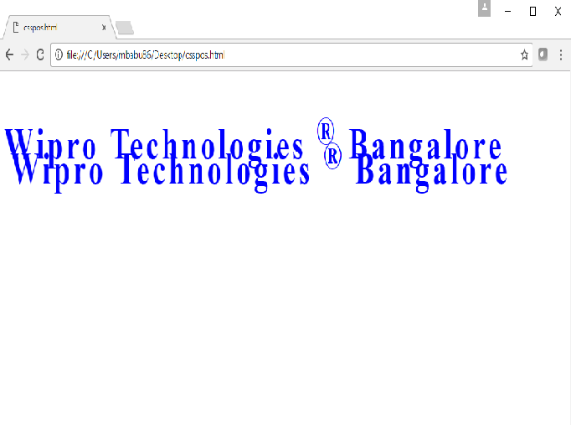
Step 6: Modify the above code, display a border around the text and save the file as “cssposborder.html”.

Step 7: Type the following code and save it as “cssabove.html”.

<html>
<head>
<style>
h2
{
position:absolute;
Z-index:1;
color:red;
}
img
{
position:relative;
top:-50px;
}
</style>
<head>
<body>
<h2>Wipro Technologies <sup>&reg;</sup> Bangalore</h2>
<img src="Wipro.jpg" width="200" height="150">
</body>
</html>

Step 8: Modify the above program and set the Z-index value as “-1”.

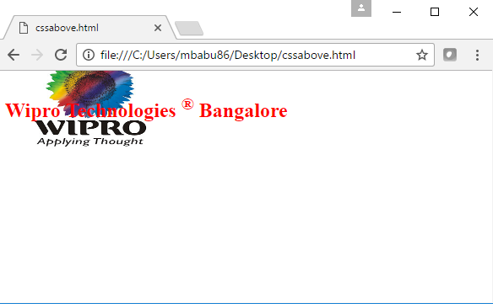
Summary of this exercise:
You have just learnt
Text properties.
Font properties.
Border properties.
Position properties.

Deliverables of the exercise:
- cssfont1.html
- csstext.html
- cssborder.html
- cssborder1.html
- csspos.html
- cssabove.html

Assignment 6: Applying styles to Tables and Form Elements

Objective: To understand the usage of CSS with tables and form elements.

Note: It’s possible to change the default look of a table and form elements by styling their html tags:

Step 1: Type the following code and save it as “csstab1.html”.

<html>
<head>
<style>
th{
color:red;
font-size:20pt;
background-color:cyan; }
td{
color:blue;
font-size:16pt; }
tr.even{
background-color:yellow;}
tr.odd{
background-color:#00f000;}
</style>
<head>
<body>
<table width="70%" border=2>
<tr><th>Name</th><th>Age</th></tr>
<tr class="even"><td>Magesh</td><td>39</td></tr>
<tr class="odd"><td>Bhoj</td><td>39</td></tr>
<tr class="even"><td>Savitha</td><td>39</td></tr>
<tr class="odd"><td>Vijayendra</td><td>39</td></tr>
</table>
</body>
</html>

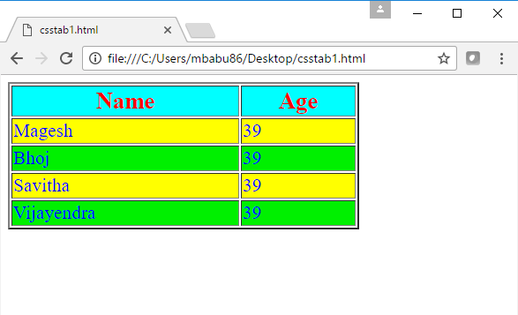
Step 2: Modify the above table include a column called “Qualification” and save the file as “csstab2.html”.

Step 3: Type the following code and save the file as “cssform1.html”.

<html>
<head>
<style>
input{
color:blue;
letter-spacing:3pt;
font-size:14pt; }
form{
border: thick solid blue; }
</style>
<head>
<body>
<form>
Name <input type="text" value="style"><br>
<input type="submit">
</form>
</body>
</html>

Step 4: create the following html file and save it as “cssform2.html”.

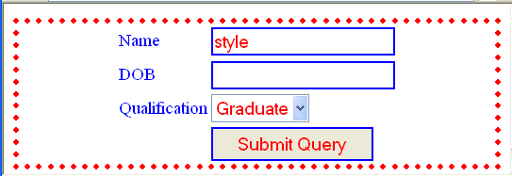

Summary of this exercise:
You have just learnt
Applying styles to <table>, <tr> and <td> tag.
Applying styles to <form>, <input> and <select> tag.

Deliverables of the exercise:
- csstab1.html
- csstab2.html
- csstab3.html

