**Supplementary materials.**

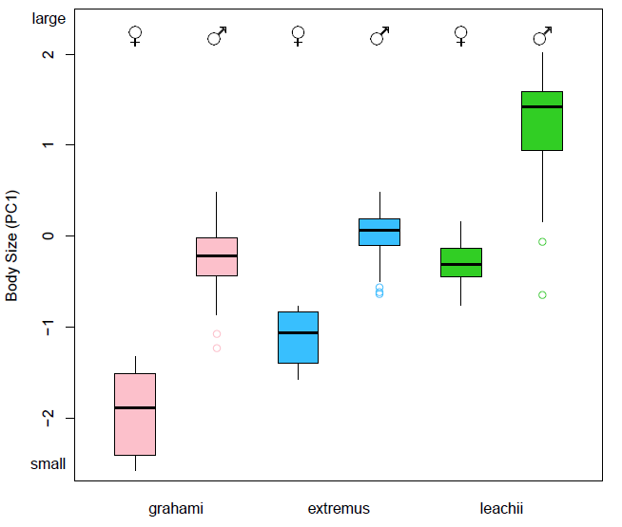

**Figure S1**. Body size differences of the introduced anoles of Bermuda; *Anolis grahami* (left), *A. extremus* (center), *A. leachii* (right). Body size is represented by PC1 of a principal components analysis of 10 size-related morphological traits that explained 96.7% of variation between species, with factor loadings ranging from 22% for snout-vent length to 71.1% for mass. Bold lines represent median values, error bars are 95% C.I.

**Table S1**. Structural habitat selection (perch use height and diameter) of all non-native Bermuda *Anolis* lizards. Microhabitat use (mean +/- 1 S.E.) by four introduced *Anolis* species on Bermuda. Communities are: GL = *A. grahami/A. leachii*, GE = *A. grahami/A. extremus*, GEL = *A. grahami/A. leachii/A. extremus*. Community level means are combined for sexes and replicate sites. Sample sizes are sometimes lower for perch diameter.

|  |  |  |  |  |  |  |  |  |
| --- | --- | --- | --- | --- | --- | --- | --- | --- |
| Community | No. sites | Species | Perch height (m) | Std Err | N | Perch diameter (cm) | Std Err | N |
| GL | 4 | *A. grahami* | 1.37 | 0.12 | 128 | 9.76 | 0.89 | 121 |
| GL | 4 | *A. leachii* | 1.53 | 0.12 | 170 | 13.76 | 1.12 | 151 |
| GE | 3 | *A. grahami* | 1.11 | 0.10 | 114 | 6.74 | 0.71 | 89 |
| GE | 3 | *A. extremus* | 1.56 | 0.24 | 42 | 12.38 | 2.01 | 38 |
| GEL | 3 | *A. grahami* | 1.58 | 0.14 | 132 | 9.78 | 0.90 | 108 |
| GEL | 3 | *A. leachii* | 1.93 | 0.33 | 34 | 11.86 | 2.03 | 34 |
| GEL | 3 | *A. extremus* | 1.51 | 0.14 | 110 | 13.99 | 1.40 | 100 |
| All combined | | *A. grahami* | 1.37 | 0.02 | 374 | 8.74 | 0.49 | 318 |
| All combined | | *A. leachii* | 1.60 | 0.11 | 204 | 13.41 | 0.99 | 185 |
| All combined | | *A. extremus* | 1.52 | 0.12 | 152 | 13.55 | 1.15 | 138 |

**Table S2**. Interspecific pairwise comparisons of three ecological axes for all coexisting species; (i) prey item size, (ii) perch height, and (iii) perch diameter. In each community, each pair of species uses a significantly different part of the resource spectrum for at least one ecological variable (significant values highlighted in bold).

|  |  |  |  |  |  |  |  |  |  |
| --- | --- | --- | --- | --- | --- | --- | --- | --- | --- |
| ***Community organization*** | | |  | Prey item size | | Perch height | | Perch diameter | |
| Species 1 | Community | Species 2 | Community | W | p value | F | p value | F | p value |
| *A. grahami* | GL | *A. leachii* | GL | 28 | 0.062 | 0.494 | 0.483 | 15.97 | **<0.001** |
| *A. grahami* | GE | *A. extremus* | GE | 42 | 0.162 | 3.606 | **0.029** | 8.832 | **<0.001** |
| *A. grahami* | GEL | *A. leachii* | GEL | 80 | 0.350 | 5.989 | **0.016** | 7.094 | **0.009** |
| *A. leachii* | GEL | *A. extremus* | GEL | 92 | 0.276 | 5.589 | **0.019** | 0.272 | 0.603 |
| *A. grahami* | GEL | *A. extremus* | GEL | 39 | 0.815 | 1.635 | 0.202 | 16.912 | **<0.001** |

**Table S3**. Body size (snout-vent length [mm] and mass [g]) comparisons of anoles on Bermuda.

|  |  |  |  |  |  |  |  |
| --- | --- | --- | --- | --- | --- | --- | --- |
| Species | *N* | Snout-vent length (mm) |  | Std Dev | Mass (g) |  | Std Dev |
| *A. extremus* | **48** | 71.28 | ± | 6.26 | 8.30 | ± | 2.22 |
| male | 44 | 72.65 | ± | 4.30 | 8.70 | ± | 1.82 |
| female | 4 | 56.28 | ± | 4.54 | 3.85 | ± | 1.00 |
| *A. grahami* | **196** | 64.04 | ± | 8.16 | 6.88 | ± | 2.62 |
| male | 169 | 66.51 | ± | 5.50 | 7.55 | ± | 2.15 |
| female | 51 | 48.56 | ± | 3.88 | 2.71 | ± | 0.68 |
| *A. leachii* | **67** | 87.01 | ± | 14.55 | 18.75 | ± | 8.88 |
| male | 51 | 93.14 | ± | 10.70 | 22.06 | ± | 7.47 |
| female | 17 | 67.49 | ± | 4.00 | 8.18 | ± | 2.07 |