James Murphree and Vu Dinh

Lab 4 timing analysis



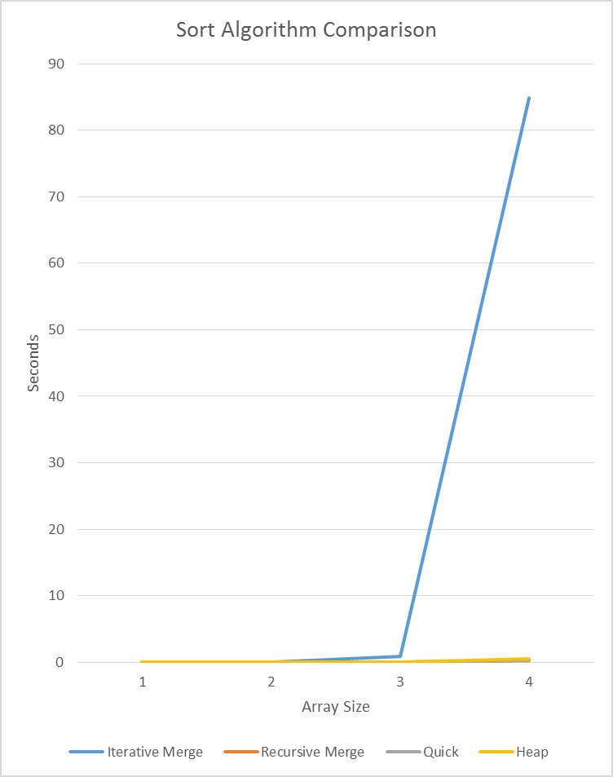

The recursive merge, quick and heap sorts all performed very well increasing at approximately the optimal N\*log(N) as the size of the array increased. The Iterative merge sort on the other hand had an exponential grows. The benefit of iterative merge sort is that it does not require a lot of memory to run, so if you are constrained by memory but not time it is the preferred method.