|  |  |  |  |  |
| --- | --- | --- | --- | --- |
| James Murphree Vu Dinh |  | Feb 23 2014 |  |  |

CSS 342 - Lab 4 Performance Report

Comparing running times of different sorting algorithms

# Analysis and Rationale

Figure 1: Performance timings for different types of sorting algorithms.

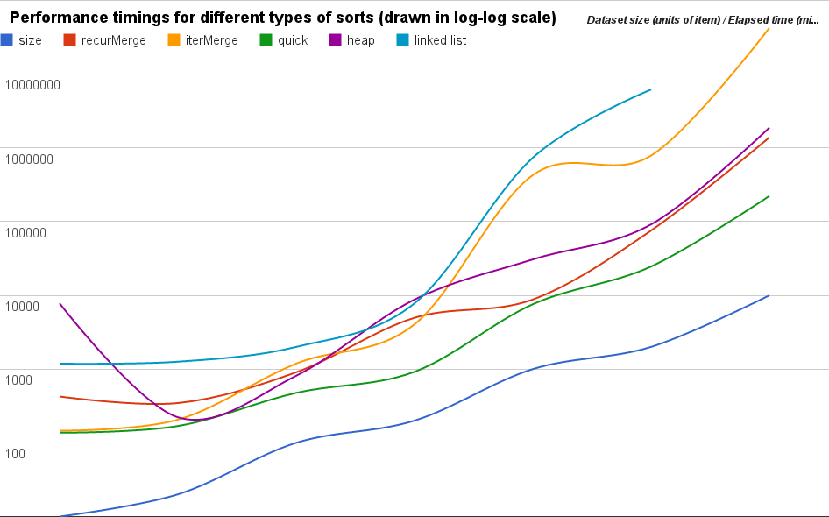

Performance data sheet for sizes 10, 20, 100, 200, 1000, 2000, and 10000, 100000, and 1000000; 34 iterations each size.

**Results**: All sorts (except for linked list merge) perform roughly similarly when optimized, i.e. use bubble with size = 10 for merges. Without bubble-sort optimization, both merge sorts fall far behind in-place quick sort.

Iterative Merge Sort performs the poorest in all testing cases, surprisingly.

**Analysis:** The log-log scale representation of the data shows a few things worthy of notice:

* The slopes of the lines indicate the exponents of the polynomial growth.
* The vertical shifts indicate a multiplicative constant

As expected, all sort functions have larger constants than the problem size itself (all lines are above the blue line). Also expectedly, they all have roughly the same average slope as the problem size, indicating a growth of nearly O(n), i.e. O(nlogn).

Interestingly, iterative merge sort performs more poorly than its recursive counterpart, the **opposite** of which is what this assignment is supposed to **prove**.

Additionally, Linked List Merge Sort does not perform as well as expected. In fact, it could not handle 34 repetitions of problem size 10,000 in reasonable amounts of time.

Other than that, the results are as expected:

* **In-place Quick Sort** **with Random pivot choice** performs the best
* **Heap Sort** is among the poorest performers due to its overhead in maintaining the heap structure
* **Recursive Merge Sort** performs worse than Quick Sort does

We suspect that Iterative Merge Sort’s poor performance, despite what we believe to be a **proper implementation** of it, is due to the fact that the 34 iterations don’t all get new, unsorted data.

# Raw Data

|  |  |  |  |  |  |
| --- | --- | --- | --- | --- | --- |
| size | recurMerge | iterMerge | quick | heap | linked list |
| 10 | 425 | 146 | 137 | 7790 | 1184 |
| 20 | 346 | 206 | 169 | 222 | 1260 |
| 100 | 905 | 1188 | 476 | 812 | 1999 |
| 200 | 4965 | 4048 | 919 | 8769 | 7791 |
| 1000 | 8784 | 427890 | 7572 | 30701 | 735867 |
| 2000 | 75729 | 786920 | 24627 | 91591 | 6182878 |
| 10000 | 1389611 | 42598345 | 222713 | 1883541 | N/A |

Another test:

|  |  |  |  |  |  |  |  |  |
| --- | --- | --- | --- | --- | --- | --- | --- | --- |
| Size |  | 100 | 1514 | 2928 | 4342 | 5756 | 7170 | 8584 |
| Recursive MergeSort |  | 780 | 94641 | 91613 | 286016 | 1492838 | 286493 | 1414562 |
| Optimized Recursive Merge Sort |  | 359 | 9460 | 102446 | 102378 | 1177978 | 211510 | 179775 |
| Iterative Merge Sort |  | 1083 | 93575 | 4482206 | 9895196 | 14914909 | 23184934 | 41410870 |
| Optimized Iterative Merge Sort |  | 300 | 115131 | 1370793 | 1828612 | 1505713 | 2208176 | 4712425 |
| Quick Sort |  | 365 | 10566 | 42120 | 105339 | 1183983 | 285893 | 1298280 |
| Heap Sort |  | 692 | 72837 | 121841 | 1309901 | 1447654 | 1502061 | 1723275 |
| LinkedList Merge Sort |  | 1176 | 123822 | 207129 | 2226831 | 2461011 | 2553504 | 2929567 |

Figure 2. Performance timings for different types of sorts in Linear-Log scale.

