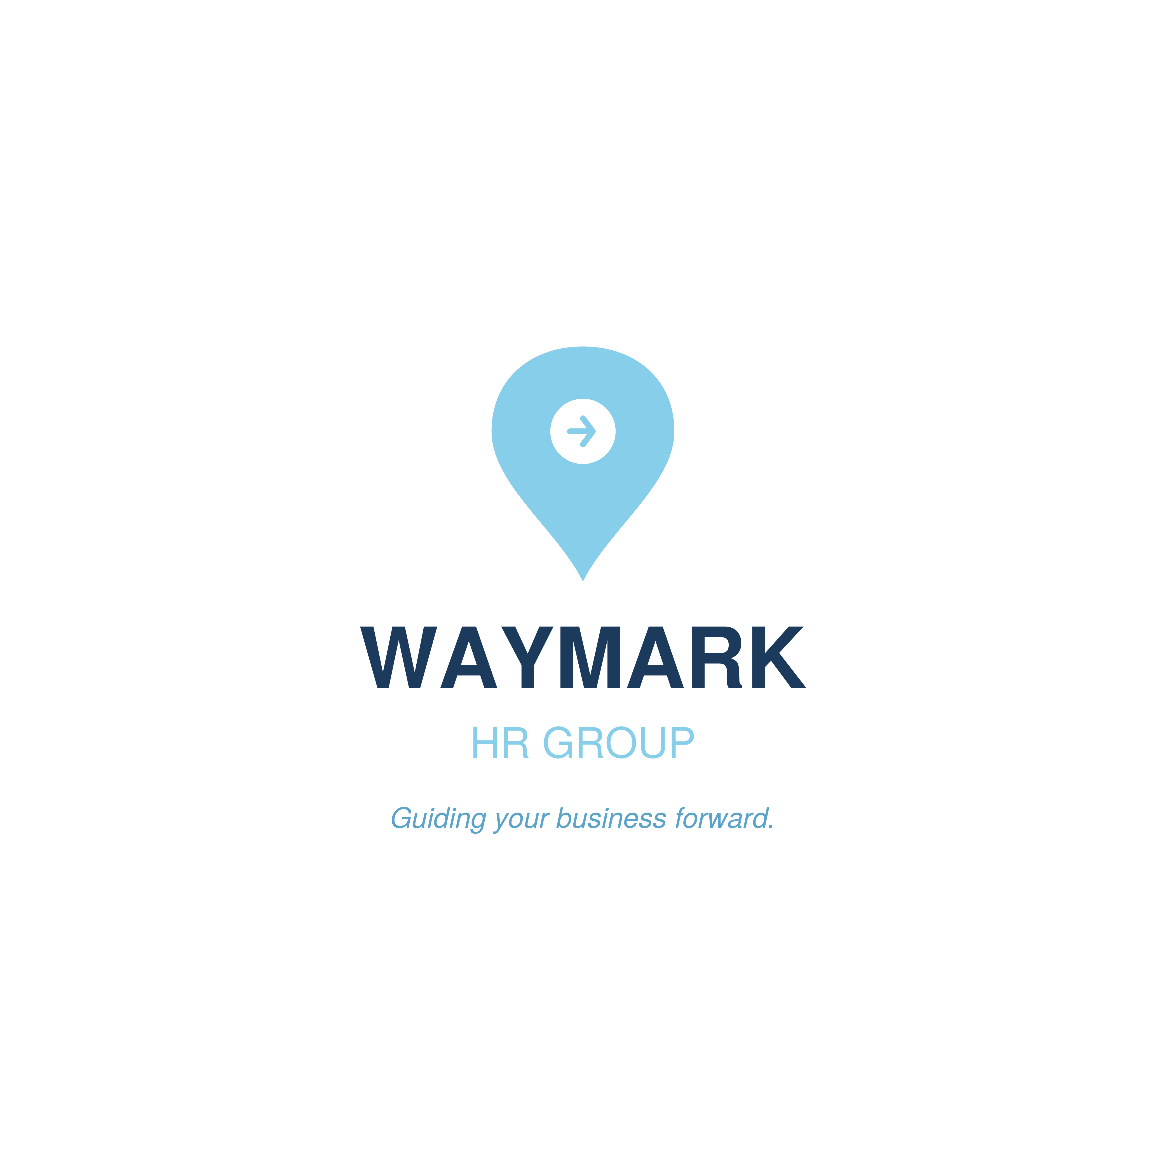
COMPREHENSIVE HR AUDIT & ADVISORY REPORT
Prepared for: Acme Logistics
Date Prepared: March 18, 2026 | Prepared by: Jamie Wahler

CONFIDENTIAL — This report has been prepared exclusively for the use of Acme Logistics by Waymark HR Group LLC. It may not be reproduced or distributed without prior written consent.

EXECUTIVE SUMMARY
Overview
Waymark HR Group LLC was engaged by Acme Logistics to perform a comprehensive HR audit spanning onboarding, policy infrastructure, workforce analytics, and overall HR operational effectiveness. This full-scope engagement provides Acme Logistics with a complete picture of its current HR posture and a clear roadmap for improvement.
Key Findings
- Onboarding processes lacked standardization, resulting in inconsistent new hire experiences.
- Critical HR policies were absent, outdated, or not formally acknowledged by employees.
- Voluntary turnover and compensation equity gaps present retention and compliance risks.
- HR operations are largely manual, with limited use of technology to scale processes.
- No formal HR metrics dashboard exists to support leadership decision-making.
Business Impact
This comprehensive HR audit provides Acme Logistics with a clear, prioritized roadmap to modernize its HR function. Addressing the findings identified in this report will meaningfully reduce legal and operational risk, improve employee experience, and position the organization for scalable, sustainable growth.

SERVICES DELIVERED
Deliverables Completed
- HR Operations Assessment: Conducted a full review of HR processes, systems, and documentation across all functional areas.
- Onboarding Program Redesign: Delivered a structured onboarding program with branded new hire welcome packages.
- HR Policy Handbook: Developed a comprehensive, compliant HR Policy Handbook covering 8 core policy areas.
- Workforce Analytics Review: Performed headcount, turnover, compensation, and engagement analyses.
- Compliance Risk Assessment: Identified policy and practice gaps posing potential legal or regulatory exposure.
- HR Roadmap Development: Produced a prioritized 90-day and long-term HR improvement roadmap.
Engagement Timeline
Phase | Activities
Week 1 | Full HR audit — discovery, data collection, document review
Week 2 | Onboarding program design and policy drafting
Week 3 | Workforce analytics, compensation review, and compliance assessment
Week 4 | Roadmap development, report preparation
Week 5 | Final review, delivery, and leadership presentation

Tools & Frameworks Used
- Waymark Onboarding Generator (Python)
- Waymark Policy Generator (Python)
- Workforce analytics toolkit
- HR audit framework

KEY RECOMMENDATIONS
The following five recommendations are prioritized based on potential business impact and implementation effort. Each is rated on a High / Medium / Low scale.
# | Recommendation | Impact | Effort | Type
1 | Standardize and Launch the New Onboarding Program  Roll out the newly designed onboarding program company-wide immediately to improve new hire retention from day one. | High | Low | Quick Win
2 | Distribute the HR Policy Handbook and Collect Acknowledgments  Issue the completed HR Policy Handbook to all employees and obtain signed acknowledgments within 30 days. | High | Low | Quick Win
3 | Remediate Compensation Equity Gaps  Address identified pay disparities in key job families to reduce legal risk and improve employee trust. | High | Medium | Short-Term
4 | Invest in an HRIS Platform  Implement a Human Resource Information System to centralize employee data, automate workflows, and enable reporting. | High | High | Long-Term Investment
5 | Build an HR Metrics & Reporting Function  Establish a regular HR reporting cadence with leadership using the defined KPI framework from this engagement. | Medium | Medium | Short-Term

NEXT STEPS & 30/60/90-DAY ACTION PLAN
Proposed Follow-On Services
Based on the findings and outcomes of this engagement, Waymark HR Group LLC recommends the following follow-on services to continue building Acme Logistics's HR capability:
- HRIS platform evaluation and implementation support
- Manager leadership development and HR training program
- Ongoing HR advisory retainer for continued compliance and strategy support
- Annual HR audit to track progress against this report's recommendations
30/60/90-Day Action Plan
30 Days
- Launch new onboarding program for all incoming hires
- Distribute HR Policy Handbook and collect employee acknowledgments
- Share audit findings with senior leadership
- Initiate compensation equity review with HR and Finance
60 Days
- Complete manager training on policies and onboarding program
- Begin HRIS platform evaluation process
- Implement quarterly headcount planning cadence
- Launch stay interview program with high-performer population
90 Days
- Finalize compensation remediation plan and begin implementation
- Select and initiate HRIS implementation project
- Launch HR metrics dashboard for leadership
- Present 90-day progress report against audit recommendations

CLOSING
Dear Acme Logistics Team,
On behalf of everyone at Waymark HR Group LLC, thank you for the opportunity to support your organization through this engagement. It has been a privilege to work alongside your team, and we are proud of the work we have accomplished together.
The deliverables contained in this report represent a meaningful investment in your people and your organization's future. We are confident that implementing the recommendations outlined here will strengthen your HR function, reduce risk, and create a better experience for your employees.
We remain committed to your success beyond this engagement. Whether you need support implementing these recommendations, have questions about the deliverables, or are ready to begin the next phase of your HR journey, our team is here to help.
Please do not hesitate to reach out at any time. We look forward to continuing to be a trusted partner for your organization.
Warm regards,
Jamie Wahler
Waymark HR Group LLC

Phone: 716-225-6347
Email: Jamie.Wahler@waymarkhrgroup.com
Website: www.waymarkhrgroup.com
Address: Buffalo, NY

This report is confidential and intended solely for the use of the named client. © 2026 Waymark HR Group LLC. All rights reserved.

