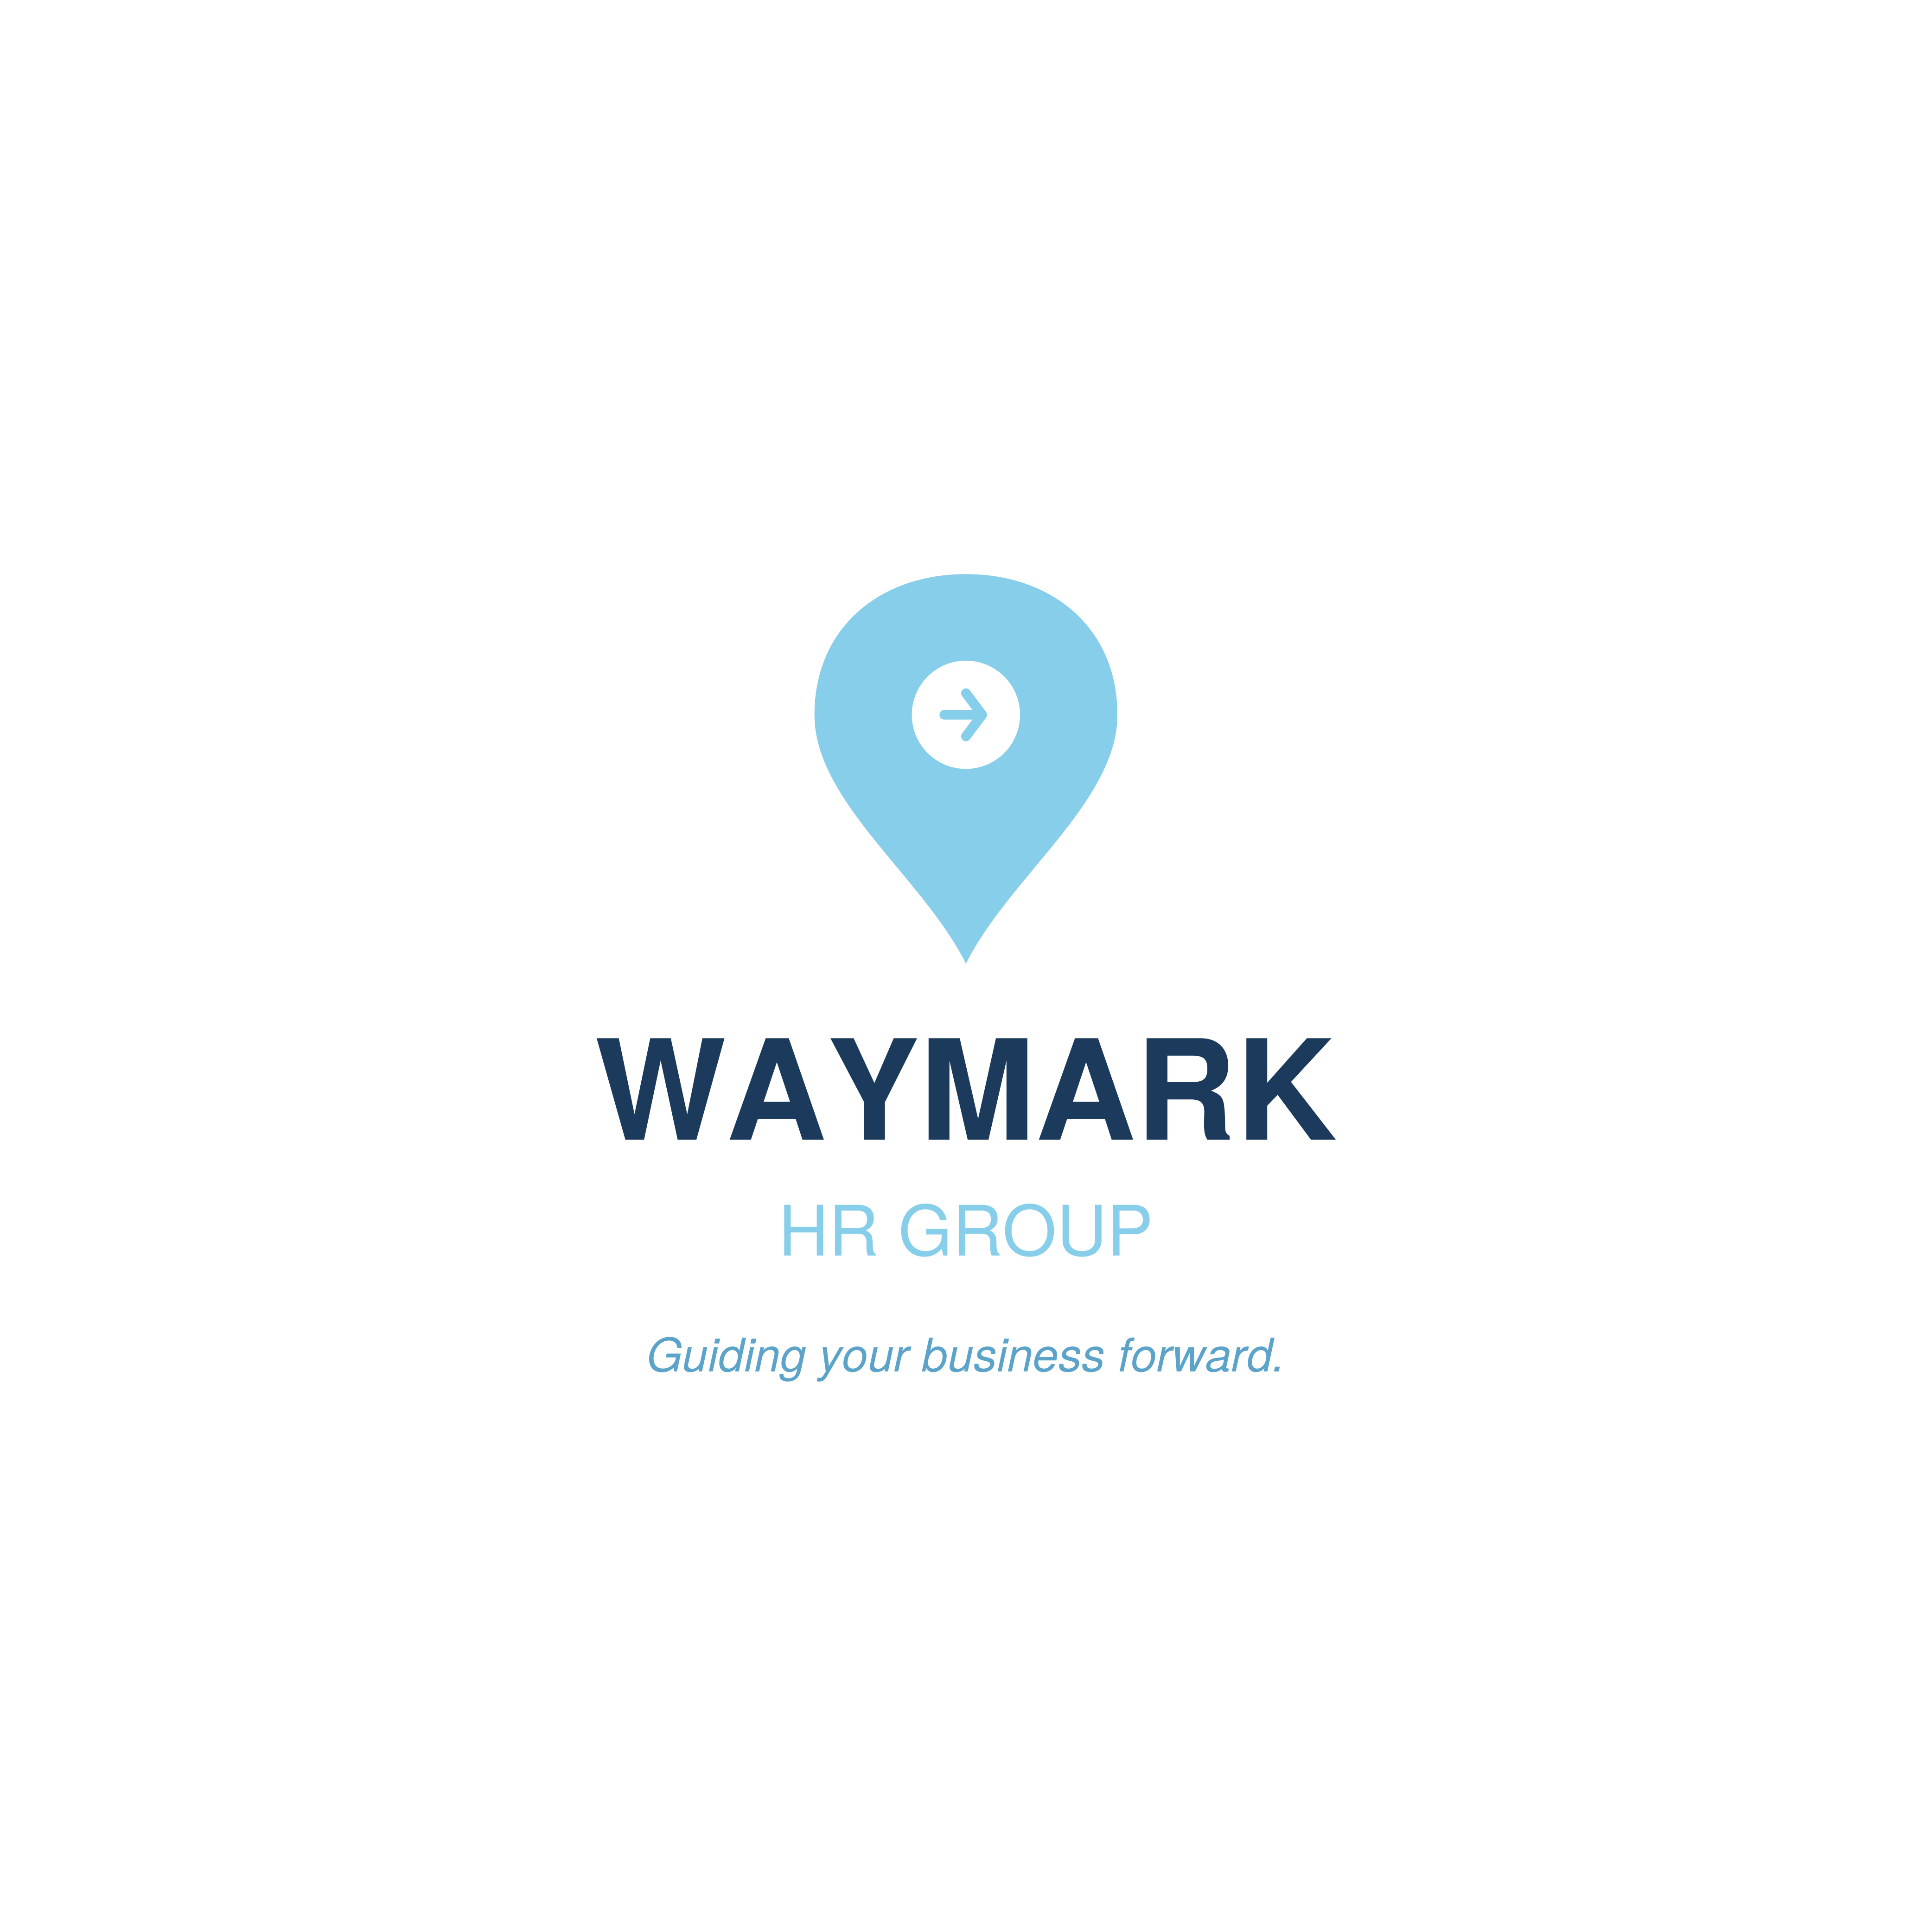
HR POLICY DEVELOPMENT ENGAGEMENT REPORT
Prepared for: BluePeak Technology
Date Prepared: March 18, 2026 | Prepared by: Jamie Wahler

CONFIDENTIAL — This report has been prepared exclusively for the use of BluePeak Technology by Waymark HR Group LLC. It may not be reproduced or distributed without prior written consent.

EXECUTIVE SUMMARY
Overview
Waymark HR Group LLC was engaged by BluePeak Technology to conduct a full review of existing HR policies and develop a comprehensive HR Policy Handbook. The engagement assessed current policy gaps, compliance risks, and alignment with Technology industry standards and applicable employment law.
Key Findings
- Multiple critical HR policies were absent or significantly outdated.
- Existing policies were not consistently communicated or acknowledged by employees.
- Several practices were identified as potential compliance risks under Technology regulations and applicable state law.
- No formal policy review cycle was in place to ensure ongoing accuracy.
Business Impact
Clear, compliant HR policies reduce legal exposure, establish consistent expectations, and support a fair and accountable workplace culture. The HR Policy Handbook delivered to BluePeak Technology provides a professionally structured framework aligned with current employment law requirements and Technology industry best practices.

SERVICES DELIVERED
Deliverables Completed
- Policy Gap Assessment: Reviewed existing documentation to identify missing, outdated, or non-compliant HR policies.
- HR Policy Handbook: Drafted a comprehensive, state-specific HR Policy Handbook covering 8 core policy areas.
- EEO & Anti-Harassment Policies: Developed compliant Equal Employment Opportunity and Anti-Harassment policies aligned with federal and state law.
- Attendance & PTO Policies: Drafted Attendance, Punctuality, and Paid Time Off policies tailored to the organization's needs.
- Code of Conduct: Created a professional Code of Conduct establishing behavioral and ethical standards.
- Compliance Review: Assessed policy content against applicable employment law requirements.
Engagement Timeline
Phase | Activities
Week 1 | Policy gap assessment and discovery
Week 2 | Policy drafting — EEO, harassment, attendance, PTO
Week 3 | Policy drafting — code of conduct, performance, social media, remote work
Week 4 | Review cycle, compliance check, and final handbook delivery

Tools & Frameworks Used
- Waymark Policy Generator (Python)
- Federal and state employment law reference
- SHRM policy framework

KEY RECOMMENDATIONS
The following five recommendations are prioritized based on potential business impact and implementation effort. Each is rated on a High / Medium / Low scale.
# | Recommendation | Impact | Effort | Type
1 | Distribute and Obtain Signed Policy Acknowledgments  Ensure all employees receive, read, and sign acknowledgment of the new HR Policy Handbook immediately. | High | Low | Quick Win
2 | Schedule Annual Policy Reviews  Establish a formal calendar-based policy review process to keep documentation current with evolving law. | High | Low | Quick Win
3 | Conduct Manager-Level Policy Training  Train all people managers on key policies — especially harassment, attendance, and performance — to ensure consistent enforcement. | High | Medium | Short-Term
4 | Implement a Digital Policy Distribution System  Move policy acknowledgment and updates to a digital HR platform to ensure version control and audit trails. | Medium | Medium | Short-Term
5 | Develop a Whistleblower & Reporting Mechanism  Establish a confidential reporting channel for policy violations and workplace concerns. | High | Medium | Long-Term Investment

NEXT STEPS & 30/60/90-DAY ACTION PLAN
Proposed Follow-On Services
Based on the findings and outcomes of this engagement, Waymark HR Group LLC recommends the following follow-on services to continue building BluePeak Technology's HR capability:
- Manager training on policy enforcement and documentation
- Employee handbook digital distribution and acknowledgment tracking
- Workforce analytics engagement to identify retention and compensation risks
- Annual compliance review to keep policies current with legal changes
30/60/90-Day Action Plan
30 Days
- Distribute HR Policy Handbook to all employees
- Collect signed acknowledgments from all staff
- Brief managers on key policy updates and enforcement expectations
- Post policies on company intranet or shared drive
60 Days
- Conduct manager policy training sessions
- Confirm 100% acknowledgment receipt from all employees
- Address any employee questions or policy clarifications
- Begin evaluation of digital policy management platforms
90 Days
- Establish annual policy review calendar
- Assess policy adherence and any early compliance issues
- Develop a whistleblower and reporting mechanism
- Plan next HR engagement (workforce analytics recommended)

CLOSING
Dear BluePeak Technology Team,
On behalf of everyone at Waymark HR Group LLC, thank you for the opportunity to support your organization through this engagement. It has been a privilege to work alongside your team, and we are proud of the work we have accomplished together.
The deliverables contained in this report represent a meaningful investment in your people and your organization's future. We are confident that implementing the recommendations outlined here will strengthen your HR function, reduce risk, and create a better experience for your employees.
We remain committed to your success beyond this engagement. Whether you need support implementing these recommendations, have questions about the deliverables, or are ready to begin the next phase of your HR journey, our team is here to help.
Please do not hesitate to reach out at any time. We look forward to continuing to be a trusted partner for your organization.
Warm regards,
Jamie Wahler
Waymark HR Group LLC

Phone: 716-225-6347
Email: Jamie.Wahler@waymarkhrgroup.com
Website: www.waymarkhrgroup.com
Address: Buffalo, NY

This report is confidential and intended solely for the use of the named client. © 2026 Waymark HR Group LLC. All rights reserved.

