Question 1:
- It took me 8.30 hours
- If I had more time, I would add the ability for the to toggle back a task if they mistakenly checked as completed

Question 2:
- I spend more time trying to solve some of the Vue3 plugin conflict. For example, the most readily available plugin for sorting was for vue2. That one would easily integrate into my project. I spent more time trying to find the best fit for the vue3. A little bit of the time was spent on aligning available material/information in design since it had to be done in exactitude.
- Moreover, some time was spend in deciding on which way would be better of the available fitting choices, for example, one had to think abit before deciding on whether to use vue store/for state management or have a simpler approach. Another one was whether to use router or just a simple onclick method. Both the options were valid but with real implications and therefore I had to take some time thinking
- Generally speaking, the project didn’t have very notable challenges

Question 3:
The simple use of “template” and the single file component in which it is treated as plain html
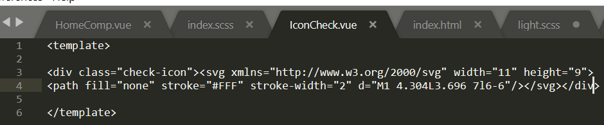

Question 4:
I would run a performance test by running load tests that simulate a production-level simulation traffic. I have done several of such tests in Vue, for example by fetching different amounts of data and testing it on lists of different sizes

Question 5:
I found the test to be generally not challenging on technical matters. I only have a problem with the google Rubik, which doesn’t really display as illustrated in the demo. However, except for if it’s by design, it would be better if certain important points such as telling the interviewee to use simple approach rather than have store as an option, and also not to use the route, it would save the development process. This is with respect to the decision making process which involves seeing through the entire process for both the options before making a well informed choice. That notwithstanding, I find the test very useful in learning as well as handling real problems in detail. Additionally, I find the test enjoyable when giving working solutions.

