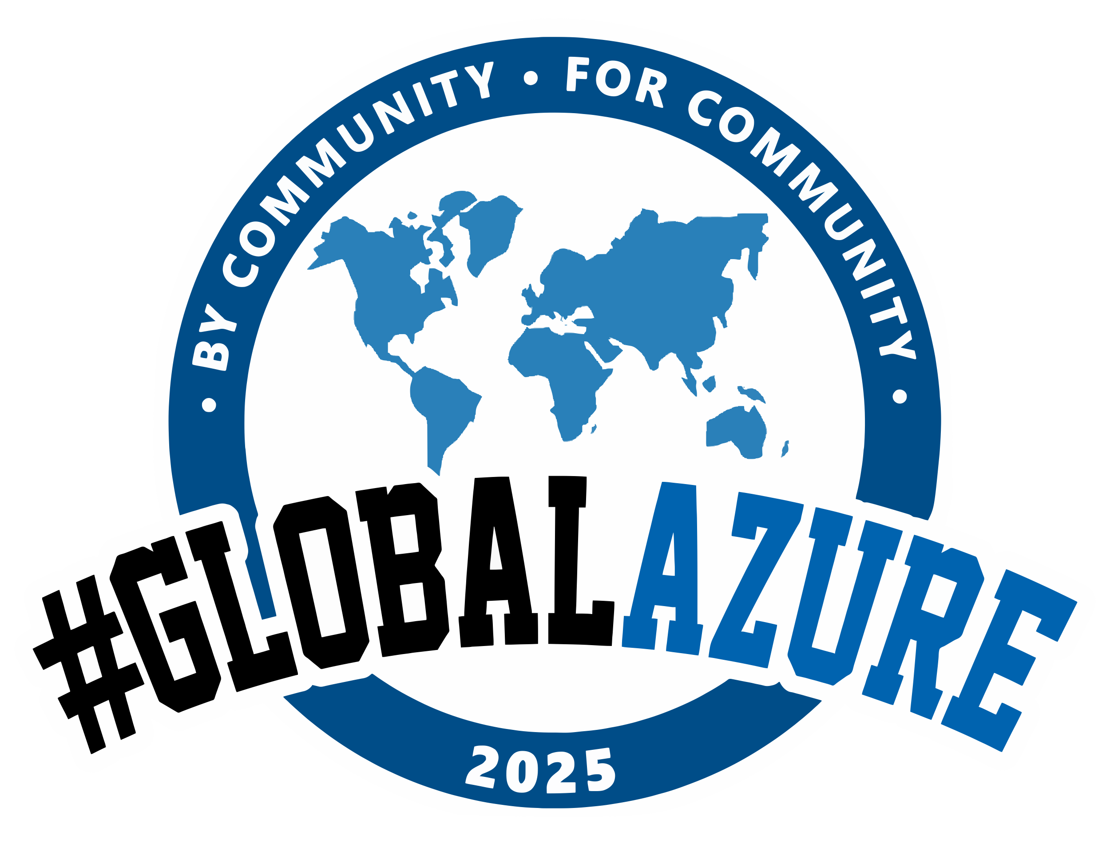
MELBOURNE Edition
Track 1 – Level 5
9:00 AM | Welcome
9:30 AM | Agentic AI: the future of innovation or just hype? Yaser Adel Mehraban
10:20 AM | Who tests their cloud code anyway? Lars Klint
11:15 AM | LEGO + Python + GPT = The Journey from Dad to Superdad with Azure AI services and Robotics! Daniel Fang
12:00 PM – 1:30PM | Lunch
12:50 PM | Sponsor Session: Navigating the perfect storm: Elevating the Role of Observability Arya Choudhury
1:40 PM | Building Responsible AI Apps with Azure AI Foundry Lachlan Wright
2:25 PM | The Future of Cloud Security: AI, Zero Trust, and Beyond Puoya Koushandehfar
3:10 PM | Afternoon Tea on Level 5
3:30 PM | Embracing the Dapr Transactional Outbox with WebAPIs on Azure Container Apps William Liebenberg
4:10 PM | Accidental Azure DBA in 2025 Copilot is your toolkit Kelly Broekstra
5:00PM | Close out & Q&A

