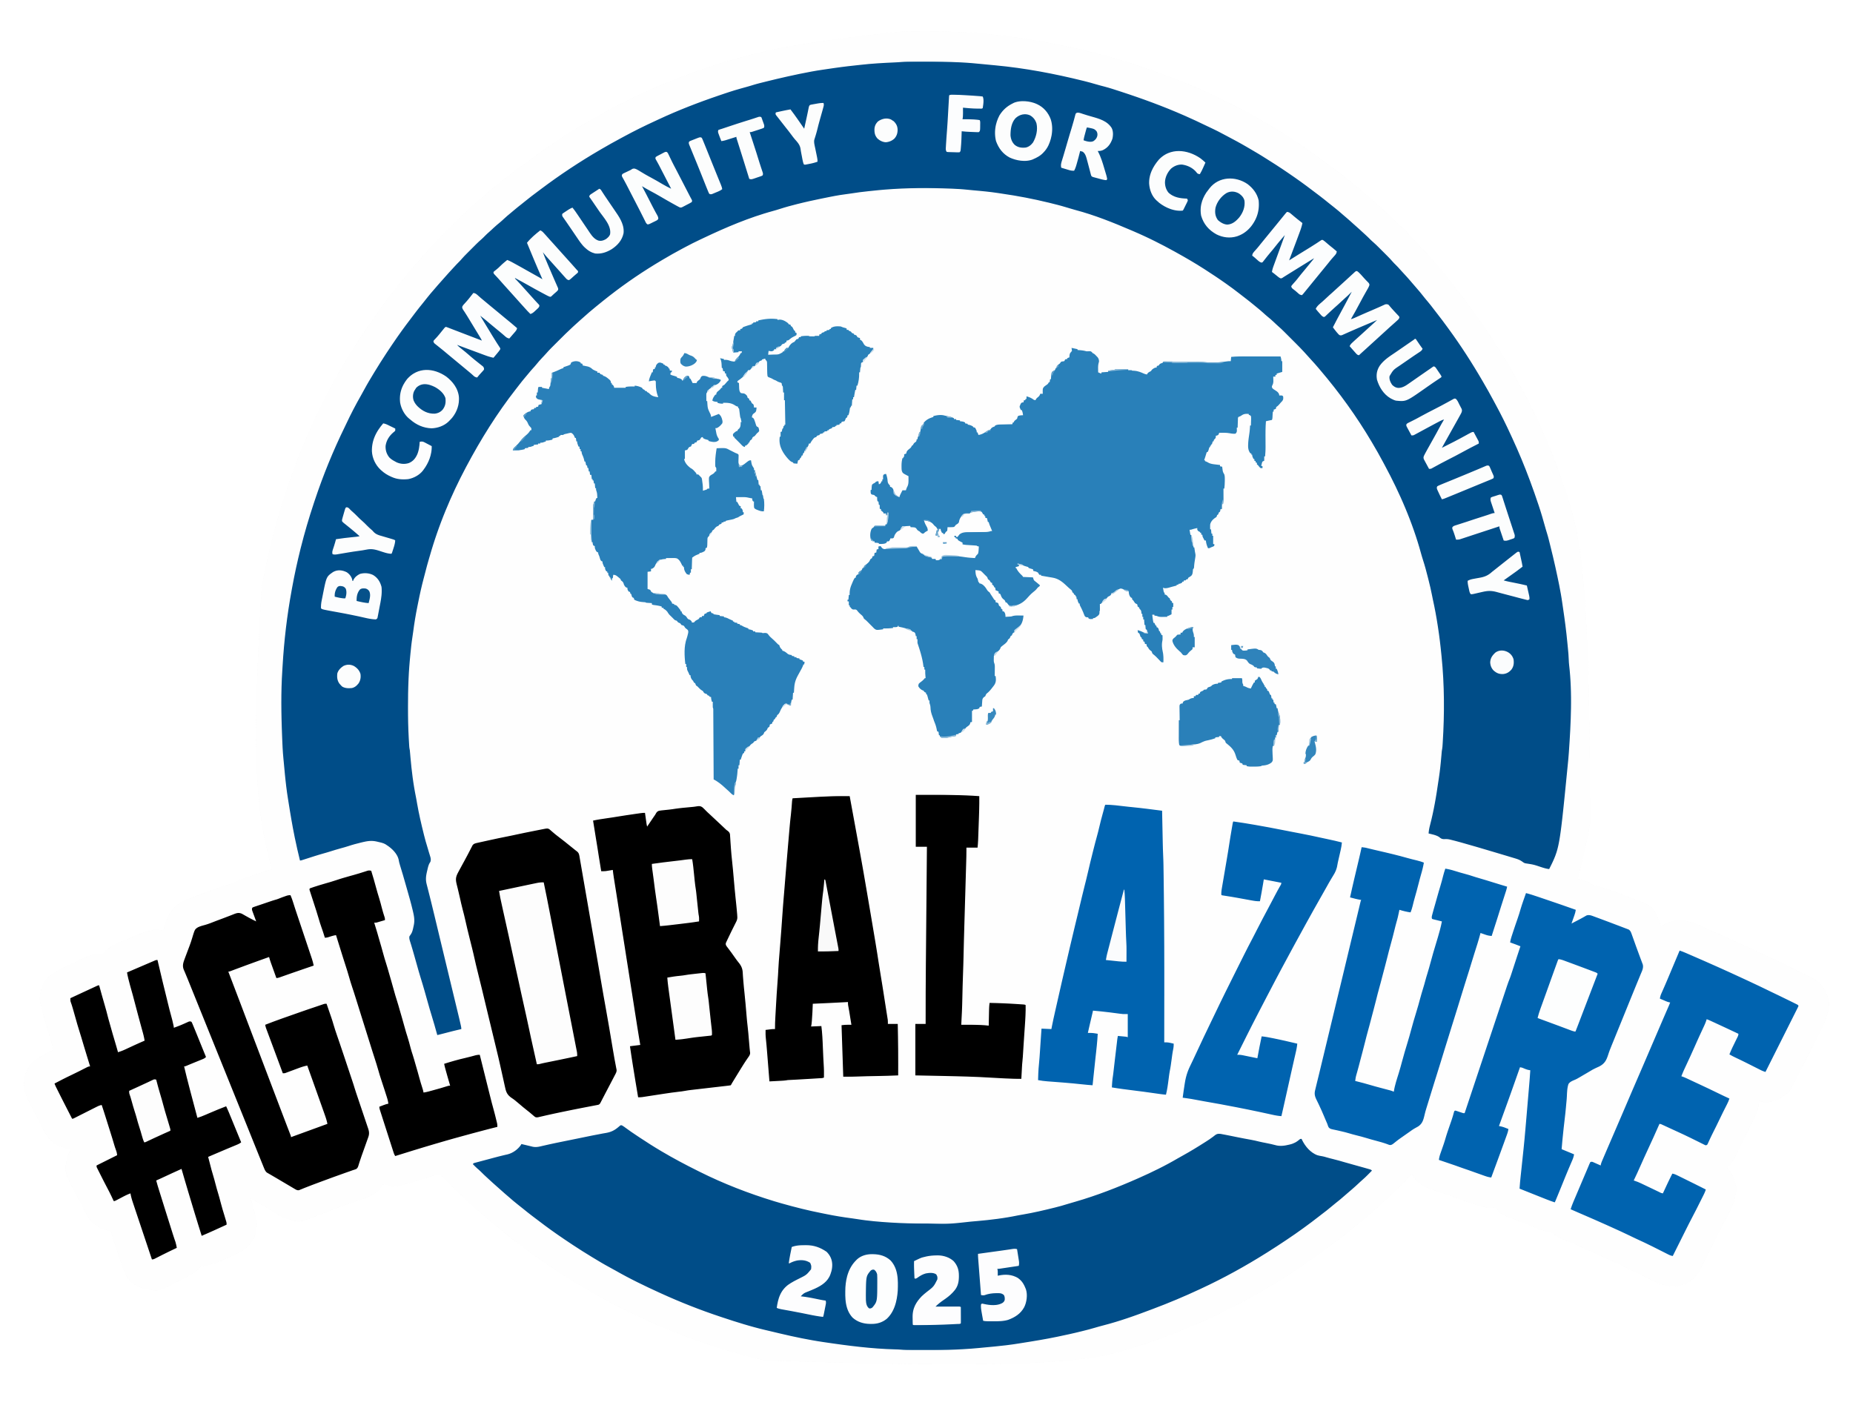
MELBOURNE Edition
Track 2 – Level 7
9:30 AM | Implementing Data Platforms with Microsoft Fabric Greg Nash
10:20 AM | Your AI, Your Rules: Building a Multi-Model Private AI Assistant on Azure Venura Athukorala
11:15 AM | Manage all the clusters with KubeFleet and AKS Fleet Manager! Will Velida
12:00 PM – 1:30PM | Lunch & Sponsor Sessions on Level 5
1:40 PM | Using Liquid Maps for your Data Transformation in Azure Functions, Websites, APIs or Logic Apps Bill Chesnut
2:25 PM | Things to Consider when Evaluating Data Platforms Manohar Punna
3:10 PM | Afternoon Tea on Level 5
3:30 PM | An introduction to Terraform Testing Craig Moyle
4:10 PM | Beyond the Basics: (Not so) Hidden Gems in Microsoft Fabric Ronak Vachhani
5:00PM | Close out on Level 5

