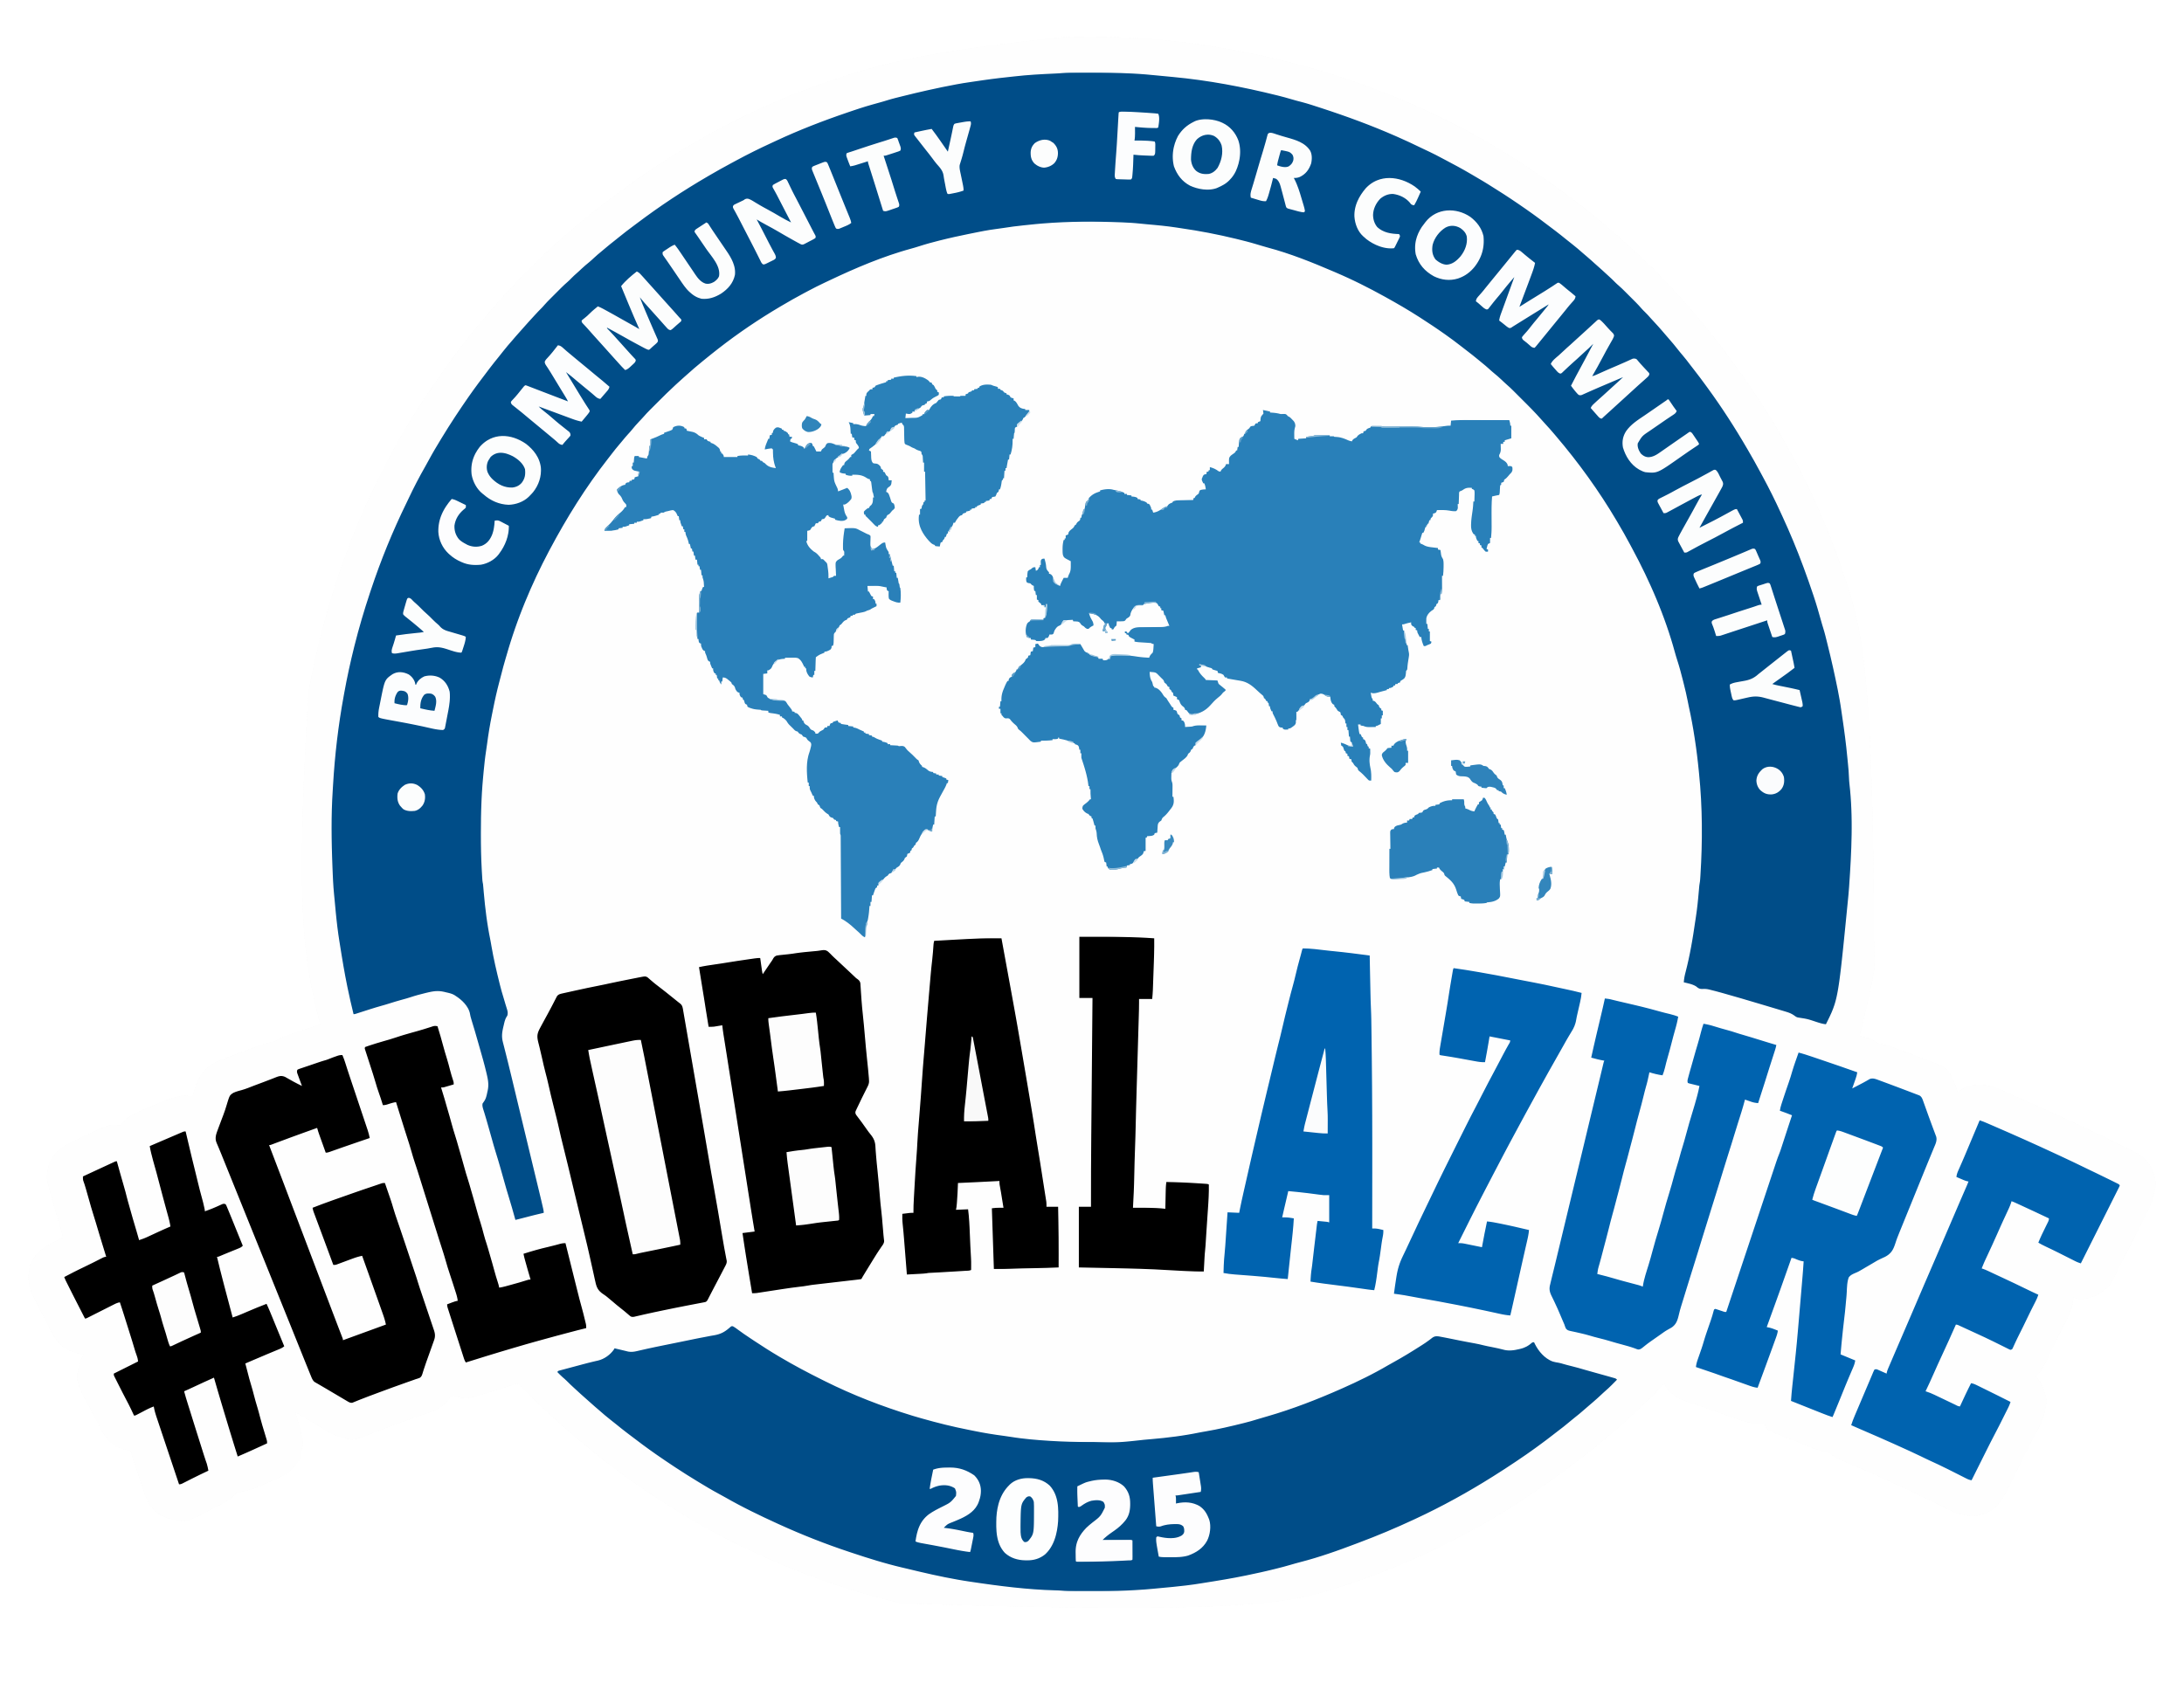
MELBOURNE Edition
Track 3 – Level 7
9:30 AM | Revolutionising DevOps with AI: From Pipelines to Deployment  AJ Bajada
10:20 AM | Innovative Use cases of Azure Virtual Network Manager in Landing Zones. Santhoshkuma Anandakrishnan
11:15 AM | Microsoft Dev Box - Let's Get Started with Team Customizations Dylan McCarthy
12:00 PM – 1:30PM | Lunch & Sponsor Sessions on Level 5
1:40 PM | Importance of evaluating Gen AI security and safety guardrails Yogi Srivastava
2:25 PM | Network Security for AI Design: The Good, The Bad and The ugly Amit Khatri
3:10 PM | Afternoon Tea on Level 5
3:30 PM | You use App Insights Right? Right? Bron Thulke
4:10 PM | API Management in the AI era Nilesh Gule
5:00PM | Close out on Level 5

