ELEC 3300

HOMEWORK 1: INTRODUCTION TO CubeIDE WORKSHEET

Please complete the following and submit your worksheet electronically before the deadline

Name : Young, James Yang Student number : 20740589 LAB Session : LA4

- Program Size in Hex: ___0x16d8________ for Optimization Level is None (-O0)

- Run your program up to the instruction
__asm(“NOP”); // Check Point for Question 2
Fill the following table. Remember you are using your *OWN* student ID.
NO MARKS WILL BE AWARDED IF YOU ARE NOT USING YOUR STUDENT ID

Expression |  | Type | Value (Please only write HEX NUMBERS below)
i |  | int | 0x20740589
j |  | int | 0x98504702
x |  | float | 0x4501a0f1
y |  | double | 0x4173c79edfc2c0aa
stdid |  | int[8] | 0x20000000
 | stdid[0] | int | 0x2
 | stdid[1] | int | 0x0
 | stdid[2] | int | 0x7
 | stdid[3] | int | 0x4
 | stdid[4] | int | 0x0
 | stdid[5] | int | 0x5
 | stdid[6] | int | 0x8
 | stdid[7] | int | 0x9
counter |  | int | 0x8
sum |  | int | 0x23

a. | What endianness is being used to store a word in memory in STM32? | Little Endian
b. | Write down the hexadecimal value of stdid. | 0x20000000
c. | What is the meaning of the value you filled in part b? | It is the starting address of stdid.
d. | How many bytes used for variables that declared as int? | 4 bytes
e. | How many bytes used for variables that declared as float? | 4 bytes
f. | Write down the hexadecimal value of x stored in memory. | 0xF1A00145
g. | What representation standard is being used to store x in memory? | IEEE 754 Single Precision
h. | How many bytes used for variables that declared as double? | 8 bytes
i. | Write down the complete hexadecimal value of y stored in memory. | 0xAAC0C2DF9EC77341
j. | What representation standard is being used to store y in memory? | Double-precision floating-point format
k. | Write down the starting address of the array swapid in hex format. | 0x2000006c
l. | Write down the starting address of the array oddid in hex format. | 0x2000008c
- Which SINGLE assembly instruction did the corresponding instruction take place

AND ____ands r3, r2__

OR ____orrs r3, r2________________________________

XOR ____eors r3, r2______________________________

- Write down the answer of your result in hexadecimal format

ANDresult __0x500500__

ORresult __0xb874478b__

XORresult ____0xb824428b_____

What are the addresses of the following variables; please write it in hexadecimal format

ANDresult ______0x20000060______

ORresult ______0x20000064______

XORresult ______0x20000068______

- What are the states of N, Z, C and V *AFTER* execution of ADDS R3, R0, R0 instruction?

N ____0__________ Z ____1________

C ____0__________ V _____0_______

Please explain your result IN DETAIL with respect to the value in R3

N: The N bit will be 1 if the MSB is 1 (result of operation is negative). However since R3 is zero so therefore it is not negative and the flag is 0.

Z: Since the value of R0 is zero, and we are adding two zeros together, therefore the result of R3 is zero so the zero flag is 1.

C: Since the operation of adding two zeros does not have a carry, so the C flag is 0.

V: Since the operation of adding two zeros does not have a overflow, so the overflow flag is also 0.

- What are the states of C and V *AFTER* execution of ADDS R3, R1, R2 instruction?

C ______0________ V _____0_______

Please explain your result IN DETAIL with respect to your value in R3 to R1 and R2

Since R1 is i=544,474,505 and R2 is j=-1,739,569,406 in decimal, the operation i+j result is
R3=-1195094901 which is within the integer range of -2³¹ to 2³¹-1 is the right result from this operation therefore there is no carry. The R3 result also shows that there is no overflow since the result of the operand gives the correct signed number (MSB of two’s complement is 1 in binary).

- What are the states of C and V *AFTER* execution of SUBS R3, R1, R2 instruction?

C ________0______ V ________1____

Please explain your result IN DETAIL with respect to your value in R3 to R1 and R2

Similarly, since R1 is the value of i=544,474,505 and R2 is j=-1,739,569,406 in decimal, therefore the expected result of i-j should be positive. However, the value of R3 is negative therefore this indicates there is an overflow. There is no carry as the result of R3 in decimal is
-2010923385 which is within the range of the integer representable value.

- Please put a screen cap of your Traditional Memory View at Check Point for Question 8 here.
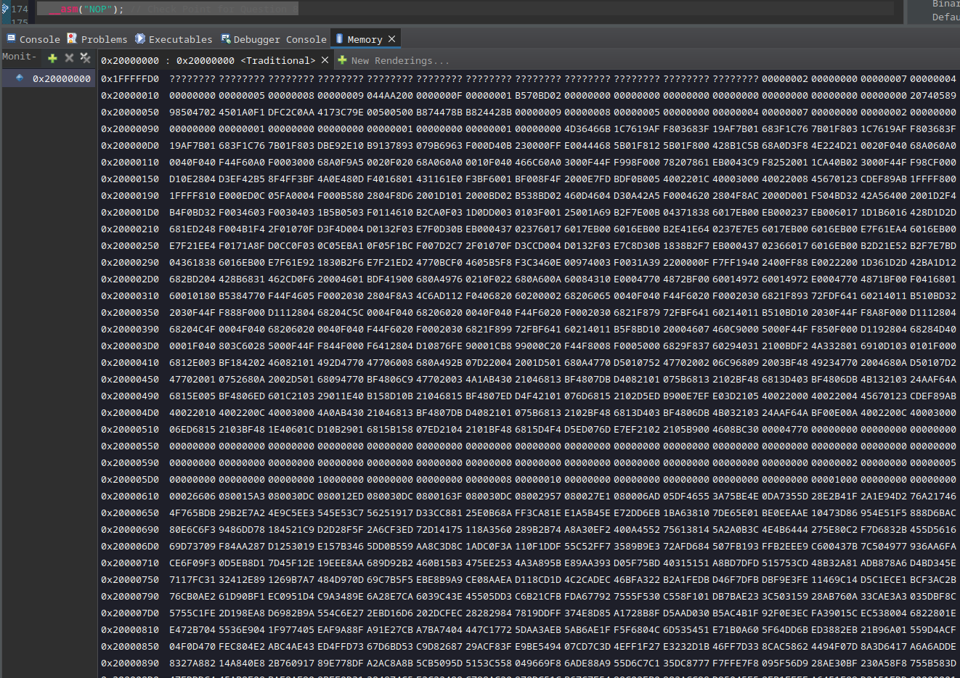

- Program Size in Hex: ____0x12ac_______ for Optimization Level is Optimize most (-O3)

Any difference compared to the Question 1 you found before? __Yes, program size is smaller_

Please briefly explain the optimization is being done by giving some examples with the help of Disassembly View.

The code is optimized by reducing the number of instructions. This is supported by the disassembly view where we can see that most commands in the optimzed version have less instructions in assembly. For example, for initializing the variable i = 0x20740589, the assembly version for the non-optimzed version has 3 instructions (ldr twice, then str). However the optimzed version only has 2 instructions (ldr twice, no str).

