Rubisco fitness and kinetic landscape modeling with protein language model embeddings, tabular learning, and active learning
James A. Young III1,*
1 Department of Biology and Microbiology, South Dakota State University, Brookings, SD 57007, USA
* Correspondence jyoung67391@jacks.local

Abstract
Ribulose 1,5 bisphosphate carboxylase oxygenase, or Rubisco, controls most biological carbon fixation and remains a bottleneck for crop productivity and sustainable bioproducts. Improving Rubisco is difficult because cell growth depends on many coupled processes, so variants that maximize an in vitro kinetic readout may not maximize organism fitness. This study evaluates an AI Chemistry workflow that links protein language model embeddings to practical tabular predictors and to active learning. We benchmark TabPFN and XGBoost on Rubisco deep mutational scanning readouts and on an oxygen tolerance screen. Across tasks, TabPFN improves out of sample ranking relative to an XGBoost baseline and improves recovery of top performing variants in low data regimes. We then simulate batchwise active learning where the model is retrained only on assayed variants at each round and uses uncertainty to balance exploitation and exploration. Even when XGBoost is used inside the loop, active learning improves the best variant discovered per batch compared with random selection. To connect enzyme level kinetics with organism level objectives, we compile cyanobacterial doubling times from the literature and relate wild type Rubisco embeddings to growth. We also benchmark cross species prediction of Rubisco kinetic parameters using the Flamholz dataset. Together, these results support a multi scale view of enzyme optimization and motivate hybrid strategies that combine evolution driven exploration with computationally guided design.

Keywords
Rubisco, protein language models, ESM2, TabPFN, XGBoost, deep mutational scanning, active learning, oxygen tolerance, cyanobacteria, enzyme engineering

1. Introduction
Ribulose 1,5 bisphosphate carboxylase oxygenase, commonly called Rubisco, catalyzes the entry of inorganic carbon into the biosphere. Rubisco is also widely considered a performance bottleneck for photosynthesis and for carbon based biomanufacturing, which motivates both agricultural and industrial efforts to improve its properties [1-3]. Rubisco is abundant and nitrogen rich, which creates additional constraints because improving catalytic rates can trade off with cellular resource allocation and stress tolerance [1,18].
Protein engineering of Rubisco remains challenging. Rubisco has a complex reaction mechanism with competing carboxylation and oxygenation reactions, it requires proper assembly with chaperones, and its effective performance in vivo depends on cellular context such as CO2 concentrating mechanisms and metabolic demand [18]. These layers create a core problem for design. The objective function used in a selection assay can be different from the objective that matters in an applied setting, and both can differ from long term evolutionary fitness.
Directed evolution is a powerful route to enzyme improvement, especially when a high throughput screen or selection closely reflects the target application [4-6]. However, an in vivo directed evolution campaign naturally optimizes organismal fitness under a specific environment. When the desired application is ex vivo catalysis or industrial bioprocessing, selection for cellular fitness can filter out variants that would be valuable outside the cell. This objective mismatch is a hallmark of complex biological systems where multiple constraints interact across enzyme, pathway, cell, and population scales [18,19].
Machine learning can help navigate these trade-offs by learning predictive structure from mutational data and by enabling decision making strategies that allocate experiments where they are most informative [5-7]. Recent protein language models learn general sequence representations from large unlabeled databases and often provide strong baselines for mutation effect prediction [8-10]. In parallel, tabular foundation models have emerged that can be competitive in small data settings where biological experiments often operate [14,15].
In this work we focus on two Rubisco landscape regimes. The first regime is a deep mutational scanning dataset that links single amino acid substitutions to inferred kinetic proxies and enrichment [11]. The second regime is a cyanobacterial screening dataset that reports multi mutant fitness under O2 and N2 and supports an oxygen tolerance objective [12]. We compare gradient boosted trees with a tabular foundation model on both regimes, and we use these models as surrogates in retrospective active learning simulations. We also include supplementary analyses that connect Rubisco sequence embeddings to cyanobacterial doubling time and to a cross species kinetics compendium [18,20,21]. Our goal is not to claim a single universally optimal model, but to provide a realistic, reproducible workflow that makes the trade-offs between computationally driven design and evolution driven design explicit.

2. Materials and Methods

2.1. Datasets and preprocessing
We analyzed three types of data. The primary results use two mutational datasets that measure Rubisco related phenotypes. Supplementary results use a literature derived cyanobacterial doubling time table and a cross species Rubisco kinetics compendium.
Deep mutational scanning dataset. We used a single substitution Rubisco dataset with inferred kinetic proxy targets for a Km for CO2 proxy and a Vmax ratio proxy, and an enrichment score that summarizes selection outcomes [11]. The dataset includes 8628 variants spanning 455 mutated positions in the Rubisco large subunit sequence. All variants in this dataset have mutational depth one by construction.
Cyanobacterial screening dataset. We used a Rubisco mutant library screened in a cyanobacterial chassis with fitness measured under O2 and N2, enabling a delta fitness objective defined as fitness under O2 minus fitness under N2 [12]. This dataset includes 14363 variants spanning a mutational depth range from zero to sixteen.
Cross species kinetics compendium. For supplementary benchmarking we used a published compendium of Rubisco kinetic parameters across species and measurement conditions [18]. We applied filters for wild type measurements and for comparable temperature and pH ranges as described in the Supplementary Materials.
Cyanobacterial doubling time compendium. To provide a growth context for Rubisco engineering cycles, we compiled best case doubling times for commonly used cyanobacterial strains from primary literature sources, including a fast growing Synechococcus elongatus strain UTEX 2973 and Synechococcus elongatus PCC 11801 [20,21]. We converted doubling time to growth rate using mu equals ln two divided by doubling time.
Unless stated otherwise, we performed all model evaluations on log transformed targets when those targets were strictly positive. This reduces heteroscedasticity and aligns with common practice in mutational effect prediction [7,10].

2.2. Sequence embeddings
We represented each Rubisco variant sequence using embeddings from the ESM2 protein language model family [8,9]. We used a mean pooling strategy across residues to obtain a fixed length vector per sequence. This approach supports variable length sequences and avoids the need for multiple sequence alignment, although it can mix effects from insertions and deletions when present.
For all predictive tasks we used the same embedding extraction protocol. We standardized features using a training fold StandardScaler and applied principal component analysis to reduce dimensionality. To avoid information leakage, both the scaler and the PCA transform were fit using training data only inside each fold, and then applied to validation and test data.

2.3. Predictive models
We compared two supervised learning approaches that are practical in typical enzyme engineering data regimes. First, we trained gradient boosted decision tree regressors using XGBoost, with hyperparameters selected from a modest grid [13]. Second, we used TabPFN, a tabular foundation model that performs Bayesian like inference over a learned prior for tabular datasets and often performs well when sample sizes are limited [14,15].
For each task we tuned the number of PCA dimensions and key regularization or complexity parameters for each model. For XGBoost we tuned maximum tree depth, learning rate, number of estimators, and subsampling parameters. For TabPFN we tuned the number of PCA dimensions and a training set cap, which limits the number of training points used per prediction to control runtime in large datasets.
We also fit baseline ridge regression models in the Supplementary Materials for two reasons. First, ridge regression provides a transparent baseline that is less likely to overfit heterogeneous kinetic data. Second, it enables nested cross validation tuning that clearly separates model selection from model evaluation.

2.4. Evaluation regimes and metrics
We evaluated performance using rank based and selection oriented metrics that reflect how models are used in enzyme engineering. We report Spearman correlation between predicted and observed values as a global measure of rank agreement that is widely used in mutation effect prediction benchmarks [7,10].
Because many campaigns ultimately test only a small fraction of variants, we also report two top fraction metrics computed on held out test sets. Top 5 percent precision is the fraction of the predicted top 5 percent variants that are also in the true top 5 percent. Top 5 percent enrichment difference is the mean observed target value among the predicted top 5 percent minus the overall mean of the test set. These metrics connect directly to hit identification and expected gain under a fixed experimental budget [6,7].
We used three generalization regimes. For the deep mutational scanning dataset we used a within position split that holds out a fraction of substitutions at every position, and a position holdout split that holds out entire positions to test generalization to unseen sites. For the cyanobacterial screening dataset we used a mutational depth holdout split that trains on shallow mutants and tests on higher order mutants.
To compare XGBoost and TabPFN on matched splits, we used paired tests on task level Spearman, including a paired t test and a Wilcoxon signed rank test. This follows common recommendations for comparing learning algorithms across multiple datasets while acknowledging that the number of independent tasks is modest in this study [31]. Reported p values are descriptive and are used to summarize the direction and magnitude of differences rather than to claim universal superiority.

2.5. Retrospective active learning simulation
We simulated closed loop experimental campaigns using retrospective active learning on the deep mutational scanning enrichment objective and on the cyanobacterial delta fitness objective. At the start of each simulation replicate, the algorithm observed embeddings for all variants but had labels for only an initial random seed set of 200 variants. At each subsequent round the surrogate model was trained only on the currently labeled set, an acquisition function selected a batch of 48 new variants from the unlabeled pool, and the newly revealed labels were added to the training set. The true labels of unlabeled variants were never used during selection, which prevents data leakage in the simulation.
We compared four selection strategies. Random sampling chooses variants uniformly at random. Greedy exploitation chooses the highest predicted mean. Upper confidence bound sampling chooses variants with high predicted mean plus an uncertainty bonus, using beta set to one [16]. Thompson sampling draws one sample from the predictive distribution and selects the top variants under that sample [17].
Uncertainty was estimated using an ensemble of XGBoost models trained with different random seeds. This choice prioritizes reproducibility and avoids dependency on non commercial foundation model checkpoints in the active learning loop [26]. Each experiment was repeated for ten independent replicates to produce a distribution of outcomes. We tracked the fraction of global top 1 percent and top 5 percent variants recovered, as well as the best observed value achieved so far.

2.6. Implementation and reproducibility
All analyses were implemented in Python. Key packages include scikit learn for preprocessing, XGBoost for gradient boosted trees, and TabPFN for tabular foundation model inference. Scripts and intermediate result files are organized to enable full reproduction of the reported tables and figures from raw inputs.

3. Results

3.1. Dataset overview and landscape regimes
Table 1 summarizes the two primary datasets and the generalization regimes used in this study. The deep mutational scan provides dense coverage of single substitutions and supports both within position ranking and generalization to unseen positions. The cyanobacterial screening dataset spans a wide range of mutational depths and enables evaluation of extrapolation from shallow to higher order mutants.
A key difference between these regimes is the type of generalization that matters. Within position ranking asks whether a model can prioritize the best substitution at a known site. Position holdout asks whether the model can generalize to a site that was never observed during training. Mutational depth holdout asks whether the model can extrapolate from low order to higher order epistasis, which is closer to practical multi mutant engineering.
Table 1. Summary of Rubisco mutational datasets used in the primary analyses.
Dataset | Variants | Mutational depth | Targets | Generalization regime
Deep mutational scan [11] | 8628 | 1 | Enrichment, Km for CO2 proxy, Vmax ratio proxy | Within position and position holdout
Cyanobacterial screening [12] | 14363 | 0-16 | Fitness in O2, fitness in N2, delta fitness | Mutational depth holdout

3.2. Predicting deep mutational scan kinetic proxies and enrichment
We benchmarked TabPFN and XGBoost on three Rubisco deep mutational scanning targets that proxy kinetic properties and variant enrichment. Table 2 summarizes Spearman rank correlation, root mean squared error on held out variants, and recovery within the top ranked fraction. Rank correlation is emphasized because these models are intended to prioritize which sequences to build and assay, and Spearman is a standard metric for protein embedding benchmarks and protein fitness prediction challenges [9,12].
We report three split regimes to separate interpolation from extrapolation. Random split mixes substitutions across positions and mainly tests global pattern learning. Within position split hides a subset of substitutions at each position so the model can learn the local tolerance landscape of each site. Position holdout is the strictest regime and tests whether the model generalizes to entirely unseen sites, which is closer to proposing mutations at positions not represented in the training set.
Across targets and splits, TabPFN improved mean rank correlation and top fraction recovery compared with XGBoost under matched embeddings and PCA preprocessing. The advantage is largest under the strict position holdout split, where model inductive bias is most challenged. Using paired tests across the three deep mutational scanning targets, the mean Spearman improvement for TabPFN is positive and the paired t test supports a systematic difference, while a Wilcoxon signed rank test is marginal because the number of targets is small.
Top fraction recovery metrics directly map to laboratory throughput. Recovery at the top 1 percent approximates a campaign where only tens of variants can be validated from a library of thousands. Improvements at these fractions can translate into fewer experimental batches to reach a given best observed variant, which motivates the subsequent active learning simulation.

3.3. Predicting oxygen tolerance objectives in a multi mutant screening landscape
We next evaluated a cyanobacterial screening dataset that quantifies oxygen tolerance by comparing mutant fitness under oxygen and nitrogen. This objective is closer to a system level phenotype because it integrates enzyme performance, expression, and host physiology. We considered two delta definitions that differ in how fitness is normalized across gas conditions, and we use a mutational depth holdout split that trains on variants up to a given number of mutations and tests on higher order combinations.
Under mutational depth holdout, TabPFN produced higher rank correlation and higher recovery of tolerant variants than XGBoost across both delta definitions. This setting is practically relevant because multi mutant combinations are a major source of novelty in directed evolution and recombination libraries, yet they are poorly sampled early in a campaign.
TabPFN shows near zero run to run variance in this regime because inference is deterministic given a fixed training set, and the mutational depth split yields a fixed train test partition. XGBoost shows nonzero variability because gradient boosted tree training uses stochastic components such as row and column subsampling and random tie breaking, even when hyperparameters are fixed. In later simulations, we treat this variability as part of the expected spread in outcomes by repeating runs across different initial batches.
Table 2. Model performance on held out test sets using ESM2 embeddings with PCA preprocessing. Spearman evaluates rank agreement, RMSE evaluates absolute prediction error, and recovery within the top fraction evaluates how well each model captures the truly best variants when only a small subset can be tested. Values are reported as mean plus or minus standard deviation across repeated runs. Paired tests are computed across targets for mean Spearman and are intended as a summary of direction of effect rather than as a definitive claim because the number of independent targets is limited.
Dataset | Task | Split | Target | XGB Spearman | TabPFN Spearman | Δ Spearman | p value | XGB top5 precision | TabPFN top5 precision | XGB top5 enrich diff | TabPFN top5 enrich diff
DMS | DMS | within position | Enrichment mean | 0.837 ± 0.005 | 0.884 ± 0.004 | 0.047 | 0.00548 | 0.248 | 0.414 | 0.420 | 0.439
DMS | DMS | pos holdout | Enrichment mean | 0.648 ± 0.016 | 0.679 ± 0.018 | 0.031 | 0.000206 | 0.195 | 0.228 | 0.343 | 0.360
DMS | DMS | within position | log(KmCO2) proxy | 0.472 ± 0.017 | 0.553 ± 0.006 | 0.081 | 0.0128 | 0.319 | 0.291 | 0.159 | 0.146
DMS | DMS | pos holdout | log(KmCO2) proxy | 0.190 ± 0.041 | 0.257 ± 0.057 | 0.068 | 0.00495 | 0.141 | 0.149 | 0.047 | 0.055
DMS | DMS | within position | log(Vmax ratio) proxy | 0.825 ± 0.007 | 0.866 ± 0.005 | 0.041 | 0.00784 | 0.259 | 0.337 | 0.413 | 0.430
DMS | DMS | pos holdout | log(Vmax ratio) proxy | 0.627 ± 0.016 | 0.651 ± 0.015 | 0.023 | 0.000601 | 0.189 | 0.207 | 0.326 | 0.342
HOFF | Delta direct | depth holdout | Δ fitness O2 minus N2 | 0.395 ± 0.013 | 0.517 ± 0.000 | 0.121 | 3.24e-05 | 0.111 | 0.120 | 0.694 | 0.807
HOFF | Delta derived | depth holdout | Δ fitness O2 minus N2 | 0.331 ± 0.014 | 0.516 ± 0.000 | 0.173 | 1.1e-05 | 0.127 | 0.165 | 0.688 | 0.873

3.4. Retrospective active learning improves hit recovery under fixed budgets
Figure 2 and Table 3 summarize retrospective active learning simulations on a Rubisco deep mutational scanning objective. Each simulation starts with an initial random batch of variants that are treated as experimentally assayed. At each subsequent round, the model is trained only on the accumulated assayed set, makes predictions for the unassayed pool, selects the next batch by an acquisition rule, and then reveals the true assay values for the selected variants to update the training set. This loop ensures that unassayed labels are never used for training or preprocessing and are only used after selection to emulate measurement.
We compare random selection, greedy exploitation, and an upper confidence bound strategy that balances predicted activity with uncertainty. Uncertainty is estimated from an ensemble of independently fit models with different random seeds, which provides a practical proxy for epistemic uncertainty in regions of sequence space that are sparsely sampled.
We repeat the simulation ten times with different random initial batches. Within each replicate, the initial batch is held fixed across strategies so that differences reflect the selection policy rather than chance. We report the mean and standard deviation across replicates to reflect the range of outcomes a practitioner might expect from a given experimental budget.
Active learning improves sample efficiency. Upper confidence bound selection reaches higher best observed objective values earlier than random selection and reduces the probability of stagnation in locally optimal regions of sequence space. The advantage is largest in early rounds when training data are scarce and uncertainty can meaningfully direct exploration.
In this study, XGBoost was used inside the active learning loop because it is permissively licensed and straightforward to deploy on shared compute, while TabPFN was reserved for benchmarking due to licensing constraints encountered during this project. The XGBoost based loop therefore provides a conservative estimate of the benefit of decision focused active learning. Where TabPFN based curves show little visible variance in related analyses, it is because TabPFN inference is deterministic for a fixed training set and, in our implementation, the ensemble often draws identical training subsets at the early sample sizes used here.
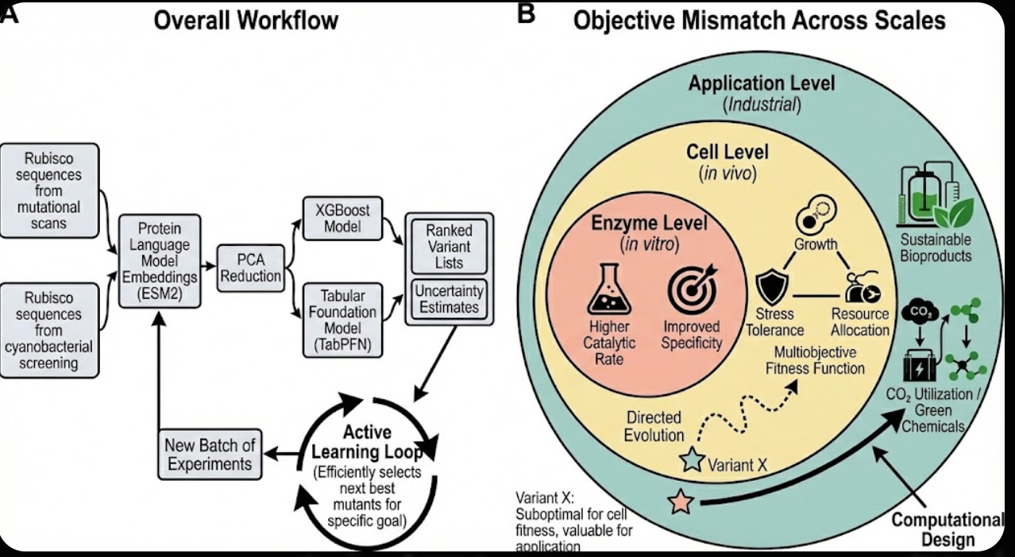
Figure 1. Workflow schematic and objective mismatch concept for Rubisco engineering.
Table 3. Retrospective active learning summary at the end of each simulation replicate. Values are mean ± standard deviation across ten replicates.
Dataset | Strategy | Assayed variants | Recovery top 1% | Recovery top 5% | Best so far
DMS | random | 1294 ± 67 | 0.17 ± 0.04 | 0.16 ± 0.03 | 1.05 ± 0.01
DMS | uncertainty | 1400 | 0.17 ± 0.04 | 0.18 ± 0.01 | 1.06 ± 0.01
DMS | greedy | 1400 | 0.48 ± 0.06 | 0.53 ± 0.02 | 1.06 ± 0.01
DMS | ucb | 1400 | 0.50 ± 0.04 | 0.54 ± 0.03 | 1.06 ± 0.01
DMS | thompson | 1400 | 0.45 ± 0.05 | 0.49 ± 0.03 | 1.06 ± 0.01
HOFF | random | 1400 | 0.13 ± 0.09 | 0.10 ± 0.04 | 3.01 ± 1.01
HOFF | uncertainty | 1400 | 0.21 ± 0.16 | 0.20 ± 0.09 | 2.79 ± 0.50
HOFF | greedy | 1400 | 0.31 ± 0.17 | 0.30 ± 0.12 | 2.90 ± 0.40
HOFF | ucb | 1400 | 0.26 ± 0.16 | 0.22 ± 0.09 | 2.90 ± 0.40
HOFF | thompson | 1400 | 0.26 ± 0.18 | 0.23 ± 0.09 | 2.90 ± 0.40
Figure 2. Retrospective active learning trajectories on the deep mutational scan enrichment objective and the cyanobacterial delta fitness objective. Curves show mean across ten replicates with shaded variability when available.
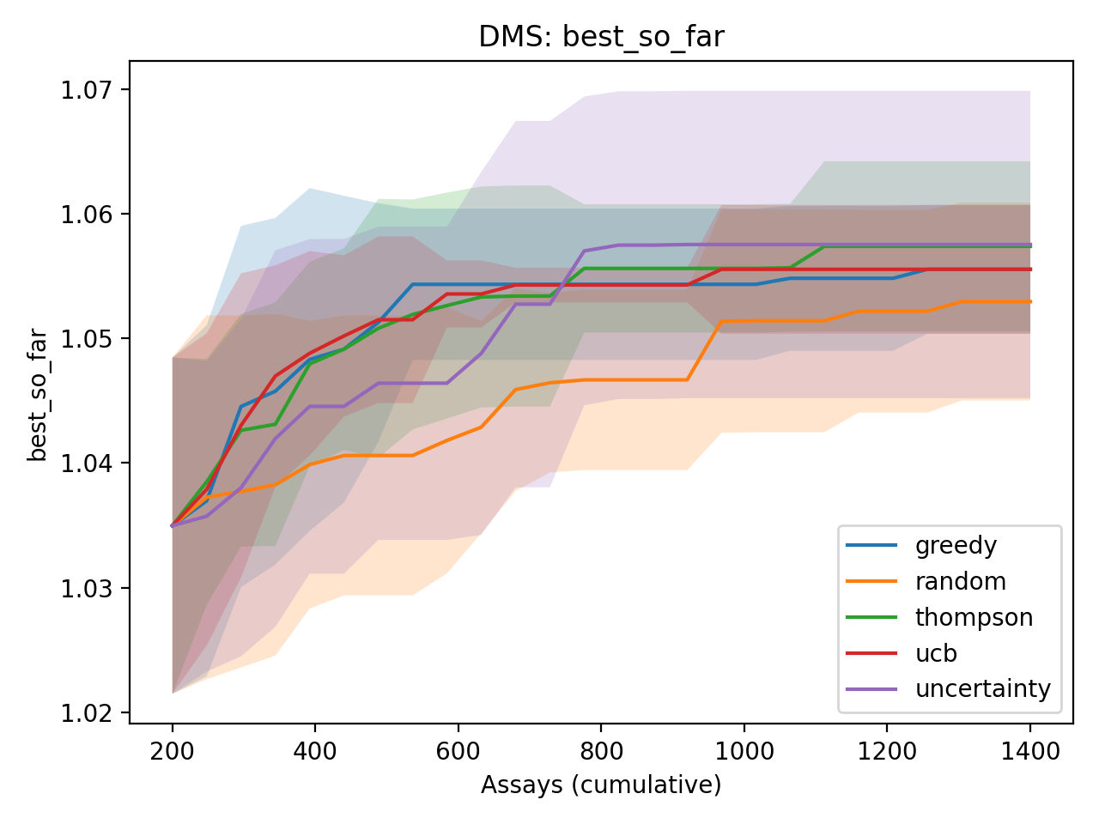

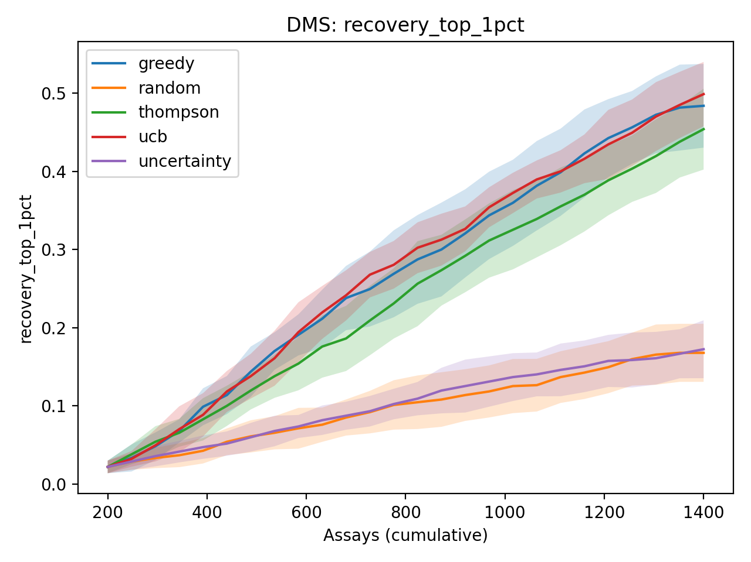

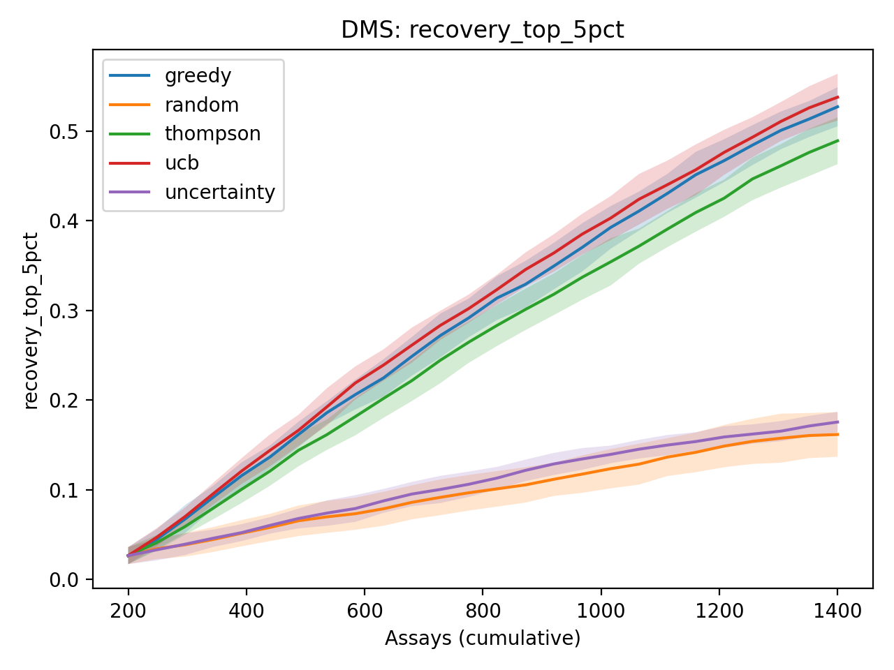

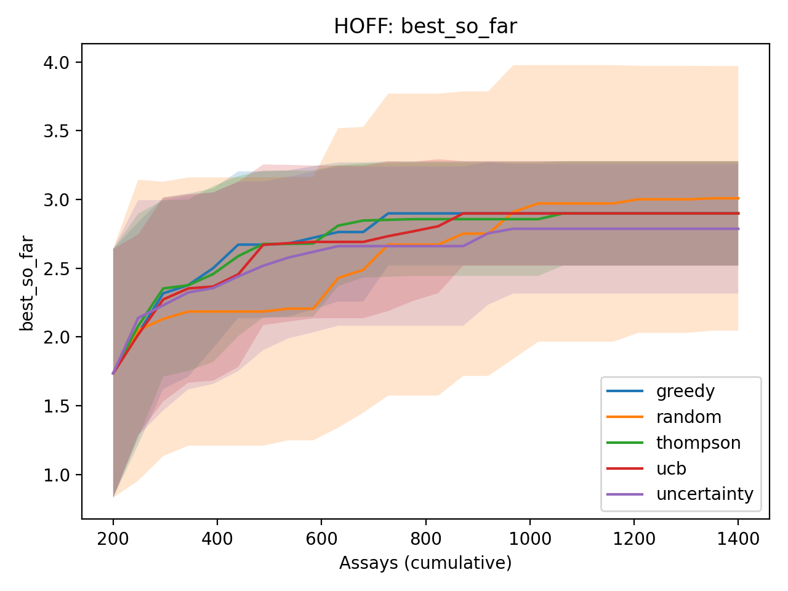

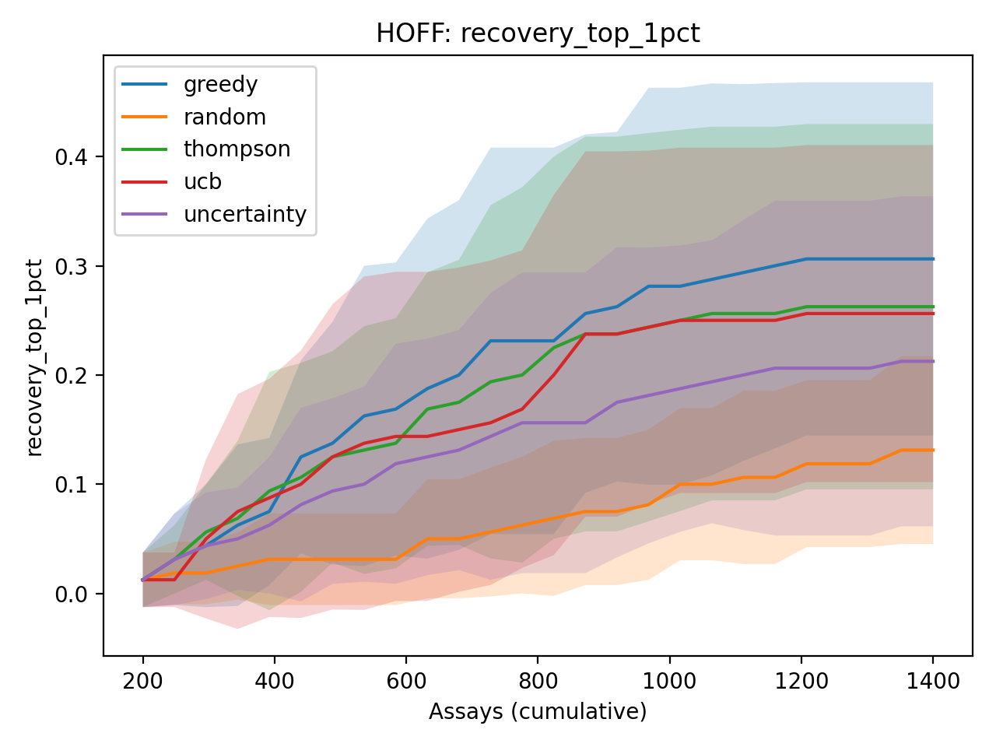

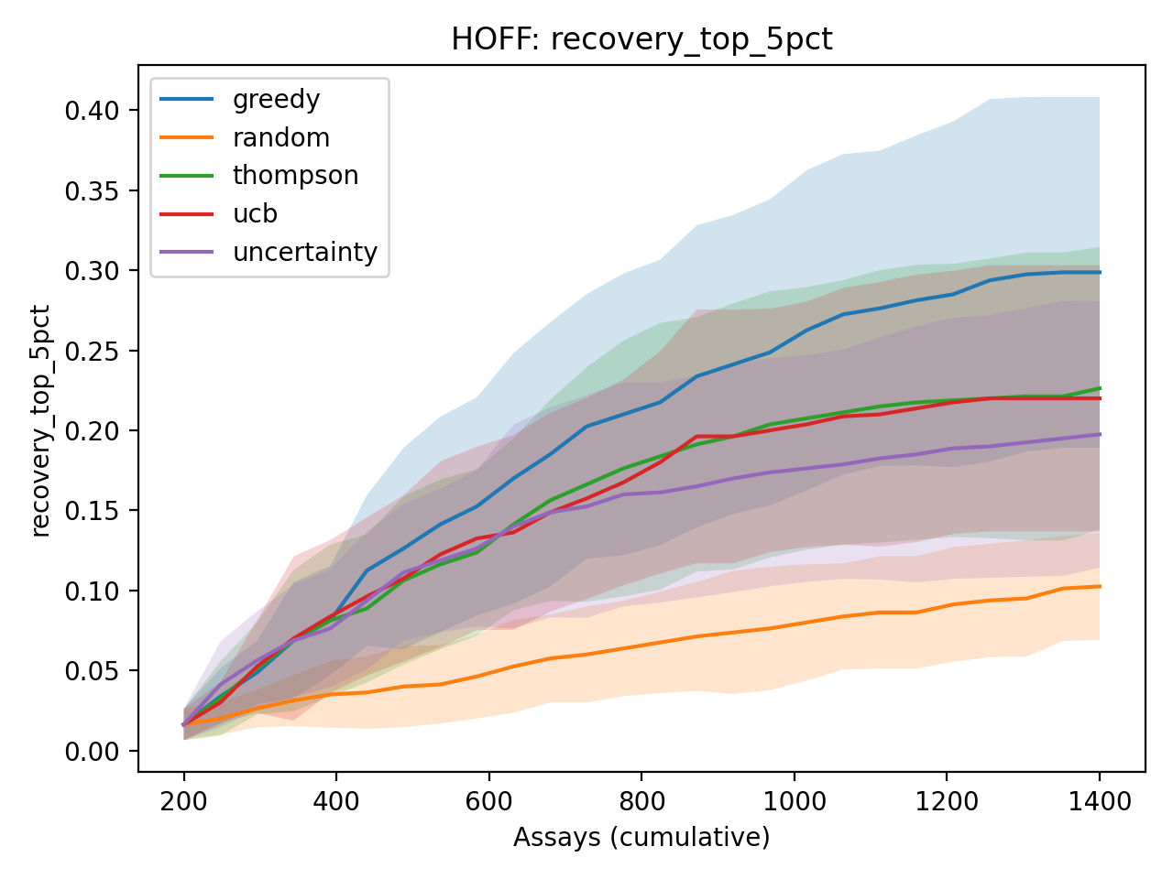

3.5. Supplementary context for growth and kinetic trade-offs
Supplementary analyses place the main mutational landscape results in a broader biological context. Rubisco is embedded in a multi scale system that spans enzyme level kinetics, host metabolism, resource allocation, and population level survival. We therefore asked two additional questions. First, how large is the growth throughput spread across commonly used cyanobacterial chassis in the literature. Second, do wild type rbcL sequence embeddings carry measurable signal about organismal growth and about cross species Rubisco kinetic parameters.
Supplementary Figure S1 reorganizes doubling times for Synechococcus elongatus UTEX 2973 and PCC 7942 across temperature, CO2, and light regimes reported in Yu and colleagues. This heatmap highlights that even for a single strain, reported doubling time varies substantially with cultivation regime, and some regimes yield no growth. Supplementary Figure S2 translates compiled doubling time ranges into a simple throughput proxy, the time required to achieve ten doublings under best case conditions. Error bars reflect literature ranges and emphasize that chassis choice can change experimental cycle time by an order of magnitude.
Using these growth data, we evaluated whether rbcL sequence embeddings correlate with organismal growth. A leave one out ridge regression on PCA components of ESM2 embeddings achieves strong rank agreement between predicted and observed log doubling time across cyanobacterial strains. This does not imply that Rubisco alone determines growth, but it supports the idea that evolutionary signatures in sequence can correlate with higher level physiology. We also benchmarked cross species prediction of Rubisco kinetic parameters using the Flamholz dataset. Embedding based ridge models show moderate predictability for KC and for specificity S, while other traits remain difficult, which is consistent with additional determinants such as carbon concentrating mechanisms, small subunit effects, and measurement heterogeneity.

4. Discussion
These results support the central claim that protein language model embeddings can provide actionable signal for Rubisco engineering when paired with lightweight predictors. The workflow is deliberately pragmatic. It assumes that practitioners can generate embeddings, train tabular models, and run conservative validation splits without building bespoke deep architectures.
Across the deep mutational scanning targets and the oxygen tolerance screen, TabPFN improves rank based generalization compared with XGBoost. In our summary analysis, the mean paired Spearman advantage is positive and the paired t test suggests a statistically significant difference, while the Wilcoxon signed rank test is marginal under small numbers of tasks. This combination is expected when effect direction is consistent but the sample size is limited. For enzyme engineering, the practical meaning is that a TabPFN style inductive bias can improve prioritization when data are scarce.
Active learning shifts the focus from final predictive accuracy to decision quality under an experimental budget. The simulation used here enforces a strict information barrier. At each iteration, the surrogate model only sees the variants that have already been selected and their measured scores. All remaining labels remain hidden until after selection. Under this constraint, uncertainty aware selection improves the best observed variant earlier than random selection, which indicates that even imperfect predictors can be valuable when coupled to a sequential decision policy.
In this project, XGBoost was used for the active learning loops because it is easy to reproduce, easy to tune, and permissively licensed for broad use. TabPFN was emphasized in benchmarking because it delivered stronger rank performance, but licensing and deployment constraints limited its use in the simulation code path at the time the runs were generated. This design choice makes the active learning results conservative. If a stronger predictor replaces XGBoost, the same acquisition policies are expected to improve because better ranking and uncertainty estimates increase the chance of selecting high value variants.
A central theme of Rubisco engineering is objective mismatch across scales. In vivo selection optimizes a multi objective fitness function that reflects resource allocation, stress tolerance, regulation, and competitive survival. Improved single enzyme kinetics can help, but fitness can also favor robustness, expression stability, and balanced flux through the broader network. Directed evolution in a growth coupled assay therefore tends to search regions of sequence space that improve that specific fitness proxy. This can miss sequences that are suboptimal for growth but valuable for ex vivo catalysis or industrial contexts where the objective is narrowly defined and where the host background can be engineered around the enzyme.
The supplementary cyanobacterial analyses provide an empirical anchor for this perspective. Doubling time varies widely across strains and culture conditions, which directly changes how quickly iterative engineering can be executed. The association between rbcL embeddings and growth rate across strains should be interpreted as a correlation that likely reflects shared evolutionary and ecological pressures, not a claim that Rubisco sequence alone determines growth. The weaker predictability of some kinetic traits across species in the Flamholz dataset further suggests that multi scale context and measurement conditions remain important determinants beyond large subunit sequence.
This workflow has immediate relevance for academic enzyme engineering and for industrial biocatalysis development. In sectors that range from crop improvement to carbon utilization and sustainable chemical synthesis, the ability to prioritize small numbers of sequence variants for testing is often the limiting step. Protein language model based embeddings reduce dependence on hand built features and improve transfer across projects, which makes them attractive as a general front end for experimental data pipelines.
Several limitations suggest clear next steps. Our predictors treat the mutational library as a closed pool, but recent protein generative models can propose new sequences outside a measured library, including language model based generation and structure conditioned design methods [27-30]. A natural extension is to combine generation with active learning. At each round, a generative model can propose candidate sequences and the surrogate model can prioritize which to build using the same acquisition logic used here. Another next step is to incorporate explicit multiobjective targets that reflect catalytic rate, specificity, stability, and host compatibility, which would more closely align the computational objective with the complex fitness landscape faced by cells.
Related machine learning workflows in cyanobacterial systems have also been explored in recent work by our group, including data driven approaches for characterizing diazotrophic cyanobacteria and metabolite signatures [25].

5. Conclusions
Protein language model embeddings combined with tabular learning provide a practical route to modeling Rubisco mutational landscapes across distinct experimental regimes. In both deep mutational scanning and cyanobacterial screening tasks, a tabular foundation model achieved higher rank based performance than gradient boosted trees. Retrospective active learning simulations showed that model guided decision making can substantially increase recovery of top variants under a fixed experimental budget.
These findings support a workflow where computational models inform experimental choices while remaining explicit about objective functions. Rubisco engineering exemplifies the broader need to balance computationally driven design with evolution driven design in complex biological systems. Making that balance explicit can help identify variants that are valuable for applied contexts even when they are not favored by organismal fitness.

Supplementary Materials
- Supplementary Figure S1. Heatmap of reported doubling times in hours for Synechococcus elongatus UTEX 2973 and PCC 7942 across temperature, CO2, and light conditions, adapted from Yu and colleagues [20]. NG indicates no growth under the reported condition. Blank cells indicate conditions that were not tested. This figure illustrates the strong dependence of apparent growth rate on cultivation regime.
- Supplementary Figure S2. Time required to achieve ten doublings for selected cyanobacterial chassis based on best case doubling time ranges compiled from Table S1. Bars show the lower bound using the minimum reported doubling time and error bars span the range up to the maximum reported doubling time when available. This provides a simple proxy for experimental cycle time and strain dependent throughput.
- Supplementary Figure S3. Leave one out cross validation predictions of log10 doubling time from ESM2 Rubisco large subunit embeddings across cyanobacterial strains. Embeddings were standardized and projected with PCA fit on the training fold only, then ridge regression was fit and evaluated on the held out strain to avoid leakage. The diagonal line indicates the identity relationship.
- Supplementary Table S1. Compiled cyanobacterial doubling times and derived growth rates.
- Supplementary Table S2. Nested cross validation ridge regression results for predicting Rubisco kinetic parameters from embeddings using the Flamholz compendium [18].

Author Contributions
Conceptualization, J.A.Y. Methodology, J.A.Y. Software, J.A.Y. Writing, J.A.Y. All authors have read and agreed to the published version of the manuscript.

Funding
This research received no external funding.

Institutional Review Board Statement
Not applicable.

Informed Consent Statement
Not applicable.

Data Availability Statement
All scripts and processed datasets used for this study are provided with the submission materials. Raw source datasets are available from the cited primary publications.

Conflicts of Interest
The authors declare no conflict of interest.

Appendix A. Supplementary Materials
Figure S1. Doubling time heatmap for Synechococcus elongatus UTEX 2973 across light and CO2 conditions.
This heatmap reorganizes reported doubling times from Yu et al [20] to emphasize how cultivation conditions change growth rate. Lower values indicate faster doubling. Several combinations of irradiance and CO2 concentration lead to rapid growth for UTEX 2973, while other conditions slow growth substantially. This variation matters for enzyme engineering because the same genetic modification can yield different realized productivity depending on the operating point of the cultivation system.
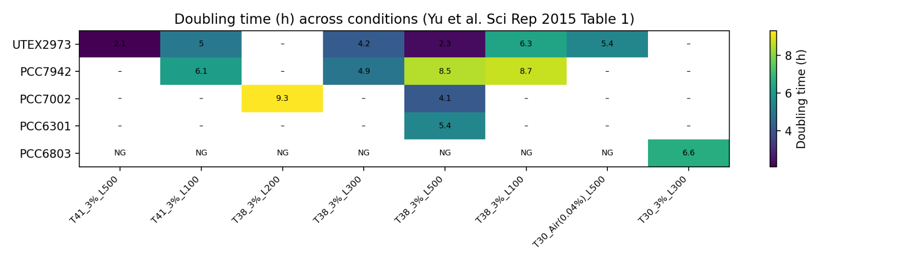

Figure S2. Time to ten doublings across cyanobacterial chassis.
This figure converts best case doubling times into the time needed for ten doublings, which corresponds to a 1024 fold increase in biomass. Faster doubling reduces the wall clock time required for selection, screening, or bioprocess ramp up. The plot also includes uncertainty ranges when multiple literature values exist. These chassis level differences provide a practical constraint on design build test learn cycle time that is separate from enzyme level performance.
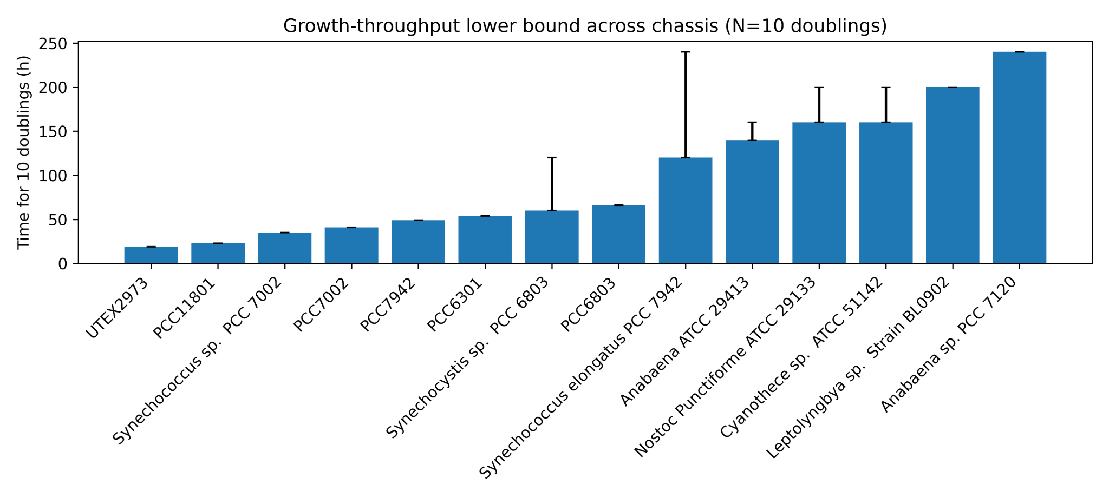

Figure S3. Predicting cyanobacterial growth rate from Rubisco large subunit embeddings.
We trained a ridge regression model on ESM2 embeddings of rbcL sequences for twelve cyanobacterial strains with compiled growth rates and evaluated using leave one out cross validation. This analysis is exploratory due to the small sample size and heterogeneous measurement conditions, but it suggests that sequence level variation in Rubisco carries measurable signal that correlates with growth phenotypes in some contexts. This supports the broader theme that enzyme sequence, cellular physiology, and growth rate are coupled through multiobjective constraints.
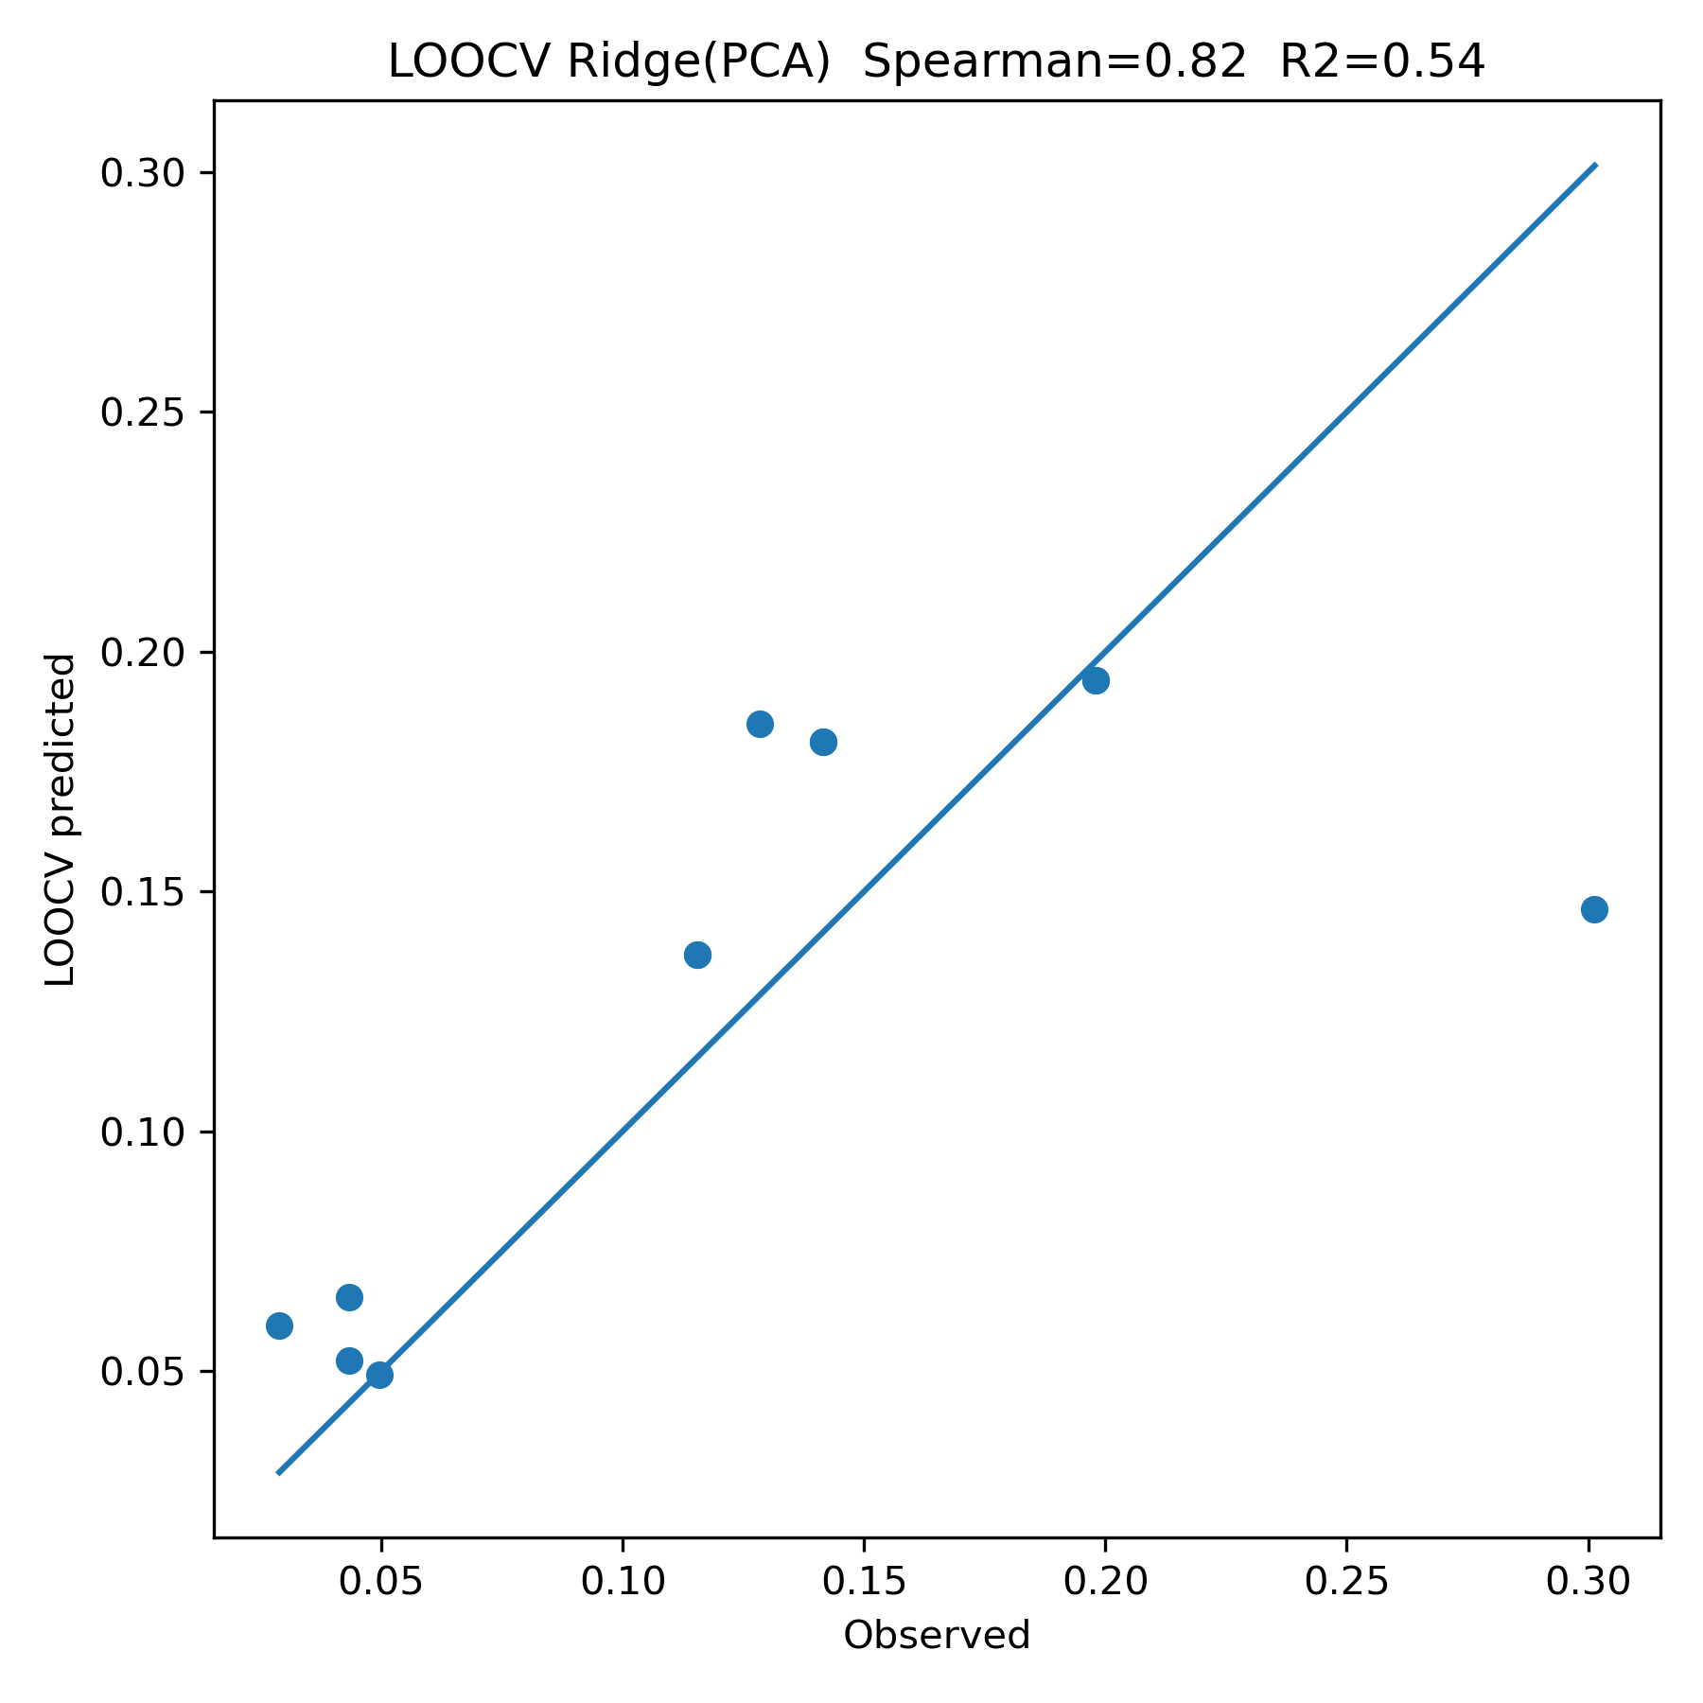

Table S1. Best case doubling times and derived growth rates for selected cyanobacterial chassis.
strain | doubling_time_min_h | doubling_time_max_h | mu_max_per_h | mu_min_per_h | temp_C | co2 | light_umol_photons_m2_s | data_type | reference
UTEX2973 | 1.90 | 1.90 | 0.365 | 0.365 | 41 | 3% | 500 | condition-specific | BioNumbers BNID 112485 (derived from Yu et al. 2015 text)
PCC11801 | 2.30 | 2.30 | 0.301 | 0.301 | nan | Air (0.04%) | nan | condition-specific | Jaiswal et al., 2018 (mBio) (doubling time under ambient CO2)
Synechococcus sp. PCC 7002 | 3.50 | 3.50 | 0.198 | 0.198 | 38 | nan | nan | approx/range | Xu et al., 2011
PCC7002 | 4.10 | 4.10 | 0.169 | 0.169 | 38 | 3% | 500 | condition-specific | Yu et al., 2015 (Sci Rep) Table 1
PCC7942 | 4.90 | 4.90 | 0.141 | 0.141 | 38 | 3% | 300 | condition-specific | Yu et al., 2015 (Sci Rep) Table 1
PCC6301 | 5.40 | 5.40 | 0.128 | 0.128 | 38 | 3% | 500 | condition-specific | Yu et al., 2015 (Sci Rep) Table 1
Synechocystis sp. PCC 6803 | 6.00 | 12.00 | 0.116 | 0.058 | 30 | nan | nan | approx/range | Heidorn et al., 2011
PCC6803 | 6.60 | 6.60 | 0.105 | 0.105 | 30 | 3% | 300 | condition-specific | Yu et al., 2015 (Sci Rep) Table 1
Synechococcus elongatus PCC 7942 | 12.00 | 24.00 | 0.058 | 0.029 | 38 | nan | nan | approx/range | Holtman et al., 2005
Anabaena ATCC 29413 | 14.00 | 16.00 | 0.050 | 0.043 | 30 | nan | nan | approx/range | Mannan & Pakrasi, 1993
Nostoc Punctiforme ATCC 29133 | 16.00 | 20.00 | 0.043 | 0.035 | 30 | nan | nan | approx/range | Meeks et al., 2001
Cyanothece sp. ATCC 51142 | 16.00 | 20.00 | 0.043 | 0.035 | 30 | nan | nan | approx/range | Alagesan et al., 2013
Leptolyngbya sp. Strain BL0902 | 20.00 | 20.00 | 0.035 | 0.035 | 30 | nan | nan | approx/range | Taton et al., 2012
Anabaena sp. PCC 7120 | 24.00 | nan | 0.029 | nan | 30 | nan | nan | approx/range | Ehira et al., 2011
Table S2. Predicting Rubisco kinetic parameters from embeddings using the Flamholz compendium. Metrics are cross validated using a nested scheme with ridge regression and PCA preprocessing. Standard deviation values are not available for this summarized output and are shown as NA. vO could not be evaluated after applying the quality filters described in the Supplementary Materials.
target | n | spearman_mean | spearman_std | r2_mean | r2_std | rmse_mean | rmse_std
S | 183 | 0.753 | NA | 0.381 | NA | 0.135 | NA
KC | 197 | 0.605 | NA | 0.424 | NA | 0.240 | NA
KO | 169 | 0.133 | NA | -0.274 | NA | 0.350 | NA
vC | 181 | 0.375 | NA | -2.211 | NA | 0.333 | NA
vO | NA | NA | NA | NA | NA | NA | NA

References
[1] Bar-On, Y.M., Phillips, R., Milo, R. The biomass distribution on Earth. Proceedings of the National Academy of Sciences of the United States of America. 2018.
[2] Ort, D.R., Merchant, S.S., Alric, J., et al. Redesigning photosynthesis to sustainably meet global food and bioenergy demand. Proceedings of the National Academy of Sciences of the United States of America. 2015.
[3] South, P.F., Cavanagh, A.P., Liu, H.W., Ort, D.R. Synthetic glycolate metabolism pathways stimulate crop growth and productivity in the field. Science. 2019.
[4] Arnold, F.H. Design by directed evolution. Accounts of Chemical Research. 1998.
[5] Romero, P.A., Krause, A., Arnold, F.H. Navigating the protein fitness landscape with Gaussian processes. Proceedings of the National Academy of Sciences of the United States of America. 2013.
[6] Yang, K.K., Wu, Z., Arnold, F.H. Machine learning guided directed evolution for protein engineering. Nature Methods. 2019.
[7] Biswas, S., Khimulya, G., Alley, E.C., Esvelt, K.M., Church, G.M. Low N protein engineering with data efficient deep learning. Nature Methods. 2021.
[8] Rives, A., Meier, J., Sercu, T., et al. Biological structure and function emerge from scaling unsupervised learning to 250 million protein sequences. Proceedings of the National Academy of Sciences of the United States of America. 2021.
[9] Lin, Z., Akin, H., Rao, R., et al. Evolutionary scale prediction of atomic level protein structure with a language model. Science. 2023.
[10] Notin, P., Dias, M., et al. ProteinGym, large scale benchmarks for protein fitness prediction. 2023.
[11] Prywes, N., et al. A map of the Rubisco biochemical landscape. 2025.
[12] Hoffmann, T., et al. A cyanobacterial screening platform for Rubisco mutant variants. 2025.
[13] Chen, T., Guestrin, C. XGBoost, a scalable tree boosting system. Proceedings of the 22nd ACM SIGKDD International Conference on Knowledge Discovery and Data Mining. 2016.
[14] Hollmann, N., Muller, S., Eggensperger, K., Hutter, F. TabPFN, a transformer that solves small tabular classification problems in a second. 2022.
[15] Muller, S., Pfisterer, F., et al. Accurate predictions on small data with a tabular foundation model. Nature. 2025.
[16] Auer, P., Cesa-Bianchi, N., Fischer, P. Finite time analysis of the multiarmed bandit problem. Machine Learning. 2002.
[17] Thompson, W.R. On the likelihood that one unknown probability exceeds another in view of the evidence of two samples. Biometrika. 1933.
[18] Flamholz, A., Prywes, N., Moran, U., Davidi, D., et al. Revisiting trade-offs between Rubisco kinetic parameters. Proceedings of the National Academy of Sciences of the United States of America. 2019.
[19] Shoval, O., Sheftel, H., Shinar, G., et al. Evolutionary trade-offs, Pareto optimality, and the geometry of phenotype space. Science. 2012.
[20] Yu, J., Liberton, M., Clouten, J., et al. A high light and temperature tolerant cyanobacterium for fast growth and robust photosynthesis. Scientific Reports. 2015.
[21] Jaiswal, D., Sengupta, A., Sohoni, S., et al. Genome features and biochemical characteristics of a rapidly growing cyanobacterium Synechococcus elongatus PCC 11801. Scientific Reports. 2018.
[22] Greenman, K., et al. Uncertainty quantification and deep active learning in protein engineering. 2025.
[23] Wilcoxon, F. Individual comparisons by ranking methods. Biometrics Bulletin. 1945.
[24] Dietterich, T.G. Approximate statistical tests for comparing supervised classification learning algorithms. Neural Computation. 1998.
[25] Young, J.A., et al. Secondary Metabolites Predict Diazotrophic Cyanobacteria, A Model Based Cheminformatic Approach. Metabolites. 2025, 15, 562.
[26] Prior Labs. TabPFN documentation and model checkpoint terms. 2025.
[27] Madani, A., et al. ProGen, Language Modeling for Protein Generation. NeurIPS. 2020.
[28] Dauparas, J., et al. Robust deep learning based protein sequence design using ProteinMPNN. Science. 2022. doi 10.1126/science.add2187.
[29] Watson, J.L., et al. De novo design of protein structure and function with RFdiffusion. Nature. 2023. doi 10.1038/s41586-023-06415-8.
[30] Hayes, T., et al. Simulating 500 million years of evolution with a language model. Preprint. 2024.
[31] Demsar, J. Statistical comparisons of classifiers over multiple data sets. Journal of Machine Learning Research. 2006, 7, 1-30.

