James Young HW10

1. **Show the details of how you would randomly assign the 4 varieties to the plots. This is straightforward.**

There are 5 plots per farm and 4 varieties to test. I would start with a baseline arrangement and use a sliding window approach to randomize the arrangement throughout the farms. (example below)

|  |  |  |  |  |  |
| --- | --- | --- | --- | --- | --- |
|  | Plot 1 | Plot 2 | Plot 3 | Plot 4 | Plot 5 |
| Farm 1 | Var07 | Var101 |  | Var289 | Var389 |
| Farm 2 | Var389 | Var07 |  | Var101 | Var289 |
| Farm 3 | Var289 | Var389 |  | Var07 | Var101 |

1. **How many different arrangements of the 4 varieties are possible in each of the farms? Hint: Just calculate this using the correct factorial. Use the right notation.**

5! = 5x4x3x2x1 = 120 combinations (if considering the fact there are 5 experimental units/block as mentioned in HW guidelines)

4! =4x3x2x1 = 24 combinations (if considering only varieties)

1. **How many different arrangements are possible for the whole study of 9 farms? Hint: use part (b) to find this value.**

If using 4! Then it is 24X23X22X21x20x19x18x17x16 = 4.7e11 arrangements

If using 5! Then it is 120x119x118x117x116x115x114x113x112=3.8e18 arrangements

1. **What is the experimental unit? Simply state the correct experimental units, Use the definitions on pages 533-534.**

The one-acre plots within each farm are the experimental unit. This means the farm is the block.

(a) Identify the design and treatment structure for this study.

|  |  |  |  |  |  |
| --- | --- | --- | --- | --- | --- |
|  | Plot 1 | Plot 2 | Plot 3 | Plot 4 | Plot 5 |
| Farm 1 | Var07 | Var101 |  | Var289 | Var389 |
| Farm 2 | Var389 | Var07 |  | Var101 | Var289 |
| Farm n… | … | … | … | … | … |

Each farm is a block and each block has 5 experimental units which are the plots. The experiment will be set up in a random block design using sliding window approach.

(b) Write a model for this study, identifying all the terms in the model. Simply state the model, hint: page 527. Make sure you name all the parts for each parameter in the model.

$$y_{ij}=μ+τ_{i}+β_{j}+ε_{ij,}$$

where $y_{ij}$ =observed response for treatment i in block j; μ =reference value (overall mean); $τ_{i}$ =effect of var treatment i, i=1,2,3,4; $β_{j}$ =effect of block j, j =1,2,3,4,5,6,7,8,9; and $ε_{ij}$ =experimental(random) error.

(c) Prepare an interaction plots and show snip. Prepare side by side interaction plots with:

• Using farm on x-axis and var as the factor in the plot

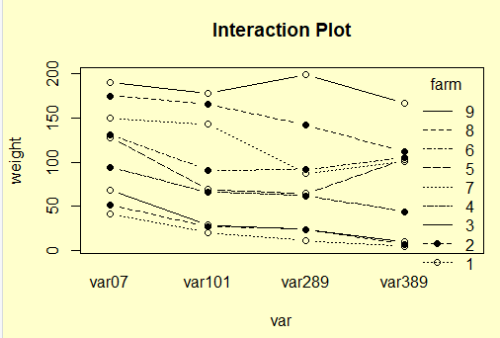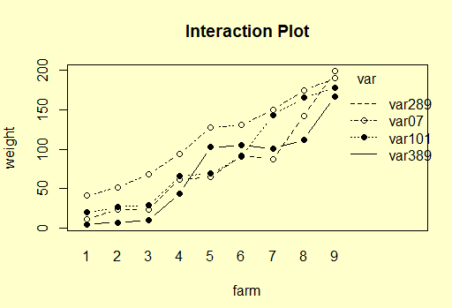

Make some comments as to what you see.

I see a strong interaction between farms 4 and 5 when looking at var101 and var289 and var389 and also a strong interaction between farm 7 and 8 looking at var289 and var389 and again a strong interaction between farm 8 and 9 between var289 and all other var’s.

R- code Appendix

### HW 10

setwd("C:\\data\\")

y <- read.csv("HW10.csv")

par(mfrow=c(1,1))

with(y, interaction.plot

(x.factor=farm,trace.factor=var,

response=weight,fun=mean, type="b", ylab="weight",

main="Interaction Plot",pch=c(1,19)))

with(y, interaction.plot

(x.factor=var,trace.factor=farm,

response=weight,fun=mean, type="b", ylab="weight",

main="Interaction Plot",pch=c(1,19)))