概述

线程的定义(Introduction)
Threads can best be described as “lightweight processes”. The traditional UNIX-style notion of a process has been found to be inconvenient, if not inadequate for several applications in distributed systems development. The needs of these applications are best served by threads, which generalize the notion of a process so that it can be associated with multiple activities. The popularity of threads has resulted in their implementation on UNIX systems and thread libraries are now widely available to programmers for the development of concurrent applications.

Threads Implementation
Threads can be implemented in one of two ways:
1. User-level threads:
There is no kernel support for multi-threaded processes. Hence, the kernel only has a single-threaded process abstraction, but multi-threaded processes are implemented in a library of procedures linked with application programs. The kernel has no knowledge of lightweight processes (threads), and therefore cannot schedule them independently. A threads run-time library organizes the scheduling of threads. A thread would block the process and therefore all threads within it if it made a blocking system call, so the asynchronous I/O facilities of UNIX are used. The major disadvantage of this scheme is that threads within a process cannot take advantage of a multi-processor.
（上段译文）User-level没有核心支持的多线程的进程。因此，核心只有单线程进程概念，而多线程进程由与应用程序连接的过程库实现。核心不知道线程的存在，也就不能独立的调度这些线程了。一个线程运行库组织线程的调度。如果一个线程调用了一个阻塞的系统调用，进程可能被阻塞，当然其中的所有线程也同时被阻塞，所以UNIX使用了异步I/O工具。这种机制的的最大缺点是不能发挥多处理器的优势。
The advantages include:
- （系统消耗小）Certain thread operations are significantly less costly. For example, switching between threads belonging to the same process do not necessarily involve a system call, and hence save this over-head.
- （可以修改以适应特殊的应用）User-level thread implementations can be customized or changed to suit the particular application requirements. This is particularly useful for real-time multimedia processing etc. Also, it is possible to support many more user-level threads than can by default by a kernel.
2. Kernel-level threads:
This implementation allows threads within different processes to be scheduled according to a single scheme of relative prioritizing. This is suited for exploiting the concurrence of multiprocessors.
核心级线程如许不同进程里的线程按照同一相对优先方法调度，这适合于发挥多处理器的并发优点。
Most of the current thread library implementations available today implement user-level threads. There have been several research projects that have implemented some form of Kernel-level threads. Notable among these are the Mach distributed OS, which combines the advantages of user-level and kernel-level threads by allowing user-level code to provide scheduling hints to the kernel thread scheduler. By providing such a two-level scheduling scheme, the kernel retains control over the allocation of processor time, but also allows a process to take advantage of multiple processors.

Thread Libraries
The two most widely used thread libraries are POSIX and Solaris thread libraries. Both implementations are inter-operable, their functionality is similar, and can be used within the same application. However, only POSIX threads are guaranteed to be fully portable to other POSIX-compliant environments.
Similarities:
Most of the functions in both libraries, libpthread and libthread, have a counterpart in the other library. POSIX functions and Solaris functions, whose names have similar endings, usually have similar functionality, number of arguments, and use of arguments. All POSIX threads function names begin with the prefix pthread? where as the Solaris threads function names begin with the prefix thr?
Differences:
POSIX
- is more portable
- establishes characteristics for each thread according to configurable attribute objects
- implements thread cancellation
- enforces scheduling algorithms
- allows for clean-up handlers for fork(2) calls
Solaris
- threads can be suspended and continued
- implements an optimized mutex, readers/writer locking
- may increase the concurrency
- implements daemon threads, for whose demise the process does not wait

Threads Standards
There are three different definitions for thread libraries competing for attention today: Win32, OS/2, and POSIX. The first two are proprietary and limited to their individual platforms (Win32 threads run only under NT and Win95, OS/2 threads on OS/2). The POSIX specification (IEEE 1003.1c, aka Pthreads) is intended for all computing platforms, and implementations are available or in the works for almost all major UNIX systems (including Linux), along with VMS.

POSIX Threads
The POSIX standard defines the API and behavior that all the Pthreads libraries must meet. It is part of the extended portion of POSIX, so it is not a requirement for meeting XPG4, but it is required for X/Open UNIX 98, and all major UNIX vendors have committed to meeting this standard. As of this writing, (7/97) almost all UNIX vendors have released a library.

Win32 and OS/2 Threads
Both the NT and OS/2 implementations contain some fairly radical differences
from the POSIX standard——to the degree that even porting from one or the other
to POSIX will prove moderately challenging. Microsoft has not announced any
plans to adopt POSIX. There are freeware POSIX libraries for Win32 (see
Commercial Products on page 249), and OS/2 also has an optional POSIX library.

DCE Threads
Before POSIX completed work on the standard, it produced a number of drafts which it published for comment. Draft 4 was used as the basis for the threads library in DCE. It is similar to the final spec, but it does contain a number of significant differences. Presumably, no one is writing any new DCE code.

Solaris Threads
Also known as UI threads, this is the library, which SunSoft used in developing Solaris 2 before the POSIX, committee completed their work. It will be available on Solaris 2 for the foreseeable future, although we expect most applications writers will opt for Pthreads. The vast majority of the two libraries are virtually identical.

Linux线程的思想及特点

LinuxThreads
http://pauillac.inria.fr/~xleroy/linuxthreads
Xavier Leroy at INRIA (Paris, France), with input from Pavel Krauz, Richard Henderson and others, has developed a Pthreads library that implements the One-to-One model, allowing it to take advantage of multiple processors. It is based on the new Linux system call, clone()2 . It runs on Linux 2.0 and up, on Intel, Alpha, SPARC, m68k, and MIPS machines. One limitation is its non-standard implementation of signal handling.

Implementation model for LinuxThreads
LinuxThreads follows the so-called "one-to-one" model: each thread is actually a separate process in the kernel. The kernel scheduler takes care of scheduling the threads, just like it schedules regular processes. The threads are created with the Linux clone() system call, which is a generalization of fork() allowing the new process to share the memory space, file descriptors, and signal handlers of the parent.
LinuxThreads采用称为1-1模型：每个线程实际上在核心是一个个单独的进程，核心的调度程序负责线程的调度，就象调度普通进程。线程是用系统调用clone()创建的，clone()系统调用是fork()的普遍形式，它允许新进程共享父进程的存储空间、文件描述符和软中断处理程序。
Advantages of the "one-to-one" model include:

- Minimal overhead on CPU-intensive multiprocessing (with about one thread per processor); 最小限度消耗的CPU级多处理技术（每个CPU一个线程）；
- Minimal overhead on I/O operations; 最小限度消耗的I/O操作；
- A simple and robust implementation (the kernel scheduler does most of the hard work for us)；一种简单和强壮的实现（核心调度程序为我们做了大部分艰难的工作）。

The main disadvantage is more expensive context switches on mutex and condition operations, which must go through the kernel. This is mitigated by the fact that context switches in the Linux kernel are pretty efficient.

Consider other implementation models

There are basically two other models. The "many-to-one" model relies on a user-level scheduler that context-switches between the threads entirely in user code; viewed from the kernel, there is only one process running. This model is completely out of the question for me, since it does not take advantage of multiprocessors, and require unholy magic to handle blocking I/O operations properly. There are several user-level thread libraries available for Linux, but I found all of them deficient in functionality, performance, and/or robustness.
还有另外两种基本模型。多对一模型依赖于用户级的调度程序，线程切换完全由用户程序完成；从核心角度看，只有一个进程正在运行。这种模型不是我们所关心的，因为它无法利用多处理器的优点，而且要用不合理的方法处理I/O操作阻塞。
The "many-to-many" model combines both kernel-level and user-level scheduling: several kernel-level threads run concurrently, each executing a user-level scheduler that selects between user threads. Most commercial Unix systems (Solaris, Digital Unix and IRIX) implement POSIX threads this way. This model combines the advantages of both the "many-to-one" and the "one-to-one" model, and is attractive because it avoids the worst-case behaviors of both models -- especially on kernels where context switches are expensive, such as Digital Unix. Unfortunately, it is pretty complex to implement, and requires kernel supporting which Linux does not provide. Linus Torvalds and other Linux kernel developers have always been pushing the "one-to-one" model in the name of overall simplicity, and are doing a pretty good job of making kernel-level context switches between threads efficient. LinuxThreads is just following the general direction they set.

Linux核心对线程的支持
Linux核心对线程的支持主要是通过其系统调用，下文将进行系统的介绍。

系统调用clone()
以下是系统调用clone的代码：
asmlinkage int sys_clone(struct pt_regs regs)
{
unsigned long clone_flags;
unsigned long newsp;

clone_flags = regs.ebx;
newsp = regs.ecx;
if (!newsp)
newsp = regs.esp;
return do_fork(clone_flags, newsp, &regs);
}

与系统调用clone功能相似的系统调用有fork,但fork事实上只是clone的功能的一部分，clone与fork的主要区别在于传递了几个参数，而当中最重要的参数就是conle_flags,下表是系统定义的几个clone_flags标志：
标志 | Value | 含义
CLONE_VM | 0x00000100 | 置起此标志在进程间共享VM
CLONE_FS | 0x00000200 | 置起此标志在进程间共享文件系统信息
CLONE_FILES | 0x00000400 | 置起此标志在进程间共享打开的文件
CLONE_SIGHAND | 0x00000800 | 置起此标志在进程间共享信号处理程序
如果置起以上标志所做的处理分别是：
置起CLONE_VM标志：
mmget(current->mm);
/*
* Set up the LDT descriptor for the clone task.
*/
copy_segments(nr, tsk, NULL);
SET_PAGE_DIR(tsk, current->mm->pgd);
置起CLONE_ FS标志：
atomic_inc(&current->fs->count);
置起CLONE_ FILES标志：
atomic_inc(&oldf->count);
置起CLONE_ SIGHAND标志：
atomic_inc(&current->sig->count);

与线程调度相关的系统调用
以下是glibc-linuxthread用来进行调度的系统调度：
.long SYMBOL_NAME(sys_sched_setparam) /* 系统调用154 */
/*用来设置进程（或线程）的调度参数*/
.long SYMBOL_NAME(sys_sched_getparam)
/*用来获取进程（或线程）的调度参数*/
.long SYMBOL_NAME(sys_sched_setscheduler)
/*用来设置进程（或线程）的调度参数*/
.long SYMBOL_NAME(sys_sched_getscheduler)
/*用来获取进程（或线程）的调度参数*/
.long SYMBOL_NAME(sys_sched_yield)
/*用来强制核心重新调度进程（或线程）*/
.long SYMBOL_NAME(sys_sched_get_priority_max)
/*用来设置进程（或线程）的调度参数*/
.long SYMBOL_NAME(sys_sched_get_priority_min)
/*用来获取进程（或线程）的调度参数*/
.long SYMBOL_NAME(sys_sched_rr_get_interval) /* 系统调用161 */
/*用来获取进程（或线程）的调度时间间隔*/

Linux线程的实现

LinuxThreads概述
现在的0.8版LinuxThreads，是迄今为止在Linux下支持threads的最好的Runtime-library，而包含0.8版LinuxThreads的最好的Runtime-library是glibc- 2.1，下文所要分析的正是glibc-linuxthreads-2.1。
首先介绍一下0.8版LinuxThreads，它实现了一种BiCapitalized面向Linux的Posix 1003.1c"pthread"标准接口。LinuxThreads提供核心级线程即每个线程是一个独立的UNIX进程，通过调用新的系统调用与其它线程共享地址空间。线程由核心调度，就象UNIX进程调度一样。使用它的要求是：LINUX 版本2.0 或以上（要求有新的clone() 系统调用和新的实时调度程序）。对于Intel平台：要求有libc 5.2.18或后续版本，推荐使用5.2.18 或 5.4.12 及其后续版本；5.3.12和5.4.7有问题，也支持glibc 2,实际上是支持它的一个特别合适的版本。到目前支持Intel, Alpha, Sparc, Motorola 68k, ARM and MIPS平台，还支持多处理器

主要的数据结构及初始化

数据结构和部分数据初始化
/* Arguments passed to thread creation routine */
//传递给线程创建程序的参数
struct pthread_start_args {
void * (*start_routine)(void *); /* function to run */
void * arg; /* its argument */
sigset_t mask; /* initial signal mask for thread */
int schedpolicy; /* initial scheduling policy (if any) */
struct sched_param schedparam; /* initial scheduling parameters (if any) */
};

/* The type of thread descriptors */
//线程描述符类型
typedef struct _pthread_descr_struct * pthread_descr;

struct _pthread_descr_struct {
pthread_descr p_nextlive, p_prevlive;
/* Double chaining of active threads */
pthread_descr p_nextwaiting; /* Next element in the queue holding the thr */
pthread_t p_tid; /* Thread identifier */
int p_pid; /* PID of Unix process */
int p_priority; /* Thread priority (== 0 if not realtime) */
struct _pthread_fastlock * p_lock; /* Spinlock for synchronized accesses */
int p_signal; /* last signal received */
sigjmp_buf * p_signal_jmp; /* where to siglongjmp on a signal or NULL */
sigjmp_buf * p_cancel_jmp; /* where to siglongjmp on a cancel or NULL */
char p_terminated; /* true if terminated e.g. by pthread_exit */
char p_detached; /* true if detached */
char p_exited; /* true if the assoc. process terminated */
void * p_retval; /* placeholder for return value */
int p_retcode; /* placeholder for return code */
pthread_descr p_joining; /* thread joining on that thread or NULL */
struct _pthread_cleanup_buffer * p_cleanup; /* cleanup functions */
char p_cancelstate; /* cancellation state */
char p_canceltype; /* cancellation type (deferred/async) */
char p_canceled; /* cancellation request pending */
int * p_errnop; /* pointer to used errno variable */
int p_errno; /* error returned by last system call */
int * p_h_errnop; /* pointer to used h_errno variable */
int p_h_errno; /* error returned by last netdb function */
char * p_in_sighandler; /* stack address of sighandler, or NULL */
char p_sigwaiting; /* true if a sigwait() is in progress */
struct pthread_start_args p_start_args; /* arguments for thread creation */
void ** p_specific[PTHREAD_KEY_1STLEVEL_SIZE]; /* thread-specific data */
void * p_libc_specific[_LIBC_TSD_KEY_N]; /* thread-specific data for libc */
int p_userstack; /* nonzero if the user provided the stack */
void *p_guardaddr; /* address of guard area or NULL */
size_t p_guardsize; /* size of guard area */
pthread_descr p_self; /* Pointer to this structure */
int p_nr; /* Index of descriptor in __pthread_handles */
};

/* The type of thread handles. */
线程句柄
typedef struct pthread_handle_struct * pthread_handle;

struct pthread_handle_struct {
struct _pthread_fastlock h_lock; /* Fast lock for sychronized access */
pthread_descr h_descr; /* Thread descriptor or NULL if invalid */
char * h_bottom; /* Lowest address in the stack thread */
};

/* The type of messages sent to the thread manager thread */
//发送给线程管理线程的请求
struct pthread_request {
pthread_descr req_thread; /* Thread doing the request */
enum { /* Request kind */
REQ_CREATE, REQ_FREE, REQ_PROCESS_EXIT, REQ_MAIN_THREAD_EXIT,
REQ_POST, REQ_DEBUG
} req_kind;
union { /* Arguments for request */
struct { /* For REQ_CREATE: */
const pthread_attr_t * attr; /* thread attributes */
void * (*fn)(void *); /* start function */
void * arg; /* argument to start function */
sigset_t mask; /* signal mask */
} create;
struct { /* For REQ_FREE: */
pthread_t thread_id; /* identifier of thread to free */
} free;
struct { /* For REQ_PROCESS_EXIT: */
int code; /* exit status */
} exit;
void * post; /* For REQ_POST: the semaphore */
} req_args;
};

/* One end of the pipe for sending requests to the thread manager. */
//向管理线程发送请求的管道的一端；初始化为-1表示管理线程还没有创建
int __pthread_manager_request = -1;

/* Other end of the pipe for sending requests to the thread manager. */

int __pthread_manager_reader;

//线程的堆栈大小
#define STACK_SIZE (2 * 1024 * 1024)
//线程的初始堆栈大小
#define INITIAL_STACK_SIZE (4 * PAGE_SIZE)

/* Attributes for threads. */
//线程的属性
typedef struct
{
int __detachstate;
int __schedpolicy;
struct __sched_param __schedparam;
int __inheritsched;
int __scope;
size_t __guardsize;
int __stackaddr_set;
void *__stackaddr;
size_t __stacksize;
} pthread_attr_t;

//每个进程的最大线程数
#define PTHREAD_THREADS_MAX 1024

Main thread and manager thread initializing

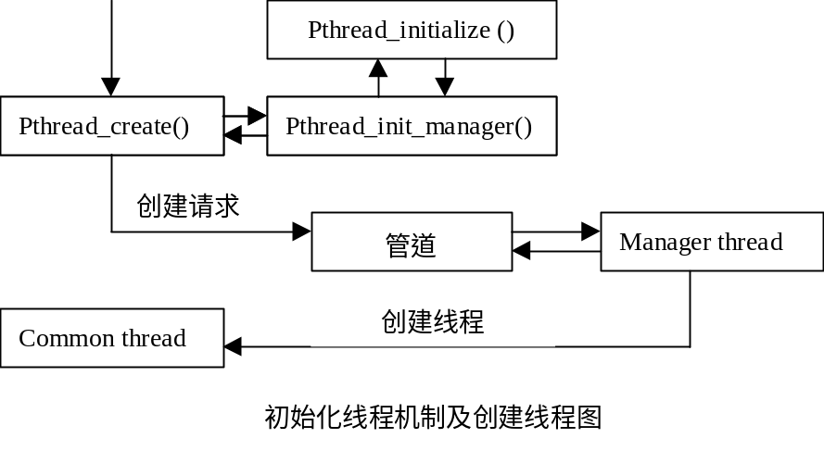

/* Thread creation */

int __pthread_create_2_1(pthread_t *thread, const pthread_attr_t *attr,
void * (*start_routine)(void *), void *arg)
{
pthread_descr self = thread_self();
struct pthread_request request;
if (__pthread_manager_request < 0) { //检查是否启动线程机制
//初始化管理线程，启动线程机制
if (__pthread_initialize_manager() < 0) return EAGAIN;
}
request.req_thread = self;
request.req_kind = REQ_CREATE;
request.req_args.create.attr = attr;
request.req_args.create.fn = start_routine;
request.req_args.create.arg = arg;
sigprocmask(SIG_SETMASK, (const sigset_t *) NULL,
&request.req_args.create.mask);
//向管理线程发送请求
__libc_write(__pthread_manager_request, (char *) &request, sizeof(request));
suspend(self);
if (THREAD_GETMEM(self, p_retcode) == 0)
*thread = (pthread_t) THREAD_GETMEM(self, p_retval);
return THREAD_GETMEM(self, p_retcode);
}

int __pthread_initialize_manager(void)
{
int manager_pipe[2];
int pid;
struct pthread_request request;

/* If basic initialization not done yet (e.g. we're called from a constructor run before our constructor), do it now */
//初始化初始线程
if (__pthread_initial_thread_bos == NULL) pthread_initialize();
/* Setup stack for thread manager */建立管理线程堆栈
__pthread_manager_thread_bos = malloc(THREAD_MANAGER_STACK_SIZE);
if (__pthread_manager_thread_bos == NULL) return -1;
__pthread_manager_thread_tos =
__pthread_manager_thread_bos + THREAD_MANAGER_STACK_SIZE;
/* Setup pipe to communicate with thread manager */
//建立与管理线程通信的管道
if (pipe(manager_pipe) == -1) {
free(__pthread_manager_thread_bos);
return -1;
}
/* Start the thread manager */启动管理线程
pid = __clone(__pthread_manager, (void **) __pthread_manager_thread_tos,
CLONE_VM | CLONE_FS | CLONE_FILES | CLONE_SIGHAND
, (void *)(long)manager_pipe[0]);
if (pid == -1) {
free(__pthread_manager_thread_bos);
__libc_close(manager_pipe[0]);
__libc_close(manager_pipe[1]);
return -1;
}
__pthread_manager_request = manager_pipe[1]; /* writing end */
__pthread_manager_reader = manager_pipe[0]; /* reading end */
__pthread_manager_thread.p_pid = pid;
/* Make gdb aware of new thread manager */
if (__pthread_threads_debug && __pthread_sig_debug > 0)
{
raise(__pthread_sig_debug);
/* We suspend ourself and gdb will wake us up when it is
ready to handle us. */
suspend(thread_self());
}
/* Synchronize debugging of the thread manager */
request.req_kind = REQ_DEBUG;
__libc_write(__pthread_manager_request, (char *) &request, sizeof(request));
return 0;
}
//初始化初始线程
static void pthread_initialize(void)
{
struct sigaction sa;
sigset_t mask;
struct rlimit limit;
int max_stack;

/* If already done (e.g. by a constructor called earlier!), bail out */
if (__pthread_initial_thread_bos != NULL) return;
#ifdef TEST_FOR_COMPARE_AND_SWAP
/* Test if compare-and-swap is available */
__pthread_has_cas = compare_and_swap_is_available();
#endif
/* For the initial stack, reserve at least STACK_SIZE bytes of stack below the current stack address, and align that on a STACK_SIZE boundary. */
//当前堆栈下为初始堆栈留出至少STACK_SIZE，并按STACK_SIZE对齐
__pthread_initial_thread_bos =
(char *)(((long)CURRENT_STACK_FRAME - 2 * STACK_SIZE) & ~(STACK_SIZE - 1));
/* Play with the stack size limit to make sure that no stack ever grows
beyond STACK_SIZE minus two pages (one page for the thread descriptor
immediately beyond, and one page to act as a guard page). */
//调整堆栈大小限制使其不能增长超过STACK_SIZE减两页（一页给线程
//描述符，一页作为保护页）
getrlimit(RLIMIT_STACK, &limit);
max_stack = STACK_SIZE - 2 * __getpagesize();
if (limit.rlim_cur > max_stack) {
limit.rlim_cur = max_stack;
setrlimit(RLIMIT_STACK, &limit);
}
/* Update the descriptor for the initial thread. */
__pthread_initial_thread.p_pid = __getpid();
/* If we have special thread_self processing, initialize that for the
main thread now. */
#ifdef INIT_THREAD_SELF
INIT_THREAD_SELF(&__pthread_initial_thread, 0);
#endif
/* The errno/h_errno variable of the main thread are the global ones. */
__pthread_initial_thread.p_errnop = &_errno;
__pthread_initial_thread.p_h_errnop = &_h_errno;
#ifdef SIGRTMIN
/* Allocate the signals used. */分配使用的软中断号
__pthread_sig_restart = __libc_allocate_rtsig (1);
__pthread_sig_cancel = __libc_allocate_rtsig (1);
__pthread_sig_debug = __libc_allocate_rtsig (1);
if (__pthread_sig_restart < 0 ||
__pthread_sig_cancel < 0 ||
__pthread_sig_debug < 0)
{
/* The kernel does not support real-time signals. Use as before
the available signals in the fixed set.
Debugging is not supported in this case. */
__pthread_sig_restart = DEFAULT_SIG_RESTART;
__pthread_sig_cancel = DEFAULT_SIG_CANCEL;
__pthread_sig_debug = 0;
}
#endif
/* Setup signal handlers for the initial thread.
Since signal handlers are shared between threads, these settings
will be inherited by all other threads. */
//设置初始进程的信号处理程序
#ifndef __i386__
sa.sa_handler = pthread_handle_sigrestart;
#else
sa.sa_handler = (__sighandler_t) pthread_handle_sigrestart;
#endif
sigemptyset(&sa.sa_mask);
sa.sa_flags = 0;
__sigaction(__pthread_sig_restart, &sa, NULL);
#ifndef __i386__
sa.sa_handler = pthread_handle_sigcancel;
#else
sa.sa_handler = (__sighandler_t) pthread_handle_sigcancel;
#endif
sa.sa_flags = 0;
__sigaction(__pthread_sig_cancel, &sa, NULL);
if (__pthread_sig_debug > 0) {
sa.sa_handler = pthread_handle_sigdebug;
sigemptyset(&sa.sa_mask);
sa.sa_flags = 0;
__sigaction(__pthread_sig_debug, &sa, NULL);
}
/* Initially, block __pthread_sig_restart. Will be unblocked on demand. */
sigemptyset(&mask);
sigaddset(&mask, __pthread_sig_restart);
sigprocmask(SIG_BLOCK, &mask, NULL);
/* Register an exit function to kill all other threads. */
/* Do it early so that user-registered atexit functions are called
before pthread_exit_process. */
__on_exit(pthread_exit_process, NULL);
}

线程的创建

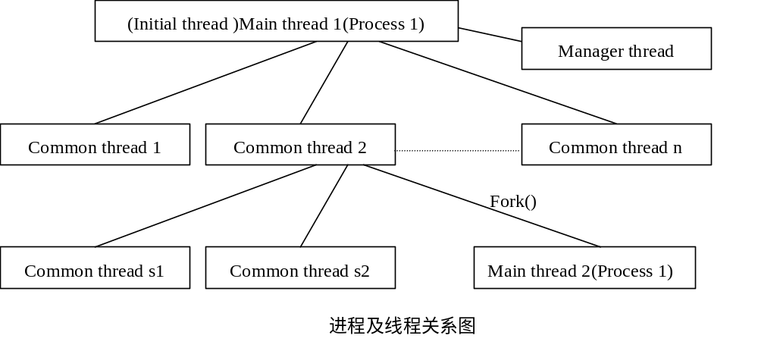Manager thread 接到创建线程请求后调用下函数。
static int pthread_handle_create(pthread_t *thread, const pthread_attr_t *attr,
void * (*start_routine)(void *), void *arg,
sigset_t * mask, int father_pid)
{
size_t sseg;
int pid;
pthread_descr new_thread;
char * new_thread_bottom;
pthread_t new_thread_id;
char *guardaddr = NULL;
size_t guardsize = 0;
int pagesize = __getpagesize();

/* First check whether we have to change the policy and if yes, whether
we can do this. Normally this should be done by examining the
return value of the __sched_setscheduler call in pthread_start_thread
but this is hard to implement. FIXME */
//检查是否需要调整调度策略，如果需要，是否能够做到
if (attr != NULL && attr->__schedpolicy != SCHED_OTHER && geteuid () != 0)
return EPERM;
/* Find a free segment for the thread, and allocate a stack if needed */
//找出一个空段，如果需要再分配堆栈
for (sseg = 2; ; sseg++)
{
if (sseg >= PTHREAD_THREADS_MAX)
return EAGAIN;
if (__pthread_handles[sseg].h_descr != NULL)
continue;
if (pthread_allocate_stack(attr, thread_segment(sseg), pagesize,
&new_thread, &new_thread_bottom,
&guardaddr, &guardsize) == 0)
break;
}
__pthread_handles_num++;
/* Allocate new thread identifier */分配新线程的标识符
pthread_threads_counter += PTHREAD_THREADS_MAX;
new_thread_id = sseg + pthread_threads_counter;
/* Initialize the thread descriptor */初始化新线程描述符
new_thread->p_nextwaiting = NULL;
new_thread->p_tid = new_thread_id;
new_thread->p_priority = 0;
new_thread->p_lock = &(__pthread_handles[sseg].h_lock);
new_thread->p_signal = 0;
new_thread->p_signal_jmp = NULL;
new_thread->p_cancel_jmp = NULL;
new_thread->p_terminated = 0;
new_thread->p_detached = attr == NULL ? 0 : attr->__detachstate;
new_thread->p_exited = 0;
new_thread->p_retval = NULL;
new_thread->p_joining = NULL;
new_thread->p_cleanup = NULL;
new_thread->p_cancelstate = PTHREAD_CANCEL_ENABLE;
new_thread->p_canceltype = PTHREAD_CANCEL_DEFERRED;
new_thread->p_canceled = 0;
new_thread->p_errnop = &new_thread->p_errno;
new_thread->p_errno = 0;
new_thread->p_h_errnop = &new_thread->p_h_errno;
new_thread->p_h_errno = 0;
new_thread->p_in_sighandler = NULL;
new_thread->p_sigwaiting = 0;
new_thread->p_guardaddr = guardaddr;
new_thread->p_guardsize = guardsize;
new_thread->p_userstack = attr != NULL && attr->__stackaddr_set;
memset (new_thread->p_specific, '\0',
PTHREAD_KEY_1STLEVEL_SIZE * sizeof (new_thread->p_specific[0]));
new_thread->p_self = new_thread;
new_thread->p_nr = sseg;
/* Initialize the thread handle */
__pthread_init_lock(&__pthread_handles[sseg].h_lock);
__pthread_handles[sseg].h_descr = new_thread;
__pthread_handles[sseg].h_bottom = new_thread_bottom;
/* Determine scheduling parameters for the thread */
//确定线程的调度参数
new_thread->p_start_args.schedpolicy = -1;
if (attr != NULL) {
switch(attr->__inheritsched) {
case PTHREAD_EXPLICIT_SCHED:
new_thread->p_start_args.schedpolicy = attr->__schedpolicy;
memcpy (&new_thread->p_start_args.schedparam, &attr->__schedparam,
sizeof (struct sched_param));
break;
case PTHREAD_INHERIT_SCHED:
/* schedpolicy doesn't need to be set, only get priority */
__sched_getparam(father_pid, &new_thread->p_start_args.schedparam);
break;
}
new_thread->p_priority =
new_thread->p_start_args.schedparam.sched_priority;
}
/* Finish setting up arguments to pthread_start_thread */
//设置pthread_start_thread的参数
new_thread->p_start_args.start_routine = start_routine;
new_thread->p_start_args.arg = arg;
new_thread->p_start_args.mask = *mask;
/* Raise priority of thread manager if needed */根据需要调整管理线程的优先级
__pthread_manager_adjust_prio(new_thread->p_priority);
/* Do the cloning */创建新线程
pid = __clone(pthread_start_thread, (void **) new_thread,
CLONE_VM | CLONE_FS | CLONE_FILES | CLONE_SIGHAND |
__pthread_sig_cancel, new_thread);
/* Check if cloning succeeded */
if (pid == -1) {
/* Free the stack if we allocated it */
if (attr == NULL || !attr->__stackaddr_set)
{
munmap((caddr_t)((char *)(new_thread+1) - INITIAL_STACK_SIZE),
INITIAL_STACK_SIZE);
if (new_thread->p_guardsize != 0)
munmap(new_thread->p_guardaddr, new_thread->p_guardsize);
}
__pthread_handles[sseg].h_descr = NULL;
__pthread_handles[sseg].h_bottom = NULL;
__pthread_handles_num--;
return errno;
}
/* Insert new thread in doubly linked list of active threads */
//将新线程插入双向链表
new_thread->p_prevlive = __pthread_main_thread;
new_thread->p_nextlive = __pthread_main_thread->p_nextlive;
__pthread_main_thread->p_nextlive->p_prevlive = new_thread;
__pthread_main_thread->p_nextlive = new_thread;
/* Set pid field of the new thread, in case we get there before the
child starts. */
new_thread->p_pid = pid;
/* We're all set */
*thread = new_thread_id;
return 0;
}

线程的堆栈分配和管理
STACK_SIZE 2*1024*1024
INITIAL_STACK_SIZE 4*PAGE_SIZE
THREAD_MANAGER_STACK_SIZE 2*PAGE_SIZE-32
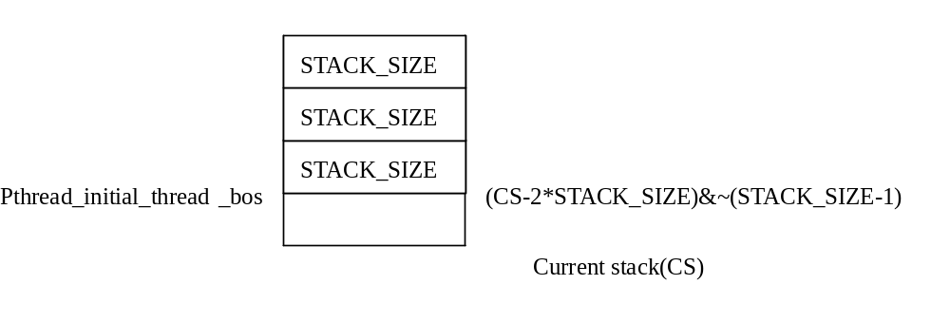
static int pthread_allocate_stack(const pthread_attr_t *attr,
pthread_descr default_new_thread,
int pagesize,
pthread_descr * out_new_thread,
char ** out_new_thread_bottom,
char ** out_guardaddr,
size_t * out_guardsize)
{
pthread_descr new_thread;
char * new_thread_bottom;
char * guardaddr;
size_t stacksize, guardsize;

if (attr != NULL && attr->__stackaddr_set)
{
/* The user provided a stack. */用户提供堆栈
new_thread =
(pthread_descr) ((long)(attr->__stackaddr) & -sizeof(void *)) - 1;
new_thread_bottom = (char *) attr->__stackaddr - attr->__stacksize;
guardaddr = NULL;
guardsize = 0;
__pthread_nonstandard_stacks = 1;
}
else
{
/* Allocate space for stack and thread descriptor at default address */
//在缺省地址分配堆栈和描述符
new_thread = default_new_thread;
new_thread_bottom = (char *) new_thread - STACK_SIZE;
if (mmap((caddr_t)((char *)(new_thread + 1) - INITIAL_STACK_SIZE), INITIAL_STACK_SIZE, PROT_READ | PROT_WRITE | PROT_EXEC, MAP_PRIVATE | MAP_ANONYMOUS | MAP_FIXED | MAP_GROWSDOWN, -1, 0) == MAP_FAILED)
/* Bad luck, this segment is already mapped. */
return -1;
/* We manage to get a stack. Now see whether we need a guard
and allocate it if necessary. Notice that the default
attributes (stack_size = STACK_SIZE - pagesize and
guardsize = pagesize) do not need a guard page, since
the RLIMIT_STACK soft limit prevents stacks from
running into one another. */
//判断是否需要保护页，如果需要就分配
if (attr == NULL ||
attr->__guardsize == 0 ||
(attr->__guardsize == pagesize &&
attr->__stacksize == STACK_SIZE - pagesize))
{
/* We don't need a guard page. */
guardaddr = NULL;
guardsize = 0;
}
else
{
/* Put a bad page at the bottom of the stack */
stacksize = roundup(attr->__stacksize, pagesize);
if (stacksize >= STACK_SIZE - pagesize)
stacksize = STACK_SIZE - pagesize;
guardaddr = (void *)new_thread - stacksize;
guardsize = attr->__guardsize;
if (mmap ((caddr_t) guardaddr, guardsize, 0, MAP_FIXED, -1, 0)
== MAP_FAILED)
{
/* We don't make this an error. */
guardaddr = NULL;
guardsize = 0;
}
}
}
*out_new_thread = new_thread;
*out_new_thread_bottom = new_thread_bottom;
*out_guardaddr = guardaddr;
*out_guardsize = guardsize;
return 0;
}
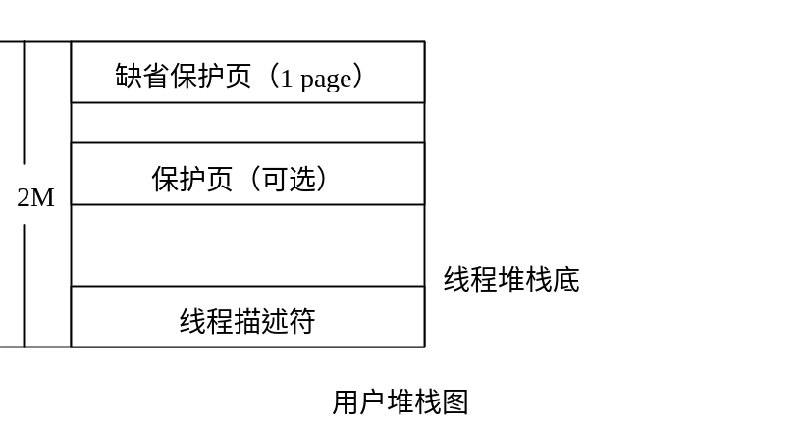

线程的调度
Common threads 的调度和普通进程并无大的区别，创建者可以自己设定线程的优先级。但是Manager thread则需要实时响应各进程提出的请求，所以Manager thread被设置成高于其它线程的优先级，方法是在创建每个新线程时调整Manager thread的优先级。

/* Adjust priority of thread manager so that it always run at a priority
higher than all threads */

void __pthread_manager_adjust_prio(int thread_prio)
{
struct sched_param param;

if (thread_prio <= __pthread_manager_thread.p_priority) return;
param.sched_priority =
thread_prio < __sched_get_priority_max(SCHED_FIFO)
? thread_prio + 1 : thread_prio;
__sched_setscheduler(__pthread_manager_thread.p_pid, SCHED_FIFO, &param);
__pthread_manager_thread.p_priority = thread_prio;
}

问题及发展

LinuxThreads与POSIX标准

已知的漏洞和局限：
- 没有共享的是它们的进程号和父进程号。根据标准应该相同，但这是我们没有实现的（直到clone()的CLONE_PID标志可用）。On recent kernels (late 2.1 kernels and the forthcoming 2.2 kernels), more than 32 signals are provided in the form of realtime signals. When run on one of those kernels, LinuxThreads uses two reserved realtime signals for its internal operation, thus leaving SIGUSR1 and SIGUSR2 free for user code. Share PID with parent cause problems with /proc and signals go to parent.
- 现在，实现时使用了两个信号SIGUSR1 and SIGUSR2，所以用户不能使用它们。理论上，应该为库保留两个信号，但是大概2.1.60版本以上就没有这个问题了。
- 线程栈分配在高端存储空间，在初始进程的堆栈下2M远处。采用“按需增长”策略，所以初始化时不会使用很多虚拟空间（现在是4K），如果需要可以增长到2M。为每个线程保留这么大的地址空间意味着，在32位体系结构下，每个进程不能有超过大约1023个线程共存（假设每个用户进程有2GB地址空间），但是这是合理的，因为每个线程使用核心的进程表的一项，而它通常限制为512项。
- “按需增长”的潜在问题是无法防止用户映射某些数据到为线程栈保留的2M地址，这可能导致以后的堆栈扩展失败。在使用这个库的时候，应该避免在固定的地址上映射。
- 信号处理不是与Posix标准完全一致，基于一个事实即线程是可以能够单独发送信号的特殊进程，所以没有发送一个信号到这个进程（所有线程的集合）的概念。更精确的说，如下是标准的要求和实现如何满足它们的：
1- Synchronous signals (generated by the thread execution, e.g. SIGFPE) are delivered to the thread that raised them. (OK.)

2- A fatal asynchronous signal terminates all threads in the process. (OK. The thread manager notices when a thread dies on a signal and kills all other threads with the same signal.)

3- An asynchronous signal will be delivered to one of the threads of the program which does not block the signal (it is unspecified which). (No, the signal is delivered to the thread it's been sent to, which based on the pid of the thread. If that thread is currently blocking the signal, the signal remains pending.)

4- The signal will be delivered to at most one thread. (OK, except for signals generated from the terminal or sent to the process group, which will be delivered to all threads.)

- The current implementation of the MIPS support assumes a MIPS ISA II processor or better. These processors support atomic operations by ll/sc instructions. Older R2000/R3000 series processors are not supported yet; support for these will have higher overhead.

- The current implementation of the ARM support assumes that the SWP (atomic swap register with memory) instruction is available. This is the case for all processors except for the ARM1 and ARM2. On StrongARM, the SWP instruction does not bypass the cache, so multi-processor support will be more troublesome.

process-shared mutexes, conditions, and semaphores
Why does not LinuxThreads implement process-shared mutexes, conditions, and semaphores?
This is another optional component of the POSIX standard. Portable applications should test _POSIX_THREAD_PROCESS_SHARED before using this facility.

The goal of this extension is to allow different processes (with different address spaces) to synchronize through mutexes, conditions or semaphores allocated in shared memory (either SVR4 shared memory segments or mmap()ed files).

The reason why this does not work in LinuxThreads is that mutexes, conditions, and semaphores are not self-contained: their waiting queues contain pointers to linked lists of thread descriptors, and these pointers are meaningful only in one address space.

Matt Messier and Sean Walton spent a significant amount of time trying to design a suitable mechanism for sharing waiting queues between processes. We came up with several solutions that combined two of the following three desirable features, but none that combines all three:

allow sharing between processes having different UIDs
supports cancellation
supports pthread_cond_timedwait

We concluded that kernel support is required to share mutexes, conditions and semaphores between processes. That's one place where Linus Torvalds's intuition that "all we need in the kernel is clone()" fails.

Until suitable kernel support is available, you'd better use traditional interprocess communications to synchronize different processes: System V semaphores and message queues, or pipes, or sockets.

Linux线程展望
未来的目标是全面的兼容POSIX标准和尽可能实现POSIX标准中可选的功能，并进一步提高LinuxThreads的效率。我相信这一天很快就会到来。

