1. Which customer has produced the most total revenue?
   1. Aldous Huxley has produced the most total revenue as a customer.
   2. select customername, sum(salesprice*quantity) as total_rev from dim_customer dc, fact_productsales fp where dc.customerid = fp.customerid group by dc.customerid order by total_rev desc limit 1;

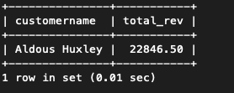

1. Which sales person has produced the most total revenue for this organization?
   1. Julian Brand has produced the most total revenue as a sales person.
   2. select salespersonname, sum(salesprice*quantity) as total_rev from fact_productsales fp, dim_salesperson ds where ds.salespersonid = fp.salespersonid group by ds.salespersonid order by total_rev desc limit 1;

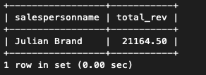

1. What is the total revenue by store for each year represented in the data warehouse?
   1. The results for each store grouped by year can be seen in the screenshot below.
   2. select storename, sum(salesprice*quantity) as total_rev, year from fact_productsales fp, dim_store ds, dim_date dd where fp.storeid = ds.storeid and fp.salesdatekey = dd.datekey group by year, fp.storeid;

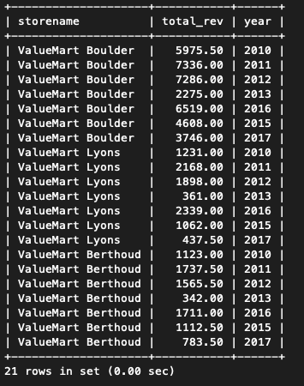

1. Which store had the highest sales dollar volume in September 2011?
   1. ValueMart Boulder had the highest sales dollar volume in September 2011.
   2. select storename, sum(salesprice*quantity) as sdv from fact_productsales fp, dim_store ds, dim_date dd where fp.storeid = ds.storeid and fp.salesdatekey = dd.datekey and year = '2011' and monthname = 'September' group by storename order by sdv desc limit 1;

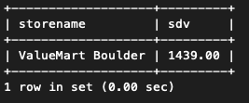

1. Describe the trend in total revenue for the Boulder store for each quarter in 2016.
   1. In 2016, the Boulder store saw a dip in revenue from quarter 1 to quarter 2 but a rise of almost two-fold from quarter 2 to quarter 3. From quarter 3 to quarter 4, the store saw a dip back to a little under the revenue from quarter 1.
   2. select storename, sum(salesprice*quantity) as sdv, quarter from fact_productsales fp, dim_store ds, dim_date dd where fp.storeid = ds.storeid and fp.salesdatekey = dd.datekey and year = '2016' and storename like '%Boulder%' group by storename, quarter order by quarter;

