James Gallmeister

Database and Information Systems

Project 1 Answers

1. select \* from offices;

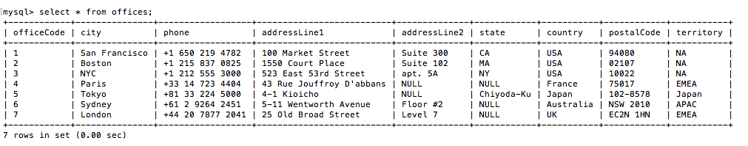

1. select employeenumber, lastname, firstname, extension from employees e, offices o where o.officecode = e.officecode and o.city = ‘Paris’;

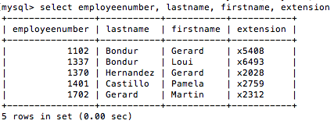

1. select productcode, productname, productvendor, buyprice, msrp from products where productline = ‘Classic Cars’ and quantityinstock between 5000 and 7000;

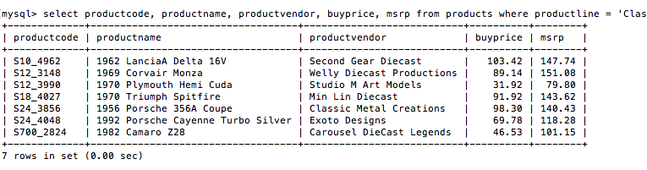

1. select productcode, productname, productvendor, buyprice, msrp from products having min(msrp);

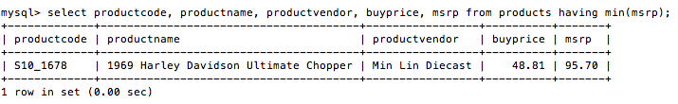

1. select productname, max(msrp-buyprice) as profit from products;

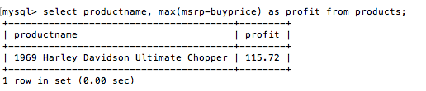

1. select country, count(country) as customercount from customers group by country having customercount >= 5 order by customercount desc;

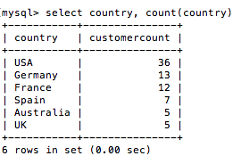

1. select o.productcode, productname, sum(quantityordered) total from products p, orderdetails o where o.productcode = p.productcode group by productcode order by total desc limit 1;

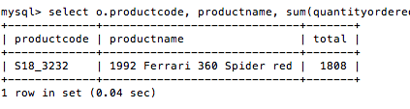

1. select employeenumber, concat(firstname, ‘ ‘, lastname) from employees where reportsto in (select employeenumber from employees where firstname = ‘Anthony’ and lastname = ‘Bow’);

