James Gallmeister

Project 2 Solutions

1. Create database

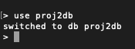

1. Drop Database

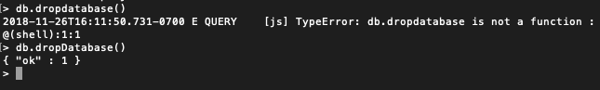

1. Create Collection



1. Drop Collection



1. Insert Document

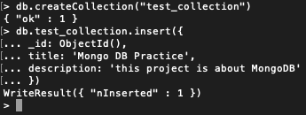

1. Query Document

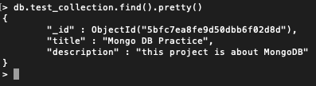

1. Update Document



1. Delete Document

