James Gallmeister

CSCI-3207

December 5, 2018

1. Create a keyspace.



This creates a keyspace which is the NoSQL equivalent of a database or a collection in MongoDB.

1. Use a keyspace.

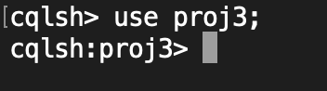

After creating the keyspace you can select that keyspace.

1. Describe a keyspaces.

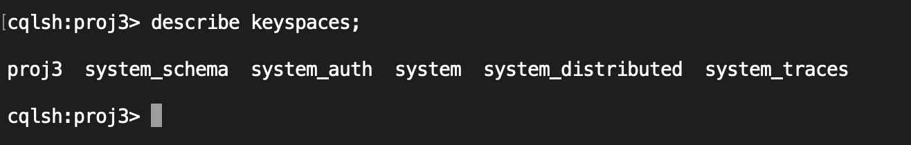

This will list all keyspaces in Cassandra.

1. Create and describe a table/column family.

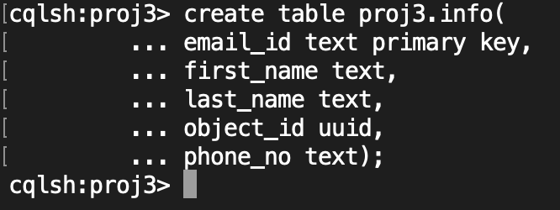

Create a table within the proj3 keyspace and define fields in that table just like with sql.

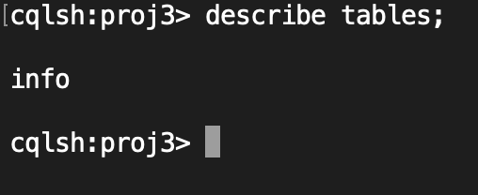

This will list all tables within the current keyspace.

1. Insert Command.



Insert a row into the user table.

1. Create an index.



Create an index to put on the `phone_no` column in the info table.

1. Update a row in the table.



1. Add/Drop/Rename a column in a table.

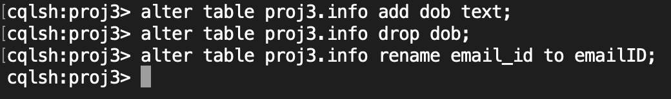

1. Run a select query.

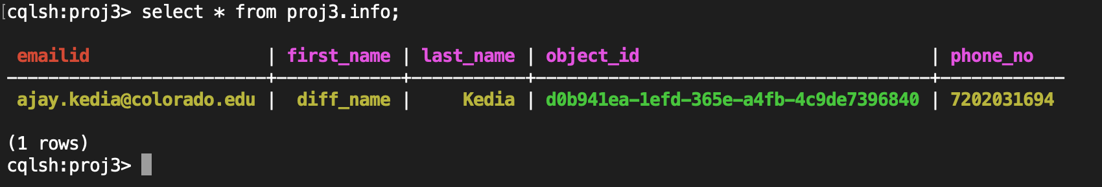

1. Drop a table and a keyspace.

