HackerFam

James Gallmeister

Lorenzo Repenning

Liam Merz Hoffmeister

Tia Basak

Andrew Pavey

Milestone 5:

For our feature testing, we will be testing the “sign-up,” “login” and “password check” features of our web application.

User Acceptance Tests:

1. Password Check
   1. Enter random characters that may not be utf-8 encoded or that may throw errors when used as user input.
2. Sign Up
   1. We will give the “sign-up” empty inputs in addition to characters that may not be encoded or able to be accepted.
3. Login
   1. We can give the login page emails and passwords that aren’t in the user database and like the above, we can try empty inputs and characters that may not be accepted due to weird encoding.

Automated Test Cases:

We wrote a script to test our application autonomously. The script tries to break our application by giving the fields above different types of inputs. These include numbers, empty strings and streams of characters that may not be encoded in regular, known encodings.

Test Script:

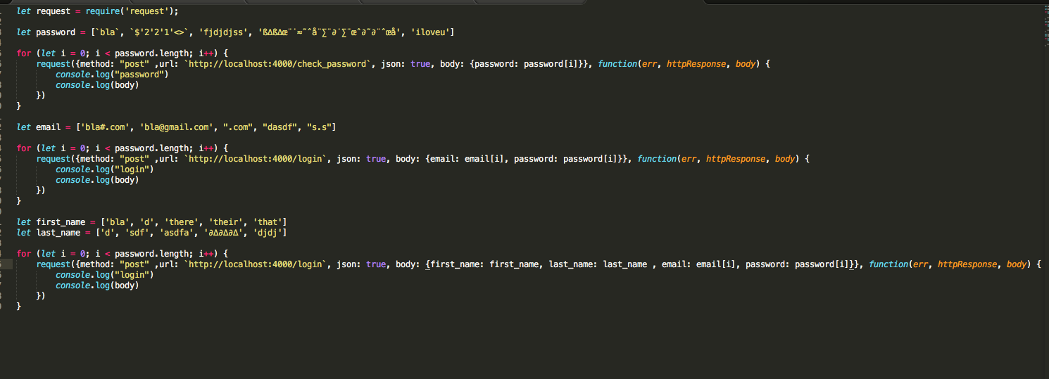

Test Results:

