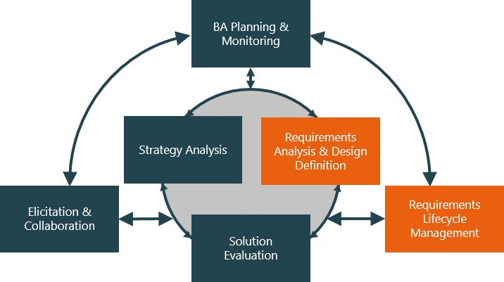

**Evaluate and communicate business requirements**

12345 John in wells

|  |  |  |  |
| --- | --- | --- | --- |
| Name of Student | Jam Generillo | ID | 18463 |

# Assessment –

# Research & Questioning

Contents

Assessment – 1

Research & Questioning 1

***Instructions:*** 1

***Business Scenario*** 1

***Task 1: Determine support areas*** 2

***Task 2: Identify stakeholders*** 3

***Task 3: Develop support procedures*** 4

***Task 4: Assign Support Personnel*** 6

***Task 5: Short Answer Questions*** 6

***Task 6: Multiple Choice Questions*** 7

Index 12

#### View My Web Support:

<https://jamgen0324.github.io/ecbr/>

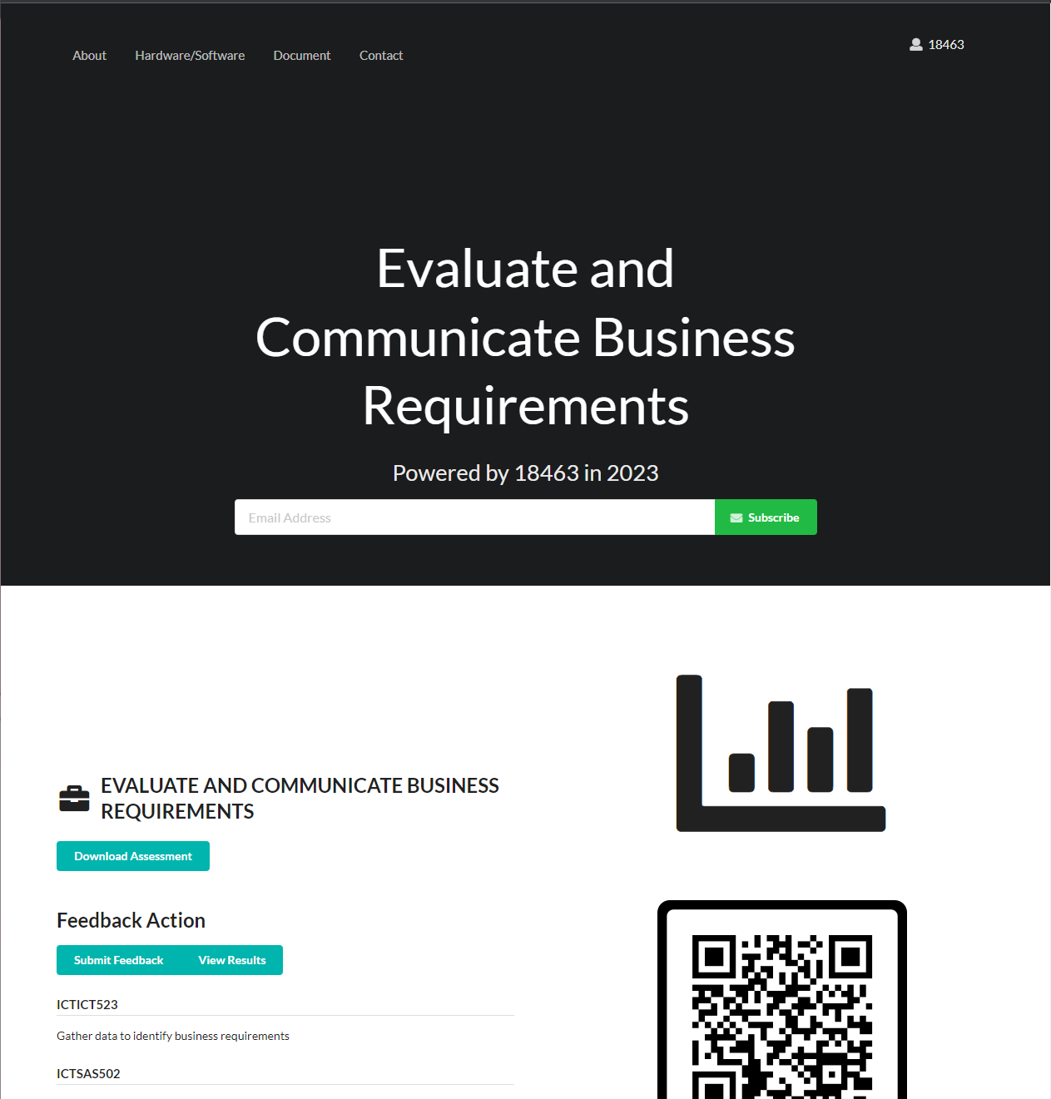

#### *Instructions:*

This assessment is to be completed individually. In this assessment you will be working through a number of written tasks based on case scenarios or research that relate directly to each element of competency for this cluster. Outlined below is information on how each of the tasks relates the element of competency covered.

Learn how to make Google Form: <https://www.youtube.com/watch?v=BtoOHhA3aPQ&t=4s>

Your tasks:

#### *Business Scenario*

D&K Books Pty Ltd is a bookstore owned by Mr. Dean Kerr. The business occupies two levels of an office building connected by escalators and lifts. D&K Books employs approximately six sales staff, one operation manager, two administrative officers, a bookkeeper and a marketing manager. They have an Ethernet network consisting of ten PCs (Intel I3 Desktop cloned), two switches, a router and three printers. They use the QuickBooks software to manage their entire business, including sales, inventory, ordering, accounts receivable, accounts payable, payroll and employee management. They also have two EFTPOS terminals one on each floor.

D&K Books has a Linux server that stores all of the data including the QuickBooks database. The server is backed up to tape regularly. They also have a website (hosted on an Australian ISP’s server, dynamic and static pages using asp.net) on which customers can browse the product catalogue and view current specials. They also lease a telephone system from Live Telecoms. The PABX (phone system) consists of a main switchboard and five remote phones with three incoming lines and a message-on-hold queue system.

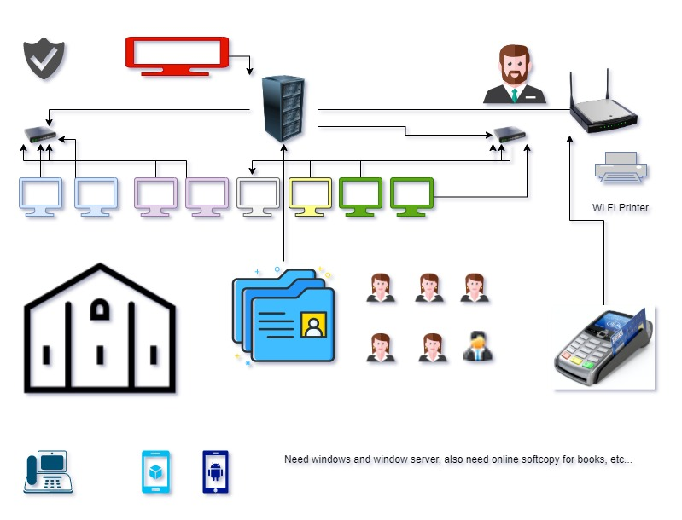

Good network system, you need setup at least:

|  |  |
| --- | --- |
| Hard ware | Software |
| Server X 1 | Window Server |
| Computer X 8 | Windows |
| Printer X 1 | SQL server |
| Telephone X 8 | Virus Protection |
| Modern X 2 | MS office |
| Network Cable | Eftpos machine More… |

#### *http://imapwebsolutions.com/wp-content/uploads/2014/07/linux-dedicated-server.pngTask 1: Determine support areas*

Identify information technology (HW and SW) and list the technology in use in D&K Books and consider the following:

* What sort of support does the technology require?
* Who is likely to provide this support?
* Does the support arrangement already exist?

Present your answer in a table such as the one below:

|  |  |  |  |  |
| --- | --- | --- | --- | --- |
| **Technology** | **Description** | **Support Required** | **Provider** | **Support Already exists? (Yes/No)** |
| QuickBooks Software | software that keeps track of all accounts, stock, GST, etc. | customisation, training, upgrades, bug fixes (patching), user support | [www.intuit.com.au](http://www.intuit.com.au)  online to find more | No |
| PC’s | Intel I3 Desktop cloned | upgrades, repairs, troubleshooting, maintenance, backup, customisation, network to link |  | No. Need find one person to do this job |
| **Server**  IconExperience » V-Collection » Server Icon | Windows Server with tape backup  May need upgrade to hard disk backup or cloud backup | User account management, security policy implementation, home folder management, permissions management, backup and restore, operating system patching, software installation |  | No. We can use 3rd party cloud database that already have a backup system |
| EFTPOS | Easy to use | No need | shop | Yes |
| Telephone system | Low cost | Phone company | Telstra | Yes |
| Website | Low cost | Yes | Godaddy | Yes |
| Network | Wireless/LAN | Repairs, troubleshooting, maintenance | None | No. Need to find one person to do this job |

Please review my website: [https://wellsjohn220.github.io/ecbr/#businesscase](https://wellsjohn220.github.io/ecbr/%23businesscase)

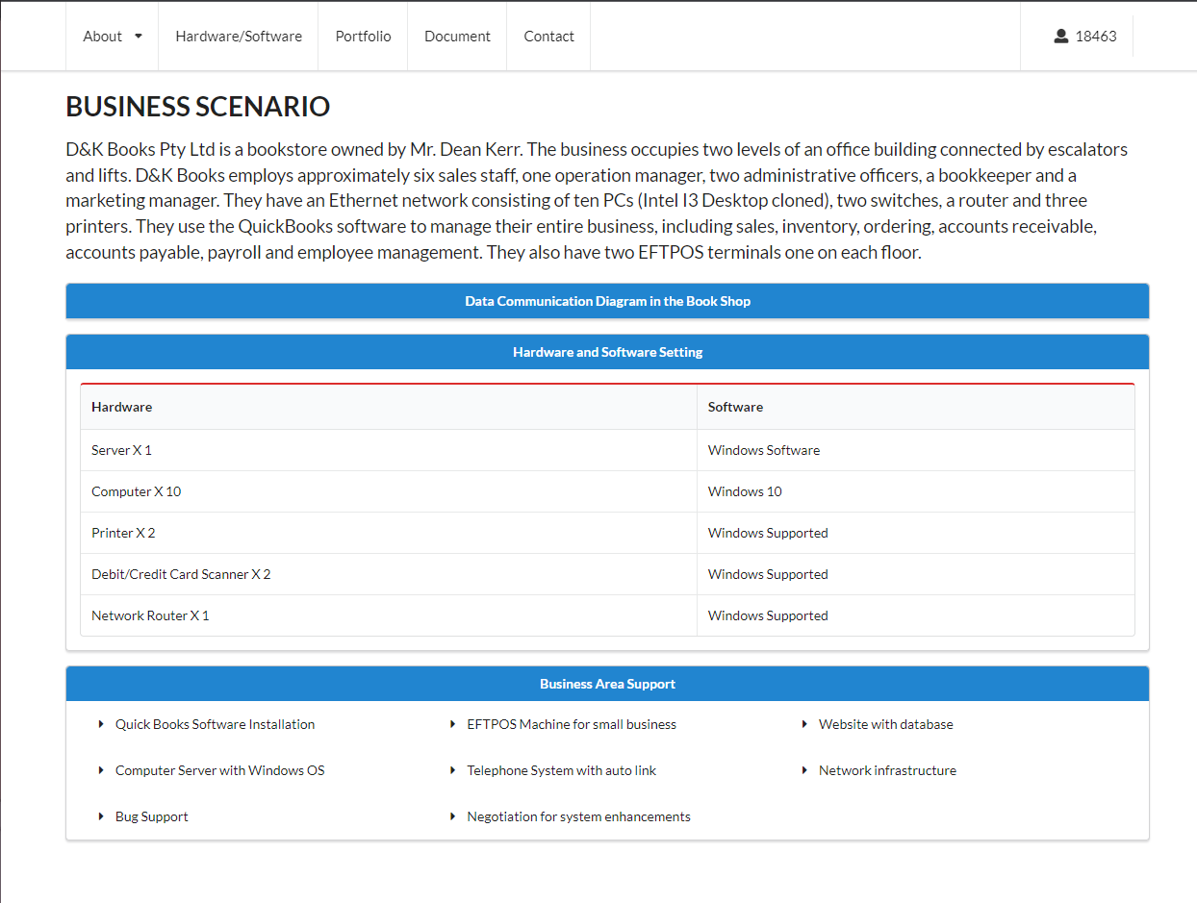

#### *Task 2: Identify stakeholders*

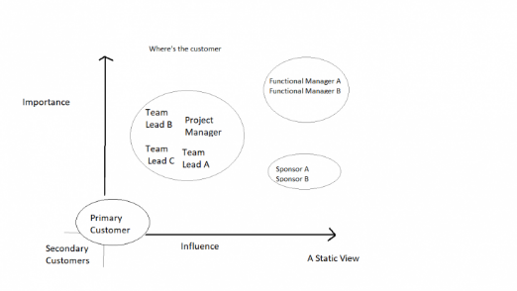 Identify stakeholders related in D&K Books system

All the staffs (the business owner, the relevant manager, the local workers and the remote workers) are stakeholders

Your comment: Investors are also stakeholders as they placed money to increase the capital of the business to further expand the business operations. As a stakeholder their actions also affects the business in many ways

#### *Task 3: Develop support procedures*

1. Describe one positive and one negative experience you have had when seeking assistance from a telecommunication company, an ISP or a computer supplier. Your experience may be via telephone, email or even voice recognition.

|  |  |  |
| --- | --- | --- |
| Type | Positive | Negative |
| Telephone | Easy to get answer | Rise of automated bots that are quite inefficient in answering calls. |
| Email | Document, Picture, words or any media | Inconsistent waiting time that depends per each company. Some take long too reply while others do not. |
| Personal Inquiry | You can get a much clear answers and all on the spot questions can be asked | Travel and cost |
| Text Message | Much more convenient and simple | Only limited to texts and sometimes it takes long to get a reply |

1. Using the experiences described above please answer the following questions.
   1. What support aspects were professional and/or unprofessional?
   2. How long did the support process take?
   3. Were the steps logical?
   4. Did they solve your problem?
   5. Was the call deflected to another area?

|  |  |  |
| --- | --- | --- |
| Items | professional | unprofessional |
| What support aspects | Friendly, Listening, Gives proper response and solutions | Not accommodating and doesn’t know how to provide a proper solution |
| How long | Very quick | Takes long to reply |
| Steps logical | Yes | No |
| Solve | Good | Can not |
| Another area | If has, need solve | If has, do not care |

Using feedback form or Google survey form.

Here is the very simple survey demo:

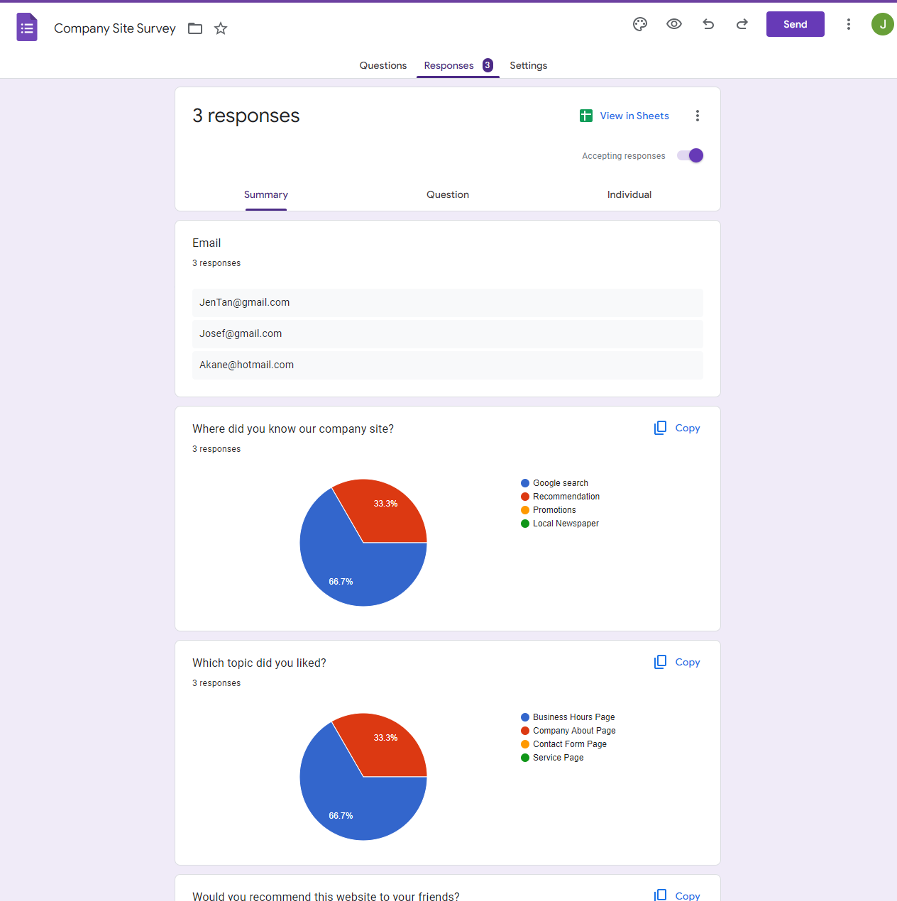

After I tested my friends, I could get nice response like:

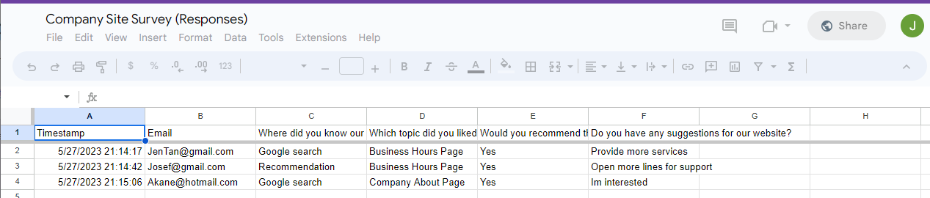

Or using link string:

<https://docs.google.com/forms/d/e/1FAIpQLSc1oXUO90U1T3ke_8ebTAYfLQR-90LqSNbH-4SqqG8YdBS5RQ/viewform>

Please review my website: <https://jamgen0324.github.io/ecbr/#task_three>

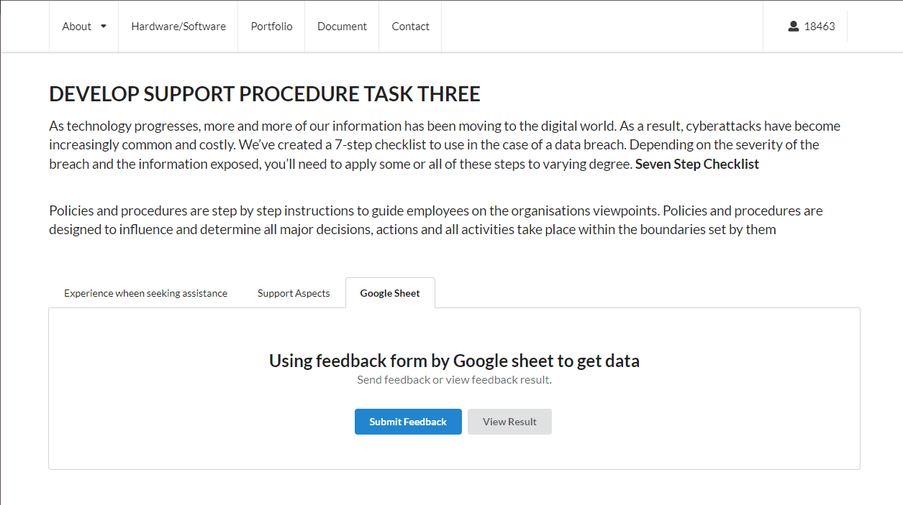

#### *Task 4: Assign Support Personnel*

Classify the following into soft skills and technical skills. Your answer should take the form of a table shown below.

|  |  |  |
| --- | --- | --- |
| **Skill** | **Soft skill** | **Technical skill** |
| A knowledge of Linux | X | X |
| The ability to work under pressure | X | X |
| The administration of Windows 2008 Server | X | X |
| The ability to formulate network and IT policies | X | X |
| The ability to write network documentation | X | X |
| The ability to give presentations | X | X |

Here is about document reequipment at support website: [https://jamgen0324.github.io/ecbr/#document](https://jamgen0324.github.io/ecbr/%23document)

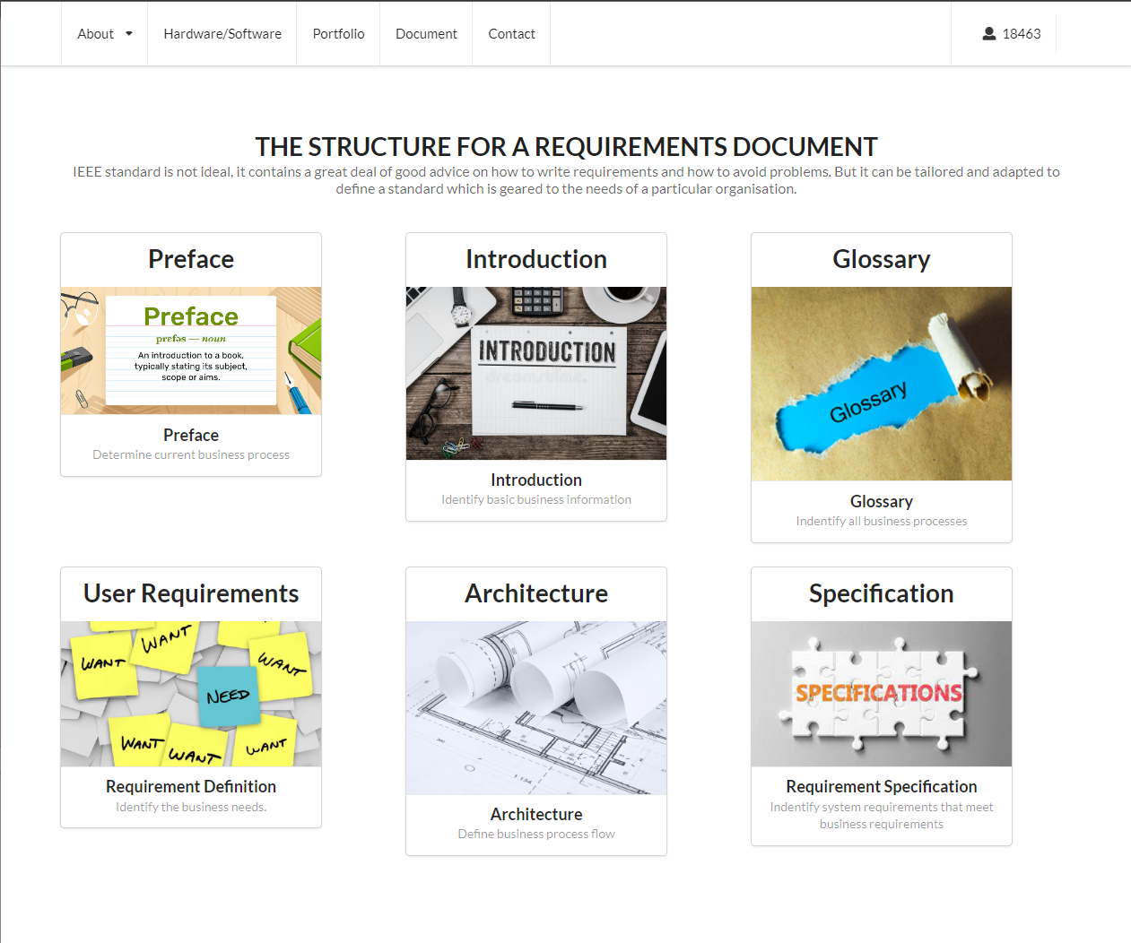

#### *Task 5: Short Answer Questions*

1. 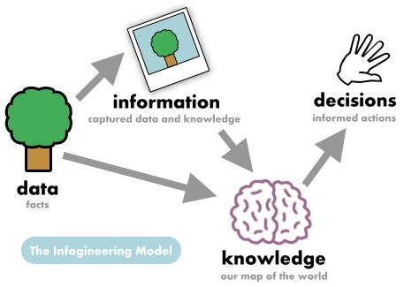Explain the relationship between data, information and knowledge.

Data is facts and with a collection of data it constructs information that can be used for us to gain knowledge and with enough knowledge we can make better decisions.

1. What is quantitative data and how can you use it.

Quantitative data is data measured in quantity. This can be used in many ways but the best example is for survey. By collecting many data we can determine the trend and with that data we can use it to make better business decisions.

1. What is qualitative data and how can you use it.

Qualitative data is data measured in quality. In the same example as surveys we can use this by what is the quality of the survey. If the survey is from a reputable site and we can gurantee that data is of high quality we can use that to make better business decisions. Some surveys or research have a good quantitative data but poor quality. It’s better to think wisely on decisions.

1. 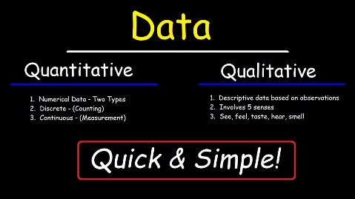Give an example of how quantitative and qualitative data can be used in conjunction with each other

If the data is of high quality and has good quantity measure we can think highly of these information while a data with high quantity but low quality we can take this information with a grain of salt. If the is both of low quantity and quality it is better to just ignore this as these data is poor and of low volume.

1. 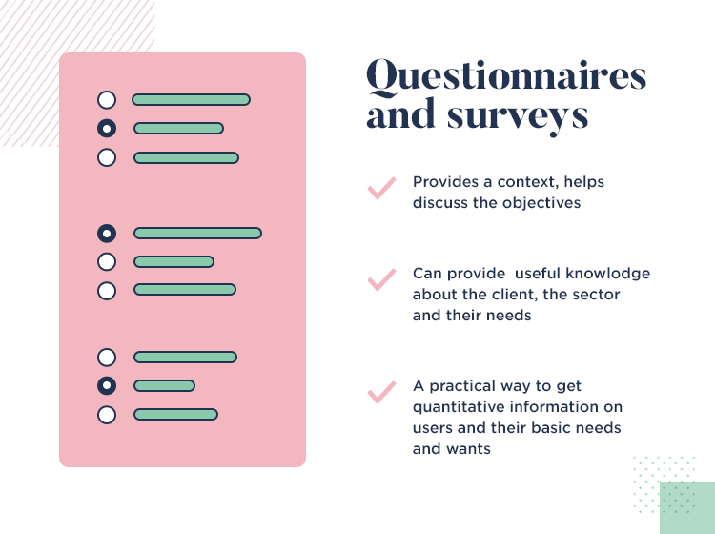What sort of methods could you use to determine client requirements for a website design and key information sources?

* Customer feedback
* Customer survey
* Customer support
* Customer service centre
* Market Trend
* Technology Trend

1. Give some examples of client requirements for a website design

* Good UI
* Works indefinitely
* Easy to update
* Easy to provide support
* Has an updated firmware

I made my web support page, could be accessed by: <https://jamgen0324.github.io/ecbr/>

#### *Task 6: Multiple Choice Questions*

1. 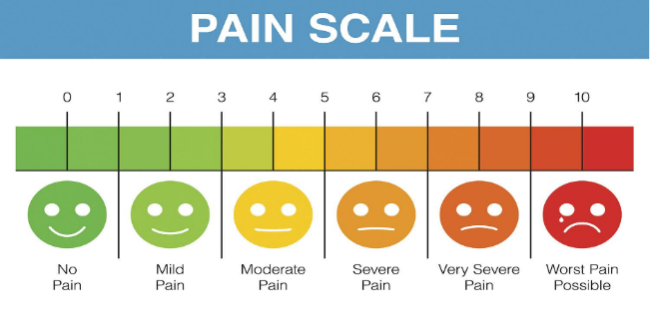Generally, how many points should a rating scale have?
   1. Five
   2. Four
   3. Ten
   4. Somewhere from 4 to 11 points Reason

So we can have a more accurate average when collecting rating. If points are low we will have a low margin to determine the appropriate rating.

Web refers: <https://lumoa.me/blog/rating-scale>

A rating scale is a closed-end survey question that is used to evaluate how survey responders feel about a particular product or statement.

Comment: 10 points! It is easy and a more accurate way of scoring a feedback.

1. What is the problem(s) with this set of response categories to the question “What is your current age?”

* 1-5
* 5-10
* 10-20
* 20-30
* 30-40
  1. The categories are not mutually exclusive
  2. The categories are not exhaustive
  3. Both a and b are problems Reason
  4. There is no problem with the above set of response categories

These categories are confusing especially for survey takers that are aged 5, 10, 20, 30 because they will be confused on which option to choose since they are not independently exclusive to each other.

1. You should mix methods in a way that provides complementary strengths and no overlapping weaknesses. This is known as the fundamental principle of mixed research.
   1. True Reason
   2. False

In order for the information to be of high quality it must also have a lot of quantity. For example if the survey has low volume of data but high quality responses we can consider it to be good but we cannot be confident with it because of its low volume. If survey results have high volume of response but of low quality it is better to ignore it since bad information is not a good basis for knowledge for business decisions. A good volume of data and of high quality is the best data that can be used to make the basis of our decisions.

1. According to the text, questionnaires can address events and characteristics taking place when?
   1. In the past (retrospective questions)
   2. In the present (current time questions)
   3. In the future (prospective questions)
   4. All of the above Reason

Questionnaires can be in any time frame depending on the questions itself. Feedback surveys are usually retrospective since we ask their experience. Present questions can be feedback that they are currently experiencing and prospective questions are usually surveys that ask on what they can improve on.

1. Which of the following are principles of questionnaire construction?
   1. Consider using multiple methods when measuring abstract constructs
   2. Use multiple items to measure abstract constructs
   3. Avoid double-barrelled questions
   4. All of the above
   5. Only b and c Reason

A good questionnaire must be at point and must not give confusion to the questionnaire takers

1. Which of these is not a method of data collection?
   1. Questionnaires
   2. Interviews
   3. Experiments Reason
   4. Observations

Experiments is usually the process of what to do with the collected data.

1. Secondary/existing data may include which of the following?
   1. Official documents
   2. Personal documents
   3. Archived research data
   4. All of the above Reason

All are information that can be used if needed.

1. An item that directs participants to different follow-up questions depending on their response is called a ____________.
   1. Response set
   2. Probe
   3. Semantic differential
   4. Contingency question Reason

Contingency questions are questions that are asked depending on the previous response. These can be open-ended or close-ended questions.

1. Which of the following terms best describes data that were originally collected at an earlier time by a different person for a different purpose?
   1. Primary data
   2. Secondary data Reason
   3. Experimental data
   4. Field notes

Secondary data refers to data that is collected by someone other than the primary user. Common sources of secondary data for social science include censuses, information collected by government departments, organizational records and data that was originally collected for other research purposes.

SOURCE: [https://en.wikipedia.org/wiki/Secondary_data#:~:text=Secondary%20data%20refers%20to%20data,collected%20for%20other%20research%20purposes.](https://en.wikipedia.org/wiki/Secondary_data%23:~:text=Secondary%20data%20refers%20to%20data,collected%20for%20other%20research%20purposes.)

1. Researchers use both open-ended and closed-ended questions to collect data. Which of the following statements is true?
   1. Open-ended questions directly provide quantitative data based on the researcher’s predetermined response categories
   2. Closed-ended questions provide quantitative data in the participant’s own words
   3. Open-ended questions provide qualitative data in the participant’s own words Reason
   4. Closed-ended questions directly provide qualitative data in the participants’ own words

Since the participants can answer the questions in their own words. It provides a better quality.

1. Open-ended questions provide primarily ______ data.
   1. Confirmatory data
   2. Qualitative data Reason
   3. Predictive data
   4. None of the above

Since the participant can answer it freely rather than a simple yes or no.

1. Which of the following is true concerning observation?
   1. It takes less time than self-report approaches
   2. It costs less money than self-report approaches
   3. It is often not possible to determine exactly why the people behave as they do Reason
   4. All of the above

Since it is only observation you cannot directly know the nature of what you are observing

1. Qualitative observation is usually done for exploratory purposes; it is also called ___________ observation.
   1. Structured
   2. Naturalistic Reason
   3. Complete
   4. Probed

Since naturalistic observations observe in a much more natural setting, you get a better quality of data from the observations.

1. When constructing a questionnaire, it is important to do each of the following except ______.
   1. Use "leading" or "loaded" questions Reason
   2. Use natural language
   3. Understand your research participants
   4. Pilot your test questionnaire

Because you want to get feedback results with a much more natural response in order to get a better quality data.

1. Another name for a Likert Scale is a(n):
   1. Interview protocol
   2. Event sampling
   3. Summated rating scale Reason
   4. Ranking

The term is often used interchangeably with rating scale.

1. Which of the following is not one of the six major methods of data collection that are used by educational researchers?
   1. Observation
   2. Interviews
   3. Questionnaires
   4. Checklists Reason

Since for educational research you are collecting unknown data and some data during the research is not anticipated

1. The type of interview in which the specific topics are decided in advance but the sequence and wording can be modified during the interview is called:
   1. The interview guide approach Reason
   2. The informal conversational interview
   3. A closed quantitative interview
   4. The standardized open-ended interview

Since informal conversational interview mimics a more natural conversation where you can have a guideline of questions but its sequence are not strict and will just go on depending on the flow of the interview.

1. Which one of the following in not a major method of data collection:
   1. Questionnaires
   2. Interviews Reason
   3. Secondary data
   4. Focus groups
   5. All of the above are methods of data collection

Since all methods are used to gather data.

1. A question during an interview such as “Why do you feel that way?” is known as a:
   1. Probe Reason
   2. Filter question
   3. Response
   4. Pilot

Since a probe questions is an open-ended question that makes the participant revel more information regarding the situation or question.

1. A census taker often collects data through which of the following?
   1. Standardized tests
   2. Interviews
   3. Secondary data
   4. Observations Reason

Since most census gather a massively amount of data they need to be simple and quick.

1. The researcher has secretly placed him or herself (as a member) in the group that is being studied. This researcher may be which of the following?
   1. A complete participant Reason
   2. An observer-as-participant
   3. A participant-as-observer
   4. None of the above

Since the researcher is also being a part of participant

1. Which of the following is not a major method of data collection?
   1. Questionnaires
   2. Focus groups
   3. Correlational method Reason
   4. Secondary data

Since this is a method of research not a data collection step.

1. Which type of interview allows the questions to emerge from the immediate context or course of things?
   1. Interview guide approach
   2. Informal conversational interview Reason
   3. Closed quantitative interview
   4. Standardized open-ended interview

Since these are open-ended questions it challenges the participant to reveal more answers than what is expected.

1. When conducting an interview, asking "Anything else?, What do you mean?, Why do you feel that way?," etc, are all forms of:
   1. Contingency questions
   2. Probes Reason
   3. Protocols
   4. Response categories

Since a probe questions is an open-ended question that makes the participant revel more information regarding the situation or question.

1. When constructing a questionnaire, there are 15 principles to which you should adhere. Which of the following is not one of those principles?
   1. Do not use "leading" or "loaded" questions
   2. Avoid double-barrelled questions
   3. Avoid double negatives
   4. Avoid using multiple items to measure a single construct Reason
2. A customer-based Service Level Agreement structure includes:
   1. An SLA covering all Customer groups and all the services they use
   2. SLAs for each service that are Customer-focused and written in business language
   3. An SLA for each service type, covering all those Customer groups that use that Service
   4. An SLA with each individual Customer group, covering all of the services they use Reason
3. Which of the following best describes the goal of Service Level Management?
   1. To maintain and improve IT service quality in line with business requirements Reason
   2. 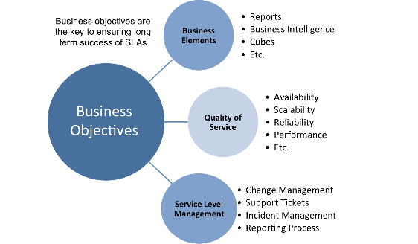To provide IT services at the lowest possible cost by agreeing with Customers their minimum requirements for service availability and ensuring performance does not exceed these targets
   3. To provide the highest possible level of service to Customers and continuously improve on this through ensuring all services operate at maximum availability
   4. To ensure that IT delivers the same standard of service at the least cost

To provide a consistent quality of service since a service is an ongoing task until that contract ends.

1. The process to implement SLAs comprises of the following activities in sequence:
   1. Draft SLAs, catalogue services, review underpinning contracts and OLAs, draft SLRs, negotiate, agree SLAs
   2. Draft SLAs, review underpinning contracts and OLAs, negotiate, catalogue services,
   3. Review underpinning contracts and OLAs, draft SLAs, catalogue services, negotiate, agree SLAs
   4. Catalogue services, establish SLRs, review underpinning contracts and OLAs, negotiate service levels, agree SLAs Reason
2. Which of the following is an example of a service level agreement (SLA) between information systems support unit and a research unit in the laboratories of a large company?
   1. The maximum response time to get the system operational should it fail.
   2. The minimum ‘up-time’.
   3. The types of information that will be provided as standard.
   4. All of the above. Reason

These are all important since if there is a bug in the system it should be fixed within a time frame depending on the contract.

1. Some organisations bring a degree of formality to the internal customer concept by encouraging (or requiring) different parts of the operation to agree on:
   1. Internal service agreements
   2. Service level agreements Reason
   3. Formal provision agreements
   4. Delivery agreements

Since these will be service for certain timeframe and the business will face consequences if they don’t know if who should fix in a bugged part of the system.

## Index

B

bookstore 3

C

categories 11

closed-ended 12

D

data collection 14

L

Linux server 3

N

negative experience 6

network 3

O

open-ended 12

S

Service Level 14

service level agreement 15

service quality 14

soft skills 9

support 6

T

technology 4

telecommunications 6