Project Management

Assessment ONE

18463 JAM GENERILLO

|  |  |  |  |
| --- | --- | --- | --- |
| Name of Student | Jam Generillo | ID | 18463 |

**Assessment 1 – Case Study**

Contents

Instruction: 2

Duration: 2

Case Study: 2

Going Green application, Green IT Project Management 2

Project profile 2

Business situation 4

Your tasks: 4

Task 1: Identify Business Strategy and Gap 4

Task 2: Recommend a feasible solution 5

Task 3: Produce a Project Charter 5

Task 4: Project Document 6

Task 5: Project Closure 9

Helpful web links to complete the assessment: 12

Search Index 13

## Instruction:

This task is to be completed individually. You need to analyse a case scenario and complete all the tasks mentioned after the scenario.

You need to demonstrate your IT project management ability to identify business strategy and gaps. You will also need to suggest a feasible solution to overcome identified gaps and produce a project charter along with a WBS to implement the proposed solution.

### Duration:

Trainer will set the duration of the assessment.

All my working could be checked at:

## Case Study:

### Going Green application, Green IT Project Management

# Project profile

Going “Green” is a mission of many companies around the globe not just for reasons of environmental responsibility, but also for cutting costs in these extremely tight economic times. Green IT efforts represent a specific focus area within enterprises that hold attention to this trend. Green IT leverages information technology to streamline operations, cut costly waste, and reduce the impact on the environment. IT typically consumes only about 10% of an organization’s energy costs, but the net effect of a Green IT project is to go beyond just energy saving. To tackle the other 90%, a Green IT project extends into a variety of other departments, and to execute such an endeavour requires an effective project management function in order to identify and prioritize goals. A Green IT transformation can be a complex process.

Vital Statistics:

* Number of project tasks - 12
* Project duration - 16 months
* Project budget - $1,200,000
* Number of users - 50

I also think using a simple case, which I knew well, could be better for my learning. Go to website:

Link URL: <https://docs.google.com/spreadsheets/d/1u1DqKqTDLkN5M5FLASx2xoe58TY6tBOCGli4BKWG4q8/edit#gid=1264554319>

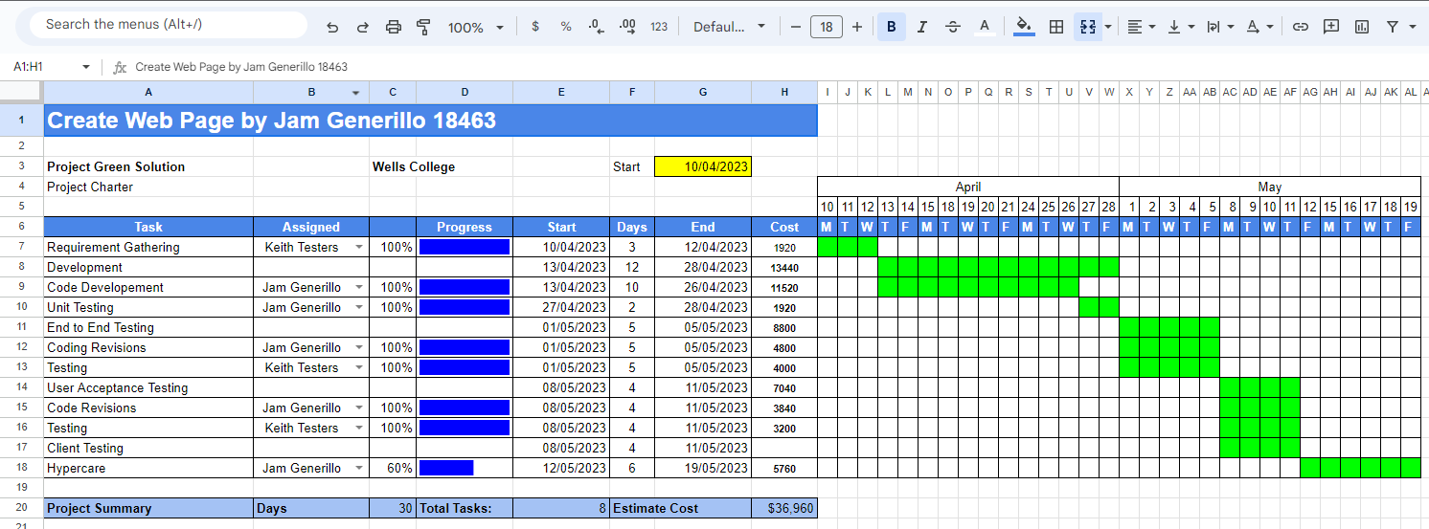

Tutor reference: <https://www.youtube.com/watch?v=8eKk0M2zGIk>

Or using GanttProject (please note, if you do not use, just delete this section):

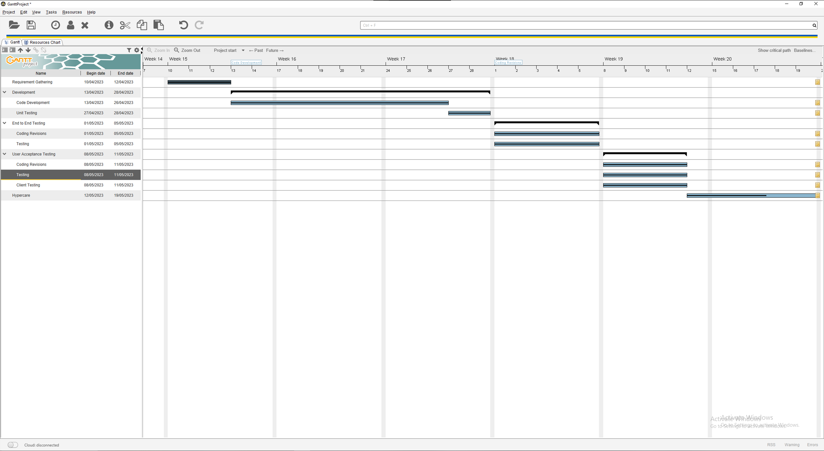

### 

## Your tasks:

### Task 1: Identify Business Strategy and Gap

Document the business’s strategies of “Green IT” and also summarise the components required changes for the participating organisation to implement “Green IT Project”. (Min. 300 words)

Business strategy is a planning function of any organisation. Business strategy incorporates having a strategic plan.

**Analyse Strategy**

The strategic plan of an organisation sets out the goals a business hopes to achieve within a specified period of time. It also helps the organisation understand the environment within which they operate and the market forces that affect them.

An analysis of the current strategic plan enables you to understand the goals of your organisation. However, in order to analyse the strategic plan, you first need to understand the structure and purpose of a strategic plan. This topic describes the elements that make up a strategic plan.

The green project we need defined every requirement. The gap which is between your plan and reality always need your notice. So you need do your best to investigate your Green Project.

# 

Assuming that we started our plan of going green in 2023 and complete it by 2030. We can see the comparison above the difference between starting with small progress until we complete it since it would be very difficult to complete it in a short amount of time. What we can do is make a simple plan that we can progressively improve until we complete our goal by 2030.

### Task 2: Recommend a feasible solution

Assume “Wells International College” is thinking of going “Green” and asked for your assistance in this project. Research different project management applications on the Internet to compare with the Green IT project management application and recommend a feasible solution with proper reasons for Windsor. (Min. 300 words)

Implementation of reusable energy. By using reusable energy sources such as Solar Panel and others we can achieve the goal of going “Green”. Another way to reduce the carbon footprint is to use a green public transportation instead of each people commuting in private vehicles. As per study commuting individually has a very big carbon impact in the environment than commuting via public transportation, it would also help if the public transportation vehicle you are taking is also running on carbon-neutral energy or much better reusable energy. We can also implement to change the main electrical supply to carbon-neutral or reusable energy since this can also help in achieving the goal.

### Task 3: Produce a Project Charter

Please view my project charter (here only show part):

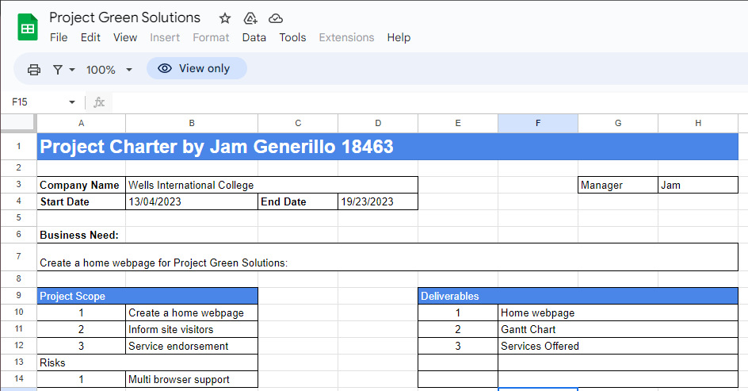

Develop a project charter for the Windsor project specifying project start date, finish date, approximate budget, project manager, project team with roles and responsibilities, project objective, project approach and stakeholders.

Name: Jam Generillo

Description: Project Green Solution

Manager: Jam

Date Approved: 13/04/2023

### Task 4: Project Document

Please check my site: <https://jamgen0324.github.io/pws/Index.html>

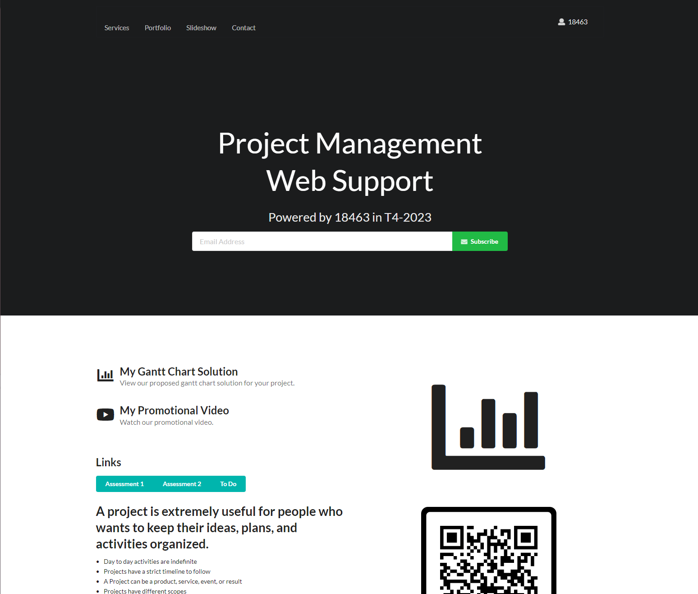

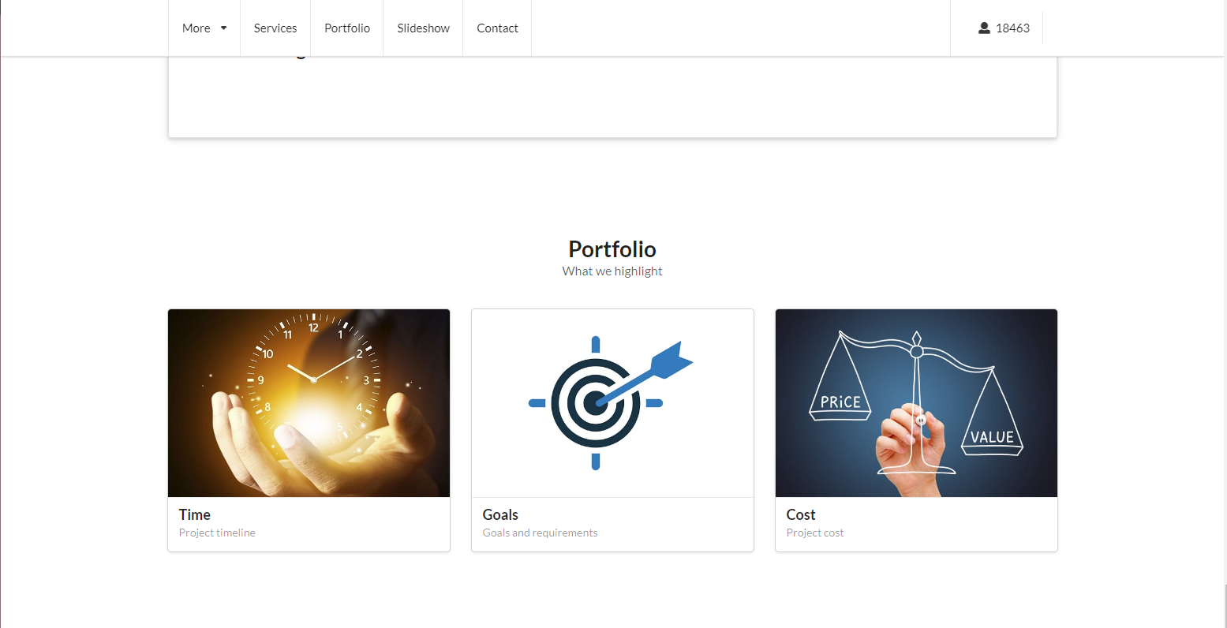

And:

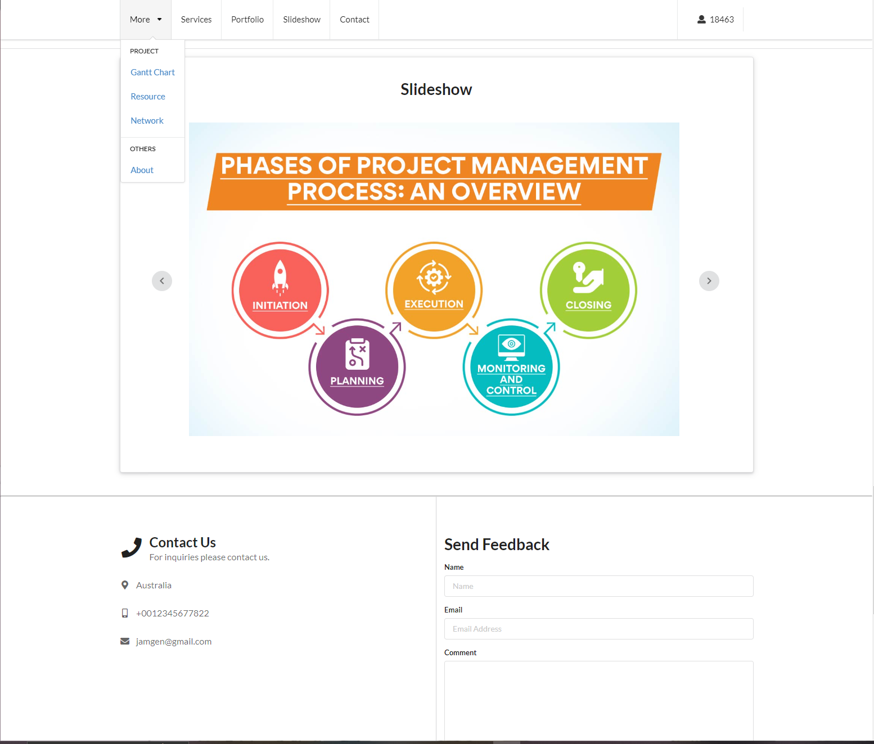

Refer to your current project, you have been asked to develop a project plan for WIC. Project plan outline as following:

In my Green project, I design following topics:

* Introduction (Select one recommendation from Task 2 for implement project plan) - we can start with a project management plan by implementing our energy source from fossil fuels to renewable energy by installing solar panels steadily with a given deadline for completion.
* Project background – Make a plan for implementing a project until completion
* Related factor to organization – Environmental factors
* Scope and objective of the project – to switch energy source from fossil fuels to renewable energy sources.
* Information gathering plan and approach – research on where to procure the hardware needed for the project and gathering information on where to procure the hardware, afterwards implementation of the hardware to be of use for the business.
* Gathering method, can be one of the following
  + Online Research
  + Questionnaire
  + Trivias
  + Case Studies
  + Feasibility studies
* Technical – Such hardware can be implemented in parallel.
* Operational – After installation, we need to do a routine maintenance
* Project plan and schedule (Development and Maintenance) – A complete plan and documentation on development and maintenance for the project. Development documents will be provided for the maintenance team in order for them to be familiar with the project that was developed by the development team.
* Work breakdown structure – This can be done with a Gantt Chart
* Gantt Chart – Provides information of the Project life cycle
* Milestone -

Above last black diamond is the milestone!

* Project Deliverable
* Communication plan – to be communicated with the client in order to have a concrete goal and to discuss what can be completed with the resources the client can provided and discuss scopes and limitations.
* Deployment Plan (If needs) – deployment will be done steadily until completion.
* Training Plan (If needs) – Training will be provided for employees that will do the maintenance.
* Recourse and budget, (budget has been limited by WIC Capital Expenditure of current fiscal year for Hardware $80,000, Software $10,000, and Outsourcing man-hours $100,000)

Above image is showing my current green project displaying part of budget!

* Risk Management – Plan in case something unexpectedly happens.
* Risk identified – if current scenarios meet any of the risk conditions.
* Contingency plan – In case of unexpected turn of events such as late delivery of hardware, we will do the necessary steps needed that is inline with our risk management plans.
* Change management – Changes in plan can be made during development and if the worst case scenario occurs such as delay in completion, we will have to discuss this with the client.
* Change control
* Conflict management

### Task 5: Project Closure

Prepare project closure document template as following:

* Project Sign-off document

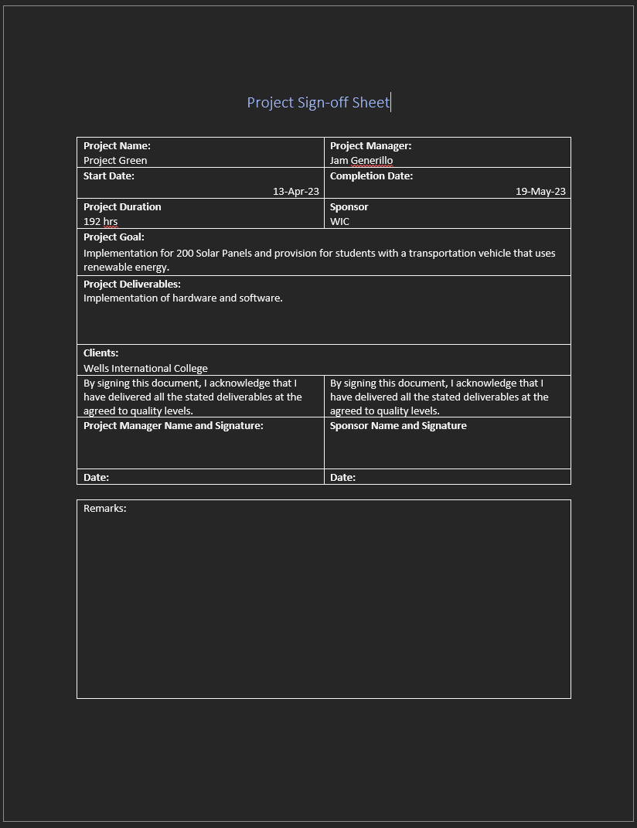

* Project evaluation document

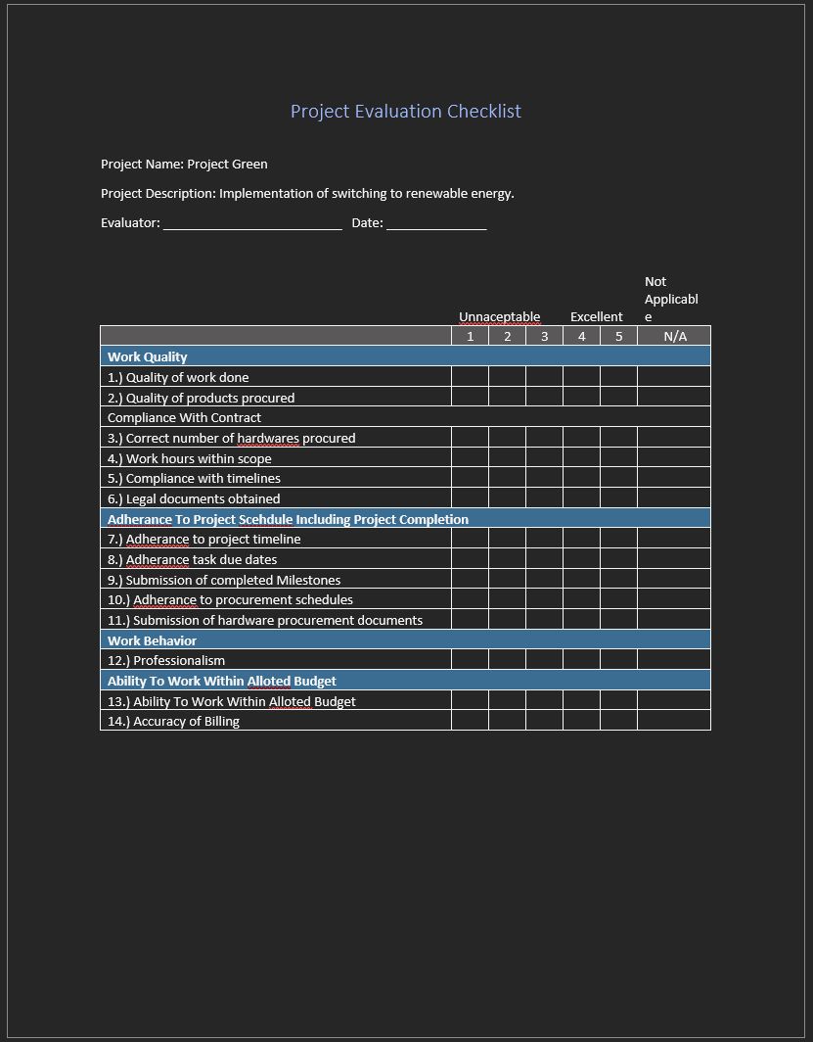

* Lesson learned template
* What we have learn through this project
* What we need to do if next project start
* What we learn some lesson. We could not make same mistake again.
* Etc.

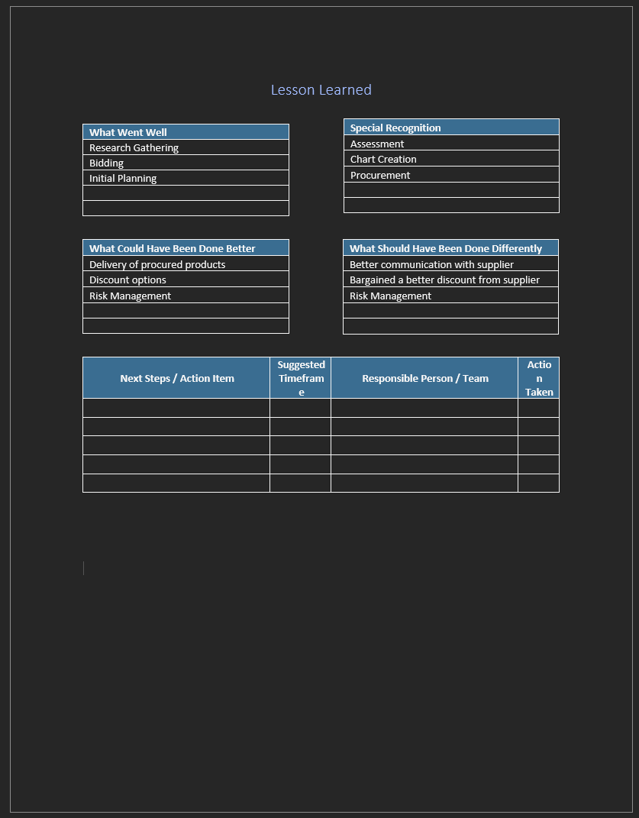

## Helpful web links to complete the assessment:

## Search Index

B

Benefit evaluation 10

Budget evaluation 10

F

feasible solution 1, 4

P

project sign off 9

Q

Quality evaluation 10

S

same mistake 10

scenario 1

specific focus 2