Full Name: Jam Generillo Student ID: 18463

Wells international college

**Project Management**

Assessment Two

|  |  |  |  |
| --- | --- | --- | --- |
| Name of Student | Jam Generillo | ID | 18463 |

**Assessment 2 – Research (Online)**

Contents

Instructions: 1

Duration: 2

Multiple-choice Questions: 2

Learning Notes: 7

What is project? 8

Please put your learning notes here: 8

Project management basic 8

Project management History 8

Project management in the future 9

Project Team 10

Document Search Index 10

## Instructions:

This is an individual assessment. Answer all the questions on the document provided by your Trainer.

## Duration:

Trainer will set the duration of the assessment.

## Multiple-choice Questions:

1. 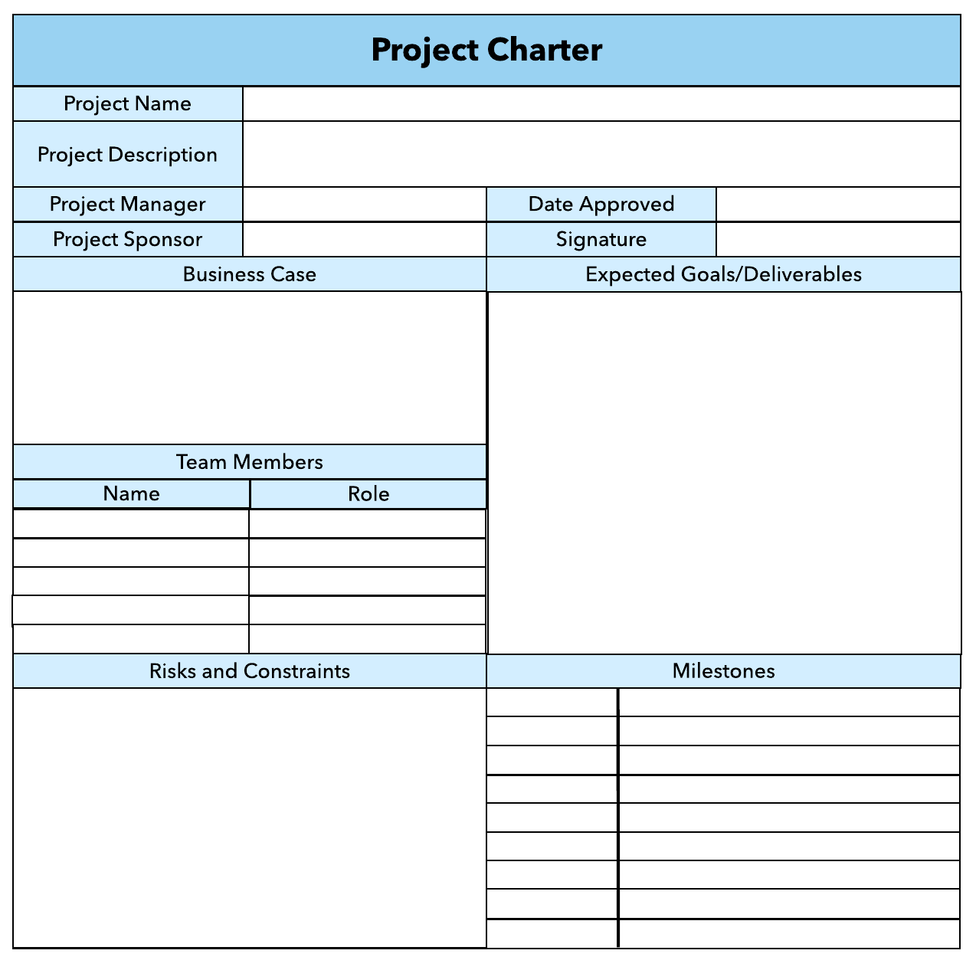What advice do we give about factoring in the commitments of project stakeholders when making your own plans?
   1. Consult student timetables to see when they might be free to attend data collection sessions.
   2. Ask external organizations what the most convenient times would be for you to visit
   3. Neither of these

d) Both A and B

Comment: stakeholders should give a confirmation of agreement with your plan.

1. Which of the following are essential components of a GANTT chart used to plan your project?
   1. Your home telephone number
   2. Your supervisor’s home telephone number
   3. The email address for the chair of the ethics committee
   4. None of the above

Comment: The essential component of a Gantt Chart is its information to display the planned schedule, cost, and tasks of the project. It also gives information on what steps you are doing in completing the project.

Web ref: <https://www.proofhub.com/articles/gantt-charts>

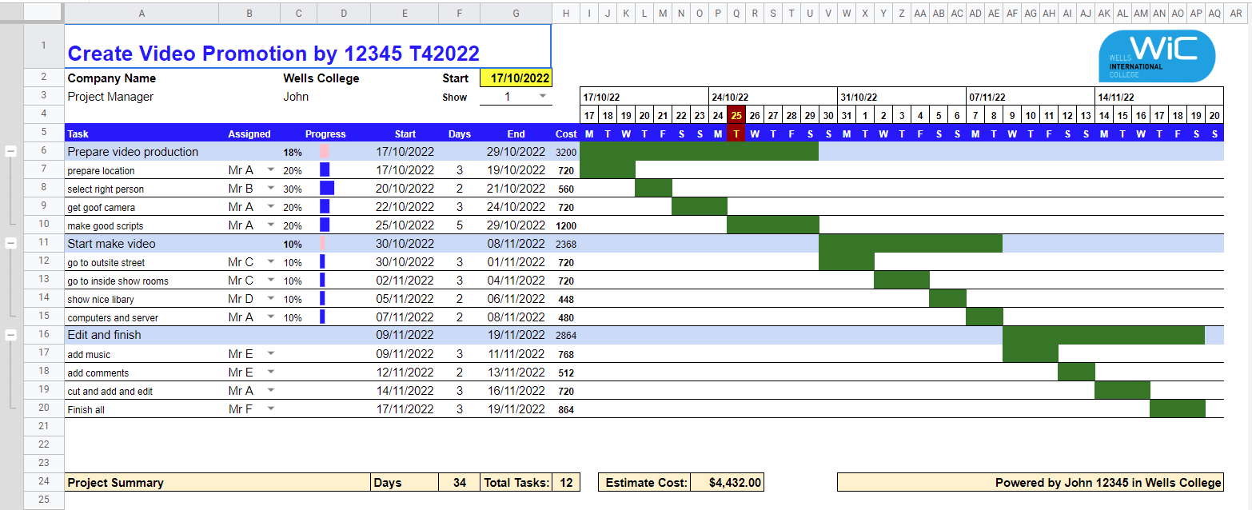

1. The intended outcome of strategy/projects integration is
   1. Clear organization focus
   2. Best use of scarce organization resources
   3. Improved communication across projects and departments
   4. Both A and C are correct
   5. A, B, and C are all correct



Comment: **Integration** management is the process of planning and implementing steps needed in order to complete a project. It involves making different plans whenever the project encounters events that are not foreseen during planning.

Web Refer: <https://en.m.wikibooks.org/wiki/Project_Management/PMBOK/Integration_Management>

1. Which of the following questions does the organization's mission statement answer?
   1. What are our long-term strategies?
   2. What are our long-term goals and objectives?
   3. How do we operate in the existing environment?
   4. What do we want to become?
   5. All of these are answered by the mission statement

1. Which of the following is not one of the requirements for successful implementation of strategies through projects?
   1. Allocation of resources
   2. Prioritizing of projects
   3. Motivation of project contributors
   4. Adequate planning and control systems
   5. All of these are requirements

1. Which of the following is the reason(s) why project managers need to understand their organization's mission and strategy?
   1. To make appropriate decisions and adjustments
   2. To be effective project advocates
   3. To be able to get their job done
   4. Both A and B are correct
   5. A, B, and C are all correct

1. Which of these is the highest priority and first strategy required for any organizational change?

a) Communication

* 1. Stress management
  2. Negotiation
  3. Learning
  4. Employee involvement

1. Which of the following is not a procedure to obtain an understanding risk in the planning stage (described in ISA 315):
   1. Inquiries of management
   2. Analytical procedures
   3. Observation and inspection
   4. Procedures for sampling audit tests

1. Assessment of control risk includes three steps. Which of the following is not one of these steps?
   1. Obtaining an understanding of internal controls and documentation of the controls
   2. Evaluate sufficiency and appropriateness of audit evidence
   3. An initial assessment and response to assessed risk based on the design of internal controls resulting in an audit planning memorandum and audit plan
   4. A final assessment based upon test of controls of operating effectiveness

1. Which of the following are not common internal control documentation techniques used by auditors?

a) Questionnaires

* 1. Company internal control manuals
  2. Narrative descriptions
  3. Check lists

1. Overall response to assessed risk may include:
   1. Identify the absence of key controls (where controls are lacking)
   2. Identify existing controls
   3. Incorporating additional elements of unpredictability in the selection of further audit procedures to be performed
   4. Determine potential material misstatements that could result

1. 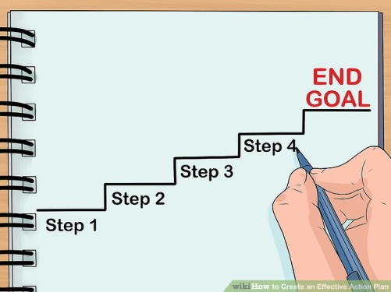Action plan Should be
   1. Specific
   2. Countable
   3. Realistic
   4. Achievable

Comment: An **action plan** is a detailed **plan** outlining actions needed to reach one or more goals. It is a step by step procedure to complete the goal in mind.

Web Refer: <https://en.wikipedia.org/wiki/Action_plan>

1. Which of the following is not a function of Project Management Tool?
   1. Plan a project
   2. Manage Tasks
   3. Manage Issues
   4. Time Tracking
   5. None of above

1. John, the project manager for the ERP Project, is about to complete the project phase review. The completion of a project phase is also known as which of the following? a) A lesson learned
   1. A kill point
   2. Earned value management
   3. Conditional advancement

1. Which of the following is not a key stakeholder in a project that creates a service internal to an organization?
   1. The project manager
   2. External customers
   3. Project vendors
   4. Project team members

1. Managing a project is best described as which one of the following?
   1. Establishing direction
   2. Functional controls over the project team and stakeholders
   3. Consistently producing key results expected by stakeholders
   4. Motivating and inspiring the project team to produce results that are expected by project stakeholders

1. You are the project manager for your organization. Influencing your organization requires which of the following?
   1. An understanding of the organizational budget
   2. Research and documentation of proven business cases
   3. An understanding of formal and informal organizational structures
   4. Positional power

1. What is the difference between a standard and a regulation?
   1. Standards are mandatory; regulations are not.
   2. Standards are optional; regulations are not.
   3. Regulations and standards are essentially the same.
   4. Regulations are usually mandatory; standards may be seen as guidelines.

1. Which of the following is an example of a deliverable at the end of the requirements-gathering phase in a software design project?
   1. Responsibility matrix creation
   2. Detail design document
   3. Business needs
   4. Project team assembled

1. At what point in a project would a kill point be acceptable?
   1. When a project team member is not performing as planned
   2. When a project reaches the end of a project phase
   3. When a project reaches the end of its budget
   4. When a project manager determines the project team cannot continue

1. Of the following, which is not an exit criterion?
   1. Customer sign-offs
   2. Quality metrics
   3. Stakeholder analysis
   4. Regulatory inspections

1. At which point is the risk of failure the least but the consequence of failure the highest?

a) During the early stages

* 1. During the middle stages
  2. During the final stages
  3. Risk of failure is even across all project phases

1. In project estimation, project manager has to provide an expert judgement, which are considered of the following EXCEPT:
   1. Impact of inflation over the project lifecycle
   2. Required labour and labour rates
   3. Material costs and assumptions
   4. Costs of quality
   5. All of above
   6. None of above

1. Which component is/are included in Quality Management Plan
   1. 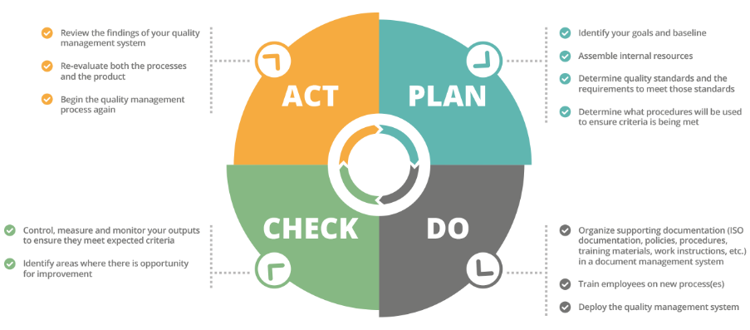Quality objectives
   2. Key project deliverables
   3. Quality standards
   4. Quality control and assurance activities
   5. All of above

Comment: The four main components of a quality management process are Quality Planning, Quality Assurance, Quality Control and Continuous Improvement.

For it to be effective, the four components must work hand by hand and executed effectively.

Web Refer: <https://info.docxellent.com/blog/main-components-quality-management>

Web Comment: When broken down, [quality control management](https://docxellent.com/document-control-solutions/quality-management/) can be segmented into four key components to be effective: quality planning, [quality control](https://docxellent.com/document-control-solutions/change-control/), [quality assurance](https://docxellent.com/service-support/software-quality-assurance/), and quality improvement.

1. What's an activity sequencing
   1. 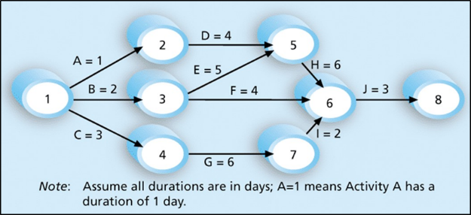The process for identifying and documenting dependencies among schedule activities
   2. The process for identifying critical activities
   3. The process for identifying ordering and schedule activities
   4. The process for planning the project

***Activity sequencing*** reviews all activities in the WBS with the goal of identifying relationships between them and classifying all the timing relationships among tasks. These relationships (aka "linkages", "dependencies", "predecessors"). Task timing relationships are important because they control task sequencing and task start and end dates. There are four types of task relationships:  
A ***finish-to-start relationship***

A ***start-to-start relationship***

A ***finish-to-finish relationship***

A***start-to-finish relationship***

Refer: <https://www.e-education.psu.edu/geog871/l5_p4.html>

Comment: activity sequencing could help make your project stage very clear and easy to follow the project progress. The process for identifying and documenting dependencies among schedule activities

## Learning Notes:

<https://www.youtube.com/watch?v=rBSCvPYGnTc&t=1323s>

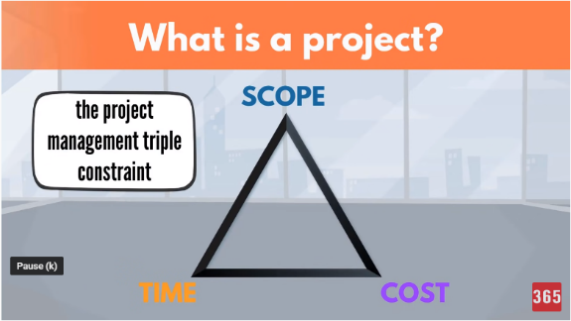A project is something extremely useful for people that want to accomplish their future ideas.

A project is a temporary endeavour undertaken to create a unique product, service or result.

Day to day activities have no end date.

Project on the other hand have a strict expiry date.

Project output is product or service or result.

Project shows different scope.

If the scope is not unique, this is a regular business process.

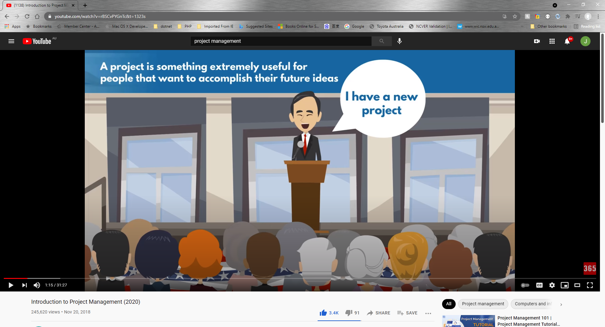

## What is project?

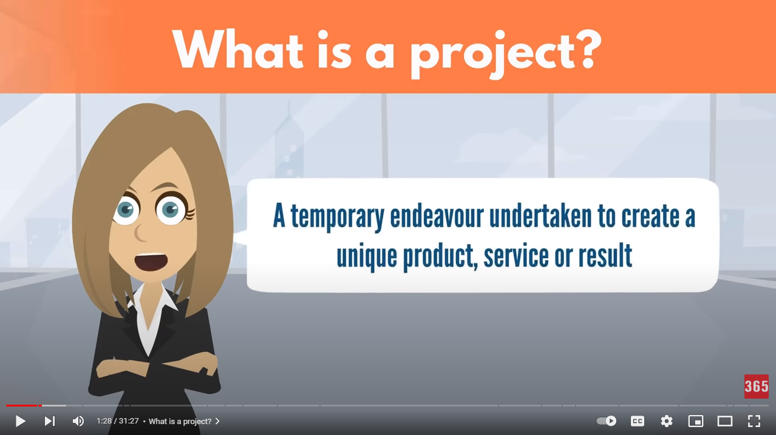

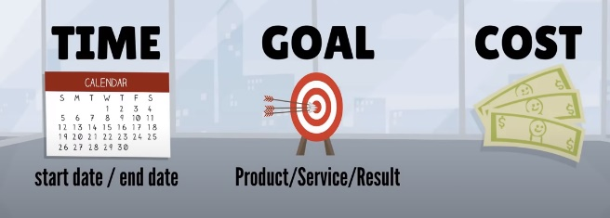project need you make a big effect in order to achieve a unique or specific goal…

project need show start date or time and finish date or time

## Please put your learning notes here:

## Project management basic

## Project management History

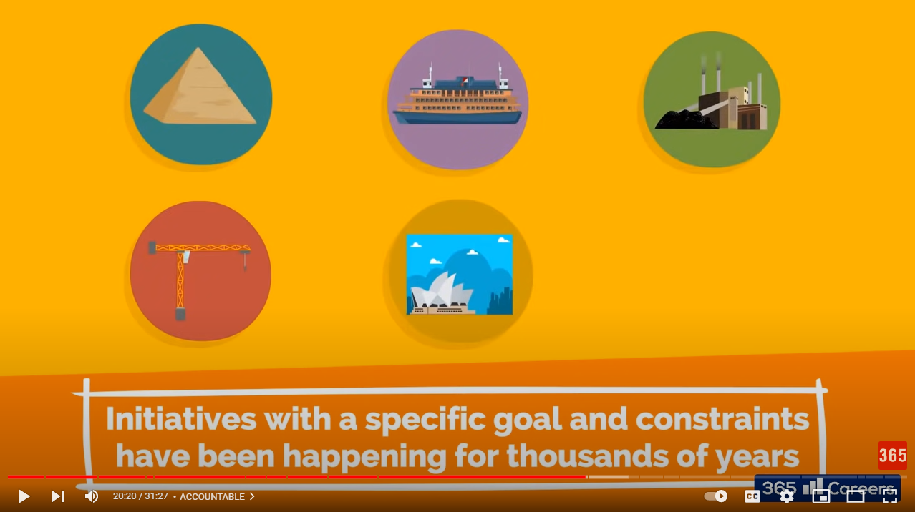

Good example is: Ancient Egypt build a big project!

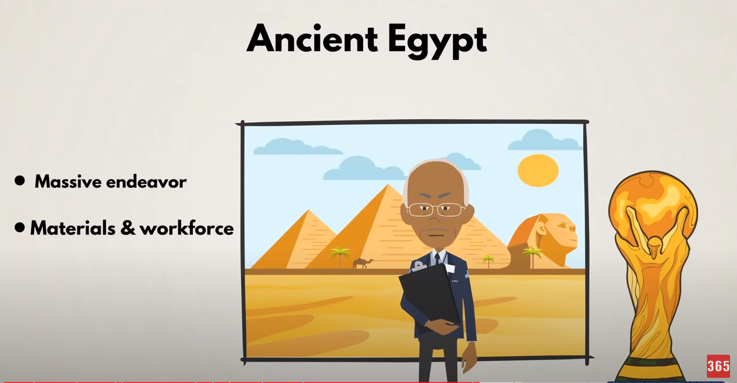

20 Century the Henry Gantt first make Gantt Chart Diagram. It is the revolution to know more about project management.

## Project management in the future

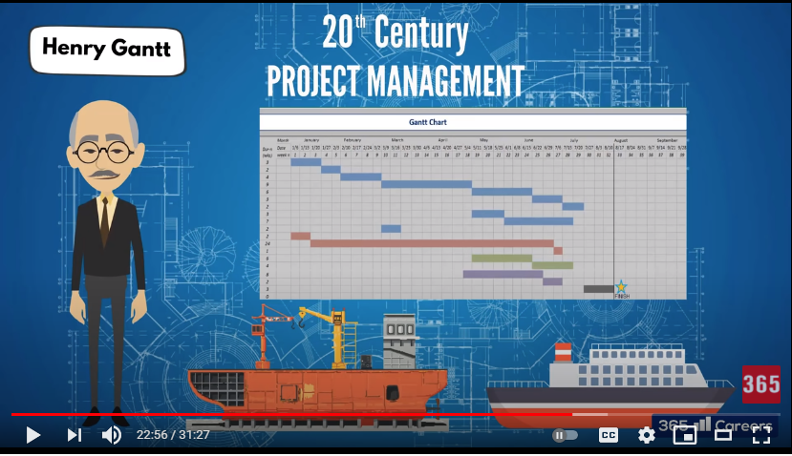

## Project Team

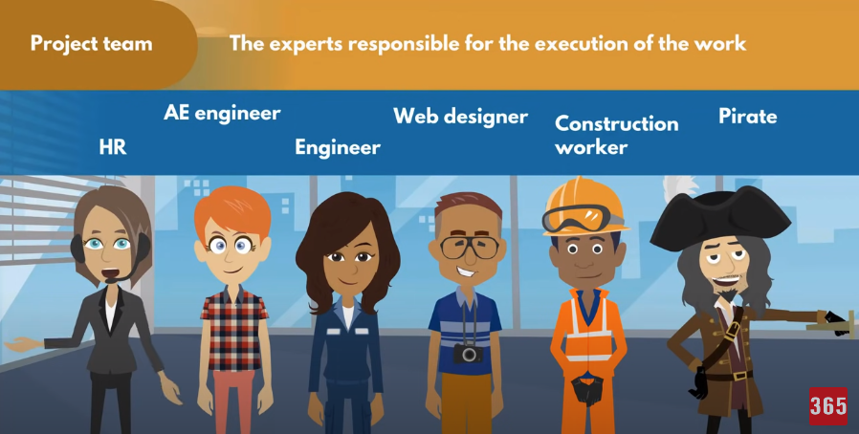

The experts responsible for the execution of the work

## Document Search Index

A

a GANTT chart 2

M

mission and strategy 3

mission statement 3

O

organizational change 3

P

project stakeholders 2

projects integration 2

S

successful implementation 3

U

understanding risk 4