LEHD Urban Industry Broad Patterns

Jamaal Green

10/31/2017

## Update on Methodology

I've collected LEHD data from 2004 to 2015 for the 48 cities where LEHD data is available. What follows is a brief cover of the industrial employment patterns for these cities over the study period. For now, these graphics are aspatial, though I will attempt a few select summary maps if space allows.

## Manufacturing Is Still Here

An initial look at this data shows a few things but an important one is that manufacturing still has a legitimate presence in city labor markets in both absolute and relative terms and that the state of manufacturing across cities is decidedly mixed. This first graphic, while admittedly busy, shows the broad pattern of the change in manufacturing employment over time in the nation's largest cities. Most cities, unfortunately, have lost manufacturing employment compared to 2005, corresponding to a more general belief that manufacturing is losing in the country and that cities, especially, are inhospitable places. But there are exceptions. The cities highlighted in red all had positive manufacturing employment growth compared to the blue cities that suffered catstrophic manufacturing job losses.

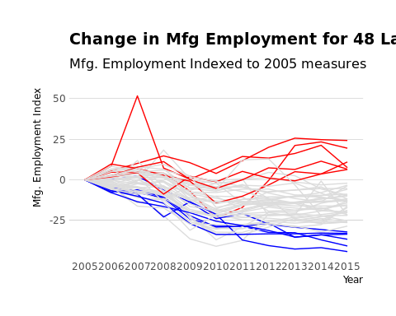

Six cities- Houston, Arlington, San Jose, Oklahoma City, Raleigh, and Tulsa- are the red lines in the previous graphic. By far the most dramatic growth in the past decade are in the energy centers of Oklahoma City, Houston, and Arlington. All three have greater than 10% employment growth in manufacturing when compared to their 2005 job numbers and Houston's manufacturing employment grew by nearly 25%. Though these cities have impressive manufacturing job growth, the *relative* importance of manufacturing employment weakened in many of the cities as the proportion of all jobs in manufacturing fell.

