**Explanation of the Logistic Regression:**

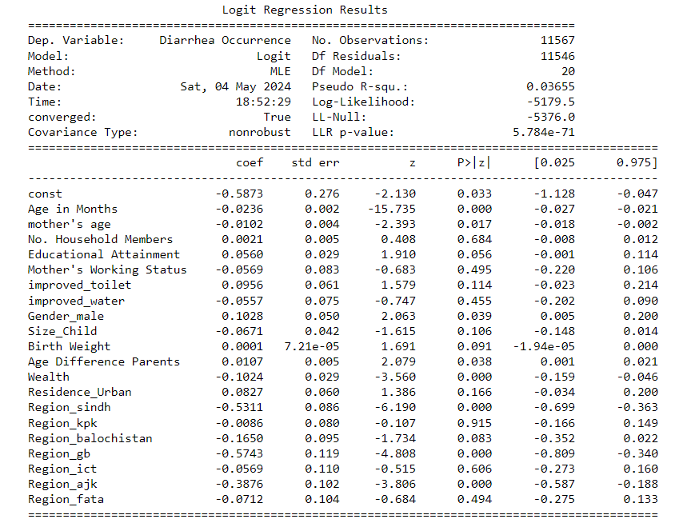

1. The LLR p-value represents the probability of the null hypothesis that none of the variables have a significant impact on the occurrence of diarrhea. Since the p-value is less than 0.05, we can reject the null hypothesis and conclude that at least one of the independent variables have a significant impact on the occurrence of diarrhea (dependent variable- DV).
2. The P>|z| value represents the probability of null hypothesis that the corresponding variables have no significant impact on the DV. The variables whose corresponding p-value is less than 0.05 (5% level) could be taken as significant. We can also judge the significance at 0.10 or 0.01 level (10% or 1% level). For example- Age in months is significant at 0.01 level whereas size of child and weight of child is significant at 0.10 level.
3. The coefficient represents how much the log odds of the DV increases when one unit of that independent variable increases. When we exponentiate the coefficient, we get the value by which the Odds of diarrhea occurrence increases for each unit increase of that independent variable does. (If you find it too complicated, just explain the first line)
4. **Age in Months:** The coefficient for age in months is statistically significant at the 1% level (p < 0.01), indicating that age has a significant effect on the likelihood of experiencing diarrhea in children. Specifically, for each additional month in age, the log odds of experiencing diarrhea decrease by 0.0236 units, holding all other variables constant.
5. **Mother's Age:** The coefficient for mother's age is also statistically significant at the 1% level (p < 0.01), suggesting that mother's age is an important factor in predicting the likelihood of diarrhea occurrence in children. With each additional year in mother's age, the log odds of experiencing diarrhea decrease by 0.0102 units.
6. **Wealth:** Wealth shows statistical significance at the 1% level (p < 0.01), indicating its strong association with the likelihood of diarrhea occurrence in children. For each unit increase in wealth, the log odds of experiencing diarrhea decrease by 0.1024 units, implying that higher wealth is associated with a lower risk of diarrhea.
7. **Gender (Male):** Gender demonstrates significance at the 5% level (p < 0.05), suggesting that gender plays a role in the likelihood of diarrhea occurrence. Being male is associated with an increase in the log odds of experiencing diarrhea by 0.1028 units compared to females.
8. **Educational Attainment:** Educational attainment is marginally significant at the 10% level (p = 0.056), implying a possible association with diarrhea occurrence. The coefficient suggests that higher levels of educational attainment may be associated with a slight increase in the log odds of experiencing diarrhea, although further investigation may be warranted to confirm this relationship.
9. **Region (Other than Punjab):** The coefficients for regions other than Punjab, including Sindh, GB, AJK, and Balochistan, are statistically significant at various levels, indicating regional disparities in the likelihood of diarrhea occurrence. Residents in these regions generally exhibit lower log odds of experiencing diarrhea compared to Punjab, with Sindh and GB showing particularly strong associations.
10. **Age Difference Between Parents:** The coefficient for Age Difference between Parents is statistically significant at the 5% level (p < 0.05), indicating its relevance in predicting the likelihood of diarrhea occurrence in children. With each additional year of age difference between parents, the log odds of experiencing diarrhea increase by 0.0107 units. This suggests that larger age differences between parents may be associated with a slightly higher risk of diarrhea in children, although the effect size is relatively small compared to other significant variables.